Batch Data Processing Using Airflow & Redshift

# Project Overview

This project processes music streaming data using AWS services. Data is ingested from Amazon S3, transformed using Python and Apache Airflow, and stored in Amazon Redshift for analytics.

# Architecture

The solution follows this architecture:

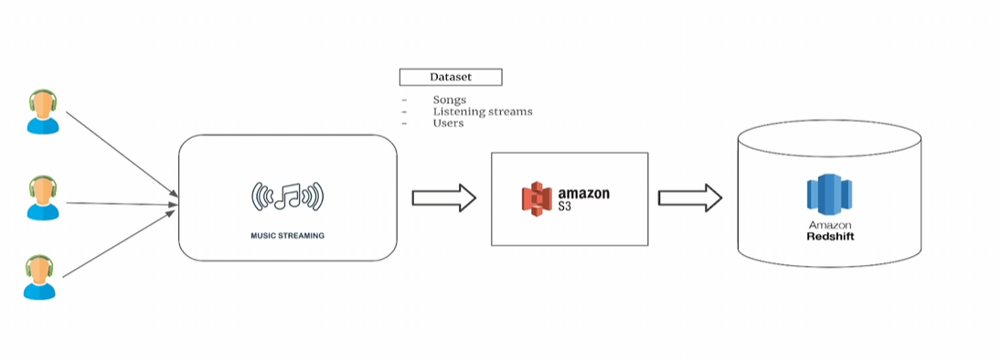

# Data Pipeline Steps

1. **Ingest Data**: Fetch CSV files from S3.  
2. **Validate Data**: Ensure required columns exist.  
3. **Transform Data**: Compute music streaming KPIs.  
4. **Load to Redshift**: Store transformed data.  
5. **Archive Processed Files**: Move files post-processing.

# Workflow

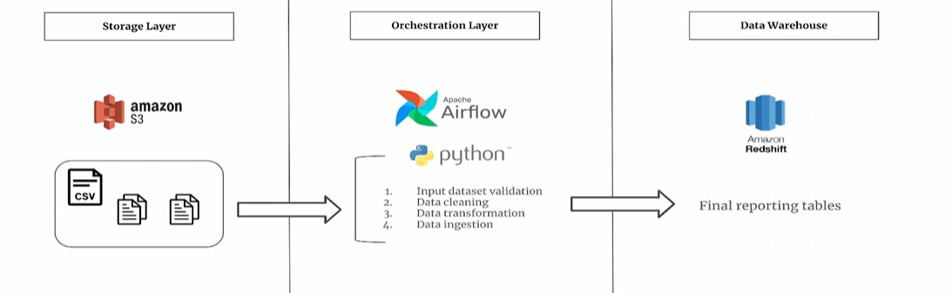

# Tools & Technologies

- **Amazon S3**: Data storage.  
- **Apache Airflow**: Orchestration.  
- **Python & Pandas**: Data transformation.  
- **Amazon Redshift**: Data warehouse.

# Conclusion

The implementation of Airflow and Redshift streamlines data processing for music analytics. Future improvements could include real-time processing and predictive analytics.