Distributed Music Streams Processing Using Airflow & DynamoDB

# Project Overview

This ETL pipeline processes music streaming data using AWS services. Airflow orchestrates workflow execution, Spark transforms raw data, and DynamoDB stores the processed results for efficient access.

# Architecture

The solution follows this architecture:

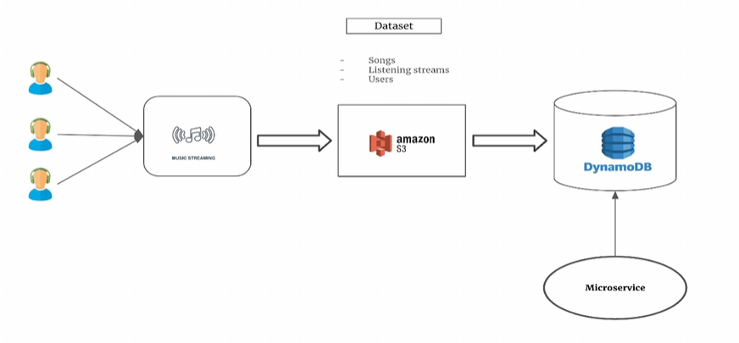

# Data Pipeline Steps

1. **Validate Data**: Ensure input files exist in S3.  
2. **Spark Transformations (AWS Glue)**: Process streams & compute KPIs.  
3. **Python Ingestion Job**: Write transformed data to DynamoDB.  
4. **Archive Processed Files**: Move data post-processing.

# Workflow

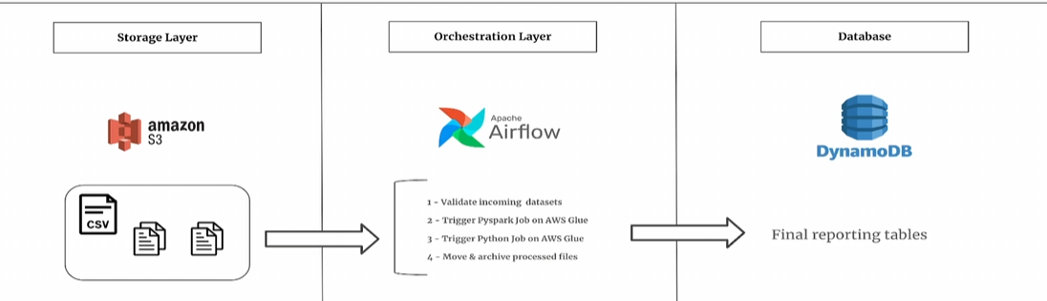

# Tools & Technologies

- **Amazon S3**: Data storage.  
- **Apache Airflow**: Orchestration.  
- **AWS Glue (Spark & Python)**: Data transformation & ingestion.  
- **Amazon DynamoDB**: Fast-access NoSQL database.

# Conclusion

This workflow ensures efficient, scalable ETL processing of music streams. Future enhancements could introduce event-driven triggers and real-time analytics.