Big Data Processing of Rental Vehicles - Website Friendly Report

# Introduction

This document outlines the implementation of an AWS-based data lake for rental vehicle analytics. The architecture enables large-scale data processing using AWS services like EMR, S3, and Athena.

# Technical Overview

The system leverages:  
- **Amazon S3** for storage  
- **AWS EMR** for distributed data processing  
- **AWS Glue** for schema inference  
- **Amazon Athena** for querying the data lake  
- **AWS Step Functions** for workflow automation

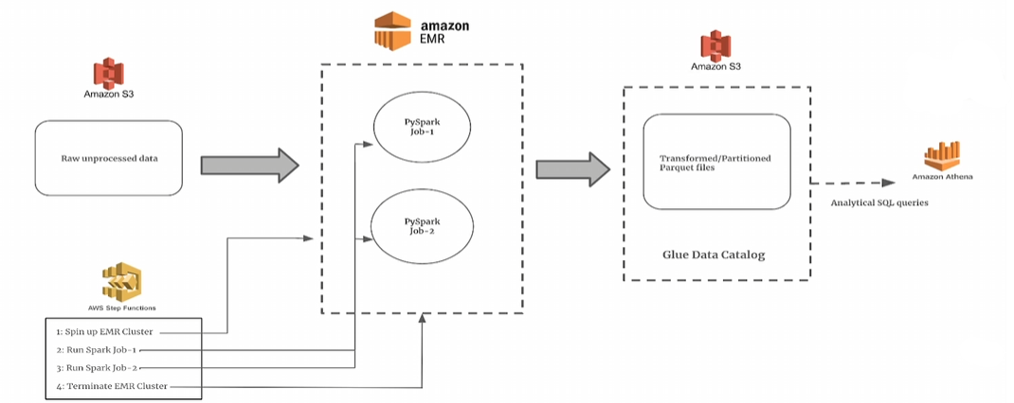

# Workflow Execution

1. **Data is uploaded to Amazon S3**  
2. **EMR executes PySpark jobs to process the data**  
3. **Transformed data is stored back in S3**  
4. **Glue crawlers create metadata for Athena queries**  
5. **Athena enables SQL queries on the data lake**

# Summary

This project highlights how AWS services simplify big data processing by reducing infrastructure management and optimizing query performance.