# E-commerce Data Processing & Lakehouse Architecture

Welcome to the documentation for our e-commerce data processing system. This document provides a high-level overview of how data is processed efficiently using AWS services.

## 1. Event-Driven Data Processing

Our system automatically processes incoming transactional data from the e-commerce platform. This ensures real-time insights and automation.

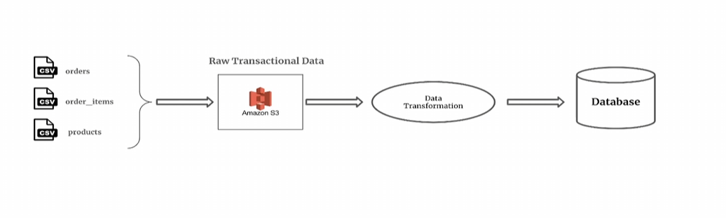

## 2. Lakehouse Architecture

We use a modern lakehouse architecture to manage and analyze large volumes of e-commerce data. This enables better data consistency, scalability, and flexibility for analytical workloads.

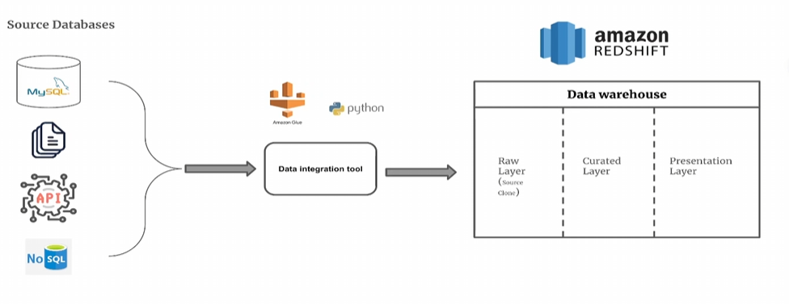

For more details, visit our website or contact support.