# Event-Driven Data Processing for Taxi Services

## Overview

This solution provides a robust event-driven data processing system for managing taxi trips. Using AWS services like Kinesis, Lambda, and DynamoDB, the system ensures real-time data processing and analytics.

## Key Features

✔️ Real-time trip tracking  
✔️ Scalable and cost-efficient serverless architecture  
✔️ Seamless integration with AWS services  
✔️ Instant analytics and reporting

## How It Works

1. **Trip Start:** Data is captured and written to Kinesis.  
2. **Trip End:** Additional details are sent to a second stream.  
3. **Lambda Functions:** Process and store data in DynamoDB.  
4. **Data Processing:** AWS Glue aggregates and transforms data.  
5. **Analytics:** Data is stored in S3 for analysis.

System Architecture:

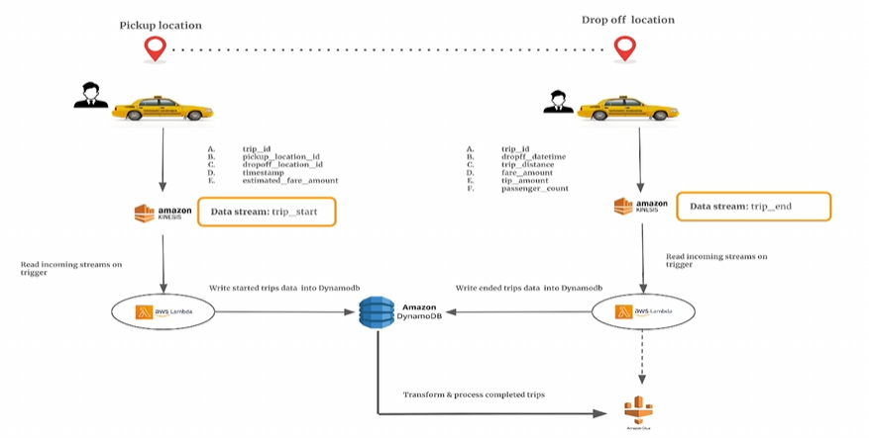

## Implementation Guide

**Step 1:** Set up Kinesis Data Streams.  
**Step 2:** Deploy AWS Lambda functions.  
**Step 3:** Configure DynamoDB for trip storage.  
**Step 4:** Set up AWS Glue for data aggregation.

## Get Started Today!

Ready to enhance your taxi service with real-time data processing? Implement this AWS-powered solution and streamline trip management effortlessly!