Real-Time Streaming Data Processing with PySpark and Kinesis

# Overview

This real-time streaming pipeline processes telecommunication network data, leveraging AWS Kinesis and PySpark. The system enables live tracking of signal strength, network provider analytics, and geographical insights.

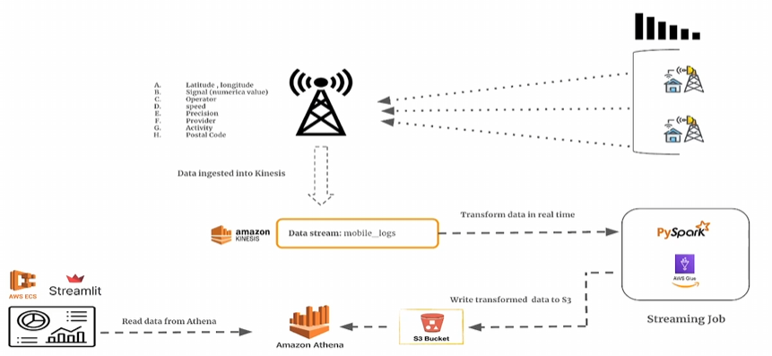

# Key Features

✔️ **Live Data Ingestion**: Captures network logs in real time using AWS Kinesis.   
✔️ **Real-Time Processing**: Uses AWS Glue and PySpark Streaming for transformations.   
✔️ **Efficient Storage**: Stores processed data in an AWS S3 data lake.   
✔️ **Instant Analytics**: Queries data via Athena for insights.   
✔️ **Interactive Dashboard**: A web dashboard built with Streamlit and deployed on ECS.

# How It Works

🔹 **Step 1**: Data is ingested from mobile network logs into AWS Kinesis.   
🔹 **Step 2**: PySpark processes the data in real-time and writes output to S3.   
🔹 **Step 3**: AWS Glue crawlers catalog the data, making it queryable.   
🔹 **Step 4**: Athena enables SQL-based queries on transformed data.   
🔹 **Step 5**: A Streamlit dashboard visualizes metrics like average signal strength and GPS precision.