Real-Time Data Ingestion for E-Commerce Analytics

# What is Real-Time Data Processing?

E-commerce businesses generate huge amounts of user data every second. Tracking user clicks, views, and interactions in **real-time** helps improve customer experience and optimize sales strategies. Our system ensures seamless ingestion of real-time clickstream data into a data warehouse for instant analysis.

# How Our System Works

Our advanced real-time data ingestion system follows these steps:

✅ Captures user actions (clicks, views, purchases) instantly.

✅ Processes and categorizes the data on the fly.

✅ Stores the data securely in Amazon Redshift and S3 for reporting and analysis.

✅ Enables real-time business insights for better decision-making.

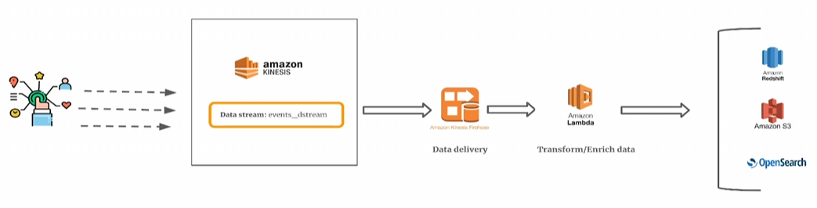

# Why Choose Our Solution?

🚀 **Real-Time Analytics** – Gain instant insights from user activity.

🔒 **Secure & Scalable** – Built on AWS for high security and scalability.

📊 **Enhanced Customer Experience** – Understand user behavior and improve engagement.

💡 **Business Optimization** – Identify trends and boost revenue with data-driven decisions.

# Start Optimizing Your Business with Real-Time Insights!

🔹 Contact us today to implement this powerful real-time analytics solution and stay ahead of the competition.