# ETL Pipeline for Rental Apartments - AWS Implementation

## Overview

This document explains how to implement an ETL pipeline for processing rental apartment data using AWS Glue, Redshift, and Step Functions.

## Architecture

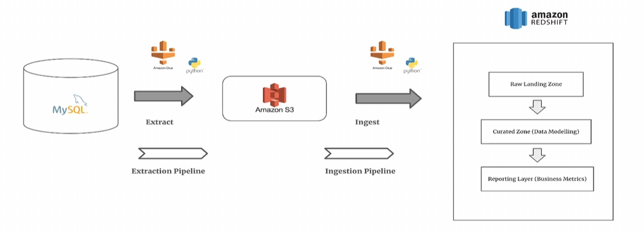

The ETL pipeline consists of data extraction, transformation, ingestion, and orchestration.

## ETL Process

1. **Extract:** Data is pulled from AWS Aurora (MySQL) and stored in Amazon S3.  
2. **Transform:** AWS Glue jobs process and clean the data.  
3. **Load:** The transformed data is ingested into Amazon Redshift.  
4. **Orchestration:** AWS Step Functions manage workflow execution.

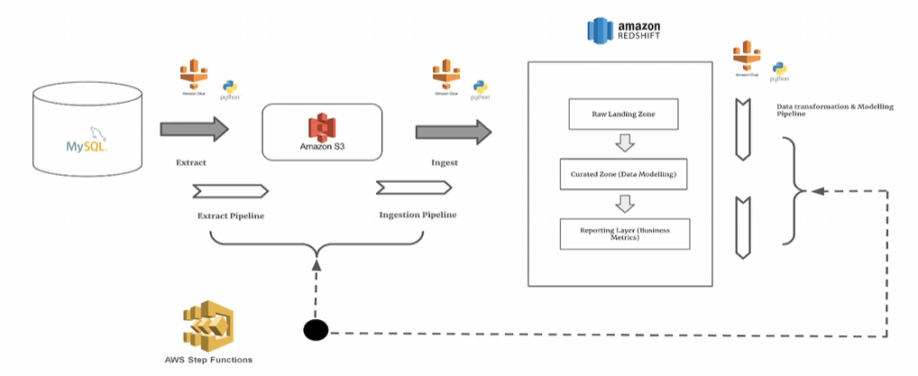

## Key AWS Services Used

- **Amazon S3**: Cloud storage for raw and processed data.  
- **AWS Glue**: ETL service using Python-based processing.  
- **Amazon Redshift**: Data warehouse for analytics.  
- **AWS Step Functions**: Workflow automation and execution.

## Benefits of the ETL Pipeline

✅ Scalable data processing  
✅ Cost-efficient cloud-native ETL  
✅ Automated workflow with Step Functions  
✅ Advanced analytics with Redshift