# VISVESVARAYA TECHNOLOGICAL UNIVERSITY

**“JnanaSangama”, Belgaum -590014, Karnataka.**



## LAB REPORT

### on

Machine Learning (23CS6PCMAL)

#### Submitted by

**Abhishek Yadav (1BM22CS009)**

#### in partial fulfillment for the award of the degree of

**BACHELOR OF ENGINEERING**

***in***

## COMPUTER SCIENCE AND ENGINEERING



**B.M.S. COLLEGE OF ENGINEERING**

**(Autonomous Institution under VTU)**

## BENGALURU-560019

## Feb-2025 to June-2025

**B.M.S. College of Engineering,**

**Bull Temple Road, Bangalore 560019;;**

(Affiliated To Visvesvaraya Technological University, Belgaum)

**Department of Computer Science and Engineering**



##### CERTIFICATE

This is to certify that the Lab work entitled “Machine Learning (23CS6PCMAL)” carried out by **Abhishek Yadav (1BM22CS009),** who is bonafide student of **B.M.S. College of Engineering.** It is in partial fulfillment for the award of **Bachelor of Engineering in Computer Science and Engineering** of the Visvesvaraya Technological University, Belgaum. The Lab report has been approved as it satisfies the academic requirements in respect of an Machine Learning (23CS6PCMAL) work prescribed for the said degree.

|  |  |
| --- | --- |
| Dr. Seema Patil  Assistant Professor  Department of CSE, BMSCE | Dr. Kavitha Sooda  Professor & HOD  Department of CSE, BMSCE |

# Index

|  |  |  |  |
| --- | --- | --- | --- |
| **Sl.**  **No.** | **Date** | **Experiment Title** | **Page No.** |
| 1 | 4-03-2025 | Write a python program to import and export data using Pandas library functions | 1-4 |
| 2 | 4-03-2025 | Demonstrate various data pre-processing techniques for a given dataset | 5-7 |
| 3 | 11-3-2025 | Implement Linear and Multi-Linear Regression algorithm using appropriate dataset | 8-16 |
| 4 | 18-3-2025 | Build Logistic Regression Model for a given dataset | 17-20 |
| 5 | 25-3-2025 | Use an appropriate data set for building the decision tree (ID3) and apply this knowledge to classify a new sample. | 21-22 |
| 6 | 01-4-2025 | Build KNN Classification model for a given dataset. | 23-24 |
| 7 | 08-4-2025 | Build Support vector machine model for a given dataset | 25-27 |
| 8 | 15-5-2025 | Implement Random forest ensemble method on a given dataset. | 28-30 |
| 9 | 15-5-2025 | Implement Boosting ensemble method on a given dataset. | 31-33 |
| 10 | 29-5-2025 | Build k-Means algorithm to cluster a set of data stored in a .CSV file. | 34-36 |
| 11 | 29-5-2025 | Implement Dimensionality reduction using Principal Component Analysis (PCA) method. | 37-41 |

Github Link:

##### <https://github.com/AbhishekCS22/6A-ML-LAB-Batch1>

##### Program 1

Write a python program to import and export data using Pandas library functions.

**Code:**

import pandas as pd

import numpy as np

import matplotlib.pyplot as plt

from sklearn.model_selection import train_test_split

from sklearn.impute import SimpleImputer

from sklearn.preprocessing import OrdinalEncoder, OneHotEncoder

from sklearn.preprocessing import StandardScaler, MinMaxScaler

from scipy import stats

df=pd.read_csv('/content/Dataset of Diabetes .csv')

df.head()

df.shape

print(df.info())

*# Summary statistics*

print(df.describe())

missing_values=df.isnull().sum()

categorical_cols = df.select_dtypes(include=['object']).columns

print("Categorical columns identified:", categorical_cols)

if len(categorical_cols) > 0:

df = pd.get_dummies(df, columns=categorical_cols, drop_first=True)

print("\nDataFrame after one-hot encoding:")

print(df.head())

else:

print("\nNo categorical columns found in the dataset.")

from sklearn.preprocessing import MinMaxScaler, StandardScaler

import pandas as pd

numerical_cols = df.select_dtypes(include=['number']).columns

scaler = MinMaxScaler()

df_minmax = df.copy() *# Create a copy to avoid modifying the original*

df_minmax[numerical_cols] = scaler.fit_transform(df[numerical_cols])

scaler = StandardScaler()

df_standard = df.copy()

df_standard[numerical_cols] = scaler.fit_transform(df[numerical_cols])

print("\nDataFrame after Min-Max Scaling:")

print(df_minmax.head())

print("\nDataFrame after Standardization:")

print(df_standard.head())

df1=pd.read_csv('/content/adult.csv')

df1.head()

from sklearn.preprocessing import MinMaxScaler, StandardScaler

import pandas as pd

numerical_cols = df1.select_dtypes(include=['number']).columns

scaler = MinMaxScaler()

df_minmax = df1.copy() *# Create a copy to avoid modifying the original*

df_minmax[numerical_cols] = scaler.fit_transform(df1[numerical_cols])

scaler = StandardScaler()

df_standard = df1.copy()

df_standard[numerical_cols] = scaler.fit_transform(df1[numerical_cols])

print("\nDataFrame after Min-Max Scaling:")

print(df_minmax.head())

print("\nDataFrame after Standardization:")

print(df_standard.head())

**Observation:**

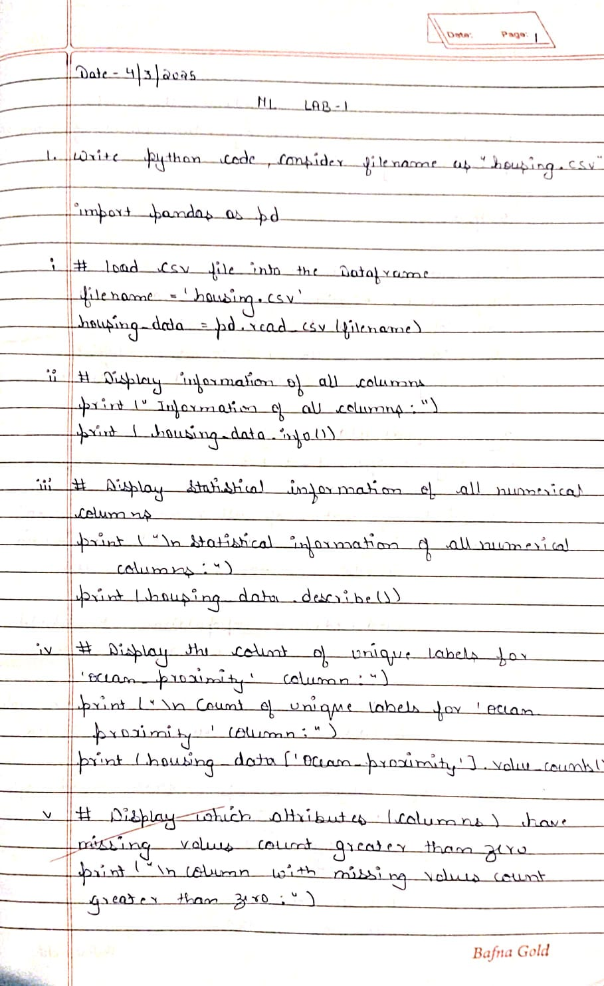

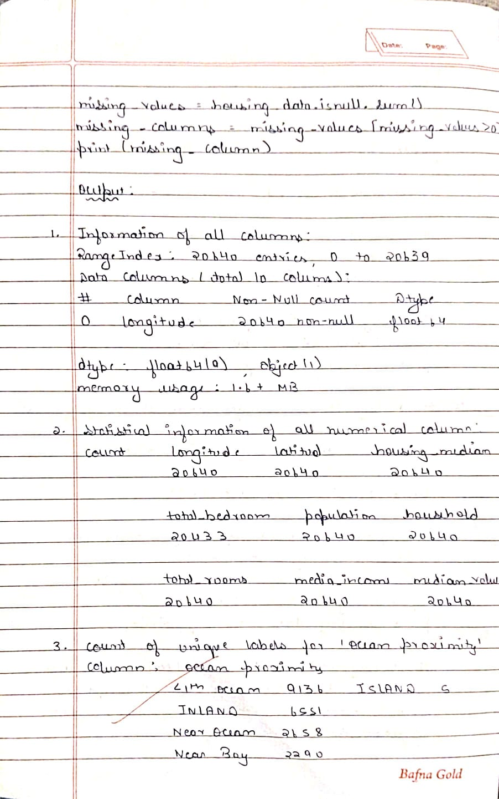

**Program 2**

Demonstrate various data pre-processing techniques for a given dataset.

**Observation:**



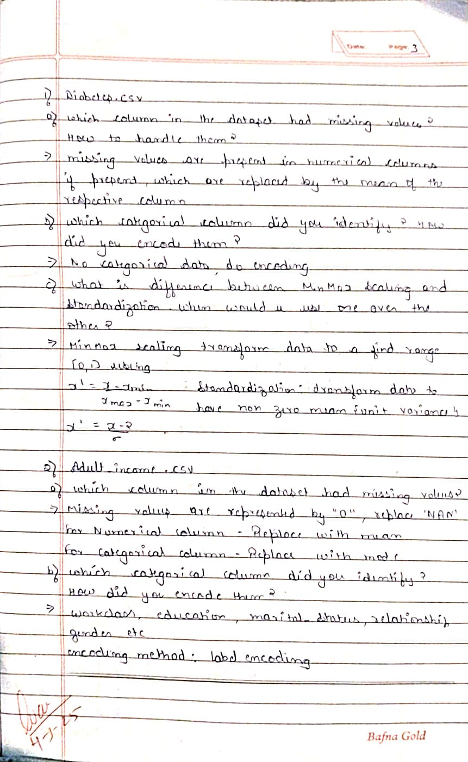

**Code:**

import pandas as pd

import numpy as np

from sklearn.preprocessing import MinMaxScaler, StandardScaler, LabelEncoder

from google.colab import files

*# Upload Files Manually in Google Colab*

uploaded = files.upload()

*# Load the datasets (replace filenames accordingly after uploading)*

diabetes_df = pd.read_csv("diabetes.csv")

adult_df = pd.read_csv("adult.csv")

*# --- Data Cleaning ---*

*# Handling Missing Values: Fill numerical columns with median, categorical with mode*

for df in [diabetes_df, adult_df]:

for col in df.columns:

if df[col].isnull().sum() > 0:

if df[col].dtype == "object":

df[col].fillna(df[col].mode()[0], inplace=True)

else:

df[col].fillna(df[col].median(), inplace=True)

*# Handling Outliers: Capping values beyond 1.5*IQR*

for df in [diabetes_df, adult_df]:

for col in df.select_dtypes(include=np.number).columns:

Q1, Q3 = df[col].quantile(0.25), df[col].quantile(0.75)

IQR = Q3 - Q1

lower, upper = Q1 - 1.5 * IQR, Q3 + 1.5 * IQR

df[col] = np.clip(df[col], lower, upper)

*# --- Handling Categorical Data ---*

for df in [diabetes_df, adult_df]:

categorical_cols = df.select_dtypes(include="object").columns

for col in categorical_cols:

df[col] = LabelEncoder().fit_transform(df[col])

*# --- Data Transformations ---*

scaler_minmax = MinMaxScaler()

scaler_standard = StandardScaler()

for df in [diabetes_df, adult_df]:

numerical_cols = df.select_dtypes(include=np.number).columns

df[numerical_cols] = scaler_minmax.fit_transform(df[numerical_cols])

df[numerical_cols] = scaler_standard.fit_transform(df[numerical_cols])

*# Save processed datasets*

diabetes_df.to_csv("processed_diabetes.csv", index=False)

adult_df.to_csv("processed_adult.csv", index=False)

*# Download processed files*

files.download("processed_diabetes.csv")

files.download("processed_adult.csv")

import pandas as pd

from google.colab import files

*# Upload Files Manually in Google Colab*

uploaded = files.upload()

*# Load the datasets*

diabetes_df = pd.read_csv("diabetes.csv")

adult_df = pd.read_csv("adult.csv")

*# Check for missing values*

missing_diabetes = diabetes_df.isnull().sum()

missing_adult = adult_df.isnull().sum()

*# Display columns with missing values*

print("Missing values in Diabetes Dataset:")

print(missing_diabetes[missing_diabetes > 0])

print("\nMissing values in Adult Income Dataset:")

print(missing_adult[missing_adult > 0])

print("Missing Values Count in Diabetes Dataset:")

print(missing_diabetes)

print("\nMissing Values Count in Adult Income Dataset:")

print(missing_adult)

categorical_diabetes = diabetes_df.select_dtypes(include="object").columns.tolist()

categorical_adult = adult_df.select_dtypes(include="object").columns.tolist()

*# Display categorical columns*

print("Categorical Columns in Diabetes Dataset:", categorical_diabetes)

print("\nCategorical Columns in Adult Income Dataset:", categorical_adult)

**Program 3**

Implement Linear and Multi-Linear Regression algorithm using appropriate dataset.

**Observation:**

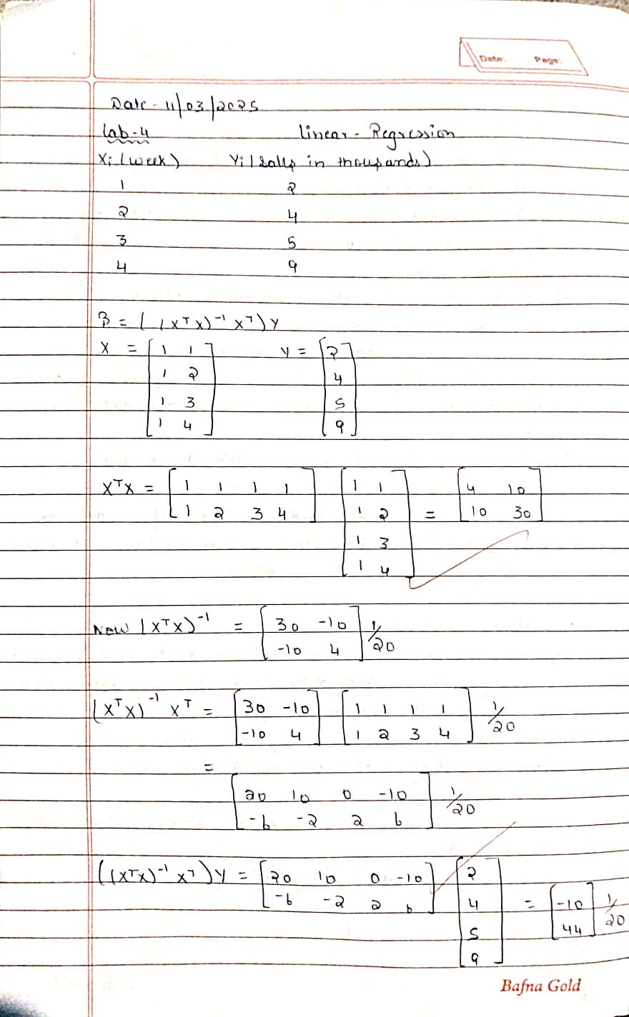

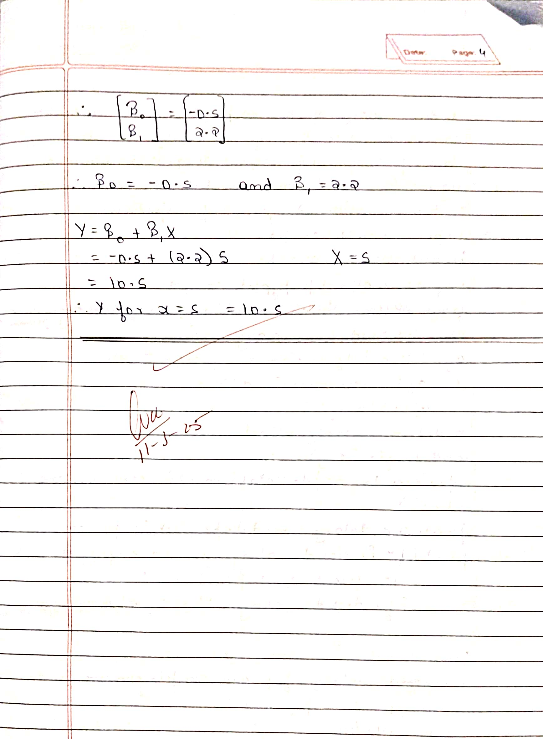

**Code:**

import numpy as np

# Given data

# x: Week numbers

# y: Sales in thousands

x = np.array([1, 2, 3, 4])

y = np.array([2, 4, 5, 9])

# Construct the design matrix X by adding a column of ones (for the intercept)

X = np.column_stack((np.ones(x.shape[0]), x))

# Compute the coefficients using the formula: beta = (X^T X)^(-1) X^T y

XtX = X.T.dot(X)            # Compute X^T X

XtX_inv = np.linalg.inv(XtX)  # Invert X^T X

XtY = X.T.dot(y)            # Compute X^T y

beta = XtX_inv.dot(XtY)     # Compute beta

# Display the computed coefficients

print("Computed coefficients (beta):", beta)

import matplotlib.pyplot as plt

# ... (previous code)

# Generate points for the regression line

x_line = np.linspace(x.min(), x.max(), 100)  # Create 100 points for a smooth line

y_line = beta[0] + beta[1] * x_line         # Calculate y-values for the line

# Plot the data points

plt.scatter(x, y, label='Data Points', color='blue')

# Plot the regression line

plt.plot(x_line, y_line, label='Linear Regression', color='red')

# Customize the plot

plt.xlabel('Week Number (x)')

plt.ylabel('Sales (thousands) (y)')

plt.title('Linear Regression Plot')

plt.legend()  # Show the legend

plt.grid(True)  # Show the grid

# Display the plot

plt.show()

import numpy as np

# Given data

x = np.array([8, 10, 12])

y = np.array([10, 13, 16])

# Construct the design matrix X (adding a column of ones for the intercept)

X = np.column_stack((np.ones(x.shape[0]), x))

# Compute beta using the normal equation: beta = (X^T X)^(-1) X^T y

XtX = X.T.dot(X)

XtX_inv = np.linalg.inv(XtX)

XtY = X.T.dot(y)

beta = XtX_inv.dot(XtY)

# Extract coefficients

beta0, beta1 = beta

print("Intercept (beta0):", beta0)

print("Slope (beta1):", beta1)

# Predict the price for a 20-inch pizza

x_new = 20

y_pred = beta0 + beta1 * x_new

print("Predicted price for a 20-inch pizza: $", y_pred)

import pandas as pd

from sklearn.linear_model import LinearRegression

# Load the data

income_data = pd.read_csv("canada_per_capita_income.csv")

# Assumed data columns: 'Year' and 'PerCapitaIncome'

print("Canada Income Data Head:")

print(income_data.head())

# Prepare feature and target

X_income = income_data[["year"]]     # Predictor variable: Year

y_income = income_data["per capita income (US$)"]  # Target variable: Per capita income

# Build and train the linear regression model

model_income = LinearRegression()

model_income.fit(X_income, y_income)

# Predict per capita income for the year 2020

predicted_income = model_income.predict([[2020]])

print("\nPredicted per capita income for Canada in 2020:", predicted_income[0])

import matplotlib.pyplot as plt

# ... (previous code)

# Predict per capita income for the year 2020

predicted_income = model_income.predict([[2020]])

print("\nPredicted per capita income for Canada in 2020:", predicted_income[0])

# Plot the data points and the regression line

plt.scatter(X_income, y_income, color='blue', label='Actual Data')

plt.plot(X_income, model_income.predict(X_income), color='red', label='Regression Line')

# Plot the prediction for 2020

plt.scatter(2020, predicted_income[0], color='green', label='Prediction for 2020')

# Customize the plot

plt.xlabel('Year')

plt.ylabel('Per Capita Income (US$)')

plt.title('Canada Per Capita Income Prediction')

plt.legend()

plt.grid(True)

# Display the plot

plt.show()

import numpy as np

import matplotlib.pyplot as plt

import pandas as pd

from sklearn.linear_model import LinearRegression

# Load the salary data

salary_data = pd.read_csv("salary.csv")

print(income_data.head())

# Check for null values and handle them (e.g., imputation or removal)

if salary_data.isnull().values.any():

    print("Null values found in the salary dataset. Handling null values...")

    # Example: Fill null values with the mean of the 'YearsExperience' column

    salary_data['YearsExperience'].fillna(salary_data['YearsExperience'].mean(), inplace=True)

    # Other options: Remove rows with nulls or use more sophisticated imputation methods

# Prepare feature and target

X_salary = salary_data[["YearsExperience"]]  # Predictor variable: Years of Experience

y_salary = salary_data["Salary"]            # Target variable: Salary

# Build and train the linear regression model

model_salary = LinearRegression()

model_salary.fit(X_salary, y_salary)

# Predict salary for an employee with 12 years of experience

predicted_salary = model_salary.predict([[12]])

print("\nPredicted salary for an employee with 12 years of experience:", predicted_salary[0])

import matplotlib.pyplot as plt

# Plot the data points and the regression line

plt.scatter(X_salary, y_salary, color='blue', label='Actual Data')

plt.plot(X_salary, model_salary.predict(X_salary), color='red', label='Regression Line')

# Plot the prediction for 12 years of experience

plt.scatter(12, predicted_salary[0], color='green', label='Prediction for 12 years')

# Customize the plot

plt.xlabel('Years of Experience')

plt.ylabel('Salary')

plt.title('Salary Prediction based on Experience')

plt.legend()

plt.grid(True)

# Display the plot

plt.show()

import pandas as pd

import numpy as np

from sklearn.linear_model import LinearRegression

# Read the CSV file (ensure the file is uploaded in your Colab environment)

df = pd.read_csv("hiring.csv")

# Rename columns for convenience

df.columns = ['experience', 'test_score', 'interview_score', 'salary']

print("Original Data:")

print(df)

# Define a mapping for text to numeric conversion for the 'experience' column

num_map = {

    "zero": 0,

    "one": 1,

    "two": 2,

    "three": 3,

    "four": 4,

    "five": 5,

    "six": 6,

    "seven": 7,

    "eight": 8,

    "nine": 9,

    "ten": 10,

    "eleven": 11,

    "twelve": 12

}

# Function to convert experience values to numeric

def convert_experience(x):

    try:

        return float(x)

    except:

        x_lower = str(x).strip().lower()

        return num_map.get(x_lower, np.nan)

# Convert the 'experience' column using the mapping

df['experience'] = df['experience'].apply(convert_experience)

# Convert 'test_score', 'interview_score', and 'salary' to numeric (coerce errors to NaN)

df['test_score'] = pd.to_numeric(df['test_score'], errors='coerce')

df['interview_score'] = pd.to_numeric(df['interview_score'], errors='coerce')

df['salary'] = pd.to_numeric(df['salary'], errors='coerce')

print("\nData After Conversion:")

print(df)

# Fill missing values in numeric columns using the column mean

df['experience'].fillna(df['experience'].mean(), inplace=True)

df['test_score'].fillna(df['test_score'].mean(), inplace=True)

df['interview_score'].fillna(df['interview_score'].mean(), inplace=True)

print("\nData After Filling Missing Values:")

print(df)

# Prepare the feature matrix X and target vector y

X = df[['experience', 'test_score', 'interview_score']]

y = df['salary']

# Build and train the Multiple Linear Regression model

model = LinearRegression()

model.fit(X, y)

# Predict salaries for the given candidate profiles

# Candidate 1: 2 years of experience, 9 test score, 6 interview score

candidate1 = np.array([[2, 9, 6]])

predicted_salary1 = model.predict(candidate1)

# Candidate 2: 12 years of experience, 10 test score, 10 interview score

candidate2 = np.array([[12, 10, 10]])

predicted_salary2 = model.predict(candidate2)

import matplotlib.pyplot as plt

# Create the plot

plt.figure(figsize=(10, 6))  # Adjust figure size for better visualization

plt.scatter(df['experience'], y, color='blue', label='Actual Salary') #Plot actual salary against years of experience

# Plot the regression line (this is an approximation since it's a multi-variable regression)

# You can visualize a single feature against the predicted salary

plt.plot(df['experience'], model.predict(X), color='red', label='Regression Line')

# Highlight predictions

plt.scatter(candidate1[0, 0], predicted_salary1, color='green', label='Candidate 1 Prediction')

plt.scatter(candidate2[0, 0], predicted_salary2, color='purple', label='Candidate 2 Prediction')

# Add labels and title

plt.xlabel("Years of Experience")

plt.ylabel("Salary")

plt.title("Salary Prediction based on Experience, Test Score, Interview Score")

# Add a legend

plt.legend()

plt.grid(True)

plt.show()

import pandas as pd

import numpy as np

from sklearn.linear_model import LinearRegression

# Read the CSV file (ensure the file is uploaded in your Colab environment)

df = pd.read_csv("1000_Companies.csv")

# Display the first few rows

print("Original Data:")

print(df.head())

# --- Data Preprocessing ---

# For numeric columns, fill missing values with the column mean

numeric_cols = ["R&D Spend", "Administration", "Marketing Spend", "Profit"]

for col in numeric_cols:

    df[col].fillna(df[col].mean(), inplace=True)

# For the categorical column 'State', fill missing values with a placeholder

df["State"].fillna("Unknown", inplace=True)

# Confirm that missing values are handled

print("\nMissing Values After Processing:")

print(df.isnull().sum())

# Separate the features and target variable

features = ["R&D Spend", "Administration", "Marketing Spend"] + \

           [col for col in df_encoded.columns if col.startswith("State_")]

X = df_encoded[features]

y = df_encoded["Profit"]

# --- Prediction for a New Company ---

# Given sample data:

# R&D Spend = 91694.48, Administration = 515841.3, Marketing Spend = 11931.24, State = 'Florida'

new_company = pd.DataFrame({

    "R&D Spend": [91694.48],

    "Administration": [515841.3],

    "Marketing Spend": [11931.24],

    "State": ["Florida"]

})

# One-hot encode the 'State' column using the same strategy as training data

new_company_encoded = pd.get_dummies(new_company, columns=["State"], drop_first=True)

# Align the new data's columns with the training features (fill missing columns with 0)

new_company_encoded = new_company_encoded.reindex(columns=X.columns, fill_value=0)

# Predict the profit using the trained model

predicted_profit = model.predict(new_company_encoded)

print("\nPredicted Profit for the New Company: $", round(predicted_profit[0], 2))

import matplotlib.pyplot as plt

# Assuming 'df_encoded', 'features', 'X', 'y', 'model', 'new_company_encoded', and 'predicted_profit' are defined from the previous code

# Create the plot

plt.figure(figsize=(10, 6))

# Scatter plot of actual profits vs. R&D Spend

plt.scatter(df_encoded["R&D Spend"], y, color='blue', label='Actual Profit')

# Plot the regression line (approximation for visualization)

plt.plot(df_encoded["R&D Spend"], model.predict(X), color='red', label='Regression Line')

# Highlight the new company's prediction

plt.scatter(new_company_encoded["R&D Spend"], predicted_profit, color='green', label='New Company Prediction')

# Add labels and title

plt.xlabel("R&D Spend")

plt.ylabel("Profit")

plt.title("Profit Prediction based on R&D Spend")

# Add a legend

plt.legend()

plt.grid(True)

plt.show()

**Program 4**

Build Logistic Regression Model for a given dataset.

**Observation:**

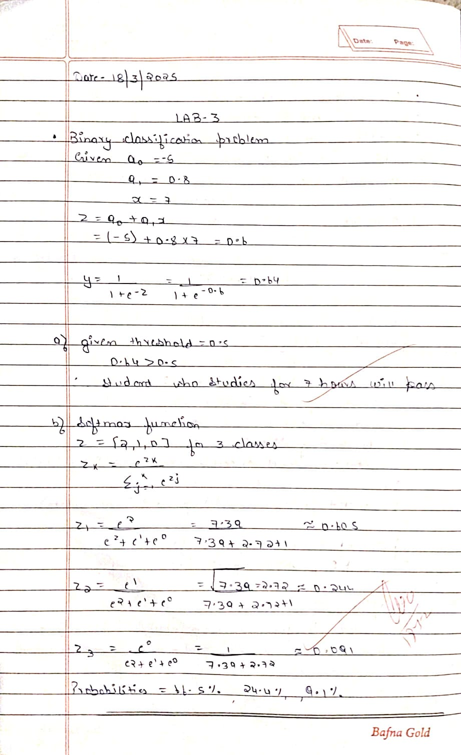

**Code:**

**Hr.csv**

import pandas as pd

import seaborn as sns

import matplotlib.pyplot as plt

from sklearn.model_selection import train_test_split

from sklearn.linear_model import LogisticRegression

from sklearn.metrics import accuracy_score, classification_report, confusion_matrix

# Load dataset

df = pd.read_csv('HR_comma_sep.csv')

# Basic Info

print("Dataset Info:")

print(df.info())

print("\nFirst few rows:")

print(df.head())

plt.figure(figsize=(8, 6))

# sns.countplot(x='salary', hue='left', data=df)

sns.barplot(x='Department', y='satisfaction_level', data=df)

# plt.title('Salary vs Employee Retention')

plt.xlabel('Departments')

plt.ylabel('Satisfaction level')

plt.show()

import seaborn as sns

import matplotlib.pyplot as plt

import pandas as pd

# Encode categorical variables (drop_first avoids dummy variable trap)

df_encoded = pd.get_dummies(df, columns=['salary', 'Department'], drop_first=True)

plt.figure(figsize=(15, 8))

sns.heatmap(df_encoded.corr(), annot=True, cmap='coolwarm')

plt.title('Correlation Matrix')

plt.show()

plt.figure(figsize=(8, 5))

sns.countplot(x='salary', hue='left', data=df, order=['low', 'medium', 'high'])

plt.title('Impact of Salary on Employee Retention')

plt.xlabel('Salary Level')

plt.ylabel('Number of Employees')

plt.legend(title='Left', labels=['Stayed', 'Left'])

plt.show()

df_encoded = pd.get_dummies(df, columns=['Department', 'salary'], drop_first=True)

# Calculate the correlation matrix

correlation_matrix = df_encoded.corr()

# Extract the correlation with 'left' (employee retention)

correlation_with_left = correlation_matrix['left'].sort_values(ascending=False)

# Display the correlation

print(correlation_with_left)

plt.figure(figsize=(12, 6))

sns.countplot(x='Department', hue='left', data=df)

# Title and labels

plt.title('Impact of Department on Employee Retention')

plt.xlabel('Department')

plt.ylabel('Number of Employees')

plt.legend(title='Left', labels=['Stayed', 'Left'])

plt.xticks(rotation=45)  # Rotate department names for readability

plt.show()

# Step 1: Preprocess the data

import pandas as pd

from sklearn.model_selection import train_test_split

from sklearn.linear_model import LogisticRegression

from sklearn.metrics import accuracy_score, classification_report

# Load the dataset

df = pd.read_csv('HR_comma_sep.csv')

# Select important features and encode categorical variable

df_encoded = pd.get_dummies(df, columns=['salary'], drop_first=True)  # This encodes salary (low -> low salary column)

# Step 2: Define features (X) and target (y)

X = df_encoded[['satisfaction_level', 'time_spend_company', 'salary_low']]  # Using low salary as a feature

y = df_encoded['left']  # Target variable (whether the employee left or stayed)

# Step 3: Train-test split

X_train, X_test, y_train, y_test = train_test_split(X, y, test_size=0.2, random_state=42)

# Step 4: Build and train the logistic regression model

model = LogisticRegression(max_iter=1000)

model.fit(X_train, y_train)

# Step 5: Make predictions

y_pred = model.predict(X_test)

# Step 6: Evaluate the model

accuracy = accuracy_score(y_test, y_pred)

print(f"Accuracy: {accuracy * 100:.2f}%")

print("\nClassification Report:")

print(classification_report(y_test, y_pred))

**Program 5**

Use an appropriate data set for building the decision tree (ID3) and apply this knowledge to classify a new sample.

**Observation:**

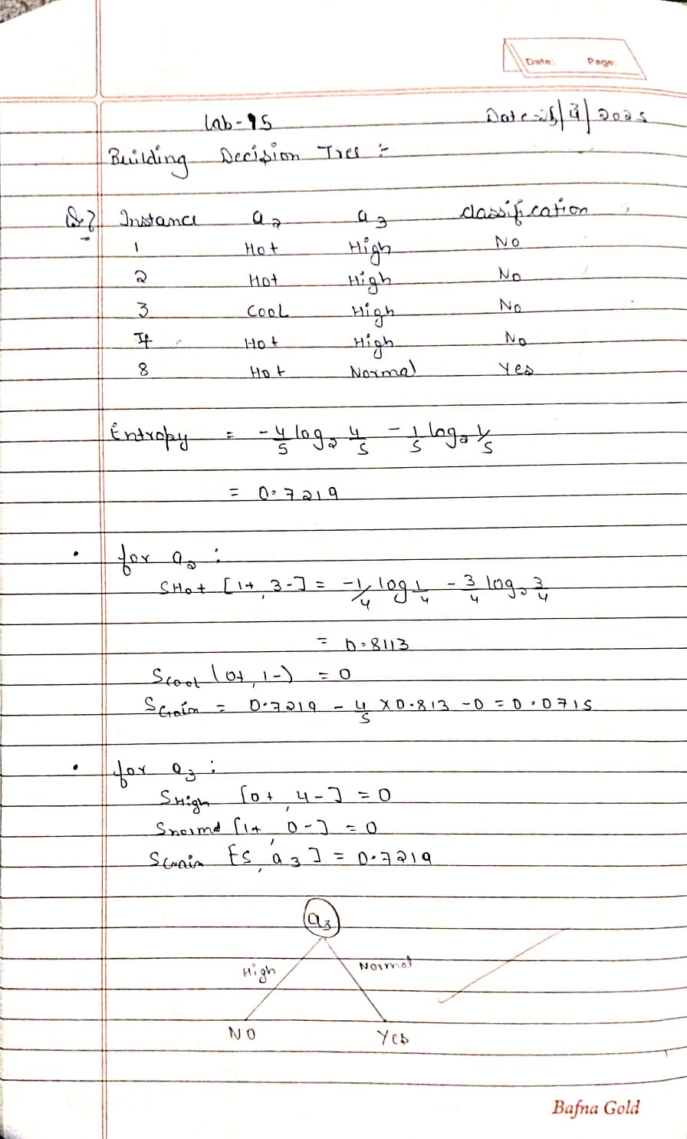

**Code:**

import pandas as pd

from sklearn.preprocessing import LabelEncoder

from sklearn.tree import DecisionTreeClassifier

from sklearn.model_selection import train_test_split

from sklearn.metrics import accuracy_score, classification_report

from sklearn.tree import plot_tree

import matplotlib.pyplot as plt

data = {

    'a1': [True, True, False, False, False, True, True, True, False, False],

    'a2': ['Hot', 'Hot', 'Hot', 'Cool', 'Cool', 'Cool', 'Hot', 'Hot', 'Cool', 'Cool'],

    'a3': ['High', 'High', 'High', 'Normal', 'Normal', 'High', 'High', 'Normal', 'Normal', 'High'],

    'Classification': ['No', 'No', 'Yes', 'Yes', 'Yes', 'No', 'No', 'Yes', 'Yes', 'Yes']

}

df = pd.DataFrame(data)

df.head()

label_encoders = {}

for column in df.columns:

    le = LabelEncoder()

    df[column] = le.fit_transform(df[column])

    label_encoders[column] = le

df.head()

X = df.drop('Classification', axis=1)

y = df['Classification']

X_train, X_test, y_train, y_test = train_test_split(X, y, test_size=0.3, random_state=42)

clf = DecisionTreeClassifier(criterion='entropy')

clf.fit(X_train, y_train)

y_pred = clf.predict(X_test)

accuracy = accuracy_score(y_test, y_pred)

accuracy

**Program 6**

Build KNN Classification model for a given dataset.

**Observation:**

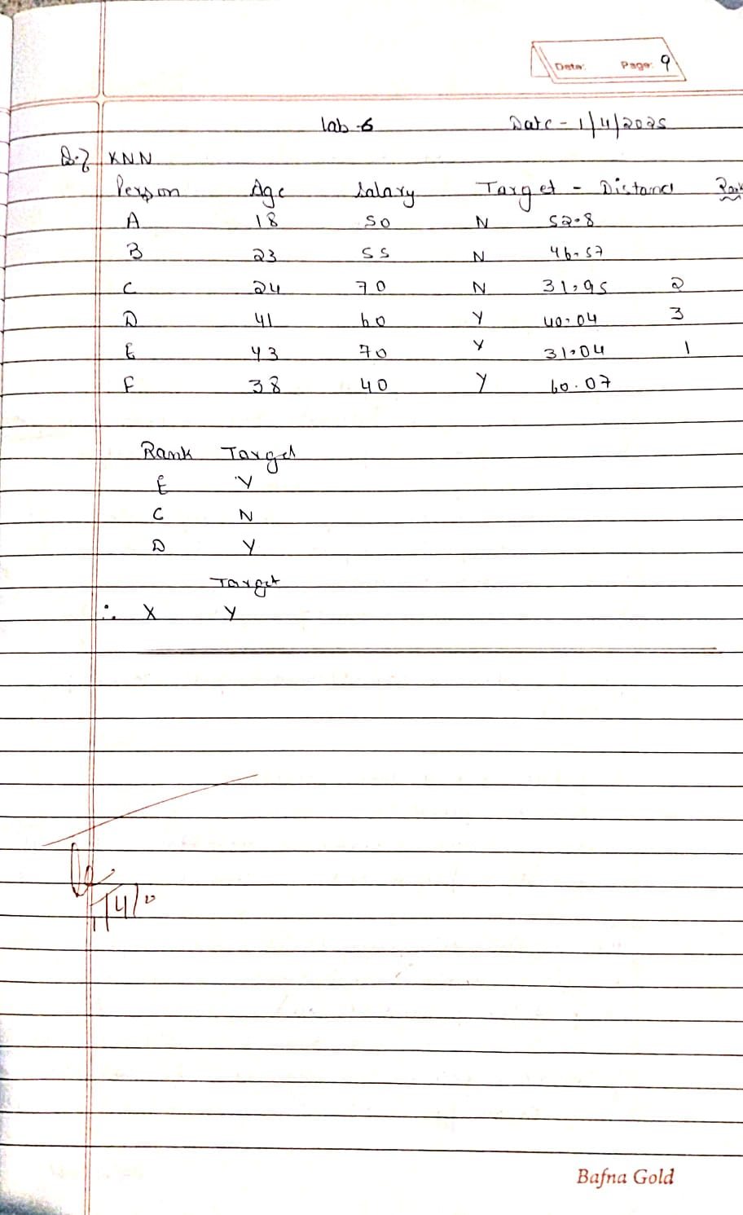

**Code:**

import pandas as pd

import numpy as np

from sklearn.model_selection import train_test_split, GridSearchCV

from sklearn.metrics import accuracy_score, classification_report, confusion_matrix

from sklearn.neighbors import KNeighborsClassifier

from sklearn.preprocessing import OrdinalEncoder, StandardScaler

data = pd.read_csv("diabetes.csv")

data.head()

X = data.iloc[:, :-1]

y = data.iloc[:, -1]

ss = StandardScaler()

X[["Pregnancies"]] = ss.fit_transform(X[["Pregnancies"]])

X[["Glucose"]] = ss.fit_transform(X[["Glucose"]])

X[["BloodPressure"]] = ss.fit_transform(X[["BloodPressure"]])

X[["SkinThickness"]] = ss.fit_transform(X[["SkinThickness"]])

X[["Insulin"]] = ss.fit_transform(X[["Insulin"]])

X[["BMI"]] = ss.fit_transform(X[["BMI"]])

X[["DiabetesPedigreeFunction"]] = ss.fit_transform(X[["DiabetesPedigreeFunction"]])

X[["Age"]] = ss.fit_transform(X[["Age"]])

X.head()

X_train, X_test, y_train, y_test = train_test_split(X, y, test_size = 0.2, random_state = 42)

knn = KNeighborsClassifier()

param_grid = {"n_neighbors": [1, 3, 5, 7, 9]}

grid = GridSearchCV(estimator = knn, param_grid = param_grid, cv = 5, scoring = "accuracy")

grid.fit(X_train, y_train)

grid.best_params_

best = grid.best_estimator_

best

y_pred = best.predict(X_test)

accuracy_score(y_test, y_pred)

**Program 7**

Build Support vector machine model for a given dataset.

**Observation:**

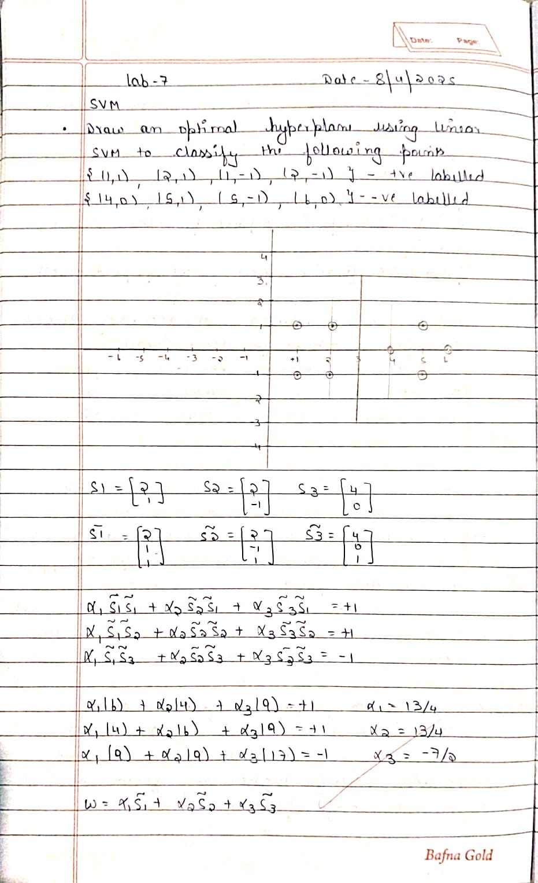

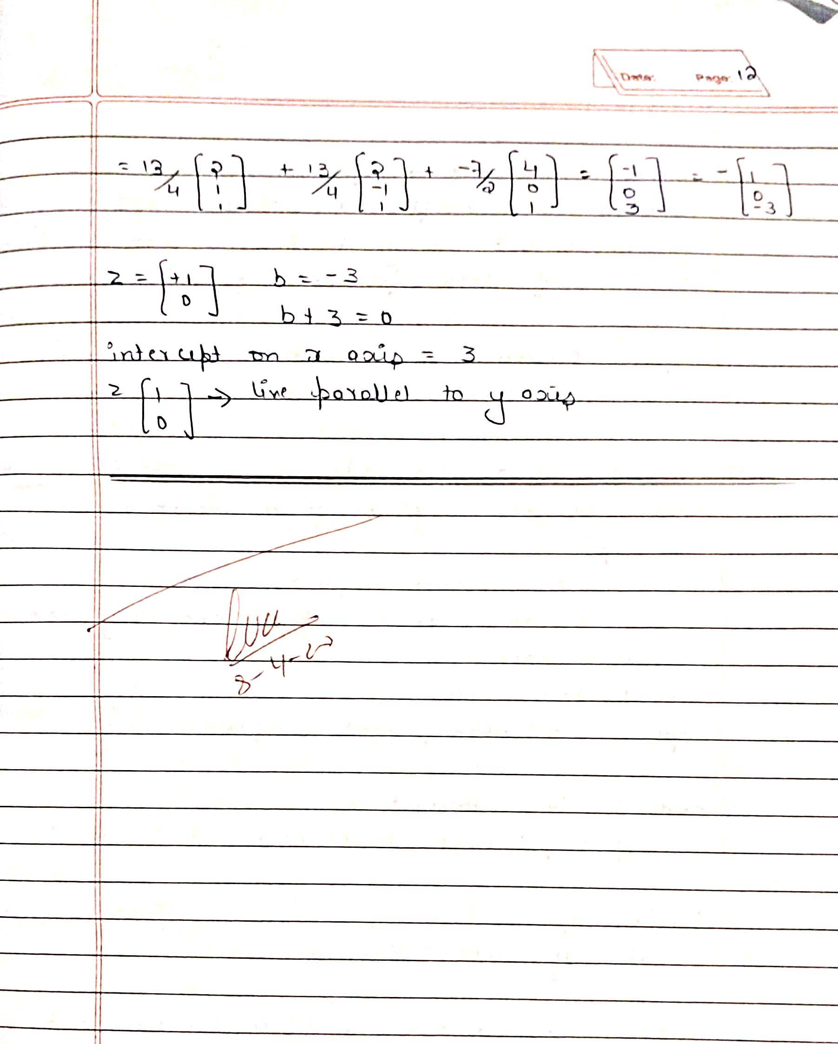

**Code:**

**Iris.csv**

import pandas as pd

from sklearn.datasets import load_digits

from sklearn.model_selection import train_test_split

from sklearn.svm import SVC

from sklearn.metrics import accuracy_score, classification_report, confusion_matrix

from sklearn.preprocessing import OrdinalEncoder

data = pd.read_csv("iris (1).csv")

data.head()

oe = OrdinalEncoder()

data[["species"]] = oe.fit_transform(data[["species"]])

data.head()

y = data.iloc[:, -1]

X = data.iloc[:, :-1]

X_train, X_test, y_train, y_test = train_test_split(X, y, test_size = 0.2, random_state = 42)

rbf_model = SVC(kernel='rbf')

rbf_model.fit(X_train, y_train)

rbf_model.score(X_test,y_test)

y_pred = rbf_model.predict(X_test)

print(confusion_matrix(y_test, y_pred))

print(classification_report(y_test, y_pred))

linear_model = SVC(kernel='linear')

linear_model.fit(X_train,y_train)

linear_model.score(X_test,y_test)

y_pred = rbf_model.predict(X_test)

print(confusion_matrix(y_test, y_pred))

**Digits.csv**

import pandas as pd

from sklearn.datasets import load_digits

from sklearn.model_selection import train_test_split

from sklearn.svm import SVC

digits = load_digits()

digits.target

dir(digits)

X_train, X_test, y_train, y_test = train_test_split(df.drop('target',axis='columns'), df.target, test_size=0.3)

rbf_model = SVC(kernel='rbf')

rbf_model.fit(X_train, y_train)

linear_model = SVC(kernel='linear')

linear_model.fit(X_train,y_train)

**Program 8**

Implement Random forest ensemble method on a given dataset.

**Observation:**





**Code:**

import numpy as np

import pandas as pd

from sklearn.model_selection import train_test_split

from sklearn.ensemble import RandomForestClassifier

from sklearn.metrics import accuracy_score, confusion_matrix

import matplotlib.pyplot as plt

from sklearn.preprocessing import OrdinalEncoder

data = pd.read_csv("iris (2).csv")

data.head()

oe = OrdinalEncoder()

data[["species"]] = oe.fit_transform(data[["species"]])

data.head()

y = data.iloc[:, -1]

X = data.iloc[:, :-1]

X_train, X_test, y_train, y_test = train_test_split(X, y, test_size = 0.2, random_state = 42)

rf = RandomForestClassifier(n_estimators=10, random_state=42)

rf.fit(X_train, y_train)

y_pred = rf.predict(X_test)

accuracy = accuracy_score(y_test, y_pred)

accuracy

n_estimators_list = [10, 50, 100, 200, 500, 1000]

accuracies = []

for n in n_estimators_list:

    rf = RandomForestClassifier(n_estimators=n, random_state=42)

    rf.fit(X_train, y_train)

    y_pred = rf.predict(X_test)

    accuracy = accuracy_score(y_test, y_pred)

    accuracies.append(accuracy)

    print(f"Accuracy with n_estimators={n}: {accuracy:.4f}")

plt.plot(n_estimators_list, accuracies, marker='o')

plt.xlabel('Number of Trees (n_estimators)')

plt.ylabel('Accuracy')

plt.title('Random Forest Accuracy vs Number of Trees')

plt.show()

optimal_n_estimators = n_estimators_list[np.argmax(accuracies)]

print(f"Best accuracy is obtained with n_estimators={optimal_n_estimators}")

**Program 9**

Implement Boosting ensemble method on a given dataset.

**Observation:**

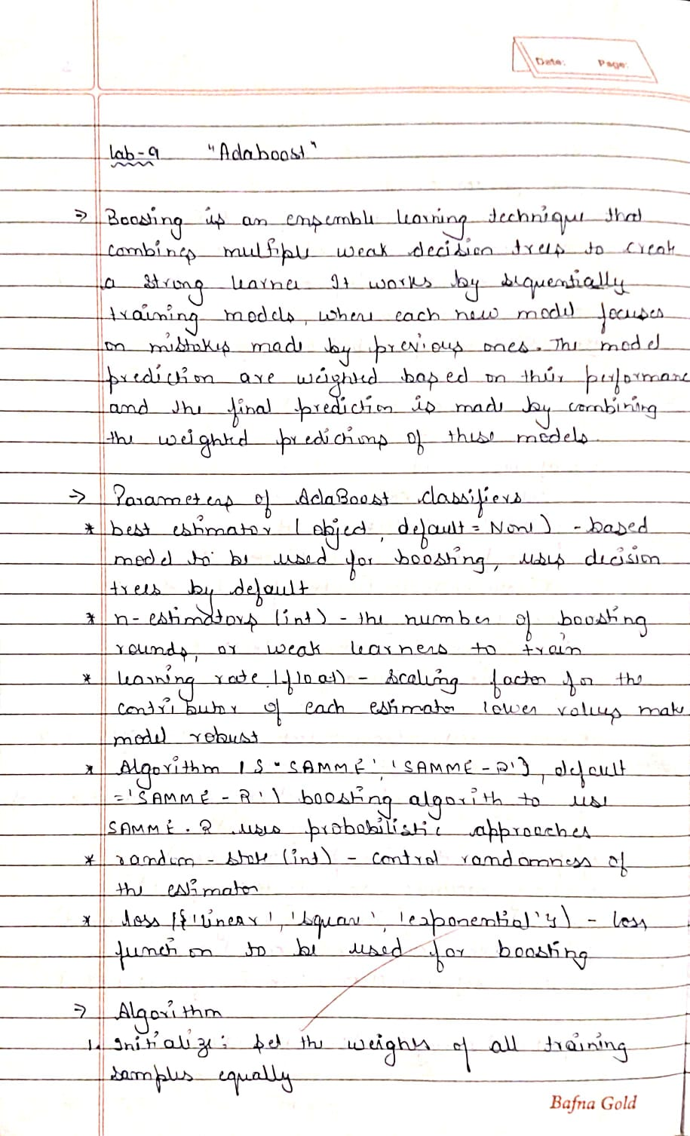

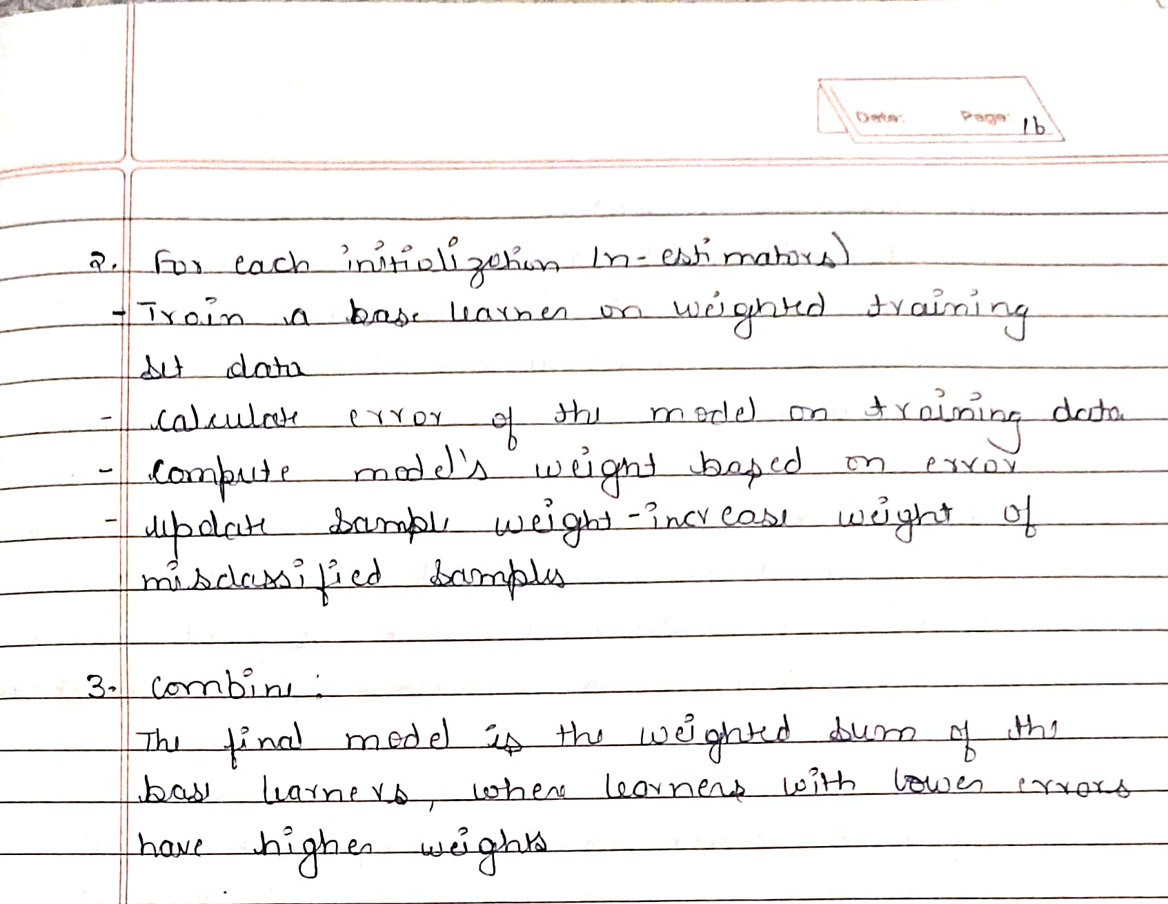

**Code:**

import numpy as np

import pandas as pd

from sklearn.model_selection import train_test_split

from sklearn.ensemble import AdaBoostClassifier

from sklearn.metrics import accuracy_score, confusion_matrix

import matplotlib.pyplot as plt

from sklearn.preprocessing import OrdinalEncoder

data = pd.read_csv("income.csv")

data.head()

y = data.iloc[:, -1]

X = data.iloc[:, :-1]

X_train, X_test, y_train, y_test = train_test_split(X, y, test_size = 0.2, random_state = 42)

rf = AdaBoostClassifier(n_estimators=1000, random_state=42)

rf.fit(X_train, y_train)

y_pred = rf.predict(X_test)

accuracy = accuracy_score(y_test, y_pred)

accuracy

n_estimators_list = [10, 50, 100, 200, 500, 1000]

accuracies = []

for n in n_estimators_list:

    rf = AdaBoostClassifier(n_estimators=n, random_state=42)

    rf.fit(X_train, y_train)

    y_pred = rf.predict(X_test)

    accuracy = accuracy_score(y_test, y_pred)

    accuracies.append(accuracy)

    print(f"Accuracy with n_estimators={n}: {accuracy:.4f}")

plt.plot(n_estimators_list, accuracies, marker='o')

plt.xlabel('Number of Trees (n_estimators)')

plt.ylabel('Accuracy')

plt.title('Random Forest Accuracy vs Number of Trees')

plt.show()

optimal_n_estimators = n_estimators_list[np.argmax(accuracies)]

print(f"Best accuracy is obtained with n_estimators={optimal_n_estimators}")

**Program 10**

Build k-Means algorithm to cluster a set of data stored in a .CSV file.

**Observation:**

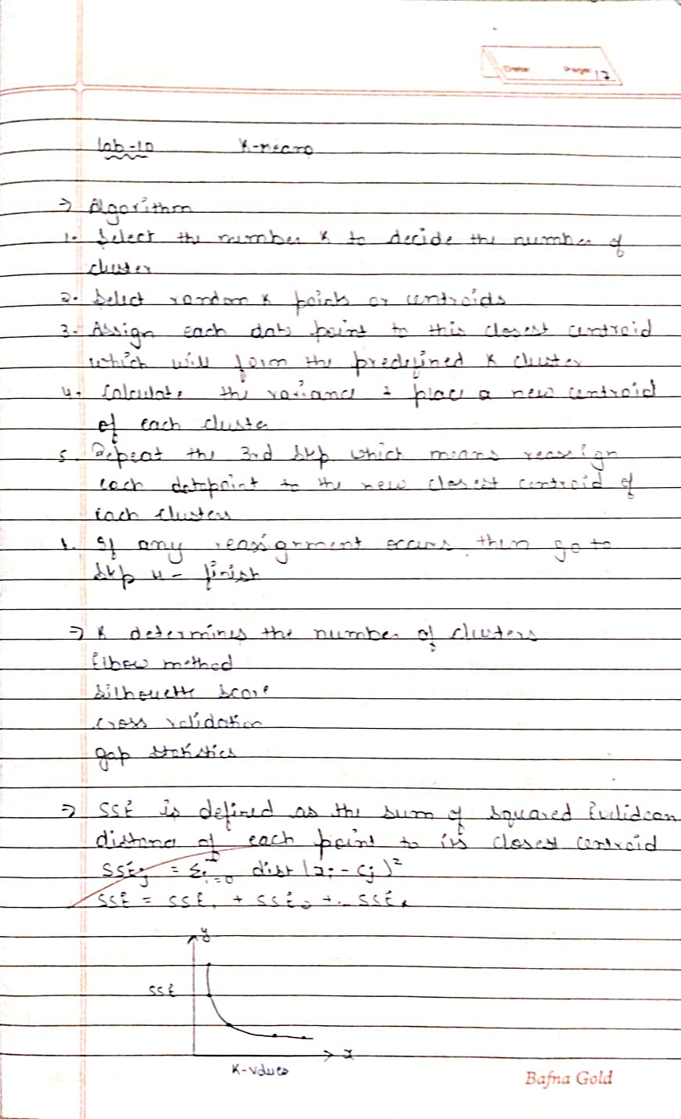

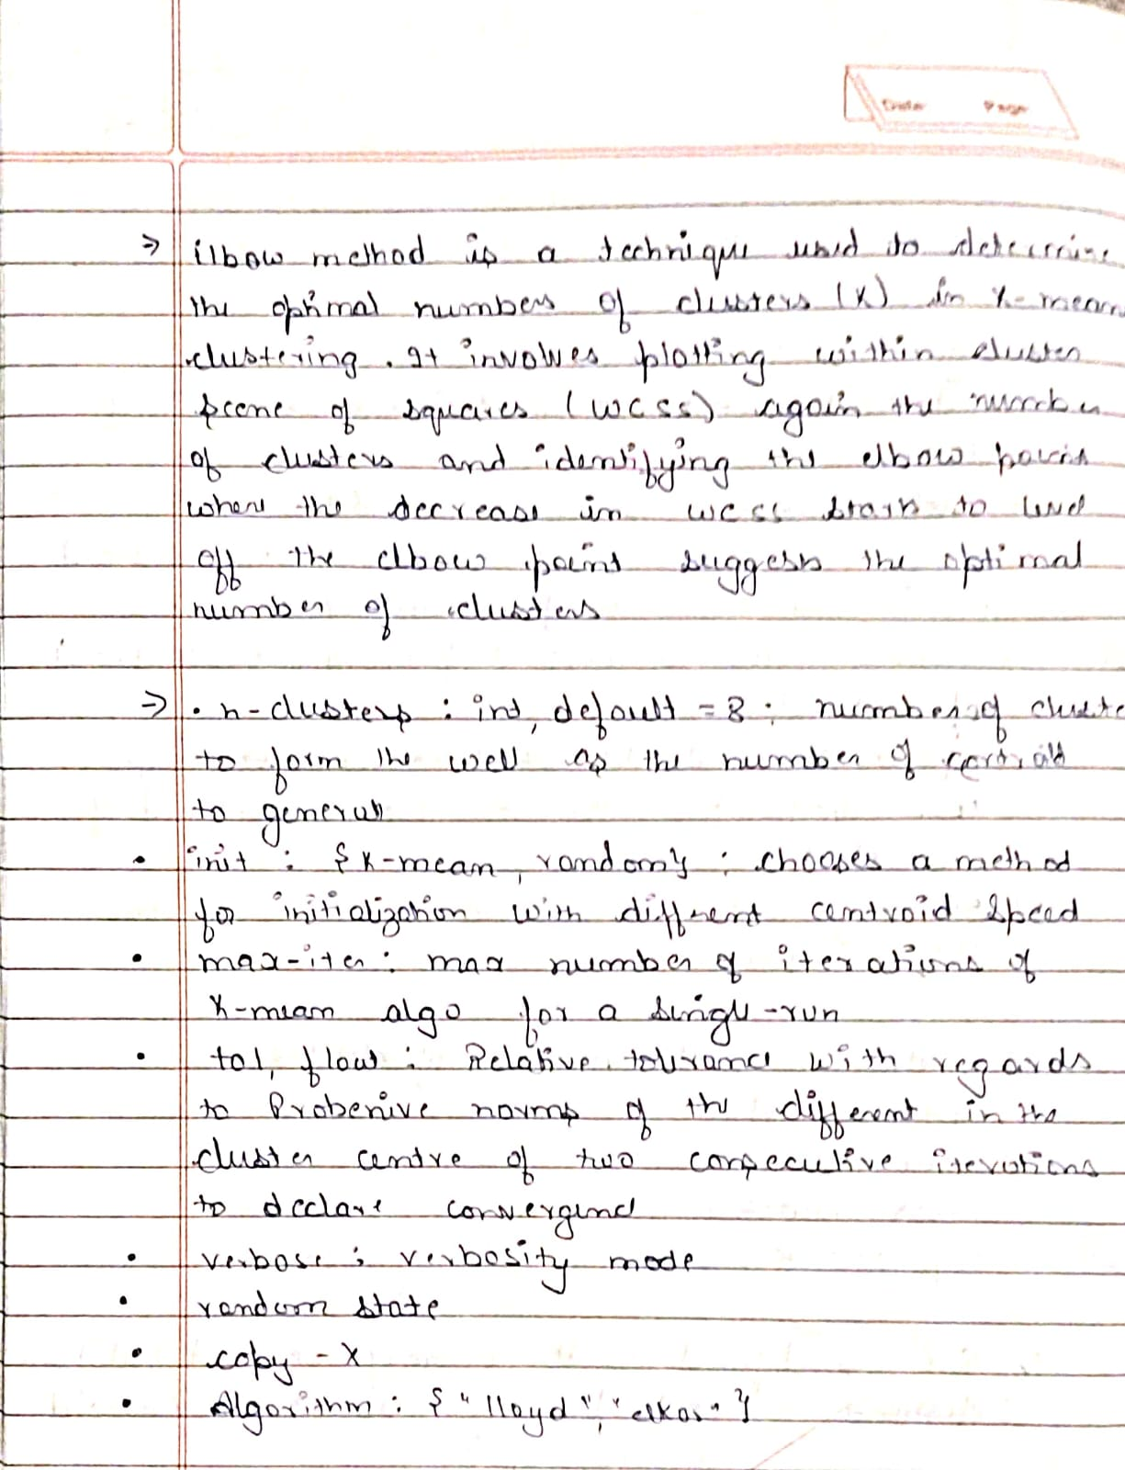

**==Code:**

# Import required libraries

import pandas as pd

import numpy as np

import matplotlib.pyplot as plt

from sklearn.cluster import KMeans

from sklearn.preprocessing import StandardScaler

# Load dataset

df = pd.read_csv("iris.csv")

# Use only petal_length and petal_width

X = df[["petal_length", "petal_width"]]

# Scale the features (helps with KMeans)

scaler = StandardScaler()

X_scaled = scaler.fit_transform(X)

# Elbow method to determine optimal K

inertia = []

k_range = range(1, 11)

for k in k_range:

    kmeans = KMeans(n_clusters=k, random_state=42)

    kmeans.fit(X_scaled)

    inertia.append(kmeans.inertia_)

# Plot the elbow curve

plt.figure(figsize=(8, 5))

plt.plot(k_range, inertia, marker='o')

plt.title("Elbow Method for Optimal k")

plt.xlabel("Number of clusters (k)")

plt.ylabel("Inertia (Within-Cluster Sum of Squares)")

plt.grid(True)

plt.show()

# Find optimal k using "elbow" (visually)

optimal_k = 3  # for IRIS, elbow is usually at 3

print(f"Optimal number of clusters (k): {optimal_k}")

**Program 11**

Implement Dimensionality reduction using Principal Component Analysis (PCA) method.

**Observation:**

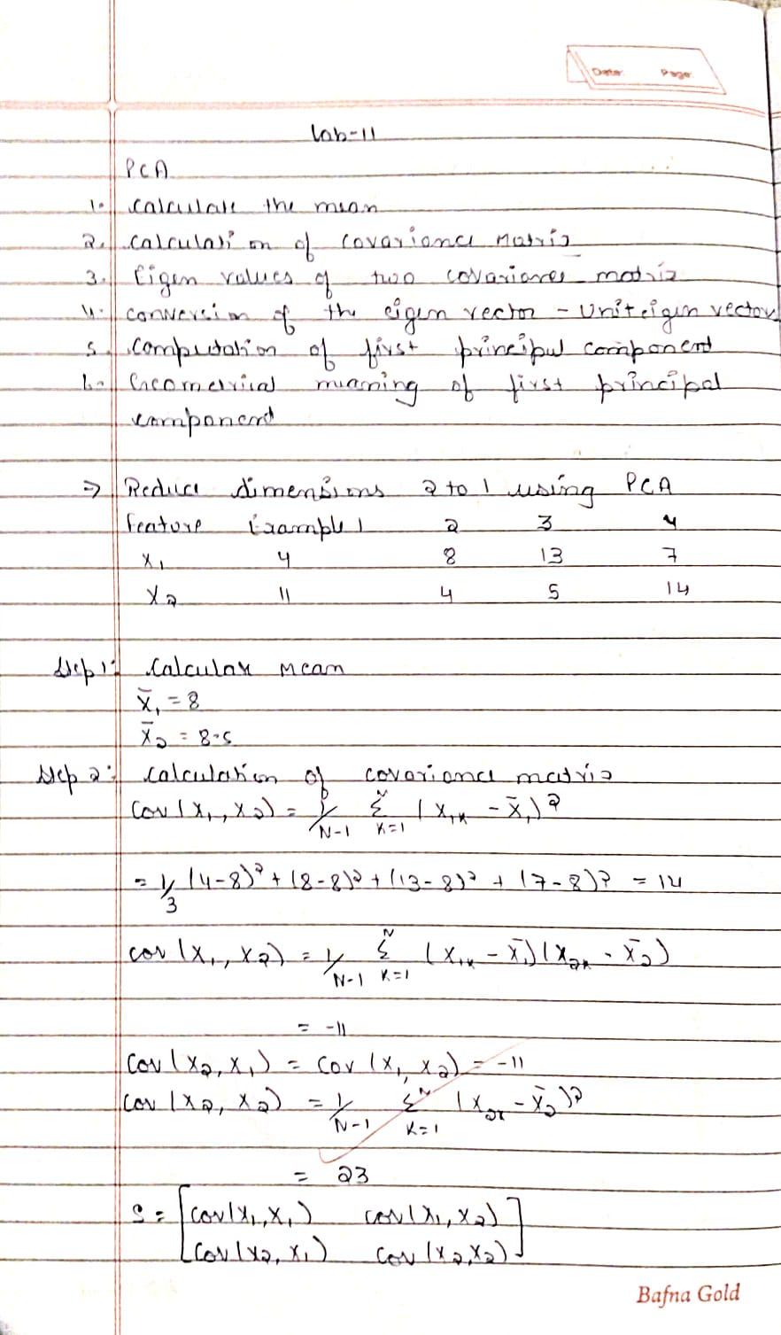

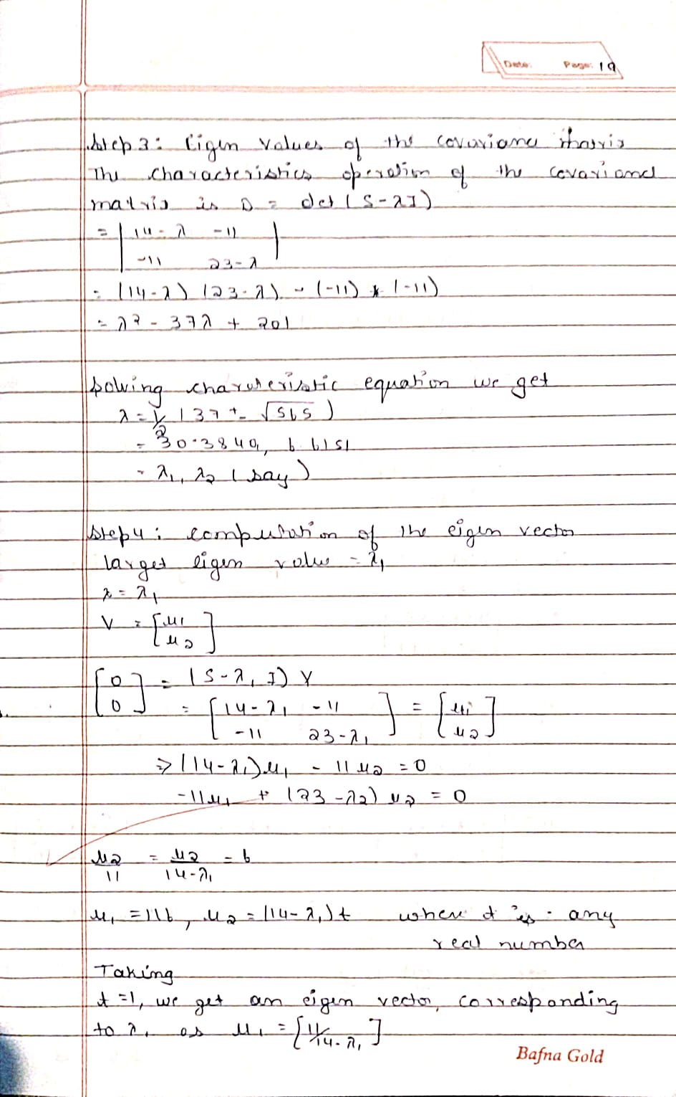

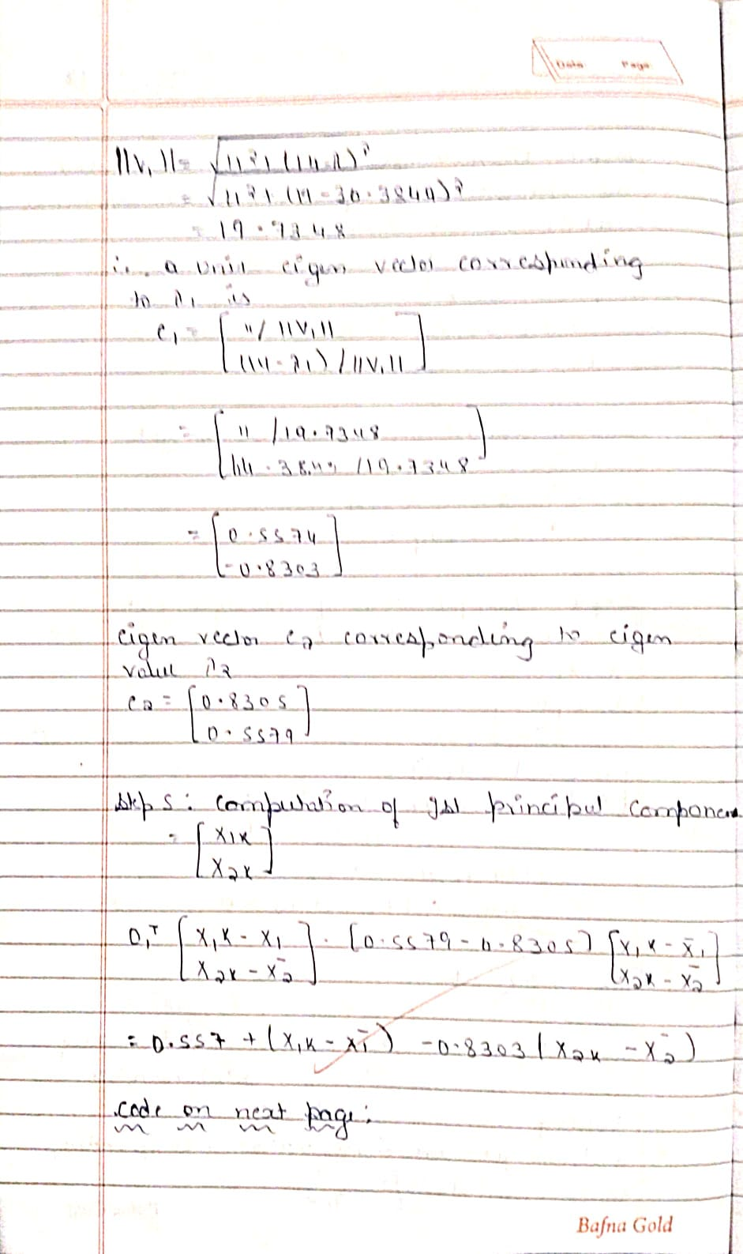

**Code:**

# Importing necessary libraries

import pandas as pd

import numpy as np

from sklearn.preprocessing import LabelEncoder, StandardScaler

from sklearn.model_selection import train_test_split

from sklearn.svm import SVC

from sklearn.linear_model import LogisticRegression

from sklearn.ensemble import RandomForestClassifier

from sklearn.metrics import accuracy_score

from sklearn.decomposition import PCA

# Load dataset

df = pd.read_csv("heart.csv")

# Separate features and target

X = df.drop("HeartDisease", axis=1)

y = df["HeartDisease"]

# Identify categorical columns

cat_cols = X.select_dtypes(include=['object']).columns.tolist()

# Label Encode binary categorical columns

label_enc = LabelEncoder()

for col in cat_cols:

    if X[col].nunique() == 2:

        X[col] = label_enc.fit_transform(X[col])

        cat_cols.remove(col)

# One-hot encode remaining categorical columns

X = pd.get_dummies(X, columns=cat_cols)

# Train-test split

X_train, X_test, y_train, y_test = train_test_split(X, y, test_size=0.2, random_state=42)

# Feature Scaling

scaler = StandardScaler()

X_train_scaled = scaler.fit_transform(X_train)

X_test_scaled = scaler.transform(X_test)

# Initialize models

models = {

    "Logistic Regression": LogisticRegression(max_iter=1000),

    "SVM": SVC(),

    "Random Forest": RandomForestClassifier()

}

# Store accuracy scores

accuracy_before_pca = {}

accuracy_after_pca = {}

# Training and evaluating models before PCA

for name, model in models.items():

    model.fit(X_train_scaled, y_train)

    y_pred = model.predict(X_test_scaled)

    acc = accuracy_score(y_test, y_pred)

    accuracy_before_pca[name] = acc

# Apply PCA

pca = PCA(n_components=0.95)  # retain 95% variance

X_train_pca = pca.fit_transform(X_train_scaled)

X_test_pca = pca.transform(X_test_scaled)

# Training and evaluating models after PCA

for name, model in models.items():

    model.fit(X_train_pca, y_train)

    y_pred = model.predict(X_test_pca)

    acc = accuracy_score(y_test, y_pred)

    accuracy_after_pca[name] = acc

# Print accuracy comparison

print("Model Accuracy Comparison (Before vs After PCA):")

print(f"{'Model':<20} {'Before PCA':<15} {'After PCA':<15}")

for name in models.keys():

    print(f"{name:<20} {accuracy_before_pca[name]:<15.4f} {accuracy_after_pca[name]:<15.4f}")