# **How Mobile CRM Enhances Customer Experience in the Insurance Industry**

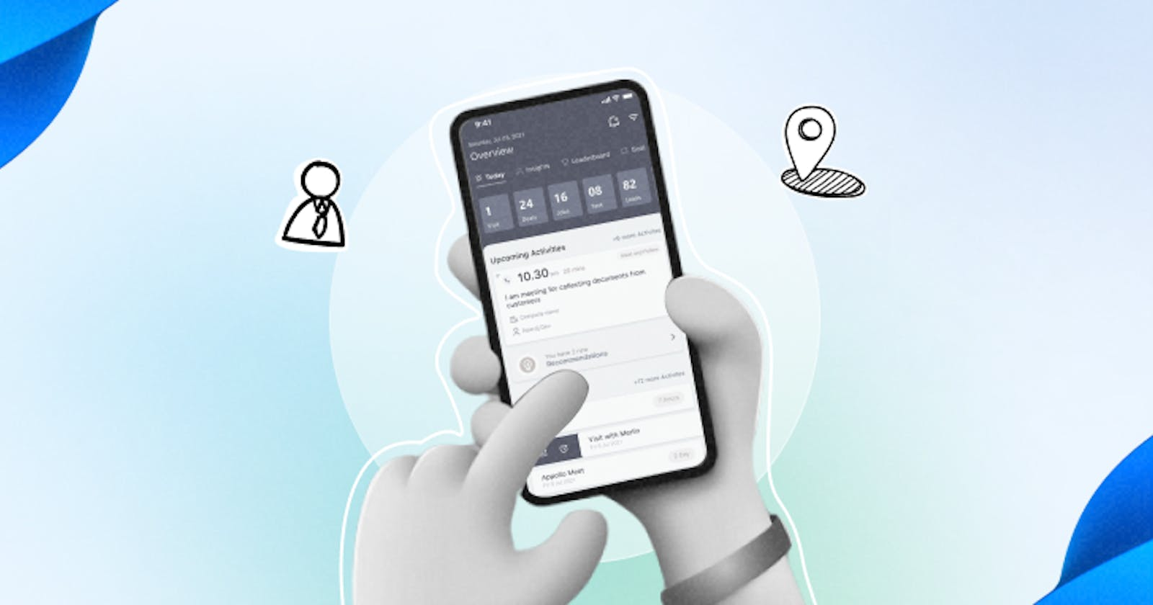

In today’s fast-paced digital age, the insurance industry faces ever-increasing pressure to adapt and improve customer experiences. [Mobile CRM](https://www.toolyt.com/mobile-crm) (Customer Relationship Management) has emerged as a powerful tool to address these challenges. In this comprehensive guide, we will explore how Mobile CRM is transforming the insurance sector and take a closer look at Toolyt Mobile CRM software to understand how it can revolutionize your insurance business.

## **The Evolution of Customer Experience in Insurance**

Historically, insurance has been seen as a complex and cumbersome industry. Customers often had to navigate intricate policies, lengthy paperwork, and slow claims processes. However, the rise of mobile technology has ushered in a new era for the insurance industry, enabling it to enhance customer experiences like never before.

### **The Role of Mobile CRM in Modernizing Insurance**

Mobile CRM has played a pivotal role in modernizing insurance operations and customer interactions. It brings several key benefits to the industry:

### **Accessibility and Convenience**

One of the primary advantages of Mobile CRM is its accessibility. Insurance agents can access vital customer information, policy details, and claims data from anywhere, at any time, using their mobile devices. This level of convenience ensures that customer inquiries can be addressed promptly, whether in the office or on the field.

### **Improved Customer Engagement**

Mobile CRM empowers insurance agents to engage with customers more effectively. It enables agents to send personalized messages, reminders, and updates directly to clients’ mobile devices. These proactive communications foster a sense of trust and transparency, which is essential in the insurance industry.

### **Enhanced Sales and Lead Management**

With Mobile CRM, insurance agents can manage leads and sales opportunities more efficiently. They can capture leads in real time, follow up on prospects, and track the progress of potential customers through the sales funnel. This proactive approach results in higher conversion rates and increased revenue.

## **Toolyt Mobile CRM – Revolutionizing Insurance Customer Experiences**

To truly understand the impact of Mobile CRM in the insurance industry, let’s delve into Toolyt Mobile [CRM software](https://www.toolyt.com/blog/crm-software-one-stop-solution-for-technology-and-sales-to-go-together/)—a cutting-edge solution designed to streamline insurance operations and enhance customer experiences.

### **What is Toolyt Mobile CRM?**

Toolyt Mobile CRM is a state-of-the-art customer relationship management system tailored specifically for the insurance sector. It offers a wide range of features that cater to the unique needs of insurance companies, agents, and policyholders.

### **Key Features of Toolyt Mobile CRM**

* Policy Management: Toolyt allows insurance agents to manage policies effortlessly. Agents can view policy details, renewal dates, and premium payments on their mobile devices. This feature ensures that clients are well informed about their policies.
* Claims Processing: Toolyt simplifies the claims process, enabling policyholders to submit claims digitally. Agents can quickly assess claims and provide updates, resulting in faster claim settlements and improved customer satisfaction.
* Lead Tracking: Toolyt Mobile CRM comes equipped with lead tracking capabilities. Agents can capture leads during client interactions and nurture them through automated workflows. This feature helps insurance agencies expand their customer base.
* Communication Tools: Toolyt facilitates seamless communication between agents and clients. Agents can send messages, notifications, and updates directly to policyholders’ mobile devices, keeping them informed and engaged.
* Analytics and Reporting: Toolyt provides robust analytics and reporting tools; it allows [sales performance tracking](https://www.toolyt.com/blog/sales-performance-tracking-why-it-matters/), identifying trends, and making data-driven decisions to enhance its services.

### **Benefits of Toolyt Mobile CRM for Insurance**

* Enhanced Customer Experience: Toolyt’s user-friendly interface and proactive communication features improve customer satisfaction and loyalty.
* Efficient Operations: With Toolyt, insurance agencies can streamline their operations, reduce paperwork, and increase overall efficiency.
* [Data Security](https://www.toolyt.com/security): Toolyt prioritizes data security and compliance, ensuring that sensitive customer information is protected.
* Real-Time Insights: The analytics and reporting tools provide valuable insights into customer behavior and market trends, allowing insurance agencies to adapt and stay competitive.

### **Conclusion**

Mobile CRM is revolutionizing the insurance industry by enhancing customer experiences, improving efficiency, and boosting profitability. With [Toolyt](https://toolyt.com/) Mobile CRM software, insurance agencies have a powerful tool at their disposal to navigate the evolving landscape of insurance and deliver exceptional services to their clients.

As the insurance sector continues to evolve, embracing Mobile CRM is no longer an option—it’s a necessity. To stay ahead in a highly competitive market, insurance agencies must harness the power of Mobile CRM to meet customer expectations, drive growth, and thrive in the digital era.

Original source: <https://toolyt.com/blog/crm/mobile-crm-in-the-insurance-industry/>