# Introduction

In this project, Google Assisted automatic door opener is developed. With the help of Servomotor connected to the NodeMCU the system communicates with Google Assistance to function. The use of Blynk app and IFTTT is prominent. To interact with the system, a button is set-up using Blynk app whereas Google Assistance is implemented with the help of IFTTT. To function, the system should be connected to the internet from which it will interact with the Blynk app and IFTTT. The use of Google Assistance provides voice over control and a smart user experience. The system is an important part of home automation. Without even reaching out for the door, he/she will be able to control the action of the door with just a push of a button or with the help of a single voice command.

# Aim

Design and implement automatic door opener model with the help of google assistance and blynk app for smart user experience.

# Objective

* Learn the use and implementation of IOT in our day-to-day activity.
* Understand the working mechanism of existing Google Assisted door opener.
* Understand the concept of home automation.
* Understand the working mechanism of technologies that will be used in the development of this project.
* Design and develop a working prototype model of Google Assisted door opener.
* Complete the project in given time.

# System Architecture

The concept and working process of the Google Assisted door opener can be well understood with the help system architecture given below.

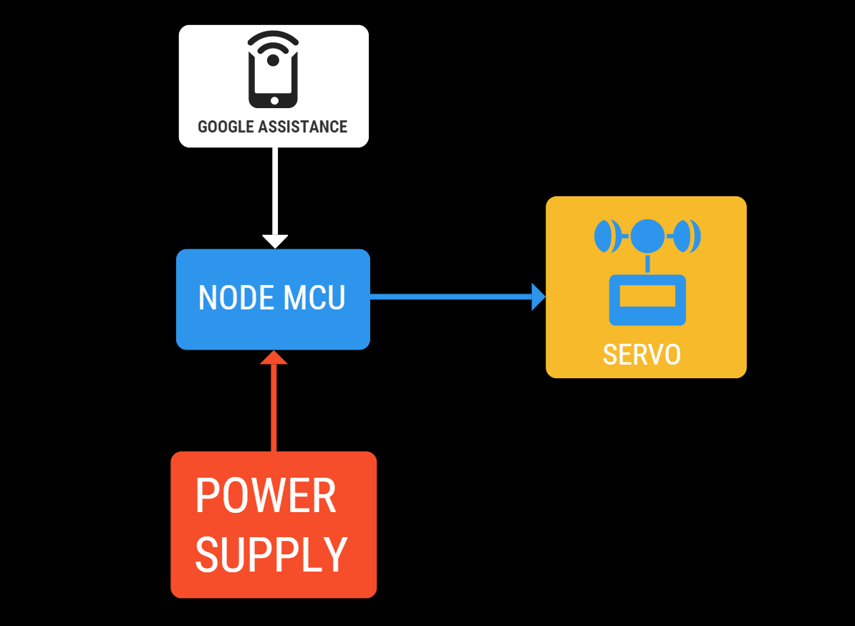

Figure 1: System Architecture of the project.

1. Firstly, the power supplied to the NodeMCU, which is then connected to the Servomotor.
2. The NodeMCU is compiled with code that communicates with a mobile device when connected over a Wi-Fi.
3. With the help of Blynk app and IFTTT, a trigger is created, which helps the mobile device to adopt google assistance feature.
4. After a trigger is created, saying “Open the door” in google assistance will set-up an event that communicates with the NodeMCU connected over a Wi-Fi, after which the NodeMCU sends data to the Servomotor and Servomotor acts accordingly.

# Methodology

The tools and technologies used in the development of the project are given below:

**NodeMCU:**

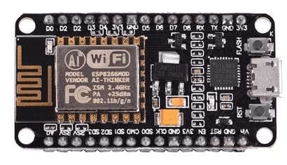

NodeMCU is a paring of firmware and hardware based around the ESP-8266 module which is a built-in Wi-Fi enabled microchip. In this project, NodeMCU is connected to a power supply which then communicates with the Servomotor to get expected response.

**Servomotor:**



Servomotor is a type of motor coupled to a sensor for positional feedback with precise control of angular positions. In this project, servomotor is user to control the opening action of the door. The door is connected to the servomotor, which will respond to the command given with the help of Google Assistance.

**Blynk App:**

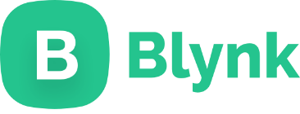

Blynk is a IOT platform that helps to control, monitor and interact with the IOT devices. In this project, Blynk app is used to set-up a button that controls the movement of servomotor, when the model is online.

**IFTTT:**



IFTTT is a platform which allows a user to interact and automate processes. This project takes great advantage from IFTTT which has allowed to use Google Assistance feature to automate the working mechanism of this system. With the help of IFTTT, a trigger has been created, which acts when given command through Google Assistance which then will sends data to NodeMCU to get the expected response. i.e., opening the door.

**Mobile device:**

## 

A mobile device with Google Assistance feature is used in this project. It is used to give command via Google Assistance which will be then sent to NodeMCU over a Wi-Fi network to get expected response.

**Arduino IDE:**

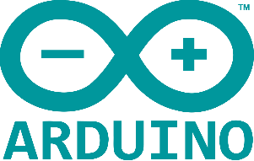

Arduino IDE is a cross-platform application that helps to compile codes written in programming languages like C, C++ and Java in Arduino boards and boards from other manufacturer.

**Type-B cable:**

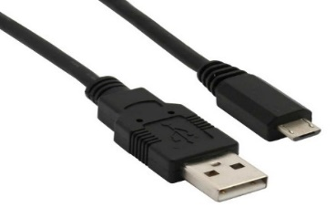

A Type-B cable is used to connect NodeMCU to the power supply.

**Breadboard:**

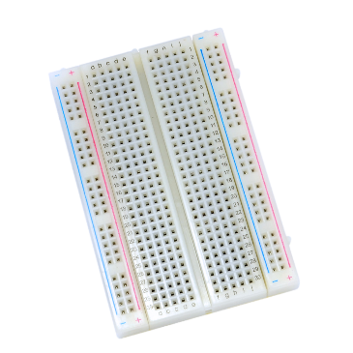

A breadboard is a device that provides support to the electrical component and is used to connect wire to the electrical component without needing to solder wire with the electrical component.

**Male-to-Male jumper wire:**

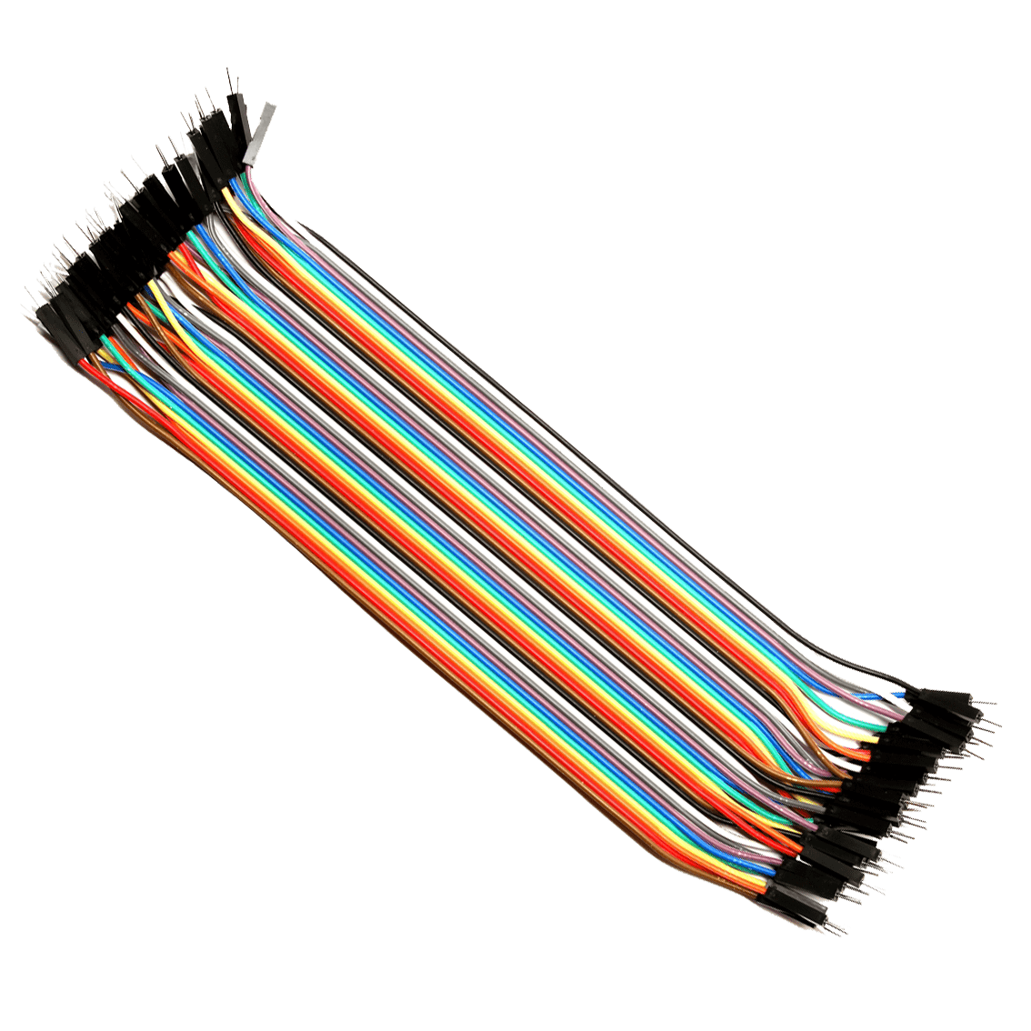

Male-to-Male jumper wire is used when connecting servomotor with NodeMCU placed in a breadboard.

## Circuit Diagram

The circuit diagram of this project is given below:

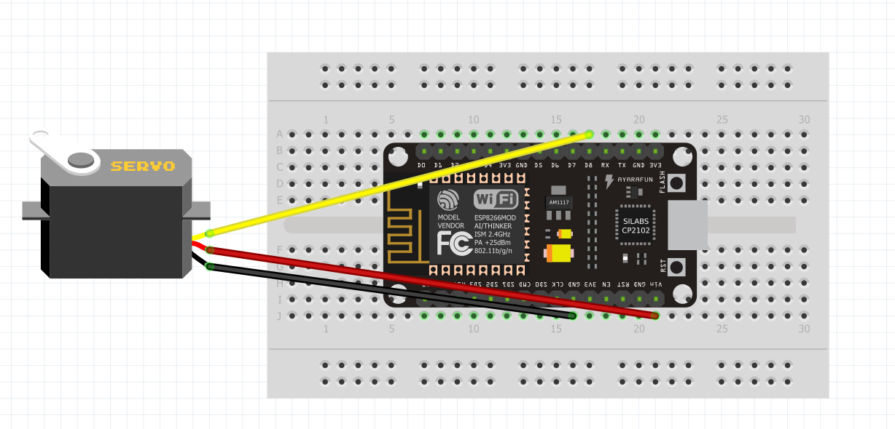

Figure : Circuit Diagram.

## Code in Arduino IDE

The code that is compiled with the help of Arduino IDE into the NodeMCU for this project is given below:

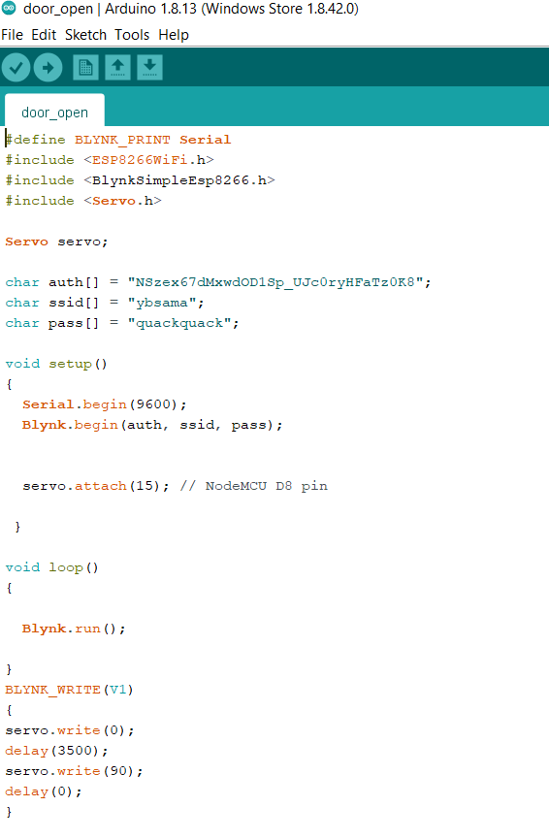

Figure 3: Code used for the project.

## Working Process

First, the servomotor and NodeMCU has been connected to each other. The red wire of servomotor is connected to the Vin pin of the NodeMCU, the brown wire is connected to the GND and the orange wire is connected to D8 pin of the NodeMCU. 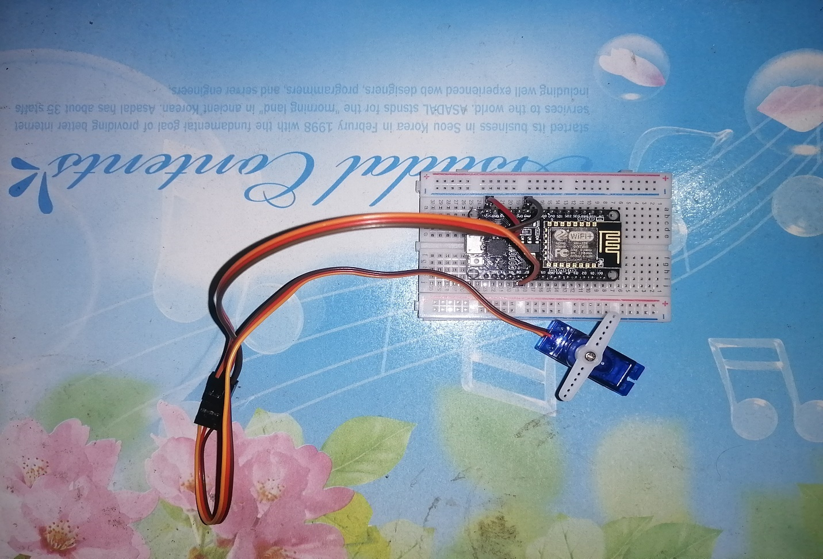

Figure 4: Connection of Servomotor and NodeMCU

Similarly, a button interface to control the movement of Servomotor is created with the help of Blynk app. To connect the blynk app and NodeMCU, an authentication token sent from the app itself is compiled using Arduino IDE to the NodeMCU. This authentication token is the key to make the communication between Blynk app, IFTTT and NodeMCU possible.

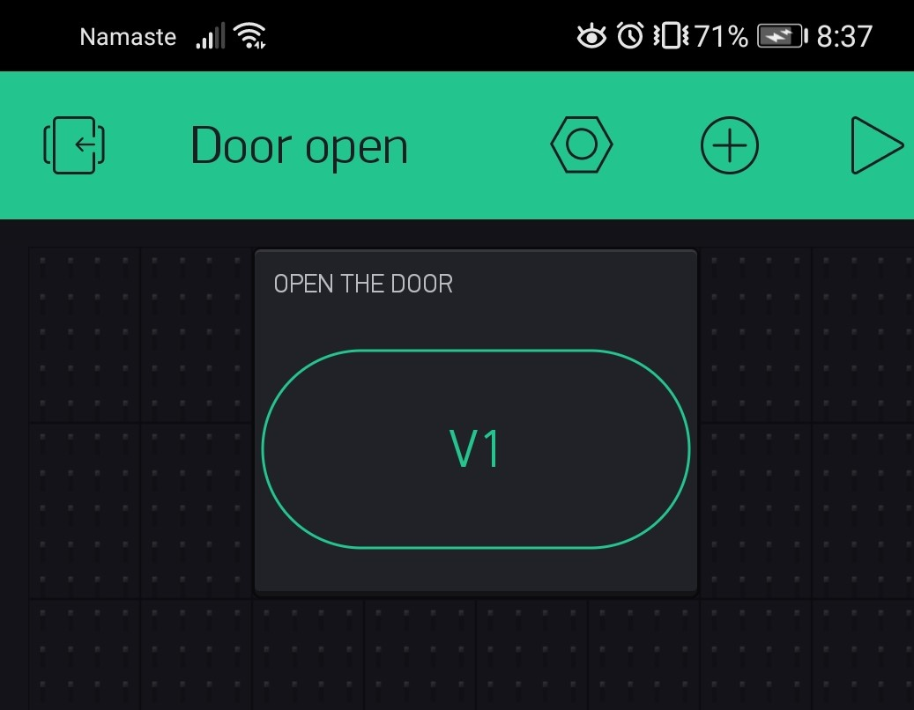

Figure : Button Interface in Blynk App.

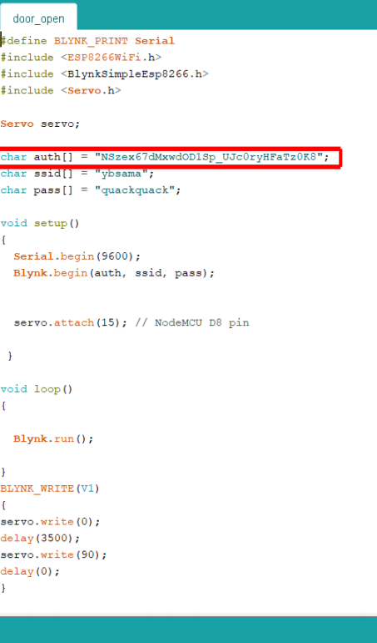

Figure : Authentication token from blynk app.

The token is also used when creating a trigger in IFTTT. In this project, IFTTT allows the use of Google Assistance. An activity is created in IFTTT with Google Assistance service where a trigger is set. So, whenever the system is connected, saying “Open the door” in Google Assistance will fire a trigger to get expected feedback i.e., Opening the door.

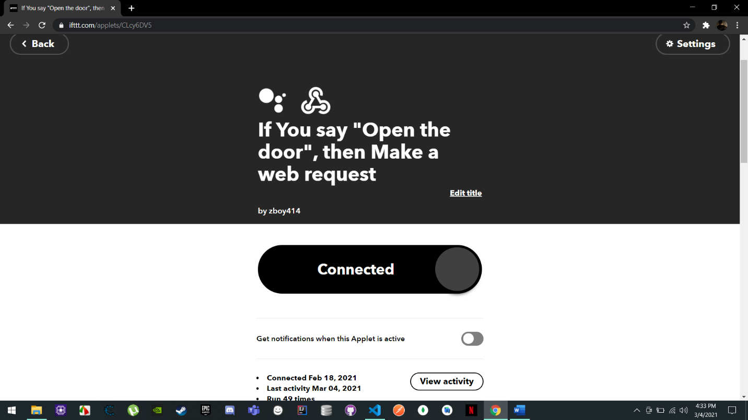

Figure : Activity created to fire a trigger in Google Assistance in IFTTT.

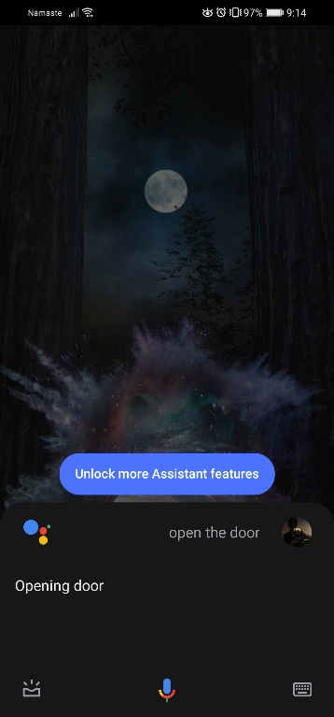

Figure : Voice command in Google Assistance.

As a delay is set, the door automatically closes after few seconds after opening.

# Limitation

This project does not contain everything in this prototype and therefore has some limitations. The following are the limitations of this system:

* User will not be able to lock and unlock the door using voice command.
* The system is not supported with button interface dedicated to lock and unlock door. As for now the user will only be able to open the door will the help of button interface using Blynk app.
* The is no display board showing the current status of the door. i.e. door locked, door unlocked, door opened, door closed.

# Future Work

An automatic door that uses the feature of Google Assistance is created in this project. This system will be able to open the door with just a simple voice command providing the sense of smart use experience. Not only with the voice command, the system is also supported with a button interface which can also be used to open the door. With the system being successful, more feature will be integrated in the near future. Not only the system will be able to open the door with a voice command, user will also be able to lock and unlock the door, providing better user experience. This will also be supported by adding another button interface for locking and unlocking the door. A display is also set to be integrated, showing the status of the door whether is locked, unlocked or open.

The system will play an important role in home automation. With the use of similar service, not only it can be used to open door, it can be used to create other system like Google Assisted lights, Google Assisted security system and many more. The system will be able to provide a better user experience for those looking for a smart environment to live in.

# Conclusion

In conclusion, this system can help understand the use of IOT in our day-to-day life. The use of different component in this project has helped get knowledge on how automation works and which sector can make better use of it. With the completion of this project, a brief knowledge on Internet of Things and its use can be achieved which in future will create an opportunity to explore more of this field.