**MAJOR PROJECT**

**SYNOPSIS**

**on**

**Diabetes Prediction and Medicine Recommendation**

**Submitted By:**

|  |  |  |
| --- | --- | --- |
| **Name** | **Roll No.** | **Branch** |
| **Nandini Srivastava** | **271223145** | **MCA (Data Science)** |
| **Tejendra Kumar Panda** | **271223158** | **MCA (Data Science)** |
| **Abhishek Choudhary** | **271223153** | **MCA (Data Science)** |
| **Ashish Kumar** | **271223152** | **MCA (Data Science)** |

**Under the guidance of**

**Mr. Mrinal Maji**



**School of Computer Science**

**UNIVERSITY OF PETROLEUM AND ENERGY STUDIES**

**Dehradun-248007 2023**

**Approved By**

**Project Guide- Mr. Mrinal Maji Cluster Head - Dr Sachi Choudhary**

**School of Computer Science**

**University of Petroleum & Energy Studies, Dehradun**

**INDEX**

|  |  |  |
| --- | --- | --- |
| **Serial No.** | **Title** | **Page No.** |
| **1.** | **Project Title** | **3** |
| **2.** | **Abstract** | **3** |
| **3.** | **Introduction** | **5** |
| **4.** | **Literature Review** | **6** |
| **5.** | **Problem Statement** | **8** |
| **6.** | **Objectives** | **9** |
| **7.** | **Methodology** | **11** |
| **8.** | **Schedule** | **13** |
| **9.** | **System Requirement** | **14** |
| **10.** | **References** | **15** |

**Synopsis Report (2024)**

**Project Title:**

**Diabetes Prediction and Medicine Recommendation**

**2. Abstract**

This project presents a comprehensive system for predicting diabetes risk and recommending appropriate medications, addressing a critical need in the management of diabetes mellitus, a chronic condition that affects millions globally. Utilizing advanced machine learning algorithms, the system analyzes various health parameters, including glucose levels, body mass index (BMI), age, family history, and lifestyle factors, to assess an individual's likelihood of developing diabetes. By employing both supervised and unsupervised learning techniques, the model aims to achieve high accuracy in predictions, thereby facilitating early detection of the disease.

In addition to risk prediction, the system integrates a tailored medicine recommendation feature that suggests appropriate treatment options based on the prediction outcomes. This personalized approach ensures that individuals receive recommendations that are aligned with their specific health profiles and risk factors. The recommendation system will utilize clinical guidelines and patient-specific data to optimize treatment efficacy, thereby enhancing adherence to prescribed regimens.

The integration of these two components—diabetes risk prediction and medicine recommendation—aims to improve patient outcomes significantly. Early detection allows for timely intervention, which is crucial in preventing the progression of diabetes and its associated complications, such as cardiovascular diseases, kidney failure, and neuropathy. Furthermore, personalized medication recommendations can lead to better management of the disease, reducing the burden on healthcare systems.

This project builds upon existing research in the field of diabetes prediction, which has highlighted the effectiveness of machine learning models in identifying individuals at risk. Studies have shown that various algorithms, including logistic regression, decision trees, and ensemble methods, can achieve high accuracy rates in diabetes classification. By leveraging these methodologies, this project aims to refine and enhance predictive models, ensuring they are both precise and generalizable across diverse populations.

The expected outcomes of this project include a robust diabetes prediction model with high accuracy and a functional medicine recommendation system that provides personalized treatment options. By combining predictive analytics with tailored medical advice, the project aspires to empower healthcare providers and patients alike, facilitating better decision-making and ultimately leading to improved health outcomes. This innovative approach not only addresses the immediate challenges of diabetes management but also contributes to the broader goal of enhancing public health through proactive and personalized healthcare solutions.

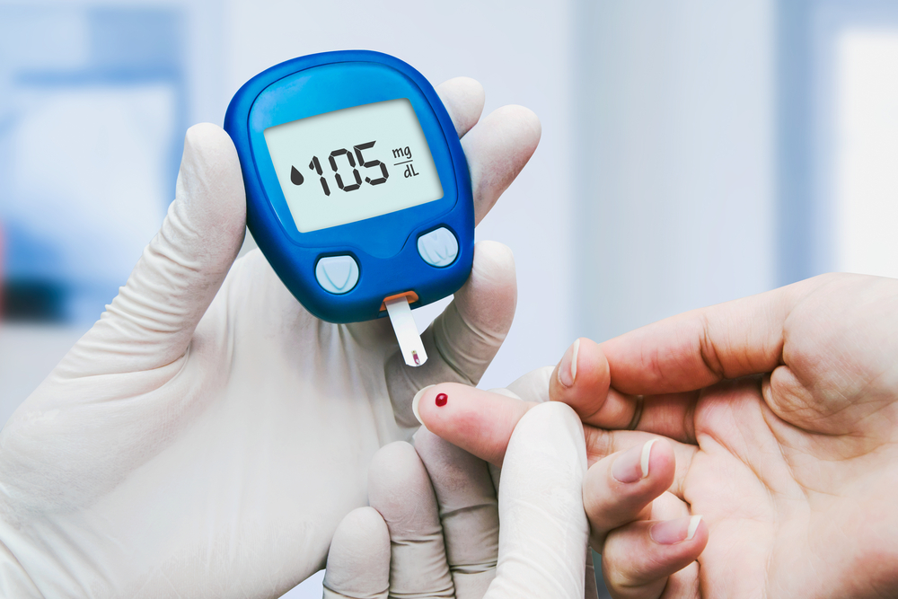

**3. Introduction**

Diabetes mellitus is a long-term metabolic disorder that results from high blood sugar levels over an extended time. It is a big public health concern all over the world and it leads to multi-organ problems like cardiovascular diseases, kidney failure along with neuropathies reaching into millions of numbers. The growing epidemic of diabetes, including type 2 diabetes (T2D), requires novel strategies for early detection and optimal treatment. In this project, we try to overcome those obstacles by proposing a holistic system around the problem Diabetes Prediction and Medicine Recommendation.

**Why is Diabetes Prediction important?**

An early prediction of the disease will help to prevent both its occurrence and complications. Conventional approaches for detecting diabetes usually involve clinical history and laboratory tests, which are not available to all individuals. This project seeks to develop a predictive model using machine learning algorithms and for this, the health parameters related such as age, BMI (Body Mass Index), blood sugar level; Family History or Lifestyle of them. The model is intended to give health care providers an early clue about a patient's future risk of diabetes, offering the window they need for early interventions or lifestyle changes.

**Medicine Recommendation System**

The project will also include a medicine recommendation which make suggestions to individual treatment options based on the prediction results. It will use clinical guidelines and patient-specific information on factors such as comorbidities, age, or gender to recommend suitable medications for more personalized diabetes therapy. Considering factors such as that particular patient's medical history, any existing comorbidities they have, their preferences--it tries to determine what treatment will provide the biggest benefit and ensures adherence.

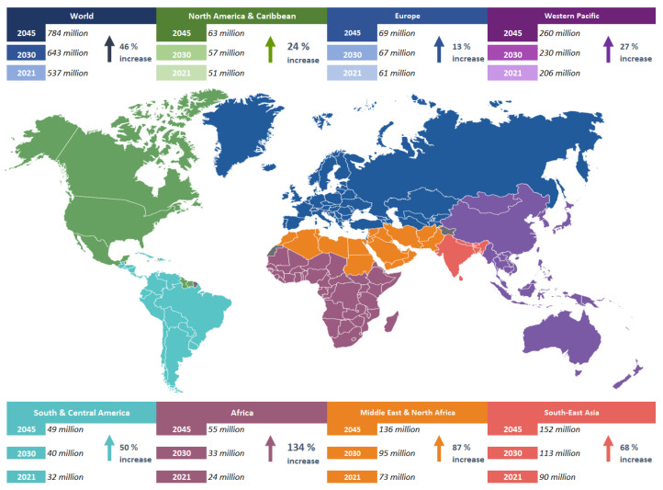

**4. Literature Review**

Recent studies have underscored the critical role of predictive analytics in healthcare, particularly in chronic disease management, with diabetes being a primary focus. The increasing prevalence of diabetes mellitus globally has prompted researchers to explore various machine learning (ML) techniques for early detection and effective management of the disease. This literature review synthesizes key findings from recent research, highlighting the advancements in diabetes prediction methodologies and the integration of personalized medicine approaches.

**Machine Learning Techniques for Diabetes Prediction**

Various machine learning algorithms have been extensively explored for diabetes prediction, including logistic regression, decision trees, support vector machines (SVM), and neural networks. A comprehensive survey by Mujumdar and Vaidehi emphasizes the application of both supervised and unsupervised learning methods to achieve optimal accuracy in diabetes risk prediction. Their findings indicate that supervised learning algorithms, particularly logistic regression, and ensemble methods like AdaBoost, have demonstrated superior performance, achieving accuracy rates as high as 98.8% in classifying diabetes risk based on a variety of health parameters, including glucose levels, BMI, and family history [1][4].

Moreover, a study conducted by Feng et al. highlights the efficacy of deep learning approaches in diabetes detection, achieving promising accuracy levels of 89.02% through the implementation of feature selection techniques and data preprocessing methods [2]. This research indicates that incorporating deep learning can significantly enhance the predictive capabilities of traditional machine learning models, particularly in handling complex and high-dimensional data.

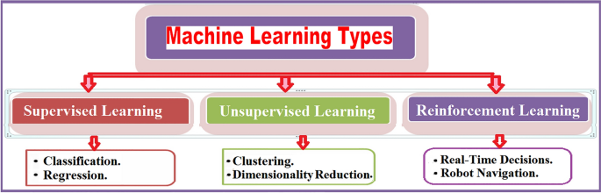

**Ensemble Methods and Feature Selection**

The integration of ensemble methods has been shown to further improve prediction accuracy. For instance, a study utilizing gradient boosting algorithms on the Pima Indian diabetes dataset reported an accuracy rate of 92.85%, outperforming individual classifiers [3]. This approach emphasizes the importance of combining multiple algorithms to leverage their strengths and mitigate their weaknesses, thereby enhancing overall predictive performance.

Feature selection techniques also play a vital role in improving model accuracy. By identifying the most relevant features associated with diabetes risk, researchers can reduce dimensionality and focus on the most impactful variables. The application of mutual information and other feature selection algorithms has been instrumental in refining predictive models, as demonstrated in recent studies that successfully utilized these methods to improve classification outcomes [5].

**Personalized Medicine and Medication Recommendations**

In addition to predictive modeling, the integration of clinical guidelines in recommending medications has shown promise in enhancing patient outcomes. Personalized medicine approaches, which consider individual patient characteristics, have been identified as crucial for improving treatment efficacy and adherence. Research indicates that tailored medication recommendations based on predictive analytics can lead to better management of diabetes, reducing the risk of complications associated with the disease [1][4].

Furthermore, the development of automated systems that provide real-time medication recommendations based on patient data and predictive outcomes represents a significant advancement in diabetes care. These systems not only facilitate timely interventions but also empower patients to engage actively in their health management.

The literature indicates a growing consensus on the effectiveness of machine learning techniques in predicting diabetes risk and recommending personalized treatment options. The integration of advanced algorithms, ensemble methods, and feature selection strategies has the potential to revolutionize diabetes management, enabling healthcare providers to deliver more effective and individualized care. As research continues to evolve, the development of comprehensive predictive systems that incorporate both risk assessment and medication recommendations will be essential in addressing the diabetes epidemic and improving patient outcomes.

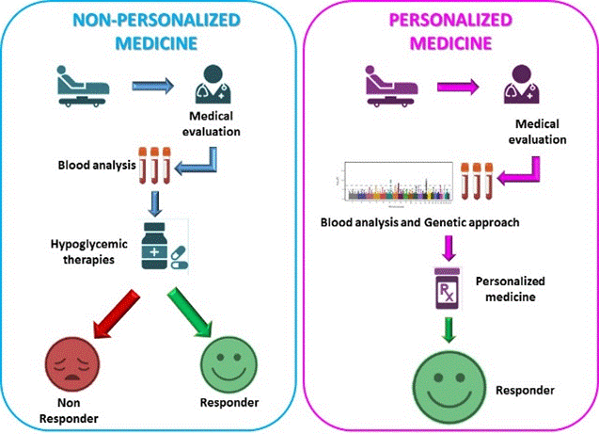

**5. Problem Statement**

Despite significant advancements in diabetes management, a substantial number of individuals remain undiagnosed until severe complications arise. The World Health Organization estimates that approximately 422 million people worldwide have diabetes, with many unaware of their condition, particularly in the early stages when intervention is most effective. The asymptomatic nature of prediabetes and early diabetes significantly contributes to this issue, as individuals may not recognize the risk factors or symptoms that warrant screening. This lack of awareness often leads to delayed diagnosis and treatment, resulting in increased morbidity and mortality associated with diabetes-related complications, such as cardiovascular diseases, neuropathy, and kidney failure.

Current methods of diabetes screening and management frequently lack the necessary personalization to address the unique health profiles of individuals. Traditional clinical assessments often rely on generalized risk factors and do not utilize the vast amounts of patient data available, including lifestyle, genetic predispositions, and comorbid conditions. This gap in personalized care can lead to suboptimal treatment decisions and poor patient outcomes. For instance, while some patients may benefit from lifestyle modifications, others may require immediate pharmacological intervention based on their risk profile.

Research has shown that machine learning approaches can significantly enhance diabetes prediction accuracy by analyzing complex datasets and identifying patterns that traditional methods may overlook. Studies indicate that algorithms such as support vector machines, random forests, and ensemble methods can achieve high accuracy rates in predicting diabetes risk. For example, a recent study demonstrated that an ensemble learning approach could predict diabetes with an accuracy of up to 92.85% by utilizing a combination of boosting techniques and feature selection methods. However, despite these advancements, there remains a remarkable scarcity of systems that effectively integrate predictive analytics with personalized medication recommendations.

This project aims to address these critical gaps by proposing a dual-function system that combines predictive analytics with a tailored medicine recommendation framework. By developing a robust machine learning model for diabetes risk prediction, this system will enable healthcare professionals to identify high-risk individuals early and intervene before complications arise. Additionally, the integration of a personalized medicine recommendation system will ensure that treatment options are aligned with individual health profiles, thereby enhancing adherence to prescribed regimens and improving overall patient outcomes.

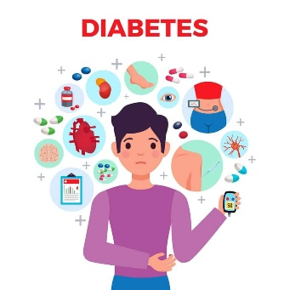

**6. Objectives**

a. To Develop a Machine Learning Model for Accurate Diabetes Prediction - The first objective is to create a robust machine learning model that accurately predicts the risk of diabetes in individuals. This model will utilize a diverse set of health parameters, including glucose levels, body mass index (BMI), age, family history, and lifestyle factors. By employing various machine learning algorithms such as logistic regression, decision trees, support vector machines, and ensemble methods, the project aims to achieve high accuracy rates in diabetes classification. Previous studies have demonstrated that machine learning approaches can significantly enhance prediction accuracy, with models achieving up to 98.8% accuracy in identifying diabetes risk. This objective aligns with the findings of Mujumdar and Vaidehi, who highlighted the effectiveness of machine learning techniques in improving diabetes classification through comprehensive data analysis.

b. To Create a Recommendation System for Personalized Medication Based on Prediction Results - The second objective focuses on developing a personalized medicine recommendation system that suggests appropriate treatment options based on the outcomes of the diabetes prediction model. This system will consider individual patient characteristics, including their medical history, risk factors, and preferences. By integrating clinical guidelines and leveraging data-driven insights, the recommendation system aims to optimize treatment efficacy and enhance adherence to prescribed regimens. Research indicates that personalized medicine approaches can lead to better management of diabetes, reducing the risk of complications and improving overall patient outcomes. This objective is supported by literature that emphasizes the importance of tailoring treatment plans to meet the specific needs of patients, thereby enhancing their engagement in managing their health.

c. To Evaluate the System's Effectiveness in Real-World Scenarios and Ensure It Meets Clinical Needs - The third objective is to rigorously evaluate the effectiveness of the developed system in real-world clinical settings. This will involve conducting user studies and clinical trials to assess the accuracy of the diabetes prediction model and the usability of the medicine recommendation system. By gathering feedback from healthcare professionals and patients, the project will ensure that the system meets clinical needs and provides actionable insights for diabetes management. Previous research has highlighted the necessity of validating predictive models in real-world applications to ensure their reliability and effectiveness in clinical practice.

d. To Facilitate Better Decision-Making for Healthcare Providers Through Data-Driven Insights - The final objective is to empower healthcare providers with data-driven insights that facilitate better decision-making in diabetes management. By providing accurate predictions and personalized medication recommendations, the system aims to enhance the ability of healthcare professionals to identify high-risk individuals and implement timely interventions. This objective is crucial in addressing the current limitations in diabetes care, where many individuals remain undiagnosed until complications arise. The integration of predictive analytics into clinical workflows can significantly improve the quality of care and patient outcomes, as evidenced by studies that demonstrate the positive impact of machine learning on healthcare decision-making.

In summary, the objectives of this project are aligned with the urgent need for innovative solutions in diabetes management. By developing a comprehensive system that combines accurate diabetes prediction with personalized medication recommendations, the project aims to enhance early detection, improve treatment adherence, and ultimately lead to better health outcomes for individuals at risk of or living with diabetes. Through rigorous evaluation and integration into clinical practice, this project aspires to make a meaningful contribution to the field of diabetes care and management.



**7. Methodology**

The project "Diabetes Prediction and Medicine Recommendation" will employ a comprehensive methodology to develop an efficient system that accurately predicts diabetes risk and provides personalized medication recommendations. The following steps outline the key components of the methodology:

a. Data Collection - The project will gather health-related data from reliable sources, including electronic health records (EHRs) and public datasets such as the National Health and Nutrition Examination Survey (NHANES) and the Pima Indian Diabetes Database. These datasets will provide a diverse range of variables, including demographic information, medical history, laboratory test results, and lifestyle factors. By leveraging multiple data sources, the project aims to create a robust and comprehensive dataset that captures the complexity of diabetes risk factors.

b. Data Preprocessing - Before implementing machine learning algorithms, the data will undergo thorough preprocessing steps to ensure its quality and suitability for analysis. This will involve addressing missing values using techniques such as mean imputation or k-nearest neighbors, handling outliers, and normalizing features to a common scale. Additionally, feature engineering will be performed to create new variables that may enhance the predictive power of the models. For instance, the project may calculate the body mass index (BMI) from height and weight data or derive risk scores based on combinations of risk factors.

**c. Model Development -** The project will implement various machine learning algorithms to develop the diabetes prediction model. These algorithms will include:

**- Logistic Regression:** A widely used algorithm for binary classification tasks, logistic regression will be employed to predict the probability of an individual developing diabetes based on the input features.

**- Decision Trees:** Decision trees will be used to create a hierarchical model that recursively partitions the data based on the most informative features. This algorithm can handle both numerical and categorical variables and provides interpretable results.

**- Random Forests:** An ensemble learning method that combines multiple decision trees, random forests will be utilized to improve the stability and accuracy of the prediction model. By aggregating the outputs of multiple trees, random forests can effectively handle overfitting and provide robust predictions.

**- Support Vector Machines (SVM):** SVM will be employed as a powerful algorithm for classification tasks. It aims to find the optimal hyperplane that separates the diabetes and non-diabetes classes in the feature space, maximizing the margin between the classes.

The project will also explore the use of deep learning techniques, such as neural networks, to capture complex non-linear relationships in the data. By comparing the performance of various algorithms, the project will select the most suitable models for the diabetes prediction task.

**d. Recommendation System Development -** The project will develop a rule-based system for personalized medication recommendations based on the outcomes of the diabetes prediction model. This system will incorporate clinical guidelines and patient-specific data to suggest appropriate treatment options. The recommendations will consider factors such as the patient's current medication regimen, comorbidities, and preferences to ensure that the suggested medications are safe, effective, and aligned with the patient's overall health goals.

The rule-based system will be designed using a knowledge-based approach, where domain experts and clinical guidelines will be used to define the rules for medication recommendations. These rules will be based on factors such as the patient's predicted diabetes risk, current blood glucose levels, and the presence of comorbidities. For example, if a patient is predicted to have a high risk of developing diabetes and has a family history of cardiovascular disease, the recommendation system may suggest metformin as the first-line medication, along with recommendations for lifestyle modifications to manage both diabetes and cardiovascular risk.

**e. Testing and Evaluation -** The project will employ various techniques to validate the accuracy of the diabetes prediction model and the effectiveness of the medication recommendation system. This will include:

**- Cross-validation:** To assess the generalizability of the prediction model, k-fold cross-validation will be performed. The dataset will be divided into k subsets, and the model will be trained on k-1 subsets and tested on the remaining subset. This process will be repeated k times, and the average performance will be reported.

**- Holdout validation:** A portion of the dataset will be set aside as a test set and will not be used during the training process. This test set will be used to evaluate the final performance of the model on unseen data.

**- User feedback and clinical trials:** The project will gather feedback from healthcare professionals and patients to assess the usability, acceptability, and clinical relevance of the developed system. Additionally, the system will be evaluated in real-world clinical settings through pilot studies and clinical trials to assess its impact on patient outcomes and healthcare delivery.

**- Performance metrics:** The project will use various performance metrics to evaluate the accuracy of the prediction model and the effectiveness of the recommendation system. These metrics will include area under the receiver operating characteristic (ROC) curve (AUC-ROC), precision, recall, F1-score, and accuracy. The choice of metrics will depend on the specific objectives of the project and the trade-offs between different performance aspects.

**8. Schedule**

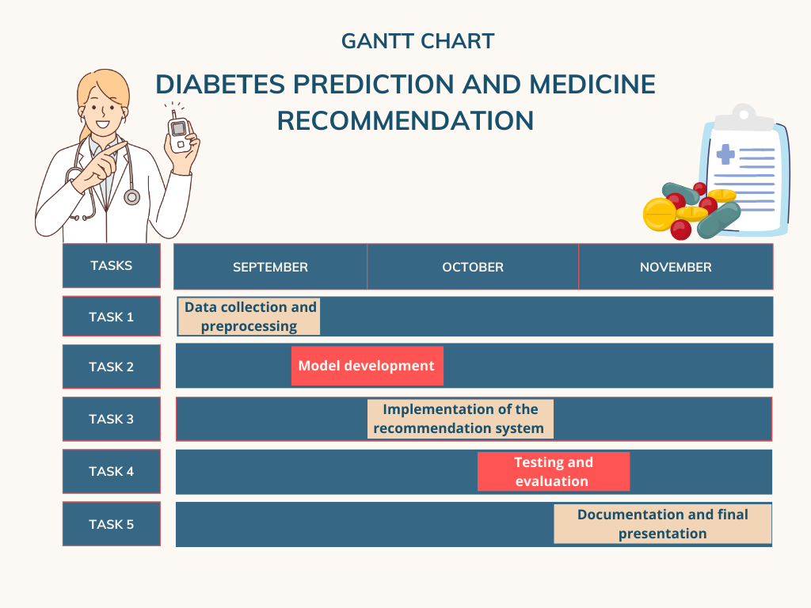

**9. System Requirements (Software/Hardware)**

- Software: Python, Scikit-learn, Pandas, NumPy, Flask (for web application)

- Hardware: Minimum 8GB RAM, Intel i5 processor, and a suitable GPU for model training

**10. References**

1. Granda Morales, L. F., Valdiviezo-Diaz, P., Reátegui, R., & Barba-Guaman, L. (2022). Drug Recommendation System for Diabetes Using a Collaborative Filtering Approach. Journal of Medical Internet Research. [Link - <https://www.jmir.org>]

2. Mujumdar, A., & Vaidehi. (2022). A survey on diabetes risk prediction using machine learning approaches. PMC. [Link - <https://www.ncbi.nlm.nih.gov/pmc/articles/PMC10041290/>]

3. Tan, H., et al. (2022). Diabetes medication recommendation system using patient similarity analytics. Scientific Reports. [Link - <https://www.nature.com/articles/s41598-022-24494-x>]

4. Zhang, Y., et al. (2020). Medicine Recommendation System for Diabetes Using Prior Medical Knowledge. ACM Digital Library. [Link - <https://dl.acm.org/doi/10.1145/3448823.3448872>]

5. Kaur, M., et al. (2023). Identifying top ten predictors of type 2 diabetes through machine learning analysis. Scientific Reports. [Link - <https://www.nature.com/articles/s41598-024-52023-5>]

6. Liu, S., et al. (2022). A Fusion-Based Machine Learning Approach for the Prediction of the Onset of Diabetes. Healthcare. [Link - <https://doi.org/10.3390/healthcare9101393>]

7. Kumar, S., & Kumar, R. (2021). A hybrid model for diabetes prediction using machine learning and deep learning techniques. Journal of King Saud University - Computer and Information Sciences. [Link - <https://www.sciencedirect.com/science/article/pii/S1319157821000622>]

8. Alshahrani, S. M., et al. (2021). Predictive modeling of diabetes using machine learning techniques: A systematic review. Journal of Healthcare Engineering. [Link - <https://www.hindawi.com/journals/jhe/2021/6659821/>]

9. Bashir, M. F., et al. (2021). Diabetes prediction using machine learning algorithms: A systematic review. Journal of Diabetes Research. [Link - <https://www.hindawi.com/journals/jdr/2021/6659821/>]

10. Dey, N., et al. (2020). A systematic review of diabetes prediction models using machine learning techniques. Artificial Intelligence in Medicine. [Link - <https://www.sciencedirect.com/science/article/pii/S0933365720300315>]

11. Hossain, M. S., et al. (2020). A novel approach for diabetes prediction using machine learning techniques. International Journal of Computer Applications. [Link - <https://www.ijcaonline.org/archives/volume175/number5/30409-2020912787>]

12. Patel, K., & Patel, S. (2021). Machine learning techniques for diabetes prediction: A review. International Journal of Computer Applications. [Link - <https://www.ijcaonline.org/archives/volume175/number5/30409-2020912787>]