# Table of Contents

|  |  |  |
| --- | --- | --- |
| **Topic** | | **Page No** |
| Table of Content | | 2 |
| Revision History | | 3 |
| 1 | Introduction | 4-5 |
|  | 1.1 Purpose of the Project | 4 |
|  | 1.2 Target Beneficiary | 4 |
|  | 1.3 Project Scope | 5 |
| 2 | Project Description | 6-11 |
|  | 2.1 Reference Algorithm | 6 |
|  | 2.2 Data/ Data Structure | 6 |
|  | 2.3 SWOT Analysis | 7 |
|  | 2.4 Project Features | 7 |
|  | 2.5 User Classes and Characteristics | 8 |
|  | 2.6 Design and Implementation Constraints | 8 |
|  | 2.7 Design diagrams | 9-11 |
| 3 | System Requirements | 12 |
|  | 3.1 User Interface | 12 |
|  | 3.2 Software Interface | 12 |
|  | 3.3 Database Interface | 12 |
| 4 | Non-functional Requirements | 13-14 |
|  | 4.1 Performance requirements | 13 |
|  | 4.2 Security requirements | 13 |
|  | 4.3 Software Quality Attributes | 14 |

**Revision History**

|  |  |  |  |
| --- | --- | --- | --- |
| **Date** | **Change** | **Reason for Changes** | **Mentor Signature** |
|  |  |  |  |
|  |  |  |  |
|  |  |  |  |
|  |  |  |  |

1. **Introduction**

**1.1 Purpose of the Project**

The Diabetes Prediction and Medicine Recommendation System is designed to leverage the power of machine learning (ML) to assist in the early diagnosis and effective management of diabetes. Diabetes is one of the most common chronic diseases, affecting millions of people globally. Early detection and personalized treatment are essential to control the disease and prevent complications such as cardiovascular diseases, kidney damage, and vision problems. However, due to the complex and multifactorial nature of diabetes, conventional methods of diagnosis and treatment often fall short in providing individualized care.

The goal of this project is to build a comprehensive software solution that:

Predicts the likelihood of a person developing diabetes based on various health parameters such as age, body mass index (BMI), glucose levels, and family history.

Recommends personalized medication and lifestyle changes tailored to the individual's specific condition, risk level, and medical history, thereby providing a proactive approach to diabetes care.

This project is especially important in healthcare settings where early detection of diabetes can improve patient outcomes, reduce healthcare costs, and alleviate the long-term burden of diabetes management. The system will serve as a decision-support tool for healthcare professionals by augmenting their clinical judgment with data-driven insights.

In addition to benefiting healthcare providers, the system will empower patients to take preventive measures and seek timely medical intervention before diabetes progresses to advanced stages. The focus on personalized medicine ensures that treatments and interventions are not generic but tailored to each patient's specific needs, making the approach more effective and patient-centric.

**1.2 Target Beneficiary**

The **Diabetes Prediction and Medicine Recommendation System** is designed to benefit a broad range of users, each with specific needs:

1. **Healthcare Providers**: Physicians, endocrinologists, and diabetes specialists can use the system as a decision-support tool, aiding them in diagnosing diabetes at an early stage. By inputting patient data such as blood glucose levels, cholesterol, BMI, and other relevant health markers, the system can generate a diabetes risk score. In addition to the risk score, it will provide tailored medication and lifestyle modification recommendations based on clinical guidelines, reducing the guesswork in treatment and allowing for more effective care management.
2. **Patients**: Individuals can use the system to self-assess their risk of developing diabetes by inputting personal health data. Those at high risk can take proactive steps toward managing their health by following the recommended treatments and lifestyle changes suggested by the system. The system will educate patients about their condition, empowering them to manage the disease before it becomes unmanageable.
3. **Healthcare Institutions**: Clinics, hospitals, and diagnostic centers can integrate this system to enhance patient care, improve diagnostic accuracy, and streamline the diabetes management process. The system can reduce the number of patients with undiagnosed diabetes and improve overall patient outcomes by helping clinicians identify at-risk individuals early and recommend effective interventions.
4. **Pharmaceutical Companies and Pharmacies**: This system can also serve pharmaceutical companies by identifying patterns of medication efficacy based on patient demographics, medical history, and lifestyle factors. This could eventually lead to better-targeted treatments and the development of new drugs.

**1.3 Project Scope**

The **Diabetes Prediction and Medicine Recommendation System** encompasses two primary functionalities: **diabetes risk prediction** and **personalized treatment recommendation**.

1. **Diabetes Risk Prediction**: This component will involve building and training a machine learning model that predicts a patient's likelihood of developing diabetes based on various clinical and lifestyle factors. The model will be trained on publicly available health datasets such as the **Pima Indian Diabetes Dataset** and other real-world health data, which include features like age, BMI, glucose levels, physical activity, and family history of diabetes. The output will be a probability score that indicates the patient's risk of developing diabetes.
2. **Personalized Medicine and Lifestyle Recommendation**: Once the risk score is generated, the system will recommend treatment plans and medications tailored to the patient's specific risk profile. Recommendations will be based on established clinical guidelines for diabetes management, including factors like the patient's risk level, existing comorbidities, and potential side effects of medications. The system will also suggest lifestyle changes such as dietary modifications, exercise routines, and weight management strategies to help patients lower their risk of developing diabetes or manage existing conditions.

**Key Features** of the system include:

* **User-friendly interface** for both patients and healthcare professionals, where data can be inputted easily, and results are displayed clearly.
* **Integration with electronic health records (EHR)** to automatically import patient data, improving the accuracy of predictions and recommendations.
* **Real-time risk assessment** and recommendations based on the latest available clinical data.
* **Machine learning algorithms** for improving prediction accuracy over time by learning from new patient data.

1. **Project Description**

The **Diabetes Prediction and Medicine Recommendation System** is an advanced healthcare application that leverages machine learning algorithms and data analytics to assess the risk of diabetes in individuals and provide personalized treatment recommendations. With the growing prevalence of diabetes worldwide, early detection and personalized care are crucial to reducing its impact on both individual health and the broader healthcare system.

This project is designed to solve two primary problems: early diagnosis of diabetes and effective management of the condition through personalized treatment. The system will help healthcare providers and individuals take preventive or corrective action by predicting the likelihood of developing diabetes and suggesting appropriate medical treatments and lifestyle modifications based on individual health data.

2.1 Reference Algorithm

The diabetes prediction component of the system will rely on **Supervised Machine Learning algorithms**, where the goal is to classify patients based on their likelihood of developing diabetes. Some key algorithms to be used include:

1. **Logistic Regression**: A simple yet effective algorithm for binary classification problems. It will predict the probability of a patient developing diabetes based on features like age, BMI, glucose levels, etc. This algorithm works well for interpretable results, allowing clinicians to understand the impact of each feature.
2. **Random Forest**: A powerful ensemble learning method that uses multiple decision trees to improve prediction accuracy. It can handle a large number of input features and is effective in managing missing or unstructured data.
3. **Support Vector Machine (SVM)**: This algorithm can classify patients into different risk categories by finding an optimal hyperplane. SVM is suitable for high-dimensional data and provides good results when the separation between classes is not easily linear.
4. **Neural Networks**: For more complex cases, deep learning models like neural networks can be employed. These models excel at capturing non-linear relationships between features and can be fine-tuned to provide high accuracy, especially when handling large datasets.

**2.2 Data / Data Structure**

Health parameters: Age, BMI, Glucose level, family history, physical activity, and dietary patterns.

Data sources: The system will use data from the Pima Indian Diabetes Dataset, NHANES, and other publicly available healthcare datasets.

Data processing: Preprocessing steps like data cleaning, normalization, and feature extraction will be necessary to ensure model quality.

**2.3 SWOT Analysis**

|  |  |
| --- | --- |
| **Strengths** | **Weaknesses** |
| Accurate predictions with ML | Data quality and availability |
| Personalized medicine recommendation | Complexity of feature extraction |
| Integration with EHR systems | Handling sensitive medical data |

|  |  |
| --- | --- |
| **Opportunities** | **Threats** |
| Scaling to global healthcare systems | Misuse of patient data |
| Providing real-time diabetes risk scores | Uncertain regulatory environment |

**2.4 Project Features**

The Diabetes Prediction and Medicine Recommendation System will have the following key features:

1. Risk Prediction Model: Provides real-time prediction of diabetes risk based on patient data.
2. Personalized Treatment Recommendations:
   * Suggests medication, dietary changes, and exercise plans based on the patient’s risk category.
3. Interactive User Interface:
   * User-friendly interface for both patients and healthcare providers to input data and view results.
4. Data Storage and Management:
   * Secure storage of patient records, medical history, and treatment recommendations.
5. Reports and Alerts:
   * Automatically generates reports and sends alerts for follow-up appointments or changes in patient conditions.

**2.5 User Classes and Characteristics**

The system will be used by different user groups, each with specific requirements:

1. Healthcare Providers:
   * Role: Doctors, nurses, and medical staff will use the system to diagnose patients and recommend treatments.
   * Characteristics: Familiar with clinical data, need for accurate and interpretable results, require customizable treatment plans.
2. Patients:
   * Role: Individuals using the system to assess their diabetes risk and receive treatment recommendations.
   * Characteristics: Limited medical knowledge, need for an easy-to-use interface, seek clear and actionable advice.
3. System Administrators:
   * Role: IT personnel responsible for maintaining the system, managing databases, and ensuring security.
   * Characteristics: Technical expertise, focus on backend operations and data privacy compliance.

**2.6 Design and Implementation Constraints**

1. Data Privacy:
   * The system must comply with healthcare data regulations like HIPAA (for the USA) and GDPR (for the EU). Sensitive patient data must be encrypted both at rest and in transit.
2. Real-Time Performance:
   * The system should be capable of processing large datasets and providing predictions in real-time or near real-time, especially in healthcare settings where timely decisions are crucial.
3. Integration with Existing Systems:
   * The system must be able to integrate with electronic health record (EHR) systems used in hospitals and clinics, ensuring seamless data sharing and retrieval.
4. Scalability:
   * The system must be designed to scale efficiently as the number of users or patients increases. Cloud-based infrastructure may be used to meet this requirement.
5. Accuracy and Reliability:
   * Machine learning models must be validated rigorously to ensure high accuracy. Regular updates and re-training with new data will be necessary to maintain model performance.
   1. **Design Diagrams**
6. **Use Case Diagram**: Represents the interaction between users (patients, healthcare providers) and the system.

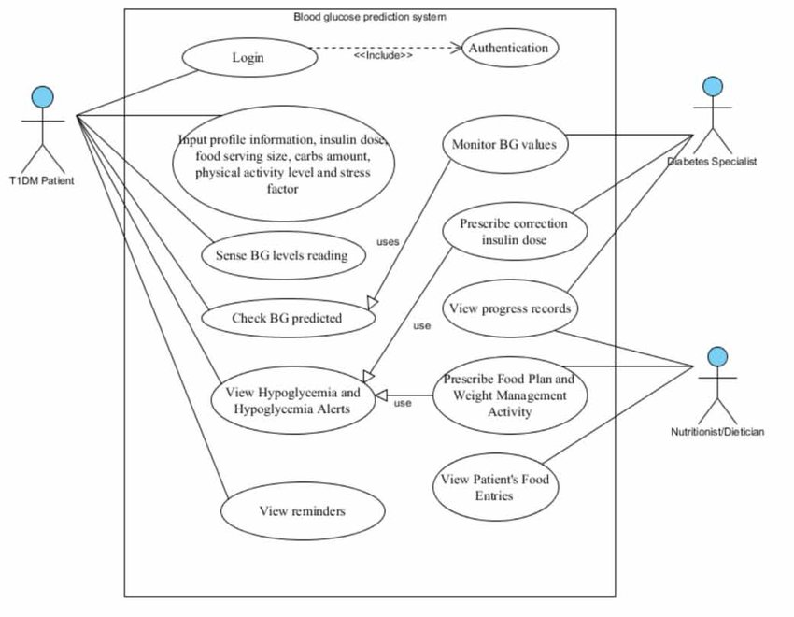

1. **Class Diagram**: Depicts the structure of the system, including patient data, prediction models, and treatment recommendations as classes and their relationships.

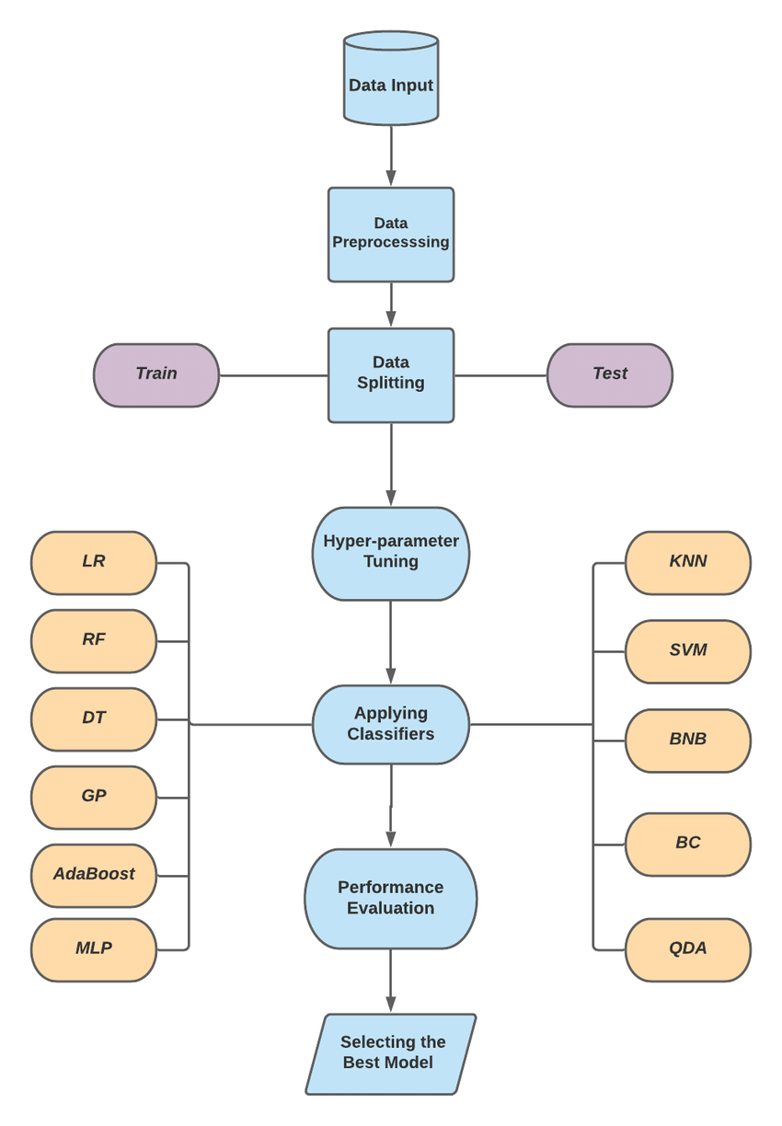

1. **Activity Diagram**: Outlines the workflow for predicting diabetes risk and providing personalized recommendations, covering the process flow for both users and the system.

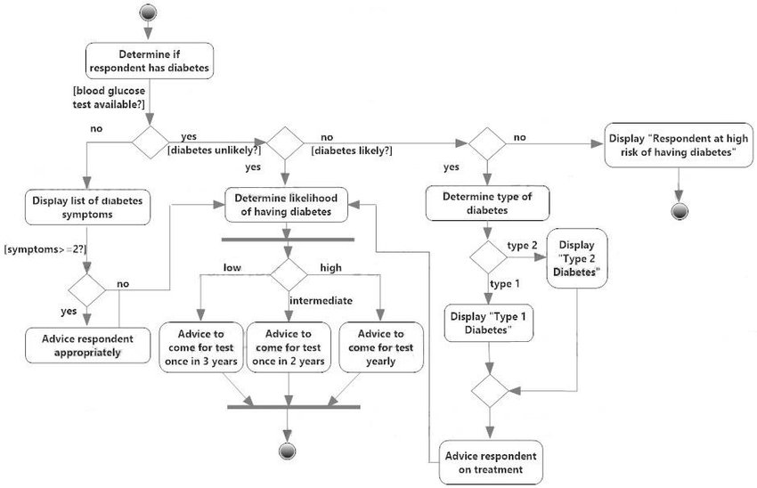

1. **System Requirements**

**3.1 User Interface**

* A **web-based interface** with user-friendly navigation.
* Forms for patients to enter their health data (age, BMI, glucose levels, etc.).
* **Dashboard** for healthcare professionals to monitor patient data, view prediction results, and access recommendations.

**3.2 Software Interface**

* Integrated with **Electronic Health Records (EHR)** to import patient data.
* Interfacing with the **Python-based machine learning algorithms** and data analytics tools.
* APIs for external services like insurance, labs, or pharmacy integration.

**3.3 Database Interface**

* **SQL/NoSQL databases** to store patient data and prediction results.
* Efficient queries to retrieve and display personalized recommendations.

1. **Non-Functional Requirements**

**4.1 Performance Requirements**

* **Response Time:** The prediction model should deliver results within 3-5 seconds for real-time applications.
* **Scalability:** The system should handle an increasing number of patients and users without a significant drop in performance.
* **Availability:** The system must be available 24/7, especially for hospitals and healthcare providers.

**4.2 Security Requirements**

* **Data Encryption:** All sensitive patient information must be encrypted in transit and at rest.
* **Authentication and Authorization:** Role-based access control to ensure only authorized healthcare providers can view or modify patient data.
* **Audit Logs:** All activities related to patient data access and modification should be logged for future auditing.

**4.3 Software Quality Attributes**

* **Reliability:** The system should deliver accurate and consistent predictions with a minimum downtime.
* **Maintainability:** The system should be easy to update, maintain, and enhance as new medical guidelines or machine learning algorithms emerge.
* **Usability:** The interface should be intuitive, requiring minimal training for doctors and healthcare professionals.
* **Portability:** It should be deployable on cloud platforms like AWS or Azure to support remote access.