Onboarding Request Review
Automation — Architecture & Enterprise Deployment Strategy
Proof of Concept (POC) Design Document

1. Executive Summary
This document describes the architecture and enterprise deployment strategy for automating the onboarding request review process currently performed manually by the operations team. The solution validates pending onboarding requests against a reference dataset, determines an approve/reject/manual-review outcome, updates the review status in the database, and — for approved requests — triggers the downstream Azure Data Factory (ADF) pipeline that processes the associated data file.
The core decision logic is deterministic wherever possible (exact match after normalization) and falls back to an LLM-based semantic comparison (Anthropic Claude) only for values that require contextual understanding to reconcile — e.g. abbreviations, synonyms, or differing phrasing that mean the same thing. This keeps the majority of decisions fast, free, and fully reproducible, while still handling real-world data variability.
The system is intentionally labeled an automation rather than an agent: every step follows a fixed, predefined sequence. The only place reasoning is introduced is a narrow, auditable fallback for semantic value comparison — not for deciding what steps to take.

2. Solution Architecture
The diagram below shows all components involved end-to-end: request submission, data validation, status update, and pipeline execution.
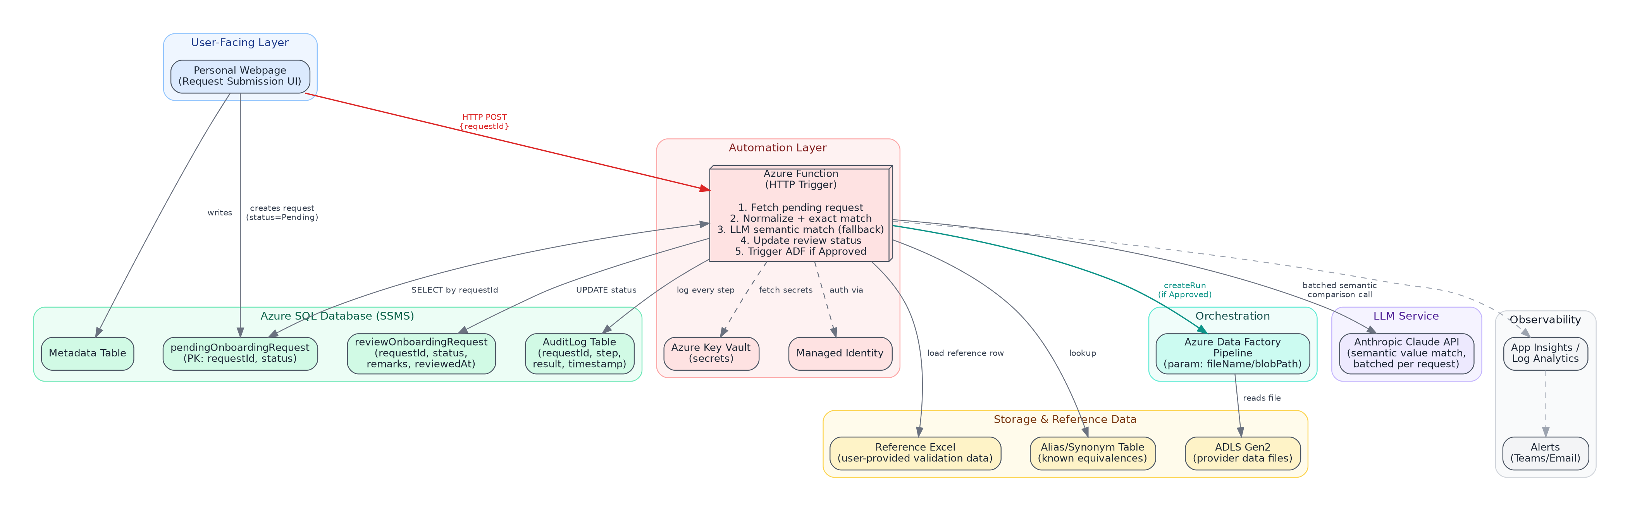
Figure 1: End-to-end solution architecture

2.1 Component Responsibilities
Component | Responsibility
Personal Webpage | Captures onboarding request details; writes to the metadata table and pendingOnboardingRequest; immediately invokes the Azure Function via HTTP POST with the requestId.
Azure SQL Database | Hosts pendingOnboardingRequest (source of truth for new requests), reviewOnboardingRequest (decision + audit fields), and an AuditLog table capturing every processing step.
Azure Function | Core automation: fetches the request, runs normalization + exact-match checks, falls back to a batched Claude API call for ambiguous columns, writes the final status, and triggers ADF when approved.
Reference Excel / Validation Data | User-provided file containing the expected/reference values per request, used as the basis of comparison. Same column names as the DB table, so no schema mapping step is required.
Alias/Synonym Table | Deterministic lookup of known equivalent values (e.g. company suffixes, region codes) — resolved before falling back to the LLM, to keep the majority of comparisons free and instant.
Anthropic Claude API | Batched, temperature-0 semantic comparison for column values that don't exact-match or resolve via alias lookup. Returns a structured MATCH / MISMATCH / UNCERTAIN verdict with a brief reason.
Azure Data Factory | Executes the existing data-processing pipeline, parameterized with the fileName / blobPath associated with the approved request.
ADLS Gen2 | Stores the raw data-provider files referenced by each onboarding request.
Key Vault + Managed Identity | Removes hard-coded credentials; the Function authenticates to SQL, ADLS, and ADF using a system-assigned Managed Identity, with any remaining secrets (e.g. Claude API key) stored in Key Vault.
App Insights / Log Analytics | Centralized logging, tracing, and alerting across every Function execution.

3. Request Validation Flow
Every request follows the same decision path. Exact-match and alias checks are attempted first (free, deterministic); the LLM is only invoked for columns that remain unresolved, and only ever produces one of three outcomes per column, never a silent guess.
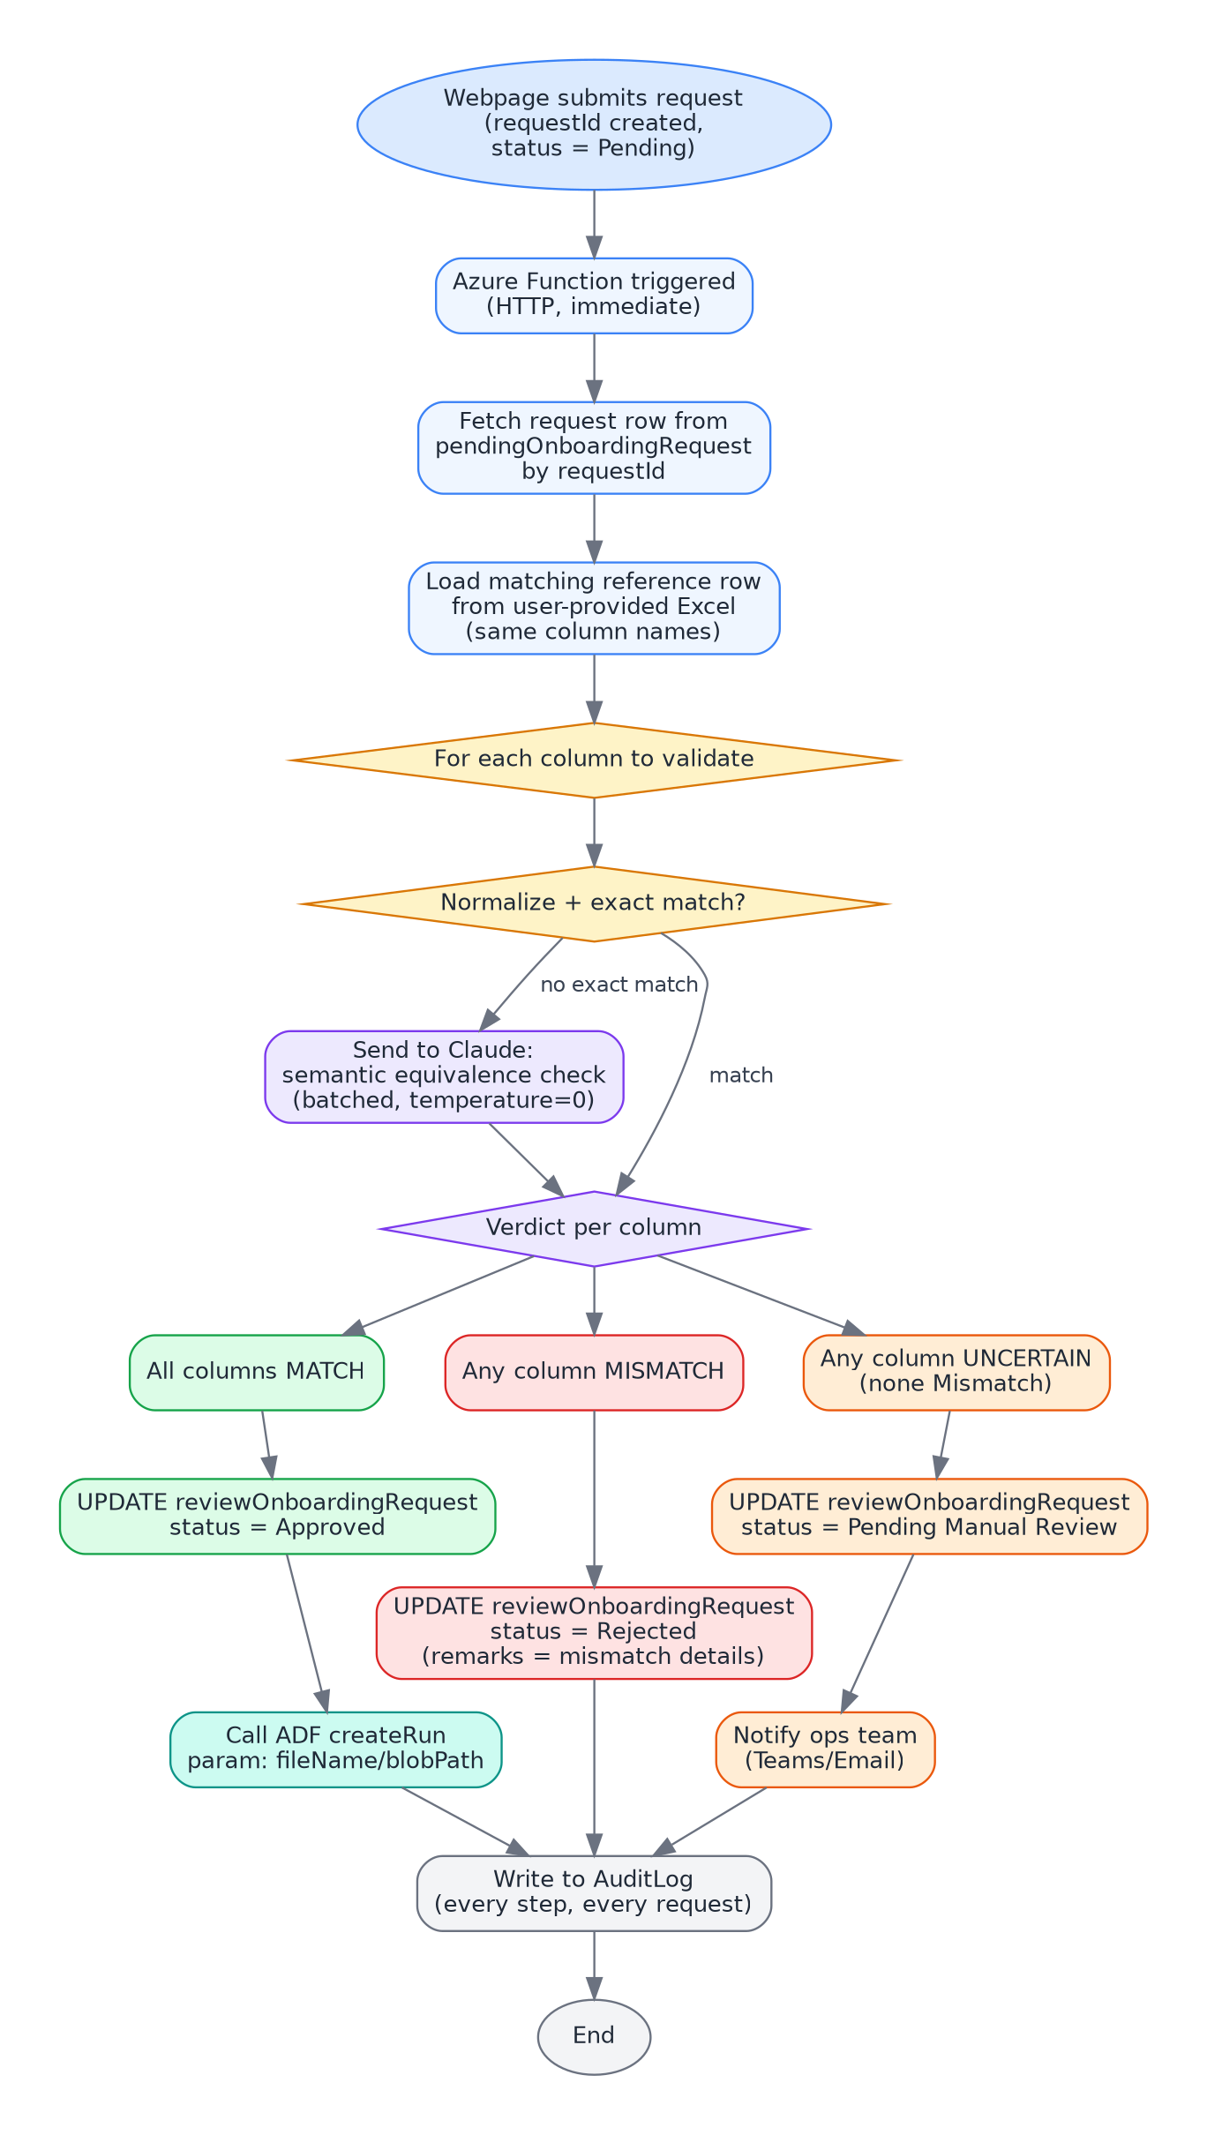
Figure 2: Per-request column validation and status decision flow

3.1 Status Outcomes
Outcome | Condition | Downstream Action
Approved | All columns resolve to MATCH (exact, alias, or LLM-verified semantic match) | reviewOnboardingRequest updated; ADF pipeline triggered with the file reference
Rejected | Any column resolves to MISMATCH | reviewOnboardingRequest updated with remarks listing the failing column(s); no pipeline trigger
Pending Manual Review | Any column resolves to UNCERTAIN and none are MISMATCH | Status set accordingly; ops team notified via Teams/Email; human resolves and the resolution is fed back into the alias table

4. Enterprise Deployment Strategy
The deployment model follows a standard three-tier promotion path (Dev → Test/UAT → Prod) with infrastructure-as-code, automated gates, and a blue-green release pattern in production to avoid downtime on an approval-critical workflow.
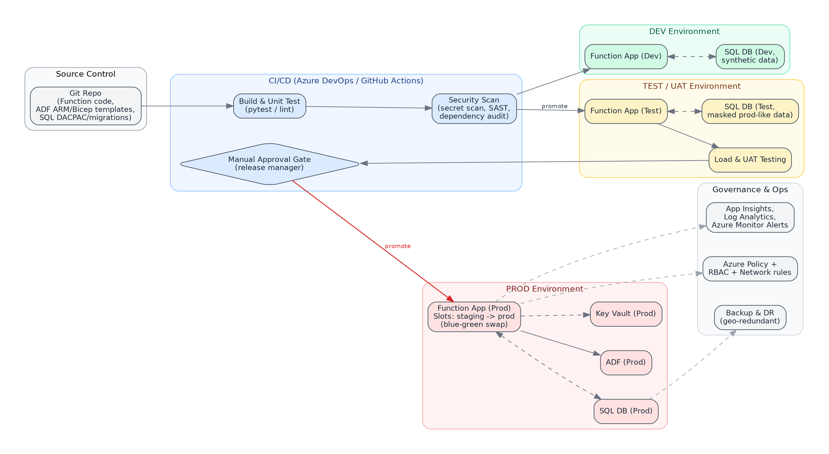
Figure 3: CI/CD promotion path and environment topology

4.1 Environment Strategy
- Dev: synthetic/sample data only; used for active development and unit testing; deploy on every merge to main.
- Test/UAT: masked, prod-representative data; used for integration testing, load testing, and business sign-off by the ops team before promotion.
- Prod: real data; deployments only via approved release with a manual gate; Function App uses a staging slot swapped into production (blue-green) to allow instant rollback.

4.2 Infrastructure as Code
All Azure resources (Function App, SQL schema/migrations, ADF pipeline definitions, Key Vault, networking) should be defined in Bicep or ARM templates and versioned in the same repository as the Function code, so environments are reproducible and drift is detectable.

4.3 CI/CD Pipeline Stages
Stage | Purpose
Build & Unit Test | Compile/lint the Function code; run unit tests for normalization, alias lookup, and validation logic branches.
Security Scan | Secret scanning, dependency vulnerability audit, static analysis (SAST) before any deployment.
Deploy to Dev | Automatic on merge to main; smoke test against synthetic data.
Deploy to Test/UAT | Automatic promotion after Dev smoke tests pass; includes load testing and ops-team business validation.
Manual Approval Gate | Release manager / process owner sign-off before Prod deployment — required given this workflow drives real approvals.
Deploy to Prod (slot swap) | Deploy to a staging slot, run smoke tests against it, then swap into production traffic; instant rollback by swapping back.

4.4 Security & Governance Baseline
- Managed Identity for all Azure-to-Azure calls (SQL, ADLS, ADF) — no embedded connection strings or keys.
- Key Vault for any remaining secrets (e.g. Claude API key), referenced via Key Vault references in Function App settings.
- RBAC scoped to least privilege per environment; separate service principals / identities for Dev, Test, and Prod.
- Azure Policy to enforce tagging, allowed regions, and diagnostic settings across all resources in this solution.
- Network restrictions (private endpoints or IP allow-listing) on the SQL Database and Key Vault in Prod.
- All approve/reject/manual-review decisions logged to the AuditLog table with the reasoning returned by the LLM, satisfying traceability requirements for an approval workflow.

5. Risk Factors and Mitigation Techniques
Risk | Impact | Mitigation
LLM produces an incorrect semantic match verdict (false MATCH or false MISMATCH) | Wrong request approved/rejected without human awareness | Use temperature=0 and a strict structured output schema; log full prompt + response per column; route low-confidence verdicts to Pending Manual Review rather than forcing a binary decision; periodically sample and audit LLM decisions against human judgment.
Non-determinism / model drift across LLM API versions | Same input could yield a different decision on re-run, weakening auditability | Pin model version where possible; log every LLM call's exact input/output; keep the deterministic exact-match + alias layer as the primary path so the majority of decisions never touch the LLM at all.
Reference Excel file has data-entry errors or is outdated | Valid requests incorrectly rejected, or invalid requests incorrectly approved | Add a lightweight validation/ingestion check on the reference file (expected columns present, no blank required fields) before it's used; version and timestamp each reference file; notify ops if the file hasn't been refreshed within an expected window.
Function App failure mid-process (e.g. SQL update succeeds, ADF trigger fails) | Inconsistent state — request marked Approved but pipeline never ran | Wrap steps in try/catch with retry policies on transient faults; make the ADF trigger step idempotent; add a reconciliation job that flags Approved requests with no corresponding ADF run after a threshold time.
Sensitive onboarding data exposed to an external LLM API | Data privacy / compliance exposure | Send only the specific column values needed for comparison, not full request records; review Anthropic's data handling terms for the API tier in use; mask or tokenize any PII fields not required for the semantic check; confirm with security/compliance before Prod rollout.
Malicious or malformed HTTP call to the Function's trigger endpoint | Unauthorized processing of arbitrary requestIds | Require function-key or Azure AD authentication on the HTTP trigger; validate that the requestId exists and is genuinely Pending before processing; rate-limit the endpoint.
Credential or secret leakage | Unauthorized access to SQL, ADLS, or ADF | Managed Identity for all Azure resource access; Key Vault for the LLM API key; no secrets in source control or app settings in plaintext; periodic secret rotation.
Alias table becomes stale or incomplete over time | Increasing reliance on (and cost of) the LLM fallback; slower processing | Feed every human-resolved Pending Manual Review case back into the alias table; review alias table coverage quarterly.
Single point of failure in Azure Function (regional outage) | Onboarding requests stop processing entirely | Deploy Function App with availability-zone redundancy where supported; enable geo-redundant backup for the SQL Database; document a manual fallback procedure for the ops team during an outage.
Business logic changes (new validation rules) without corresponding code updates | Automation silently applies outdated rules | Version the validation logic alongside the reference file schema; require a code/config review whenever validation rules change; maintain a changelog visible to the ops team.

6. Suggested Rollout Plan
- Phase 1 — POC (current scope): Build the Azure Function with exact-match + alias + LLM fallback; deploy to Dev only; validate against a representative sample of historical requests; run in parallel with the manual process (shadow mode, no live approvals yet).
- Phase 2 — Pilot: Deploy to Test/UAT; enable live processing for a single provider or a limited request volume; ops team reviews every automated decision for a defined period before trusting it fully.
- Phase 3 — Controlled Production Rollout: Deploy to Prod behind the manual approval gate; enable for all providers; keep Pending Manual Review as a safety net; monitor audit logs weekly.
- Phase 4 — Optimization: Expand the alias table based on real Pending Manual Review resolutions; tune LLM confidence thresholds; consider adding a natural-language query interface over the AuditLog for the ops team (“why was request X rejected?”).

7. Open Items for Sign-off
- Confirm data classification of onboarding request fields sent to the Claude API, and get compliance sign-off if any field is considered sensitive/PII.
- Confirm authentication mechanism for the webpage → Function call (Azure AD, function key, or API Management front door).
- Define the SLA for Pending Manual Review resolution and the notification channel (Teams vs. Email vs. both).
- Confirm ADF pipeline's existing error-handling behavior, so the Function's retry/reconciliation logic aligns with it rather than duplicating it.

