Submission Guidelines -: Attach Screenshots or command along with explanation and submit in doc(google doc or microsoft doc) format and share your github repo link
=== PART 1 EVIDENCE ===
Instance: i-05060927c9ba2db4b Public IP: 44.199.169.53
Flask URL: http://44.199.169.53:5000
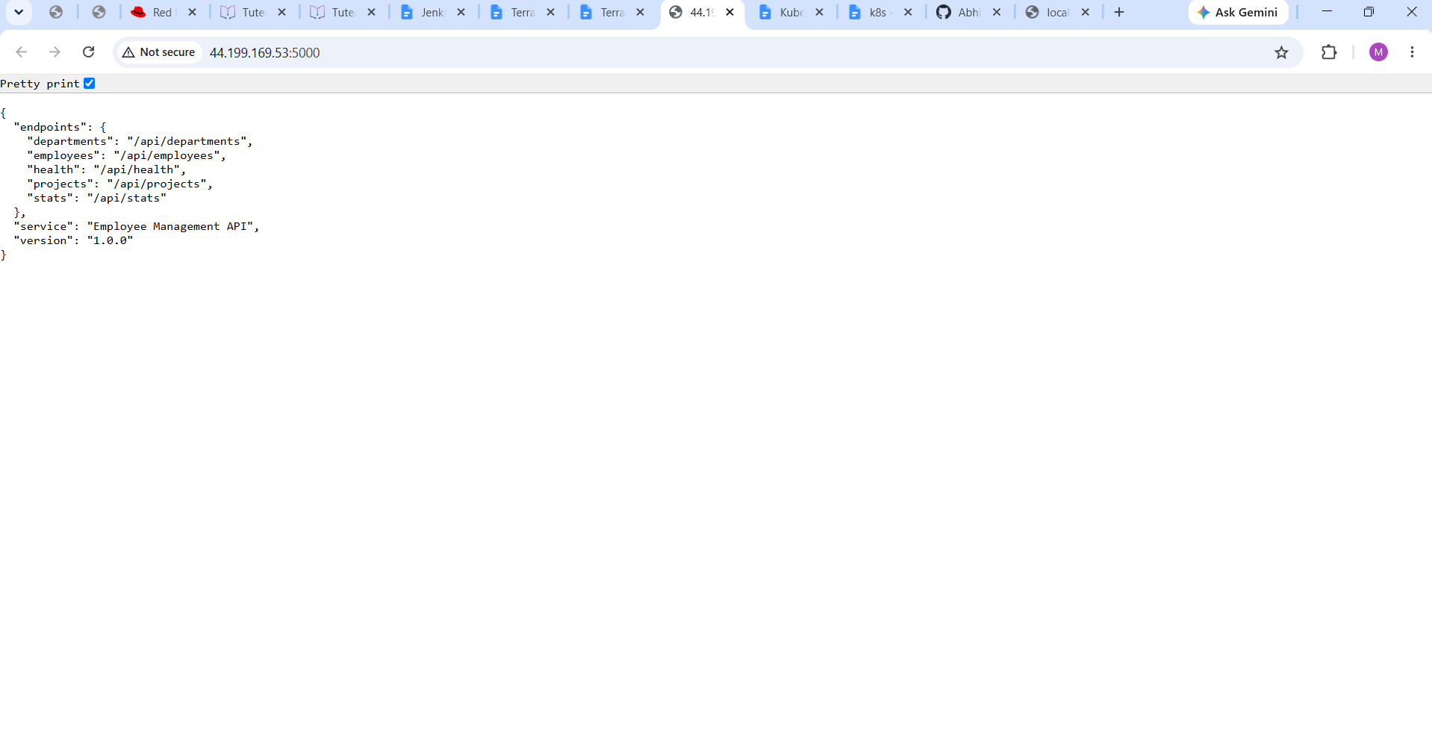
Express URL: http://44.199.169.53:3000
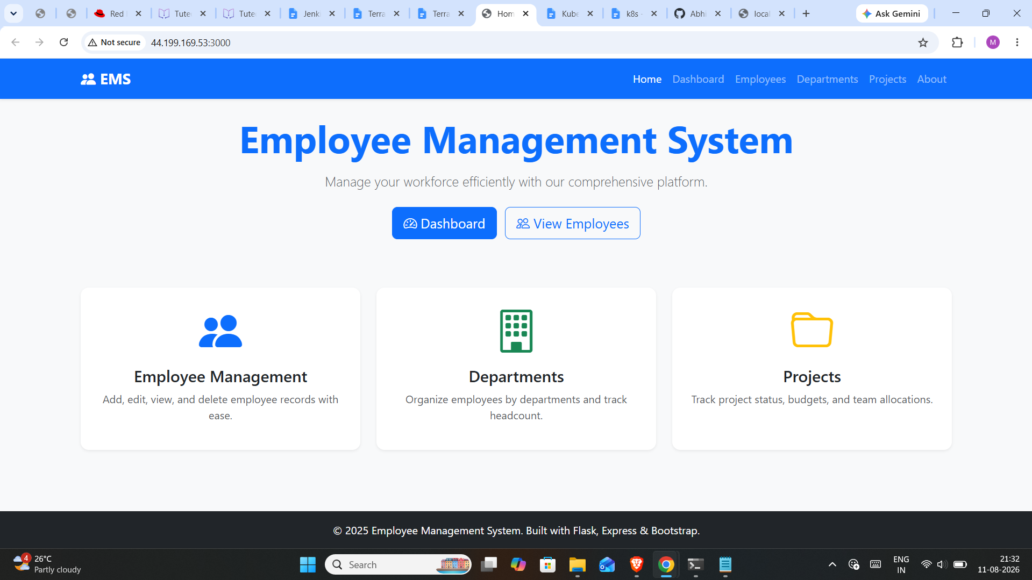

--- Health check:
{"service":"employee-management-api","status":"healthy","version":"1.0.0"}

--- Frontend page title:
<title>Home - Employee Management</title>

=== PART 2 EVIDENCE ===
VPC: vpc-0c2877fe38ef4d30f | Public subnet: subnet-0606494c04c46c631
Backend: i-0c8661713587c0167 | Public IP 98.87.78.92 | Private IP 10.0.0.204 | URL http://98.87.78.92:5000
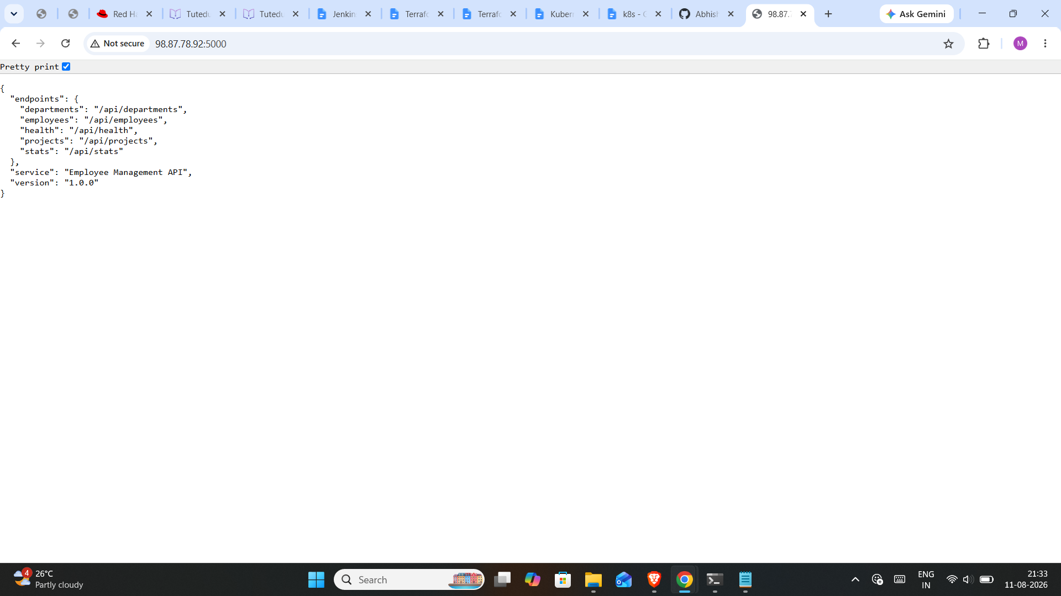
Frontend: i-001a6f526a62586fa | Public IP 52.1.164.110 | URL http://52.1.164.110:3000
Backend health:
{"service":"employee-management-api","status":"healthy","version":"1.0.0"}

Frontend dashboard (cross-instance via private IP 10.0.0.204:5000):
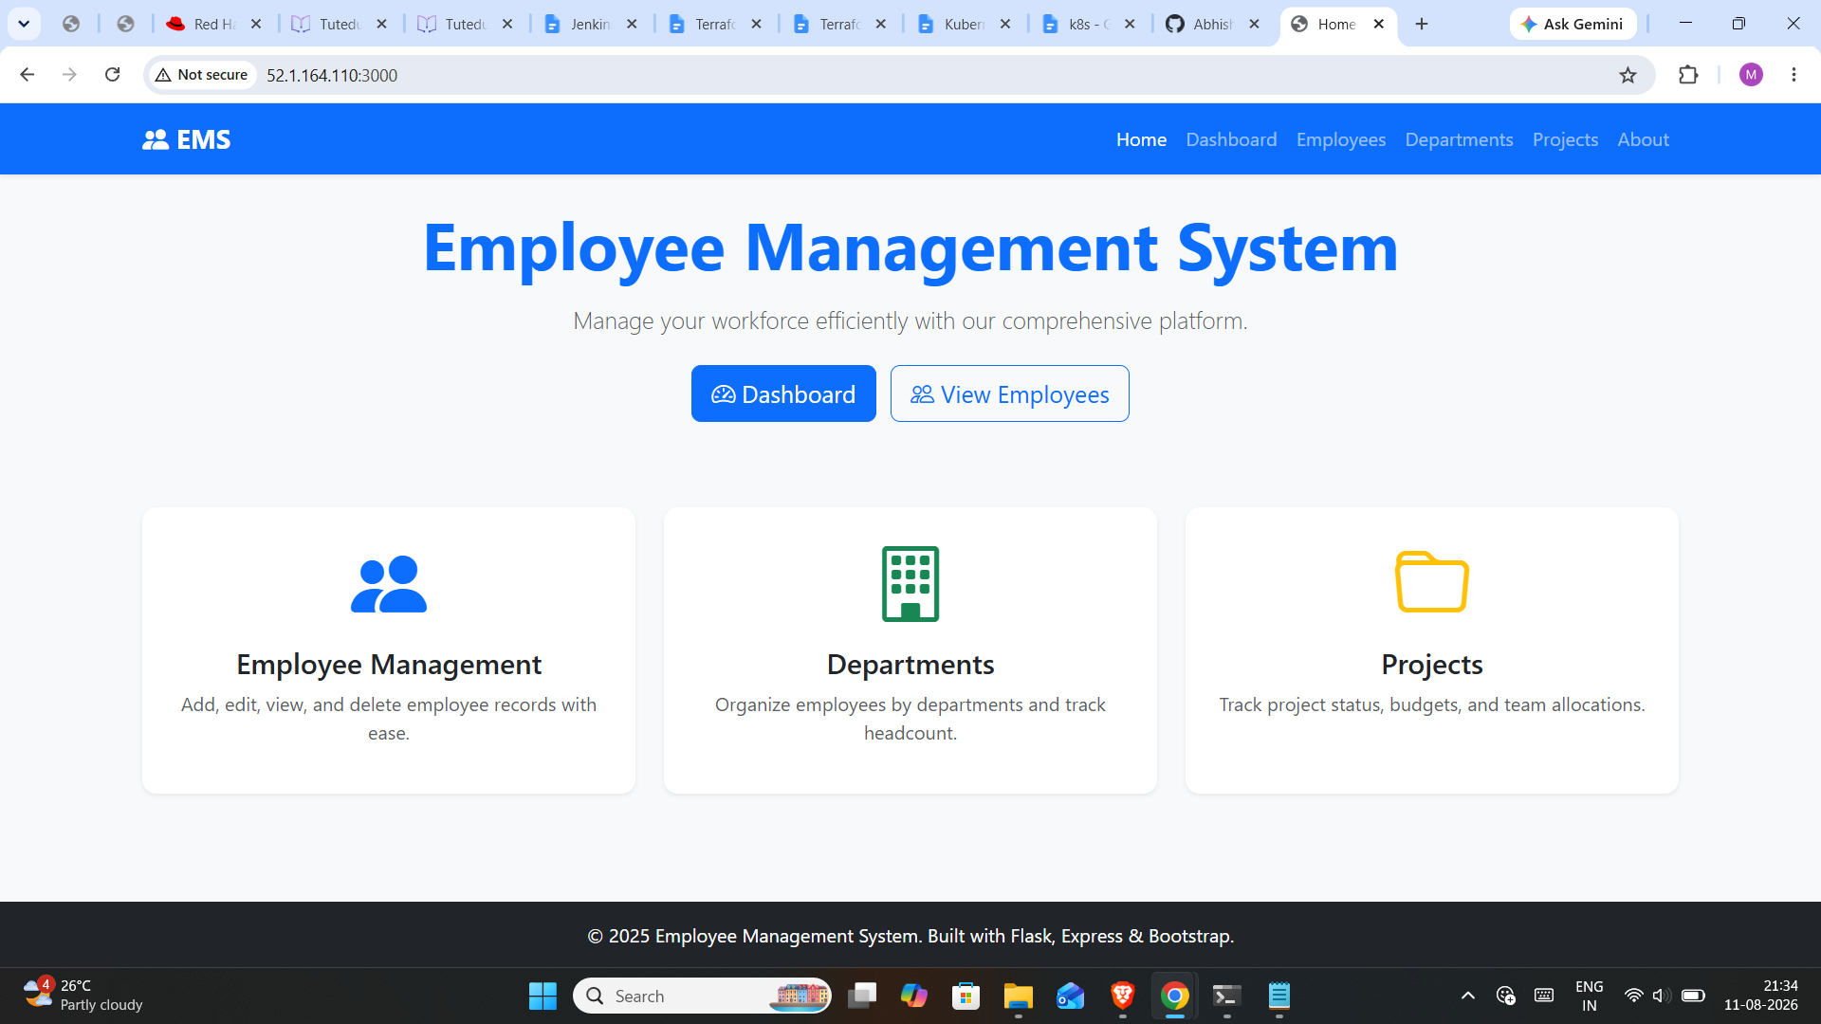
<title>Dashboard - Employee Management</title>
Frontend->backend direct private IP test:
{"service":"employee-management-api","status":"healthy","version":"1.0.0"}

=== PART 3 EVIDENCE ===
ALB DNS: employee-alb-965088500.us-east-1.elb.amazonaws.com
App URL: http://employee-alb-965088500.us-east-1.elb.amazonaws.com | API URL:
http://employee-alb-965088500.us-east-1.elb.amazonaws.com/api/health
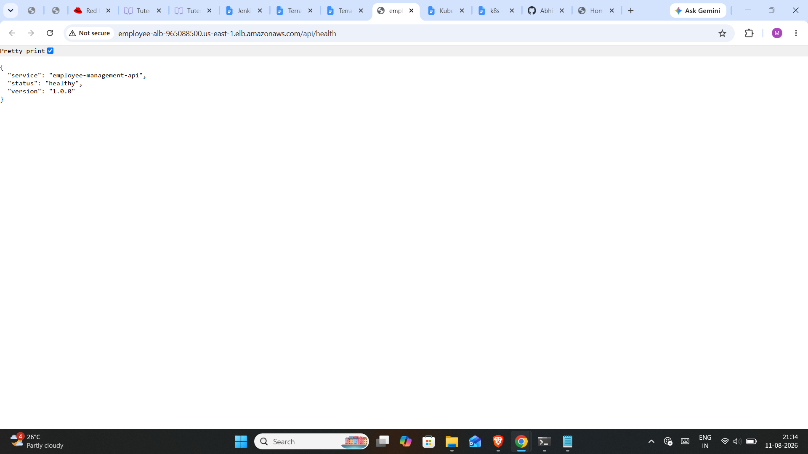

ECR backend: 883765745699.dkr.ecr.us-east-1.amazonaws.com/employee-backend:latest
ECR frontend: 883765745699.dkr.ecr.us-east-1.amazonaws.com/employee-frontend:latest
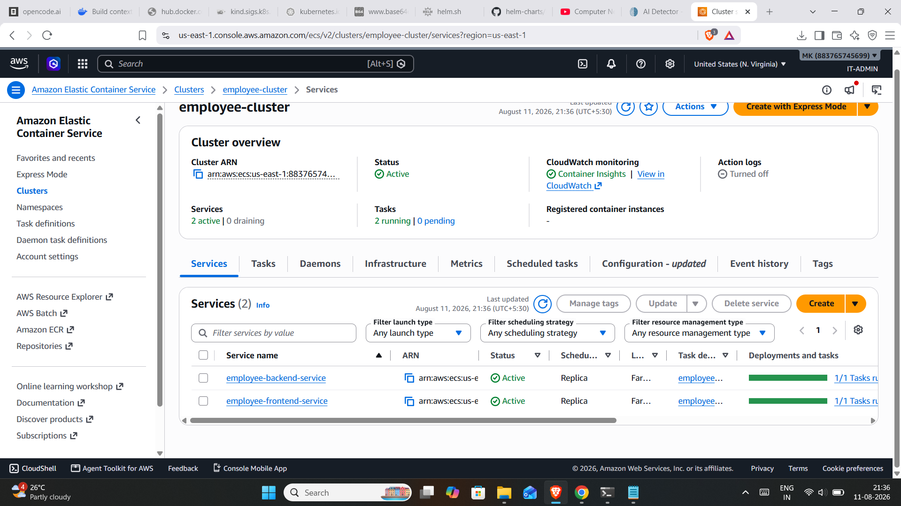

ECS cluster: employee-cluster (Fargate)
--- ALB frontend page:
<title>Home - Employee Management</title>
--- ALB API health:
{"service":"employee-management-api","status":"healthy","version":"1.0.0"}

--- ALB create+list (full loop):
create HTTP 201
3 employees

git hub: https://github.com/AbhishekDesaii/employee-management-aws.git

