1. Deploy your previous assignment flask frontend and express backend in kubernetes cluster locally with minikube.
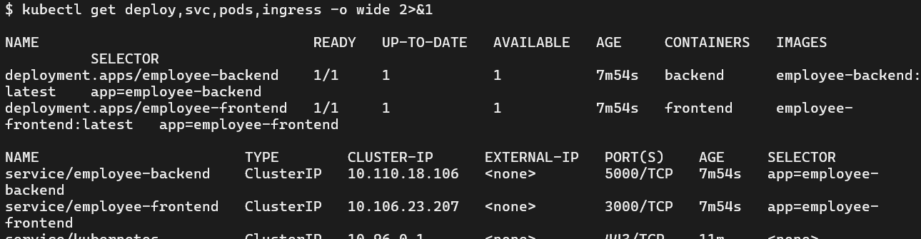
Frontend:
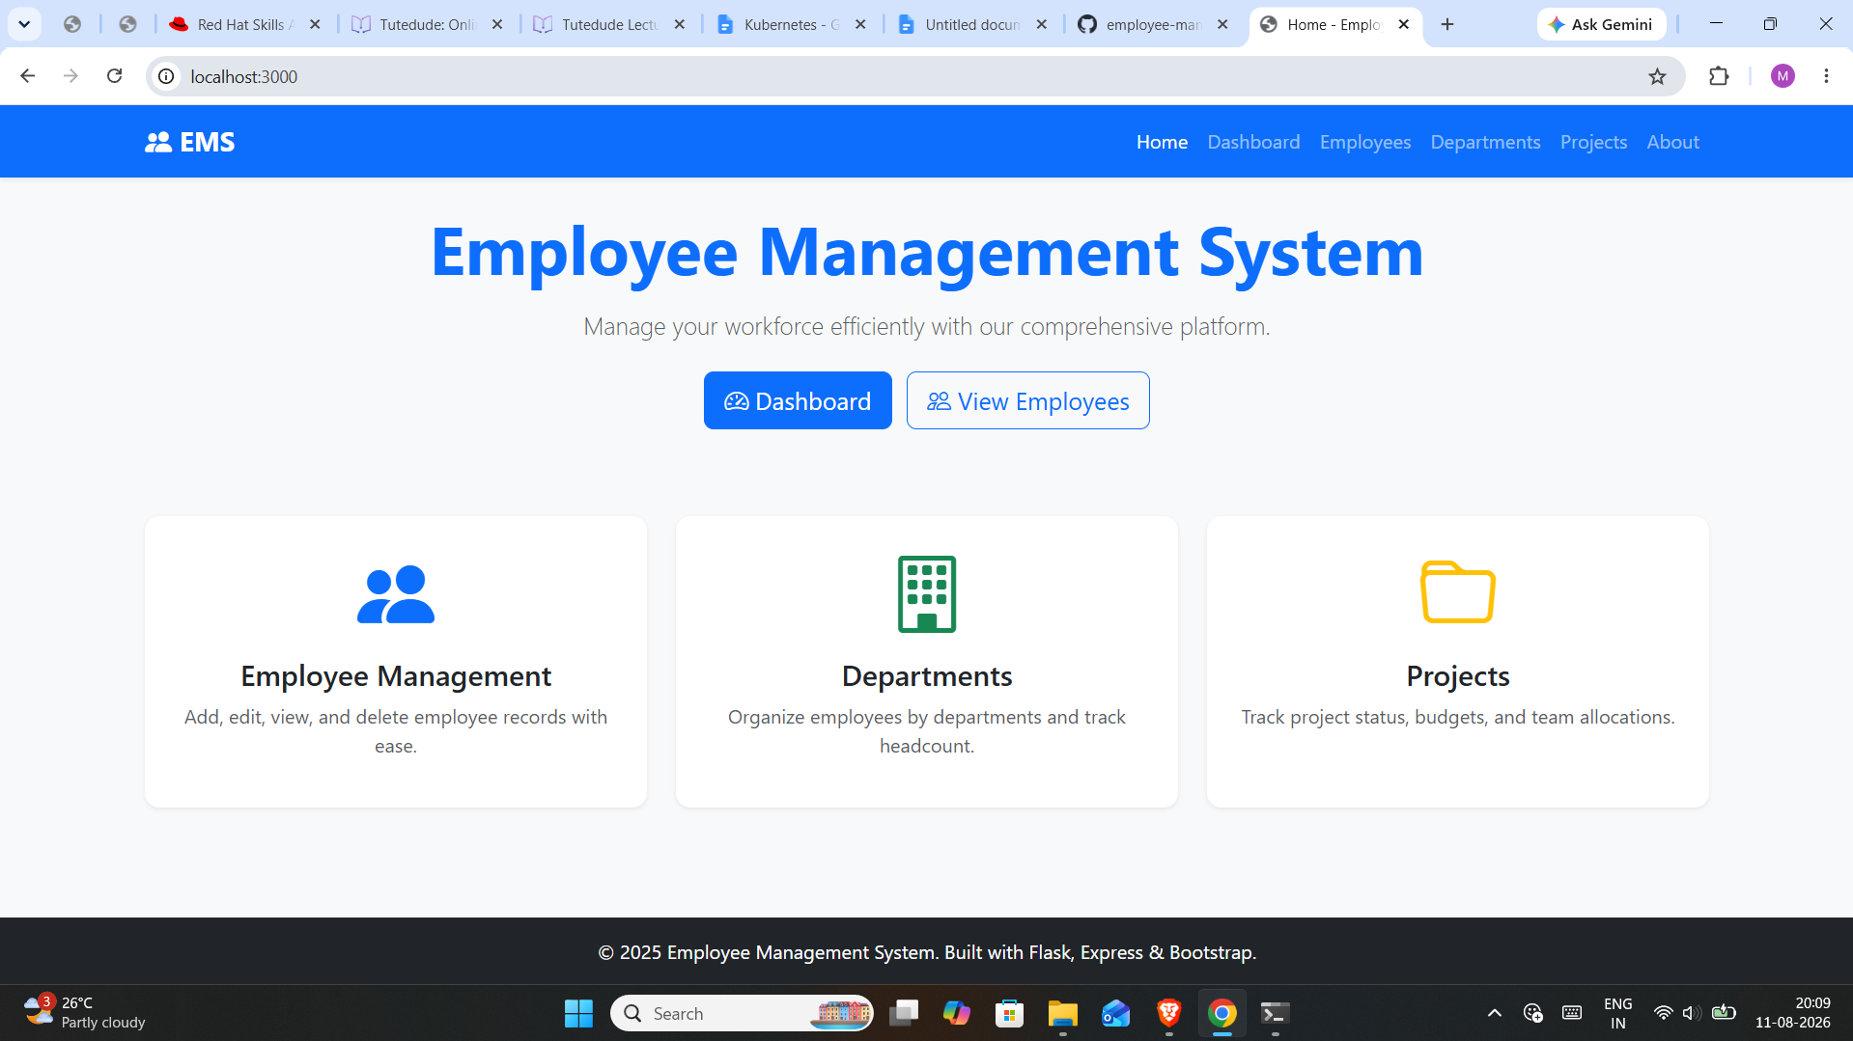

Backend:
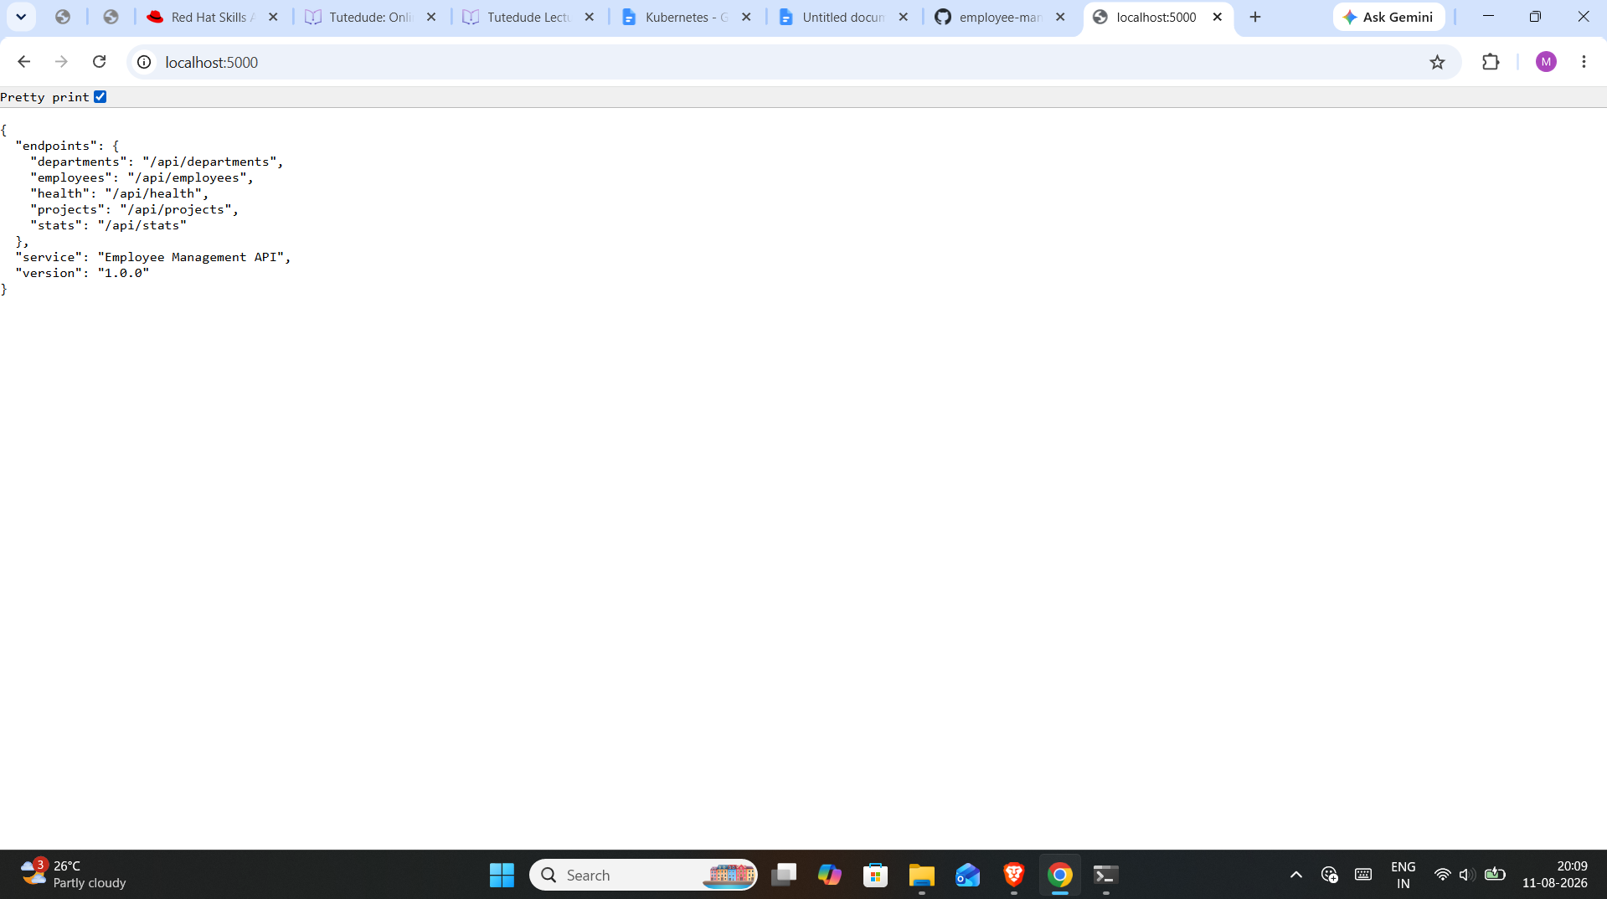
GitHub link:
https://github.com/AbhishekDesaii/employee-management-aws.git

