Linux-Assignment-2

What will the following commands do?

1. echo “Hello, world!”

Answer: echo command prints the text provided to it , Hello, world will display on the screen.

1. Name= “Productive”

Answer: It creates the variable name as “Name” and store the “Productive” in it .

We can use echo $name to access the string.

1. touch file.txt

Answer: It is used to create new or empty file. If there is no file named file.txt in the current directory, the touch command will create an empty file with that name.

1. ls -a

Answer: This command is used to list all directories and files including hidden file .

1. rm file.txt

Answer: rm means remove or delete the directories or files permanently.

1. cp file1.txt file2.txt

Answer: The cp command copies files or directories. Here, it will create a new file called file2.txt with the same contents as file1.txt. If file2.txt already exists, it will be overwritten.

1. mv file.txt /path/to/directory/

Answer: It is a command that allows you to move file.txt from its current location to a different directory on your system.

1. chmod 755 script.sh

Answer: Changes the permissions of the file script.sh.

Owner: Read, write, and execute (4+2+1=7). rwx

Group: Read and execute (4+1=5). r-x

Other: Read and execute (4+1=5). r-x

The owner can read, write, and execute the script, while others can only read and execute it.

1. grep "pattern" file.txt

Answer: Searches for the specified “pattern” within file.txt. Prints all lines in file.txt that contain the “pattern”.

1. kill PID

Answer: Sends a signal to terminate the process with the given PID.

1. mkdir mydir && cd mydir && touch file.txt && echo "Hello, World!" > file.txt && cat file.txt

Answer: 1. mkdir : It will creates a directory name mydir.

2. cd mydir : changes to mydir directory.

3. touch file.txt : Creates an empty file named file.txt.

4. echo “hello, World!” > file.txt : Writes hello world into file.txt.

5. cat file.txt : Display the contents of file.txt.

1. ls -l | grep ".txt"

Answer: ls -l : Lists all files and directories with detailed information.

grep “.txt”: Filters the output to show only files with a .txt extension.

Lists all .txt files in the current directory with detailed information.

1. cat file1.txt file2.txt | sort | uniq

Answer: file1.txt and file2.txt will merge the contents of file.

sort : Sorts the combined output.

Uniq : Filters out duplicate lines.

1. ls -l | grep “^d”

Answer: The grep "^d" command extracts lines where the first character is d, which represents directories in the output of ls -l. It will show all the directory in the screen.

1. grep -r "pattern" /path/to/directory/ explain with example

Answer: Eg: grep -r "Abhishek" /home/cdac/LINUXA

SSIGNMENT In this command the string Abhishek will be searched in all the directory or .txt file.

1. cat file1.txt file2.txt | sort | uniq –d

Answer: cat file1.txt file2.txt : Merge the contents of file1 and file2

Sort : Sorts the combined lines alphabetically.

Uniq -d : It will print only duplicate words.

1. chmod 644 file.txt

Answer: Sets the file's permissions so the owner can read and write it, while everyone else can only read it.

6(rw-) : The owner can read and write the file.

4(r--) : the group can read the file.

4(r--) : And other can read the file.

1. cp -r source_directory destination_directory

Answer: cp : To copy command , -r : It is used to copy directories recursively, meaning it will copy not only the directory itself but also all of its contents, including subdirectories and files within them.

source_directory : The directory you want to copy.

destination_directory : The location where you want to copy the contants.

This commands is commonly used when you need to make a backup of a directory or move a directory to a new location while preserving its structure.

1. find /home/user/documents -name "*.txt"

Answer: This commands is use to list all the .txt file on the console/screen .

1. chmod u+x file.txt

Answer: This command is used to give permission to execute the file to the user(owner).

1. echo $PATH

Answer: echo : this command is used to display text or the value of a variable in the terminal.

$PATH: Display all the path of your system like the below example :

/usr/local/sbin:/usr/local/bin:/usr/sbin:/usr/bin:/sbin:/bin:/usr/games:/usr/local/games:/usr/lib/wsl/lib:/mnt/c/Program Files/Eclipse Adoptium/jdk-17.0.12.7-hotspot/bin:/mnt/c/Windows/system32:/mnt/c/Windows:/mnt/c/Windows/System32/Wbem:/mnt/c/Windows/System32/WindowsPowerShell/v1.0/

Part B

Identify True or False:

1. ls is used to list files and directories in a directory.

Answer : True

2. mv is used to move files and directories.

Answer : True

3. cd is used to copy files and directories.

Answer : False : “ cp” is used to copy file and directories and “cd” is used to change the current directory

4. pwd stands for "print working directory" and displays the current directory.

Answer : True

5. grep is used to search for patterns in files.

Answer : True

6. chmod 755 file.txt gives read, write, and execute permissions to the owner, and read and execute permissions to group and others.

Answer : True

7. mkdir -p directory1/directory2 creates nested directories, creating directory2 inside directory1 if directory1 does not exist.

Answer : True

8. rm -rf file.txt deletes a file forcefully without confirmation.

Answer : True

Identify the Incorrect Commands:

1. chmodx is used to change file permissions.

Answer : Is incorrect. The correct command to change file permissions is chmod

2. cpy is used to copy files and directories.

Answer : Is incorrect.

The correct command to copy files and directories is cp.

3. mkfile is used to create a new file.

Answer : Is Incorrect.

touch is used to create the new file

4. catx is used to concatenate files.

Answer : Is Incorrect.

Cat is used to concatenate files and display file.

5. rn is used to rename files.

Answer : Is Incorrect.

mv is used to rename the file.

**Part C**

Question 1: Write a shell script that prints "Hello, World!" to the terminal.

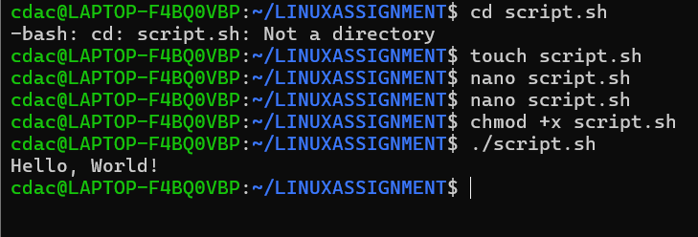

Question 2: Declare a variable named "name" and assign the value "CDAC Mumbai" to it. Print the value of the variable.

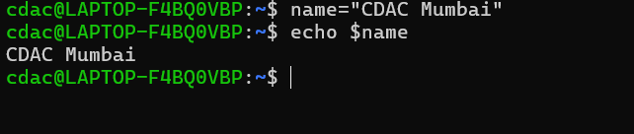

Question 3: Write a shell script that takes a number as input from the user and prints it.

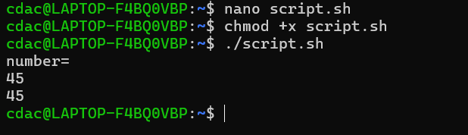

Question 4: Write a shell script that performs addition of two numbers (e.g., 5 and 3) and prints the result.

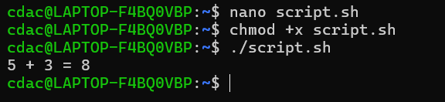

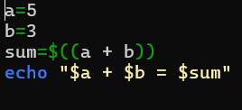

Question 5: Write a shell script that takes a number as input and prints "Even" if it is even, otherwise prints "Odd".

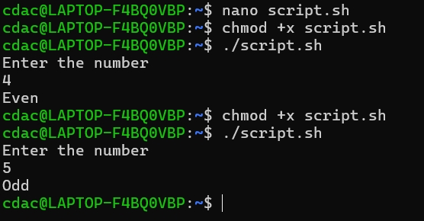

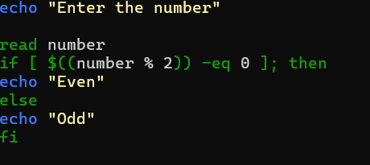

Question 6: Write a shell script that uses a for loop to print numbers from 1 to 5.

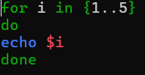

Question 7: Write a shell script that uses a while loop to print numbers from 1 to 5.

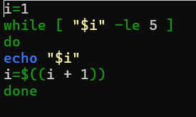

Question 8: Write a shell script that checks if a file named "file.txt" exists in the current directory. If it does, print "File exists", otherwise, print "File does not exist".

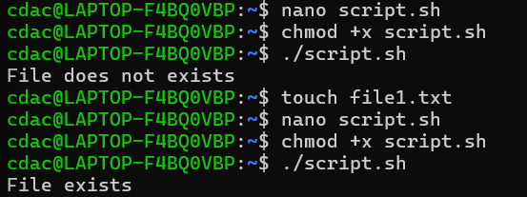

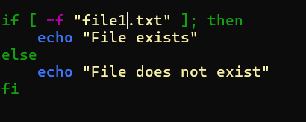

Question 9: Write a shell script that uses the if statement to check if a number is greater than 10 and prints a message accordingly.

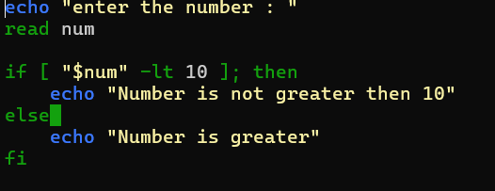

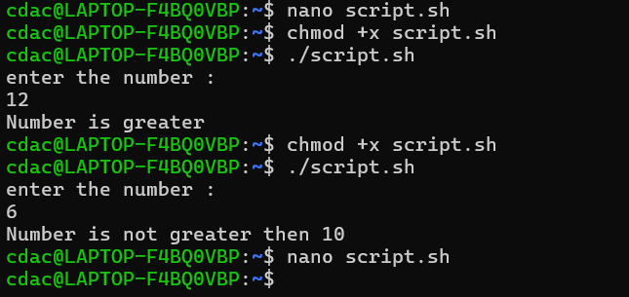

Question 10: Write a shell script that uses nested for loops to print a multiplication table for numbers from 1 to 5. The output should be formatted nicely, with each row representing a number and each column representing the multiplication result for that number.

