Single task code:

#include <stdio.h>
#include <time.h>
#include <pthread.h>

#define SIZE 10000000

int data[SIZE];

//data generation
void generate_data() {
for (int i = 0; i < SIZE; i++) {
data[i] = i % 10;
}
}

//sinle task function
void* single_task_operations(void* arg) {

long long sum = 0;
long long product = 1;
long long count_gt_5 = 0;
const long long MOD = 1000000007;

int min = data[0];

for (int i = 0; i < SIZE; i++) {

sum += data[i]; //sum

//multiplication
if (data[i] != 0)
product = (product * data[i]) % MOD;

//minimum
if (data[i] < min)
min = data[i];

//count>5
if (data[i] > 5)
count_gt_5++;
}

//average
double avg = (double)sum / SIZE;

printf("Task 1 Sum = %lld\n", sum);
printf("Task 2 Product (mod) = %lld\n", product);
printf("Task 3 Average = %.2f\n", avg);
printf("Task 4 Minimum = %d\n", min);
printf("Task 5 Count > 5 = %lld\n", count_gt_5);

return NULL;
}

int main() {

struct timespec start, end;
pthread_t t1;

generate_data();
printf("Single Task \n");

clock_gettime(CLOCK_MONOTONIC, &start);

pthread_create(&t1, NULL, single_task_operations, NULL);
pthread_join(t1, NULL);

clock_gettime(CLOCK_MONOTONIC, &end);

double time_taken =
(end.tv_sec - start.tv_sec) +
(end.tv_nsec - start.tv_nsec) / 1e9;

printf("Total Execution Time = %.4f seconds\n", time_taken);

return 0;
}

Multiple task code:

#include <stdio.h>
#include <pthread.h>
#include <time.h>

#define SIZE 10000000

int data[SIZE];

//data generation
void generate_data() {
for (int i = 0; i < SIZE; i++) {
data[i] = i % 10;
}
}

//task1 sum
void* task_sum(void* arg) {
long long sum = 0;
for (int i = 0; i < SIZE; i++)
sum += data[i];

printf("Task 1 (Sum) = %lld\n", sum);
return NULL;
}

//task2 multiplication
void* task_mul(void* arg) {
long long mul = 1;
const long long MOD = 1000000007;

for (int i = 0; i < SIZE; i++) {
if (data[i] != 0)
mul = (mul * data[i]) % MOD;
}

printf("Task 2 (Multiplication) = %lld\n", mul);
return NULL;
}

//task3 average
void* task_avg(void* arg) {
long long sum = 0;
for (int i = 0; i < SIZE; i++)
sum += data[i];

printf("Task 3 (Average) = %.2f\n", (double)sum / SIZE);
return NULL;
}

//task4 minimum
void* task_min(void* arg) {
int min = data[0];
for (int i = 1; i < SIZE; i++) {
if (data[i] < min)
min = data[i];
}

printf("Task 4 (Minimum) = %d\n", min);
return NULL;
}

//task5 count>5
void* task_count(void* arg) {
long long count = 0;
for (int i = 0; i < SIZE; i++) {
if (data[i] > 5)
count++;
}

printf("Task 5 (Count > 5) = %lld\n", count);
return NULL;
}

int main() {
pthread_t t1, t2, t3, t4, t5;
struct timespec start, end;

generate_data();

printf("Starting MULTI-TASK execution...\n");

clock_gettime(CLOCK_MONOTONIC, &start);

pthread_create(&t1, NULL, task_sum, NULL);
pthread_create(&t2, NULL, task_mul, NULL);
pthread_create(&t3, NULL, task_avg, NULL);
pthread_create(&t4, NULL, task_min, NULL);
pthread_create(&t5, NULL, task_count, NULL);

pthread_join(t1, NULL);
pthread_join(t2, NULL);
pthread_join(t3, NULL);
pthread_join(t4, NULL);
pthread_join(t5, NULL);

clock_gettime(CLOCK_MONOTONIC, &end);

double total_time =
(end.tv_sec - start.tv_sec) +
(end.tv_nsec - start.tv_nsec) / 1e9;

printf("\nTotal Execution Time = %.4f seconds\n", total_time);

return 0;
}

Output:
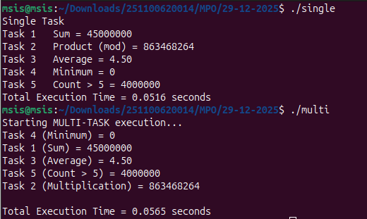
Observation:

There are 5 tasks, the large array of data is given to all tasks, the tasks are
Task1 - sum of array
Task2 - multiplication of array (modulo)
Task3 - average value of array
Task4 – minimum value of array
Task5 – count the element greater then 5 in an array

In single task execution i created single pthread and it will wait for each task to complete. The total time for execution is 0.0516 seconds.

In multitask execution i created 5 pthreads and run it parallelly. The total time for execution is 0.0565 seconds.

Here multitask takes more time then single task cause thread creation and synchronization add overhead, all threads access same data, single task uses one loop and it gives better cache locality.

