Program for single threaded execution:
#include <stdio.h>
#include <stdlib.h>
#include <time.h>

#define SIZE 100000000 // Large data value

long long sum = 0;
int data[SIZE];

// Custom function to generate data without rand()
void generate_data() {
for (int i = 0; i < SIZE; i++) {
data[i] = i % 10;
}
}

// Task 1: Sum the entire array
long long task1() {
long long local_sum = 0;
for (int i = 0; i < SIZE; i++) {
local_sum += data[i];
}
return local_sum;
}

// Task 2: Count occurrences of even numbers in the array
long long task2() {
long long even_count = 0;
for (int i = 0; i < SIZE; i++) {
if (data[i] % 2 == 0) {
even_count++;
}
}
return even_count;
}

// Task 3: Calculate the product of all elements (modulo 1000000007)
long long task3() {
long long product = 1;
const long long MOD = 1000000007;
for (int i = 0; i < SIZE; i++) {
if (data[i] != 0) {
product = (product * data[i]) % MOD;
}
}
return product;
}

// Task 4: Find the maximum value in the array
int task4() {
int max_value = data[0];
for (int i = 1; i < SIZE; i++) {
if (data[i] > max_value) {
max_value = data[i];
}
}
return max_value;
}

// Task 5: Find the sum of odd indexed elements
long long task5() {
long long odd_sum = 0;
for (int i = 1; i < SIZE; i += 2) {
odd_sum += data[i];
}
return odd_sum;
}

void perform_task(int task_id) {
long long result;
switch (task_id) {
case 1:
result = task1();
printf("Task %d completed. Sum: %lld\n", task_id, result);
break;
case 2:
result = task2();
printf("Task %d completed. Even count: %lld\n", task_id, result);
break;
case 3:
result = task3();
printf("Task %d completed. Product: %lld\n", task_id, result);
break;
case 4:
result = task4();
printf("Task %d completed. Max value: %d\n", task_id, result);
break;
case 5:
result = task5();
printf("Task %d completed. Odd indexed sum: %lld\n", task_id, result);
break;
}
}

int main() {
struct timespec start, end;
generate_data();

printf("Starting 5 Sequential Tasks...\n");
clock_gettime(CLOCK_MONOTONIC, &start);

for (int i = 1; i <= 5; i++) {
perform_task(i);
}

clock_gettime(CLOCK_MONOTONIC, &end);
double time_taken = (end.tv_sec - start.tv_sec) + (end.tv_nsec - start.tv_nsec) / 1e9;

printf("\nTotal Sequential Time: %.4f seconds\n", time_taken);
return 0;
}

Program for multithreaded execution:
#include <stdio.h>
#include <stdlib.h>
#include <pthread.h>
#include <time.h>

#define SIZE 100000000
int data[SIZE];

// Custom function to generate data without rand()
void generate_data() {
for (int i = 0; i < SIZE; i++) {
data[i] = i % 10;
}
}

// Task 1: Sum the entire array
long long task1() {
long long local_sum = 0;
for (int i = 0; i < SIZE; i++) {
local_sum += data[i];
}
return local_sum;
}

// Task 2: Count occurrences of even numbers in the array
long long task2() {
long long even_count = 0;
for (int i = 0; i < SIZE; i++) {
if (data[i] % 2 == 0) {
even_count++;
}
}
return even_count;
}

// Task 3: Calculate the product of all elements
long long task3() {
long long product = 1;
const long long MOD = 1000000007;
for (int i = 0; i < SIZE; i++) {
if (data[i] != 0) { // Only multiply if the value is not zero
product = (product * data[i]) % MOD;
}
}
return product;
}

// Task 4: Find the maximum value in the array
int task4() {
int max_value = data[0];
for (int i = 1; i < SIZE; i++) {
if (data[i] > max_value) {
max_value = data[i];
}
}
return max_value;
}

// Task 5: Find the sum of odd indexed elements
long long task5() {
long long odd_sum = 0;
for (int i = 1; i < SIZE; i += 2) {
odd_sum += data[i];
}
return odd_sum;
}

void* thread_task(void* arg) {
int id = *((int*)arg);
long long result;
switch (id) {
case 1:
result = task1();
printf("Thread %d completed. Sum: %lld\n", id, result);
break;
case 2:
result = task2();
printf("Thread %d completed. Even count: %lld\n", id, result);
break;
case 3:
result = task3();
printf("Thread %d completed. Product: %lld\n", id, result);
break;
case 4:
result = task4();
printf("Thread %d completed. Max value: %d\n", id, result);
break;
case 5:
result = task5();
printf("Thread %d completed. Odd indexed sum: %lld\n", id, result);
break;
}
return NULL;
}

int main() {
pthread_t threads[5];
int thread_ids[5];
struct timespec start, end;

generate_data();

printf("Starting 5 Parallel Threads...\n");
clock_gettime(CLOCK_MONOTONIC, &start);

for (int i = 0; i < 5; i++) {
thread_ids[i] = i + 1;
pthread_create(&threads[i], NULL, thread_task, &thread_ids[i]);
}

for (int i = 0; i < 5; i++) {
pthread_join(threads[i], NULL);
}

clock_gettime(CLOCK_MONOTONIC, &end);
double time_taken = (end.tv_sec - start.tv_sec) + (end.tv_nsec - start.tv_nsec) / 1e9;

printf("\nTotal Multitasked Time: %.4f seconds\n", time_taken);
return 0;
}

Result

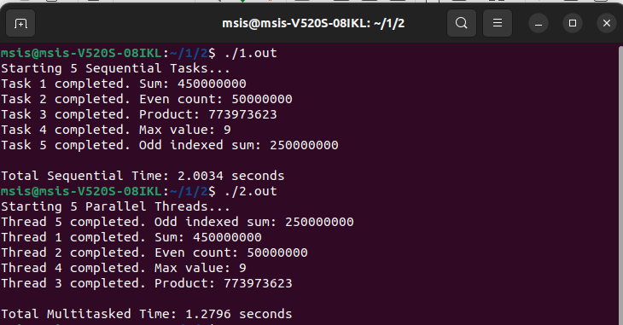
Observation

There are 5 task that are running. The tasks are
Firstly it create a long array data .
Task 1: Sum the entire array
Task 2: Count occurrences of even numbers in the array.
Task 3: Calculate the product of all elements (modulo 1000000007).
Task 4: Find the maximum value in the array.
Task 5: Find the sum of odd indexed elements.

Initially the task is performed sequentially one by one. The time taken by the program for execution is Total Sequential Time: 2.0034 seconds.

Next Created a multithread program using pthread_create and executed parallaly. The time taken for program execution is Total Multitasked Time: 1.2796 seconds.

The conclution of the program is multithreading reduces the execution time. The task that are shorter can finish first. Since it increases the throughput.

