1. Write a multithreaded program to multiply every element of a large array by a constant value. Create four threads and print the thread number for each multiplication performed.

#include <stdio.h>
#include <pthread.h>

#define SIZE 10000000 // 10 million
#define THREADS 4

int arr[SIZE];
int constant = 3;

void* multiply(void* arg) {
int thread_no = *(int*)arg;

int start = thread_no * (SIZE / THREADS);
int end = (thread_no + 1) * (SIZE / THREADS);

printf("Thread %d working on indexes %d to %d\n",
thread_no + 1, start, end - 1);

for (int i = start; i < end; i++) {
arr[i] *= constant;

}
return NULL;
}

int main() {
pthread_t t[THREADS];
int thread_no[THREADS];

// Initialize array
for (int i = 0; i < SIZE; i++) {
arr[i] = i;
}

for (int i = 0; i < THREADS; i++) {
thread_no[i] = i;
pthread_create(&t[i], NULL, multiply, &thread_no[i]);
}

for (int i = 0; i < THREADS; i++) {
pthread_join(t[i], NULL);
}

printf("\nAll threads completed.\n");
return 0;
}
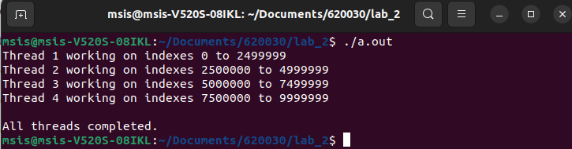
2. Write a multithreaded program to add two large arrays. Create four threads and print the thread number for every computation carried out.

#include <stdio.h>
#include <pthread.h>

#define SIZE 9000000 // 9 million elements
#define THREADS 3

int A[SIZE], B[SIZE], C[SIZE];

void* add(void* arg) {
int thread_no = *(int*)arg;

int start = thread_no * (SIZE / THREADS);
int end = (thread_no + 1) * (SIZE / THREADS);

printf("Thread %d adding indexes %d to %d\n",
thread_no + 1, start, end - 1);

for (int i = start; i < end; i++) {
C[i] = A[i] + B[i];

}

return NULL;
}

int main() {
pthread_t t[THREADS];
int thread_no[THREADS];

// Initialize arrays
for (int i = 0; i < SIZE; i++) {
A[i] = i;
B[i] = SIZE - i;
}

// Create threads
for (int i = 0; i < THREADS; i++) {
thread_no[i] = i;
pthread_create(&t[i], NULL, add, &thread_no[i]);
}

// Wait for threads
for (int i = 0; i < THREADS; i++) {
pthread_join(t[i], NULL);
}
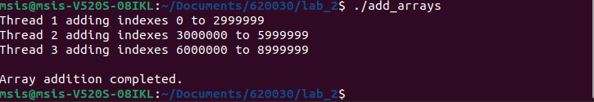

3. Create two separate functions, one for adding two arrays and another for multiplying two arrays. Write a program that executes these two functions using two separate threads.

#include <stdio.h>
#include <pthread.h>

#define SIZE 6000000 // Large array size

int A[SIZE], B[SIZE], C[SIZE], D[SIZE];

void* add_array(void* arg) {
printf("Add thread started\n");

for (int i = 0; i < SIZE; i++) {
C[i] = A[i] + B[i];

}

printf("Add thread finished\n");
return NULL;
}

void* multiply_array(void* arg) {
printf("Multiply thread started\n");

for (int i = 0; i < SIZE; i++) {
D[i] = A[i] * B[i];

// Print first few indexes only
if (i < 3) {
printf("Multiply thread computed index %d\n", i);
}
}

printf("Multiply thread finished\n");
return NULL;
}

int main() {
pthread_t t1, t2;

// Initialize arrays
for (int i = 0; i < SIZE; i++) {
A[i] = i;
B[i] = SIZE - i;
}

// Create threads
pthread_create(&t1, NULL, add_array, NULL);
pthread_create(&t2, NULL, multiply_array, NULL);

// Wait for threads to complete
pthread_join(t1, NULL);
pthread_join(t2, NULL);

printf("\nBoth operations completed.\n");
return 0;
}

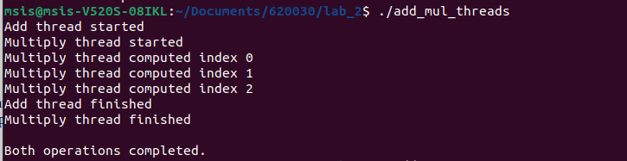

4. Write a multithreaded program to multiply every element of a large array by a constant value such that:

Even-numbered threads multiply elements at even indices

Odd-numbered threads multiply elements at odd indices

(Assume array indexing starts from 0.)

#include <stdio.h>
#include <pthread.h>

#define SIZE 10000000 // 10 million elements
int arr[SIZE];
int constant = 5;

void* multiply_even(void* arg) {
int start = 0; // even indexes
int end = SIZE - 1; // last index

printf("Even thread multiplying indexes 0 to %d\n", SIZE - 1);

for (int i = start; i < SIZE; i += 2) {
arr[i] *= constant;
}

printf("Even thread finished\n");
return NULL;
}

void* multiply_odd(void* arg) {
int start = 1; // odd indexes
int end = SIZE - 1;

printf("Odd thread multiplying indexes 1 to %d\n", SIZE - 1);

for (int i = start; i < SIZE; i += 2) {
arr[i] *= constant;
}

printf("Odd thread finished\n");
return NULL;
}

int main() {
pthread_t even_thread, odd_thread;

// Initialize array
for (int i = 0; i < SIZE; i++) {
arr[i] = i + 1;
}

// Create threads
pthread_create(&even_thread, NULL, multiply_even, NULL);
pthread_create(&odd_thread, NULL, multiply_odd, NULL);

// Wait for threads to finish
pthread_join(even_thread, NULL);
pthread_join(odd_thread, NULL);

printf("\nMultiplication completed for large array.\n");

return 0;
}

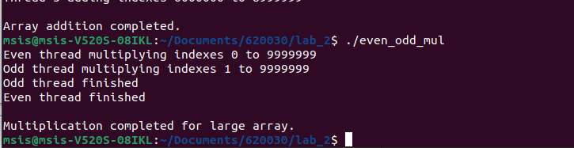

5. Write a program that accepts two numbers from the user, num1 and num2. The program should list all numbers between 0 and num2 that are divisible by num1 using multithreading.

#include <stdio.h>
#include <stdlib.h>

int main() {
long long num1, num2;

// Input two numbers
printf("Enter the first number (size of array): ");
scanf("%lld", &num1);
printf("Enter the second number (divisor): ");
scanf("%lld", &num2);

// Allocate array dynamically (large array)
long long *arr = (long long*) malloc(num1 * sizeof(long long));
if (arr == NULL) {
printf("Memory allocation failed!\n");
return 1;
}

// Initialize array
for (long long i = 0; i < num1; i++) {
arr[i] = i;
}

printf("Numbers divisible by %lld:\n", num2);
for (long long i = 0; i < num1; i++) {
if (arr[i] % num2 == 0) {
printf("%lld ", arr[i]);
}
}

printf("\n");

free(arr); // free allocated memory
return 0;
}

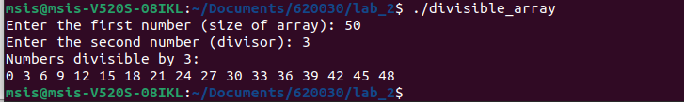

Observation:

- In the first program i taken large data and created four threads and each threads multiplied different element by a constant value and printed thread number.
- In the second program taken two large array and each thread performed addition on separate arrays and printed the thread number.
- In this third program there is two operation as to made adddition and multiplication on two separate threads where one thread executed addition and vice versa. Both ran concurrently
- In fourth program four threds are crated and even threads processed even indices and vice versa.
- In progrm five taken two values from user and computed where the number between 0 to num2 is divisible by num1 and printed the output.

