Accessing the ticketing system in my web browser as shown in the Fig. (a) below

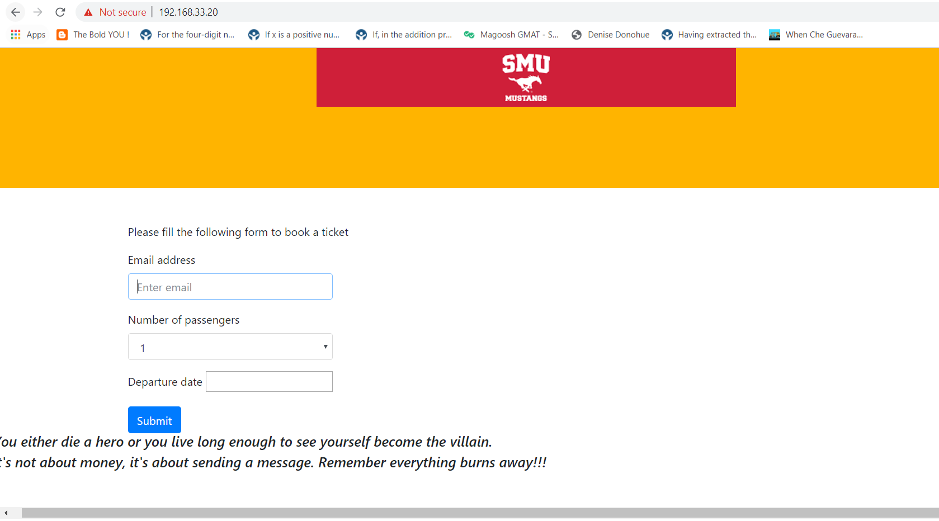

Fig. (a)

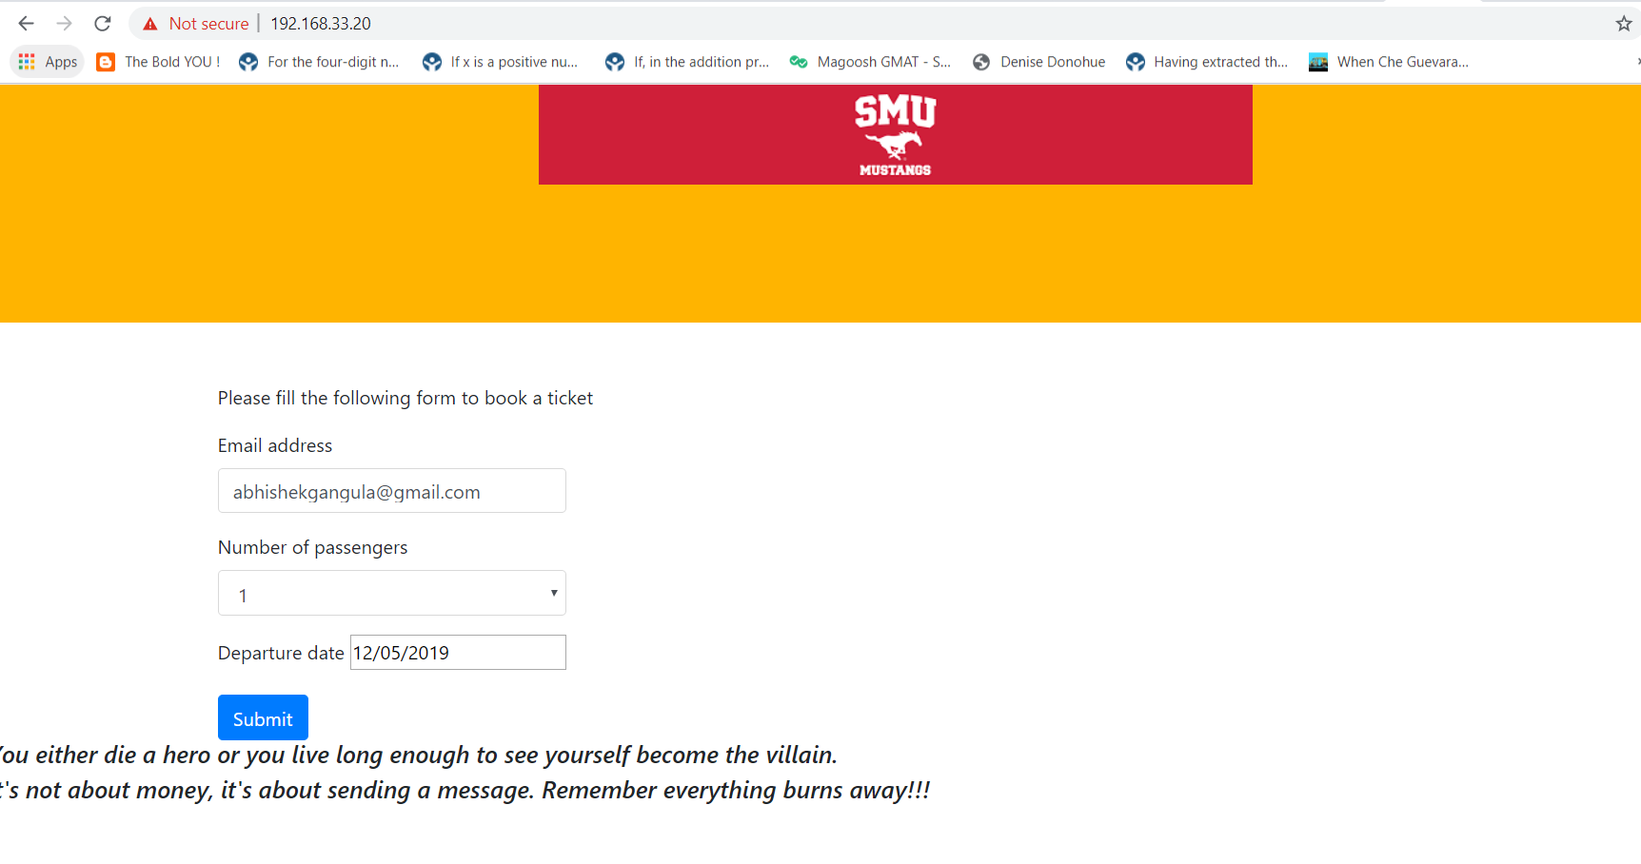

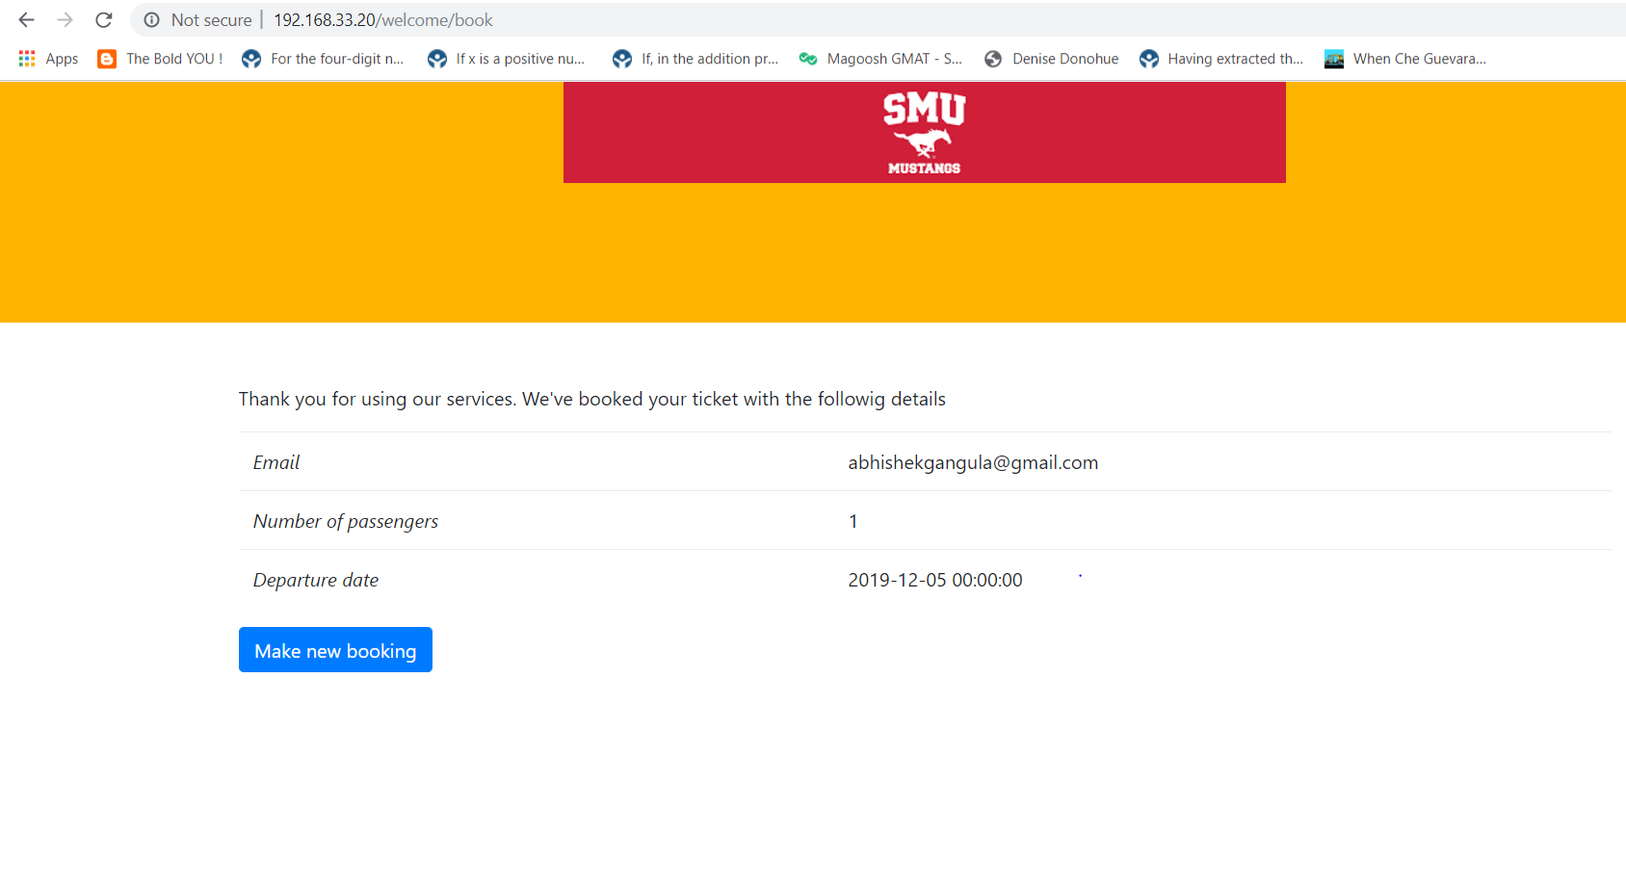

1. **What did you do in this lab?**

Firstly, I created 3 VM’s using the vagrant file and since Ansible needs a controller, I made one of them to be a controller and the other two to be the database and a frontend end web server. Using the playbooks, I configured the web server and database on these two servers.

1. **What problems did you to face in this lab?**

I had a problem while writing the playbook and I figured out later that the issue was due to the slightly different indentation in the playbook file which I got resolved.

1. **How did you solve this problem?**

The “tasks” line was not exactly below the “name” which I got to learn later and fixed it.

1. **What aspects of the lab were unclear?**

All the lab aspects were clear and understood.