



Essay / Assignment Title: Exploring Artificial Intelligence Trends Across Sectors through Tableau Visualizations.

Programme title: MSc Data Analytics

Name: Abhishek Garg

Year: 2025 - 2026

CONTENTS

Table of Contents
CONTENTS 2
ABSTRACT 4
1. INTRODUCTION 5
2. LITERATURE REVIEW 6
3. METHODOLOGY 7
4. EVALUATION & FINDINGS 10
5. REFLECTION ON AI IMPACT 13
CONCLUDING REMARKS 14
BIBLIOGRAPHY 15
APPENDIX 16

Statement of compliance with academic ethics and the avoidance of plagiarism

I honestly declare that this dissertation is entirely my own work and none of its part has been copied from printed or electronic sources, translated from foreign sources and reproduced from essays of other researchers or students. Wherever I have been based on ideas or other people texts I clearly declare it through the good use of references following academic ethics.
(In the case that is proved that part of the essay does not constitute an original work, but a copy of an already published essay or from another source, the student will be expelled permanently from the program).

Name and Surname: ABHISHEK GARG
Date: 06/02/2026

ABSTRACT

This paper will analyze the trends in artificial intelligence investment around the world and in sectors in the last five years (2018-2024) through interactive visualization tools in Tableau. The study of three integrated data sets, such as AI investment data of 25 and more focal areas, OECD sectoral adoption data, and Eurostat regional data indicates that cumulative AI investment has reached up to 340.8 billion, but still, organizations have adopted it only up to 16.6. The infrastructure category, at 45% of 2024 totals ($37 billion), is the most dominant, but fields relating to applications such as robotics exhibit explosive year-over-year growth (1,600%). Information and communication industry holds the first position in terms of adoption, then comes the Finance and Insurance; traditional industries are far behind. The Python-based data preprocessing allowed processing challenges with the Eurostat TSV complex structure, whereas interactive dashboards and year parameter, calculated field, and geographic heatmap features of Tableau allowed finding patterns. The results show that AI is moving to the early majority stage, and the number of significant implementation gaps between investment and deployment is large because of the need of infrastructure, the lack of talent and the complexity of change in the organization. The methodology based on visualization was fundamental to the exposure of inverse correlations between the amount of investment and the rate of expansion, sector trends, and geographic clustering patterns that mere data cannot display.

INTRODUCTION

Artificial Intelligence has evolved past being in the experimental phase of technology to become a strategic necessity that is transforming industries around the world. The global AI investment is expected to increase four times between 2018 and 2024, growing to billions to trillions of dollars of cumulative investment, with a previously unseen boom in the deployment of technological capital (Stanford HAI, 2024). However, even with such a huge financial investment, organizational adoption is low at 16.6 which shows a big gap between investment and operational implementation.
The paper examines the trends in AI adoption along various dimensions, including time trends, sector expansion, geographic touchpoints and geographic areas of interest and focus of investment with the aid of complex data visualization tools. The study answers three main questions: How have patterns of AI investment in various areas of application changed? Are the sectoral differences in the use of AI in organizations? What can interactive visualization tell us about the correlation between investment size and growth momentum?
The project uses Tableau to be the main tool of visualization with the addition of Excel analytics and Python-based preprocessing of the data to convert multi-dimensional multi-faceted data into actionable information that can be used by the stakeholders, such as investors, enterprises, policymakers, and technology providers.

LITERATURE REVIEW

2.1 The trends in AIs adoption and investment.
According to the recent literature, AI is being diffused in the economic sectors at a high pace. According to the OECD (2023), the adoption of AI is unevenly distributed in the enterprises with 10 or more employees based on industries, with information and communication industries showing the highest adoption rates. According to McKinsey Global Institute (2023), although 50-60 percent of organizations test AI in any of their business functions, a full-scale implementation is deficient due to gaps in data infrastructure, talent shortage, and organizational inertia.
In Stanford AI Index Report (2024), it is noted that in 2021, AI investment in the major corporations around the world was at all-time highs before declining in 2022-2023 due to market revaluation after the initial hype. The report cites infrastructure and underlying models as two major areas of investment focus, which is in line with the findings that general-purpose AI capabilities should be deployed first before applications-specific deployment.
2.2 Sectoral Differences in AI adoption.
There are heterogeneous adoption patterns in sectoral analysis. Brynjolfsson and McElheran (2016) determine that technological-intensive industries embrace digital innovations faster and more wholesomely compared to traditional industries. Financial services can be noted as highly integrative of AI due to regulatory demands, requirements to detect fraud, and algorithmic trading use (Cao, 2022). On the other hand, construction, agriculture, and traditional manufacturing have lower adoption rates because of the issue of digitization and the lack of skills among workforce (Acemoglu and Restrepo, 2020).
2.3 Data Visualization for Artificial Intelligence.
Proper visualization converts data that is complicated into information that can be accessed. Few (2012) highlights that the recognition of patterns that cannot be detected by the analysis of tabular data is made possible with the help of the following: selection of the chart, use of colors, and design of the layout. Kirk (2019) suggests interactive dashboards to enable the analysis of the data through exploration, enabling the users to dynamically filter, drill-down, and cross-reference the dimensions. Computer programs For the analysis of multidimensional AI adoption, Tableau is especially applicable due to its ability to integrate various sources of data, introduce calculative fields and develop geographic images (Murray, 2017).

METHODOLOGY

3.1 Data Sources
Three major datasets were used to conduct this analysis:
- AI Investment Data (AI_Investment.csv): This is the data on global AI investment in billions of U.S. dollars in 25+ of focus areas between 2018 and 2024, such as AI Infrastructure, Data Management, Healthcare, Robotics, NLP Customer Support, Manufacturing, and emerging technologies.
- OECD Business Data (ORCDdataset.csv): The data is on the AI adoption rates by sector expressed as percentage of enterprises using AI, by country (REFAREA), economic activity (NACE classification), and in percentages (2020-2024).
- Eurostat Regional Data (Eurostat_clean_long.csv): This data contains European regional AI adoption statistics in NUTS geographic granularity and allows visualization of heatmaps of the adoption patterns of each country and sub-region in Europe.
3.2 Data Cleaning and Pre-processing
Python Pre-processing Eurostat Data.
- Eurostat data was also very difficult to process using Tableau because of its complicated TSV format, and this arrangement had to be cleaned by using Python. The following transformations were used in the pandas library:
- Column Splitting: The original TSV had collapsed metadata in a column (freq,nacer2,sizeemp,indicis,unit,geo\TIMEPERIOD). Str.split (, expand=True) was used to then subdivide this into discrete fields: frequency, NACE sector code, employment size, type of indicators, unit, and geographic code.
- Data Reshaping: I used the melt() data manipulation function to transform the wide data (years as columns: 2023, 2024, 2025) into long format data with Year and AdoptionRate columns, which was necessary to use in Tableau as time-series data.
- Missing Value Handling: I have substituted the missing data indicator in Eurostat (":) with pd.NA and changed to numbers with error coercion using pd.tonumeric() to ensure that my visualizations handled nulls correctly.
- Data Type Conversion: I made sure that the Year column would be integer and AdoptionRate will be a float which will optimize the performance of Tableau to identify fields and calculate.

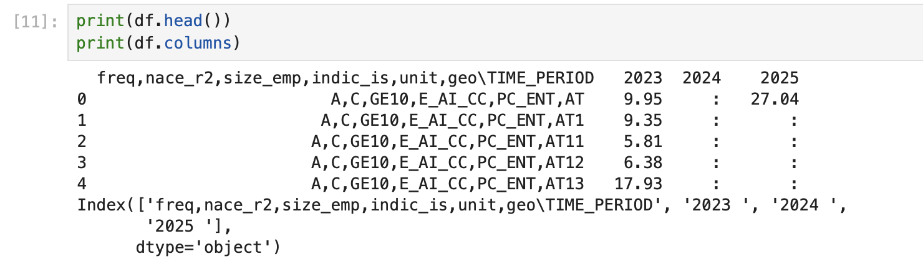
Figure 1 (Eurostat dataset before cleaning)

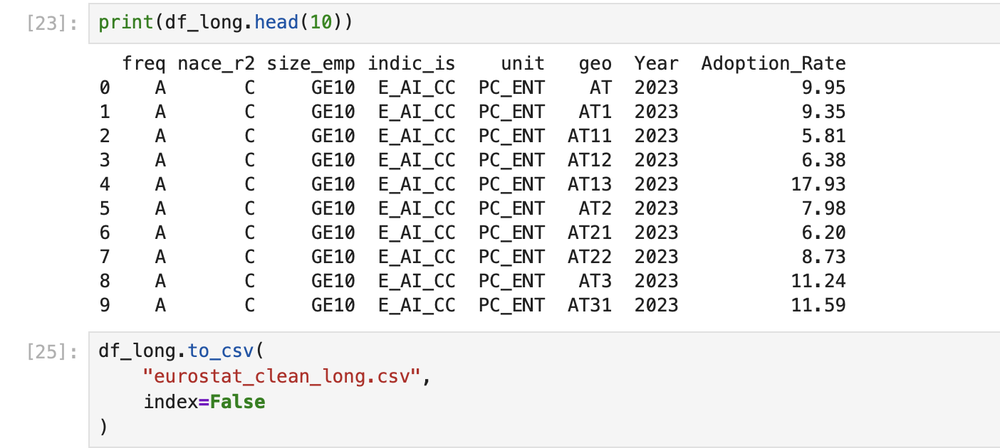
Figure 2 (Eurostat dataset after cleaning)

Tableau Data Integration
- I imported all the three CSV files to Tableau, creating relationships between the datasets based on the Year as the main connecting field.
- To make the analysis of the growth dynamic in all the visualizations I developed calculated fields: ((SUM([Investment Current Year]) - SUM([Investment Previous Year]) / SUM([Investment Previous Year])) * 100.
- I created geographic mapping by integrating Eurostat geo codes with geographic information that is inbuilt in Tableau which allowed me to render the heatmap appropriately.

Excel Data Preparation
The creation of calculated fields using Excel, development of pivot tables, and construction of combo charts were used. Growth rates have been determined using the
Formula: ((InvestmentCurrentYear - InvestmentPreviousYear)/InvestmentPreviousYear) x 100.
Pivot tables aggregated investment by area of focus and time interval, and cross-tabulation analysis was done.

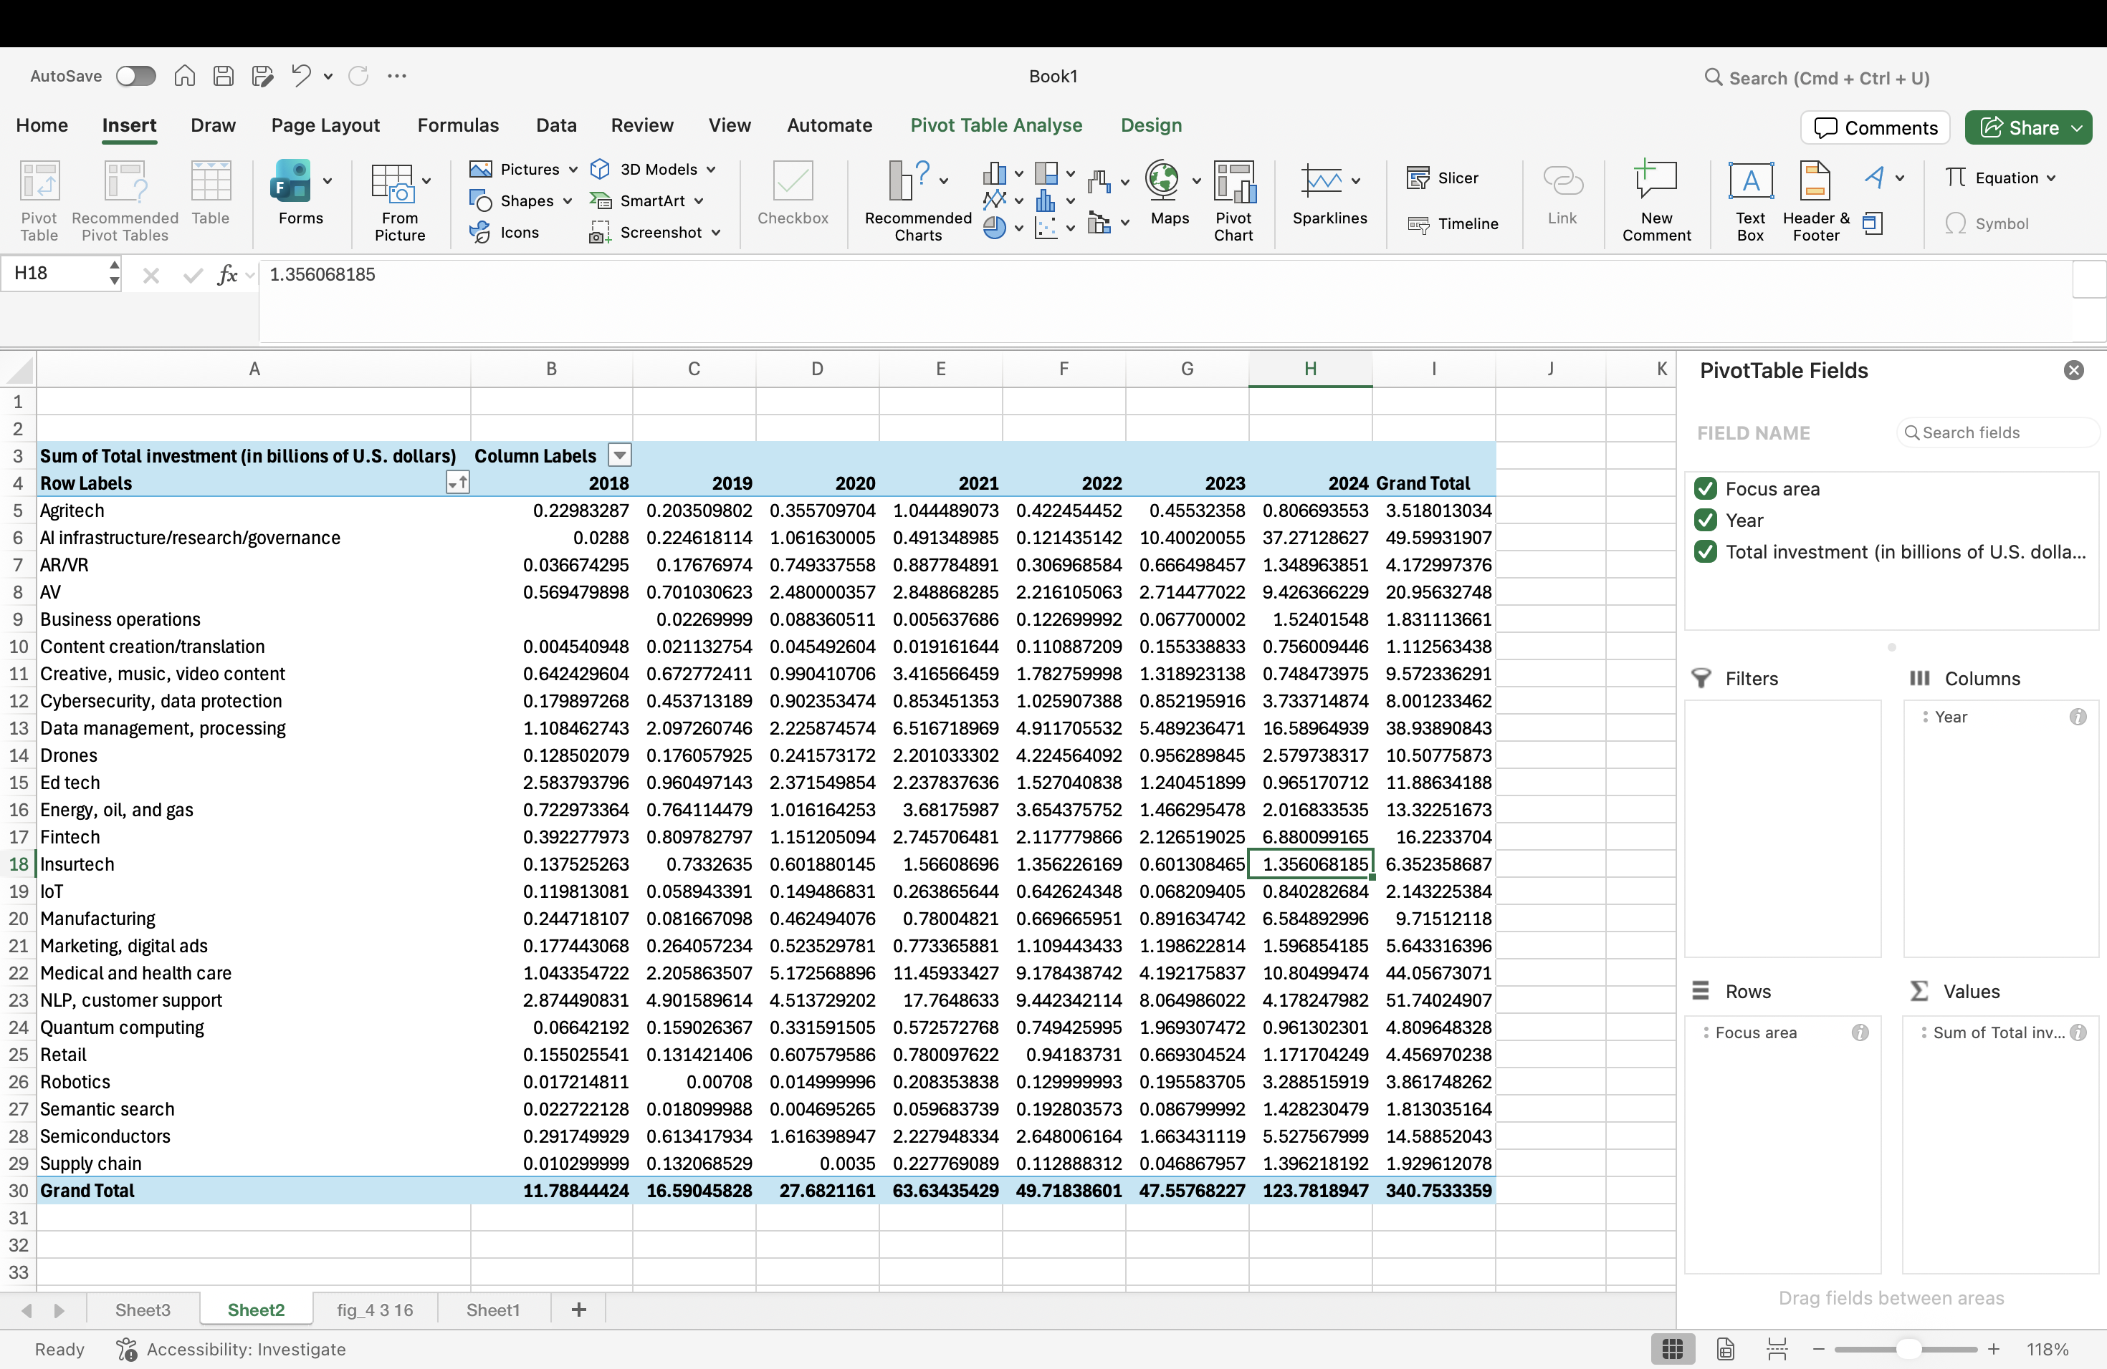
Figure 3 (Pivot Table)

EVALUATION & FINDINGS

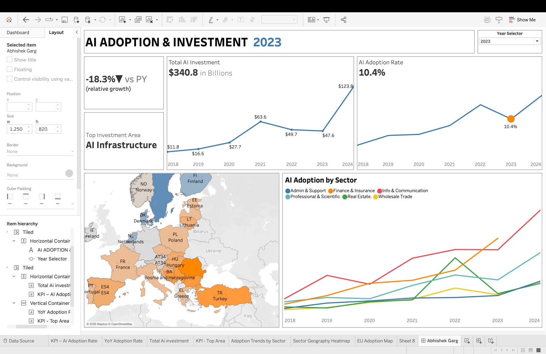
Figure 4 (Dashboard Overview)

4.1 Growth in AI Investment: The amount of AI investment has grown exponentially, with spending increasing by a staggering 11.8B in 2018, then 340.8B in 2021, and it indicates that the technology is leaving the lab and becoming a business strategy. The market is still in the upswing, as 2024 has increased by 53.3% per year.
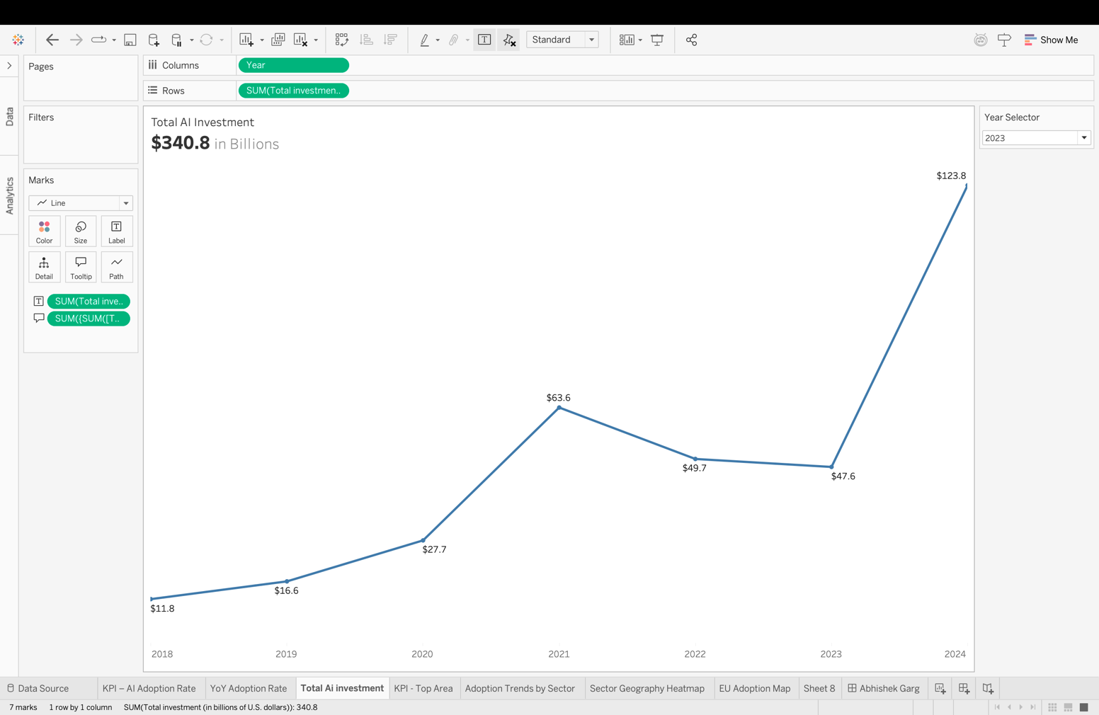
Figure 5 (Growth in AI investment)

4.2 Infrastructure Dominance: 45% of $123.8B investment in 2024 (37B) is allocated to AI infrastructure, which is an indication that individuals view the back-end technology as a key before I get to apps. Second place ( Data Management $16.6B) supports that infrastructure-first strategy.
4.3 Adoption -Investment Divergence: Despite the massive capital flow, after all, only 16.6% of companies have implemented AI. The distance is due to the necessity of the appropriate infra, talent crunch, and internal change obstacles, thus there is plenty of space to develop in the future.
4.4 Sectoral Leadership: Info & Comm sector is on the top of the adoption, then Finance and Insure. The old players such as Wholesale Trade and Real Estate are catching up and with this early movers have an opportunity to differentiate and capture the wave.

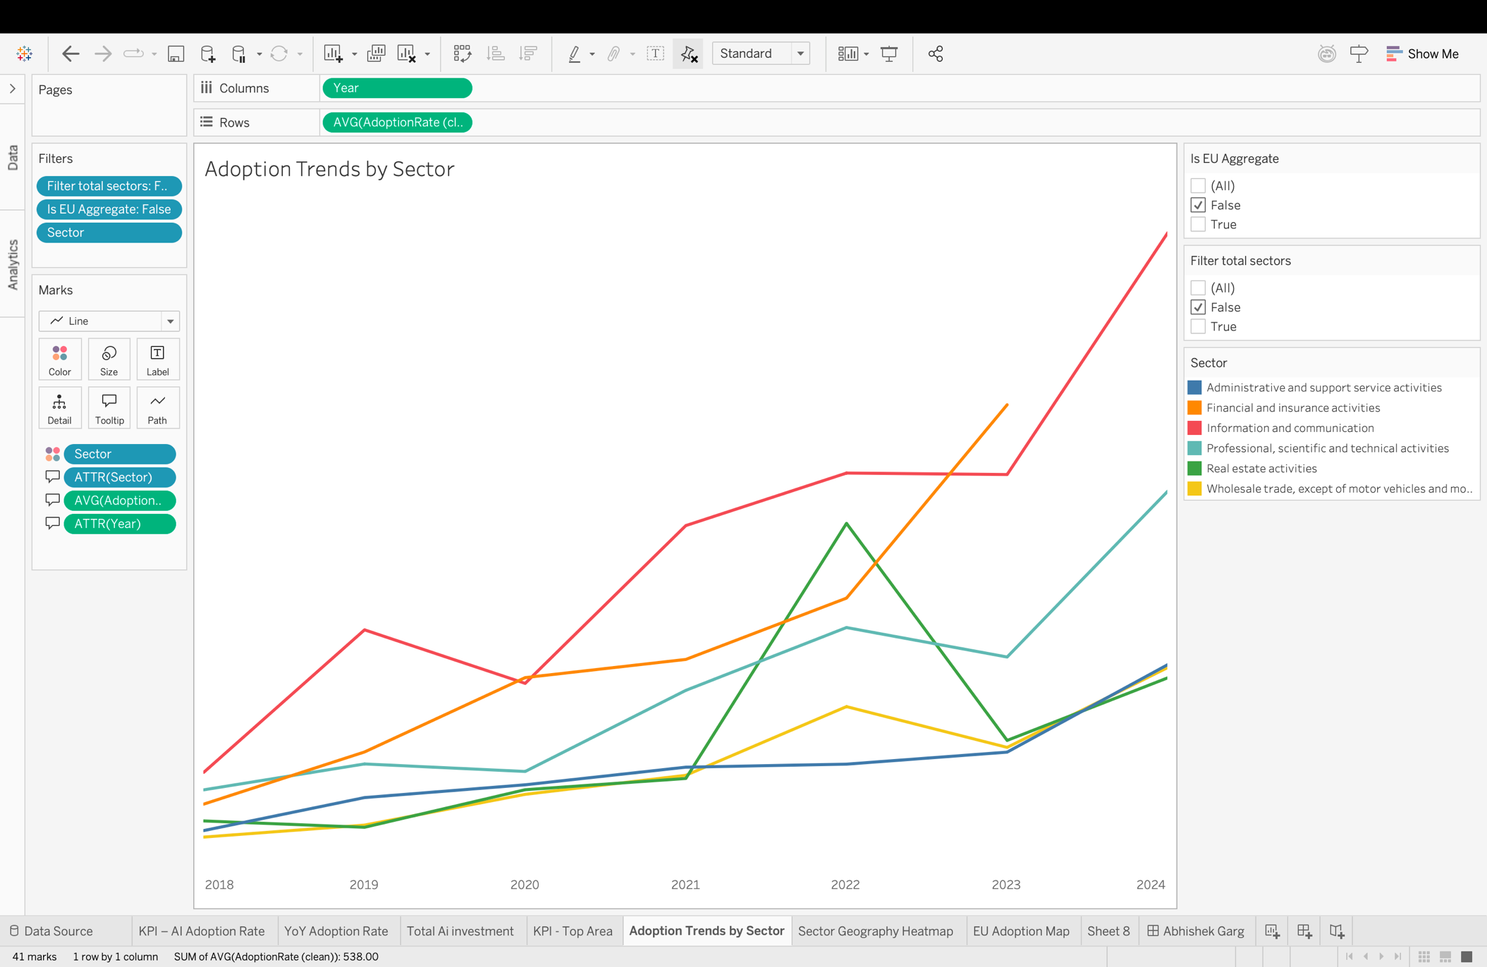
Figure 6 (AI adoption by sector)

4.5 Growth vs. Maturity Trade-off: Small bases (Robotics 1,600% YoY and Manufacturing 650% YoY) go hot, whereas mature markets (NLP customer support 16-18% YoY and cybersecurity 23-24% YoY) are growing at a niche.
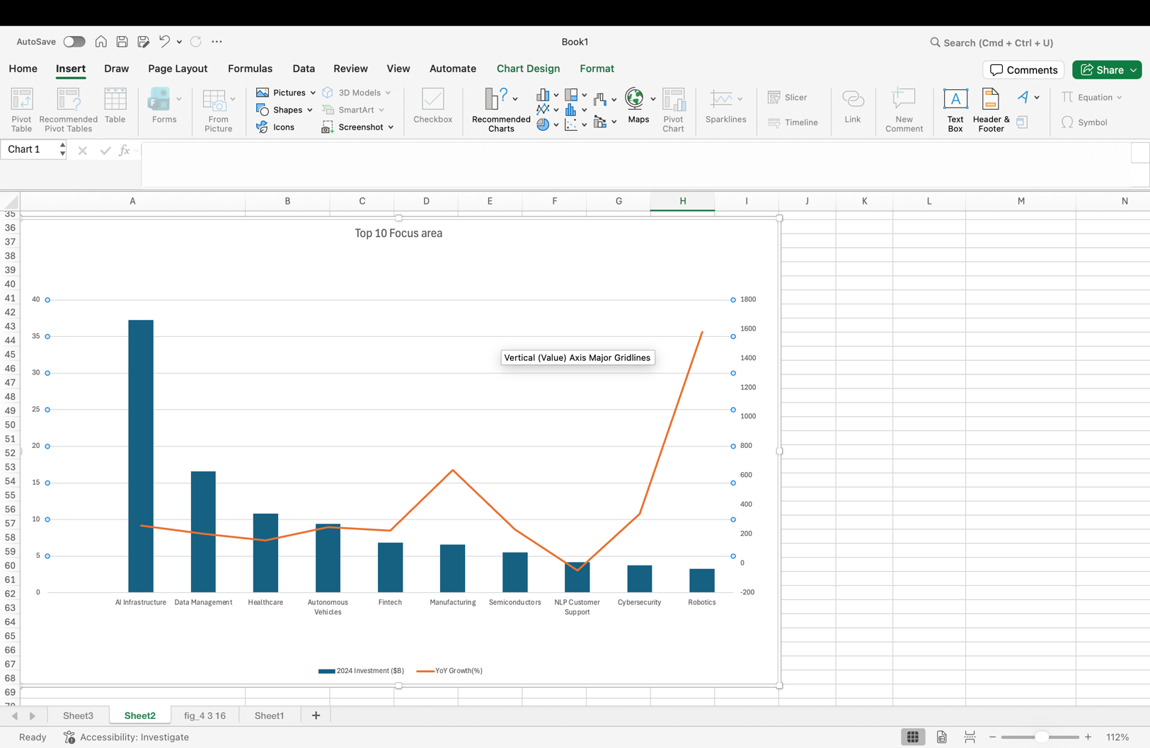
Figure 7 (Top 10 Focus area – Excel)
4.6 Geographic Patterns: Europe heatmap demonstrates that the adoption is not camped in the classical economic tables, with some Eastern regions of the EU performing significantly better than they should, which suggests that national strategies and talent pools can work better than GDP.
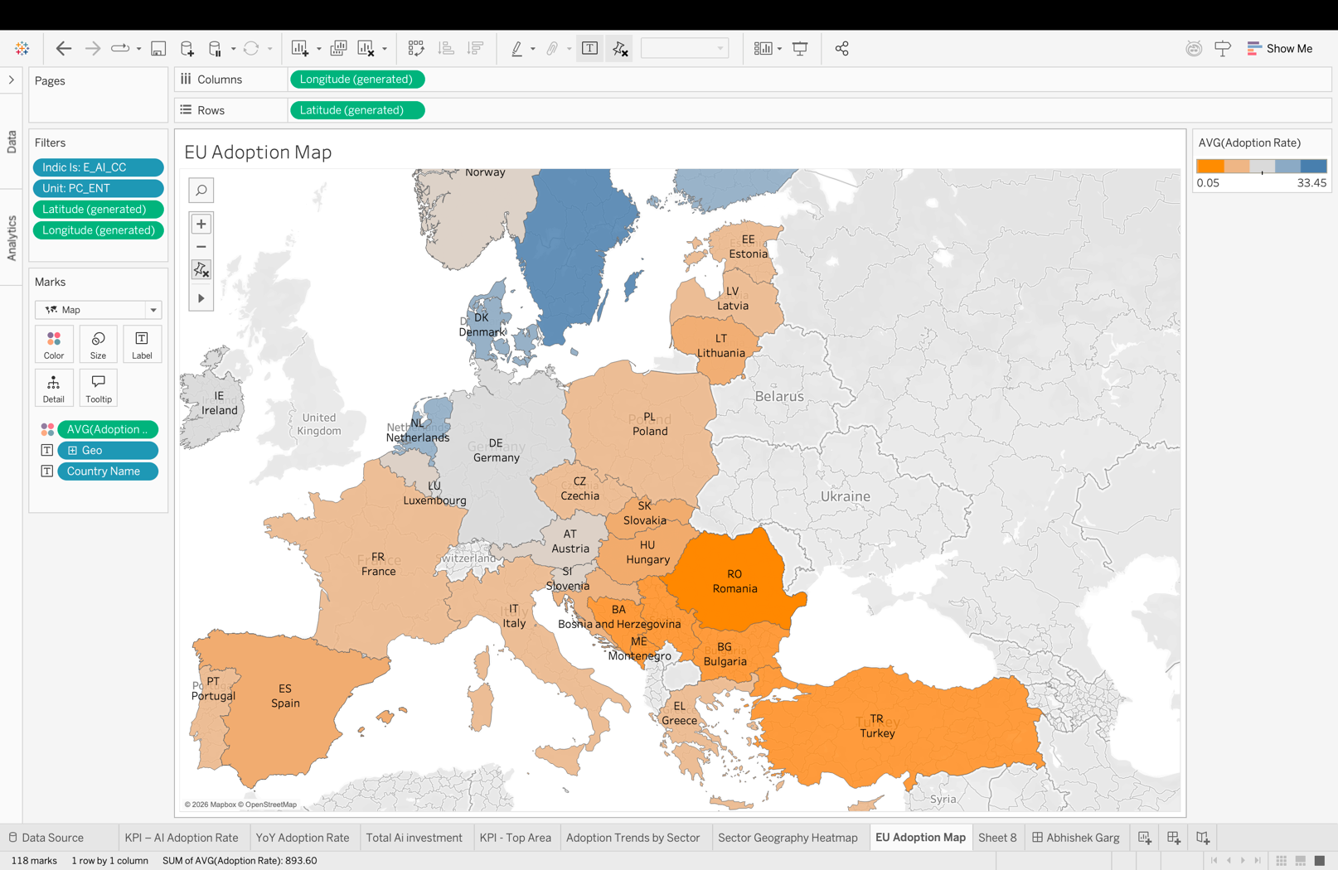
Figure 8 (EU AI Adoption map)

REFLECTION ON AI IMPACT

In my analysis, I found that one of the most interesting paradoxes in the transition of AI as an emerging technology to strategic imperative is the fact that it is a strategic technology. Even with the huge investment (340B+), 16.6 percent of organizations have implemented AI meaning that we are in the early majority inflection point-infrastructure development is made first before it can be applied widely. The winner-takes-most competition in the Information and Communication and Finance industries that I have seen and the application-specific AI (Robotics, Manufacturing) grow explosively the next value-generation wave will take place at the application layer instead of the infrastructure.
The pattern discovery that I needed was only made possible by the way my visualization-based style treated the data- raw data would show no pattern of the inverse relationship between investment size and growth rate, disparate adoption trends by sector, or geographic clusters. To the stakeholders, I came up with several implications, including that investors ought to distinguish infrastructure plays (stable, large) and applications (volatile, high-growth); enterprises in the traditional industry can still gain first-mover advantages, and talent development and regulatory clarity can be used by policy-makers to meaningfully contribute to regional competitiveness.

CONCLUDING REMARKS

In my in-depth study, I found out that AI has evolved to be not an experimental technology, but a strategic necessity, spending well over $340 billion during the last seven years, but with the adoption to date of 16.6% in organizations, there remains a lot more to come. My visualizations reveal that infrastructure investment (45 of 2024 total) is dominant, technology sectors are more likely to be adopted and traditional industries are slower in adoption and emerging applications exhibit explosive growth with small bases.
To the stakeholders, I found the following strategic implications: investors need to distinguish bets in steady infrastructure play-offs and high-growth application; enterprises are still able to take first mover advantage in old fashioned industry; and the technology implementation-adoption gap indicates the necessity of talent building and organizational transformation over and above pure acquisition of technology. Tableau is powerful because it can convert complex and multi-dimensional data into actionable insights by making use of interactive visualization, which is exhibited by my project.

BIBLIOGRAPHY

- Acemoglu, D. and Restrepo, P. (2020) 'Robots and jobs: Evidence from US labor markets', Journal of Political Economy, 128(6), pp. 2188-2244.
- Brynjolfsson, E. and McElheran, K. (2016) 'The rapid adoption of data-driven decision-making', American Economic Review, 106(5), pp. 133-139.
- Cao, L. (2022) 'AI in finance: Challenges, techniques, and opportunities', ACM Computing Surveys, 55(3), pp. 1-38.
- Few, S. (2012) Show me the numbers: Designing tables and graphs to enlighten. 2nd edn. Burlingame, CA: Analytics Press.
- Kirk, A. (2019) Data visualisation: A handbook for data driven design. 2nd edn. London: SAGE Publications.
- McKinney, W. (2010) 'Data structures for statistical computing in Python', Proceedings of the 9th Python in Science Conference, Austin, TX, pp. 56-61.
- McKinsey Global Institute (2023) The state of AI in 2023: Generative AI's breakout year. Available at: https://www.mckinsey.com/capabilities/quantumblack/our-insights/the-state-of-ai-in-2023-generative-AIs-breakout-year (Accessed: 15 January 2026).
- Murray, S. (2017) Interactive data visualization for the web. 2nd edn. Sebastopol, CA: O'Reilly Media.
- OECD (2023) OECD digital economy outlook 2024. Paris: OECD Publishing. doi: 10.1787/6b0eca42-en.
- Rogers, E.M. (2003) Diffusion of innovations. 5th edn. New York: Free Press.
- Stanford HAI (2024) Artificial intelligence index report 2024. Stanford, CA: Stanford University Human-Centered Artificial Intelligence. Available at: https://aiindex.stanford.edu/report/ (Accessed: 10 January 2026).

APPENDIX

The GitHub repository containing the full implementation and supporting files for this assignment can be accessed at:
https://github.com/AbhishekGarg0507/AI_Adoption_assignment

