SOLID

# Single Responsibility Principle

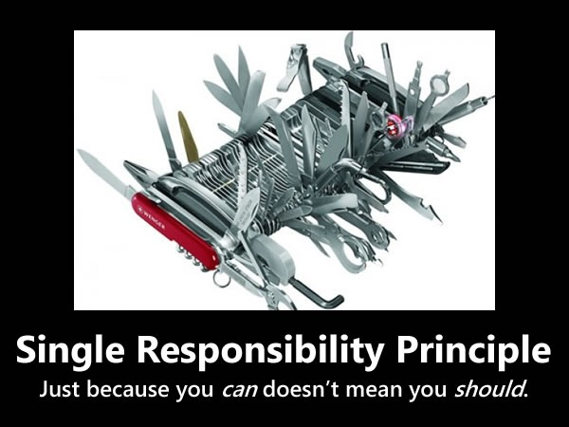

A class should have one, and only one, reason to change, meaning that a class should have only one job. Every object should have a single responsibility and that all of its services should be aligned with that responsibility.

EXAMPLE:

Consider a module that compiles and prints a report. Such a module can be changed for two reasons. First, the content of the report can change. Second, the format of the report can change. These two things change for very different causes; one substantive, and one cosmetic. The single responsibility principle says that these two aspects of the problem are really two separate responsibilities, and should therefore be in separate classes or modules. It would be a bad design to couple two things that change for different reasons at different times.

# Open Closed Principle

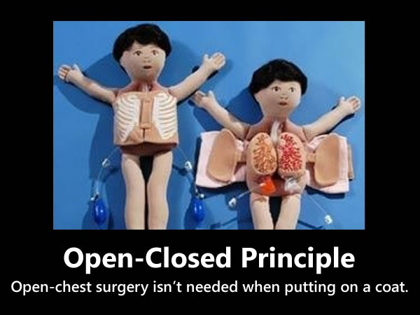

Create a Base class with Required functionality, and ensure we will not modify that class. (Closed for modification)  
Create a Derived class by inheriting the Base class for extension (Open for modification)

Software entities – such as classes, modules, functions and so on – should be open for extension but closed for modification. The idea is that it’s often better to make changes to things like classes by adding to or building on top of them (using mechanisms like subclassing or polymorphism) rather than modifying their code.

# Liskov Substitution Principle



If any module is using a Base class then the reference to that Base class can be replaced with a Derived class without affecting the functionality of the module.

Subclases should be substitutable for the classes from which they were derived. For example, if MySubclass is a subclass of MyClass, you should be able to replace MyClass with MySubclass without bunging up the program.

# Interface Segregation Principle

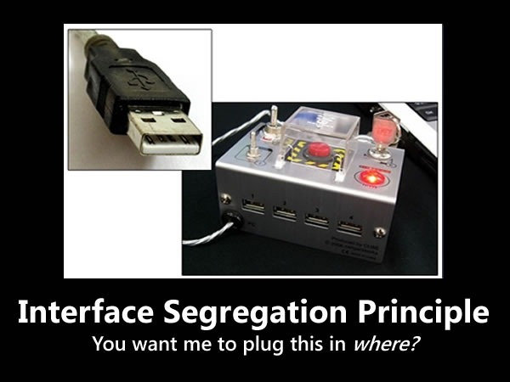

Clients should not be forced to depend upon interfaces that they do not use.

# Dependency Inversion Principle

depend on abstractions not on concrete implementations.