Q1. What is the total revenue generated by male vs. female customers?
SELECT gender AS GENDER, SUM(purchase_amount) AS TOTAL_REVENUE
FROM customer
GROUP BY gender;
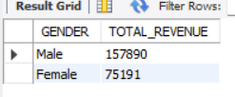
Q2. Which customers used a discount but still spent more than the average purchase amount?

select customer_id, purchase_amount
from customer
where discount_applied = 'Yes' and purchase_amount >= (select AVG(purchase_amount) from customer)
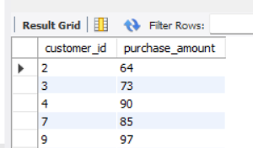

Q3. Which are the top 5 products with the highest average review rating?

SELECT item_purchased,
ROUND(AVG(review_rating), 2) AS Average_Product_Rating
FROM customer
GROUP BY item_purchased
ORDER BY AVG(review_rating) DESC
LIMIT 5;
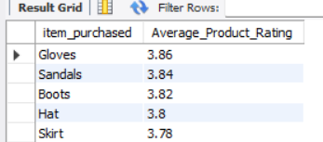
Q4. Compare the average Purchase Amounts between Standard and Express Shipping.
select shipping_type,
ROUND(AVG(purchase_amount),2)
from customer
where shipping_type in ('Standard','Express')
group by shipping_type;
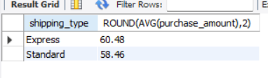
Q5. Do subscribed customers spend more? Compare average spend and total revenue between subscribers and non-subscribers.
SELECT subscription_status,
COUNT(customer_id) AS total_customers,
ROUND(AVG(purchase_amount),2) AS avg_spend,
ROUND(SUM(purchase_amount),2) AS total_revenue
FROM customer
GROUP BY subscription_status
ORDER BY total_revenue,avg_spend DESC;
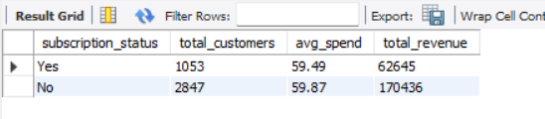
Q6. Which 5 products have the highest percentage of purchases with discounts applied?
SELECT item_purchased,
ROUND(100.0 * SUM(CASE WHEN discount_applied = 'Yes' THEN 1 ELSE 0 END)/COUNT(*),2) AS discount_rate
FROM customer
GROUP BY item_purchased
ORDER BY discount_rate DESC
LIMIT 5;
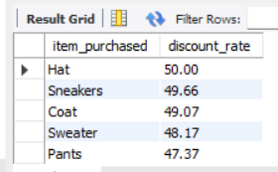

Q7. Segment customers into New, Returning, and Loyal based on their total number of previous purchases, and show the count of each segment.
WITH customer_type AS (
SELECT
customer_id,
previous_purchases,
CASE
WHEN previous_purchases = 1 THEN 'New'
WHEN previous_purchases BETWEEN 2 AND 10 THEN 'Returning'
ELSE 'Loyal'
END AS customer_segment
FROM customer
)
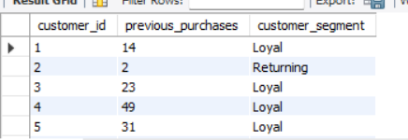
Q8. What are the top 3 most purchased products within each category?
WITH item_counts AS (
SELECT category,
item_purchased,
COUNT(customer_id) AS total_orders,
ROW_NUMBER() OVER (PARTITION BY category ORDER BY COUNT(customer_id) DESC) AS item_rank
FROM customer
GROUP BY category, item_purchased
)
SELECT item_rank,category, item_purchased, total_orders
FROM item_counts
WHERE item_rank <=3;
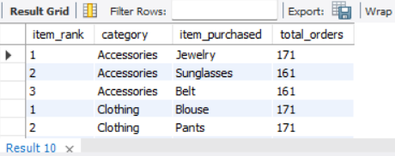

Q9. Are customers who are repeat buyers (more than 5 previous purchases) also likely to subscribe?
SELECT subscription_status,
COUNT(customer_id) AS repeat_buyers
FROM customer
WHERE previous_purchases > 5
GROUP BY subscription_status;
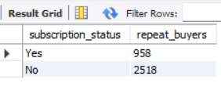
Q10. What is the revenue contribution of each age group?
SELECT
age_group,
SUM(purchase_amount) AS total_revenue
FROM customer
GROUP BY age_group
ORDER BY total_revenue desc;
