SELECT
ROUND(SUM(total_price),2) AS Total_Revenue
FROM pizza_sales;

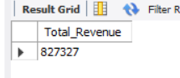
SELECT
ROUND (
SUM(total_price) / COUNT( DISTINCT order_id), 2) AS AVERAGE_ORDER_VALUE
FROM pizza_sales;

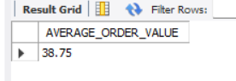
SELECT
SUM(quantity) AS TOTAL_PIZZA_SOLD
FROM pizza_sales;

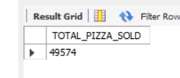
SELECT
COUNT( DISTINCT ORDER_ID ) AS TOTAL_ORDERS
FROM pizza_sales;
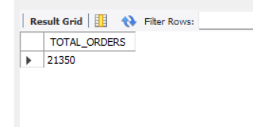
SELECT
ROUND(SUM(quantity) / COUNT(DISTINCT order_id),2) AS AVERAGE_PIZZA_PRE_ORDER
FROM pizza_sales;
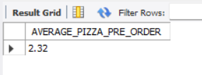

SELECT
DAYNAME(order_date) AS day_name,
COUNT(DISTINCT order_id) AS total_orders
FROM pizza_sales
GROUP BY day_name
ORDER BY FIELD(day_name,
'Monday',
'Tuesday',
'Wednesday',
'Thursday',
'Friday',
'Saturday',
'Sunday');
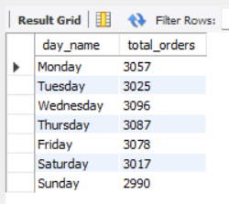
SELECT
HOUR(order_time) AS order_hour,
COUNT(DISTINCT order_id) AS total_orders
FROM pizza_sales
GROUP BY order_hour
ORDER BY order_hour;
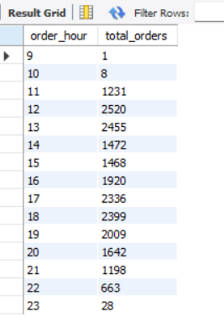

SELECT
pizza_category,
ROUND(SUM(total_price), 2) AS total_sales,
ROUND(
SUM(total_price) * 100 / (SELECT SUM(total_price) FROM pizza_sales),
2
) AS percentage_of_sales
FROM pizza_sales
GROUP BY pizza_category
ORDER BY percentage_of_sales DESC;

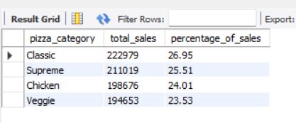

SELECT
pizza_size,
ROUND(SUM(total_price), 2) AS total_sales,
ROUND(
SUM(total_price) * 100 / (SELECT SUM(total_price) FROM pizza_sales),
2
) AS percentage_of_sales
FROM pizza_sales
GROUP BY pizza_size
ORDER BY percentage_of_sales DESC;
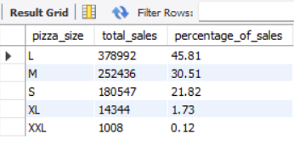
SELECT
pizza_category,
SUM(quantity) AS total_pizzas_sold
FROM pizza_sales
GROUP BY pizza_category
ORDER BY total_pizzas_sold DESC;
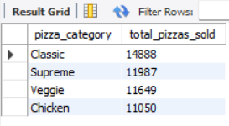
SELECT
pizza_name,
ROUND(SUM(total_price), 2) AS total_revenue
FROM pizza_sales
GROUP BY pizza_name
ORDER BY total_revenue DESC
LIMIT 5;
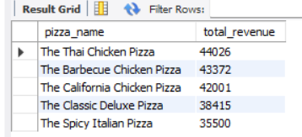
SELECT
pizza_name,
ROUND(SUM(total_price), 2) AS total_revenue
FROM pizza_sales
GROUP BY pizza_name
ORDER BY total_revenue ASC
LIMIT 5;
