INTRODUCTION

NetCampus is basically a full and pro solution for the universities, colleges and schools which manages all type problems related to academic and management.

NetCampus Student Portal consists of 8 modules with respective sub modules in each module

8 modules are as follows:

1. My Page
2. Fee Module
3. Academic
4. Examination
5. Online Exam
6. Library
7. Work flow Manager
8. Other Utility

The purpose for this document is to provide a idea of how this student portal is capable to manage the records and also understand about the use of each module of student portal in elaborated manner.

How to Login in Student Portal

Step 1 Write the URL <https://ssipmt.mynetcampus.com/> on any Browser such as chrome browser

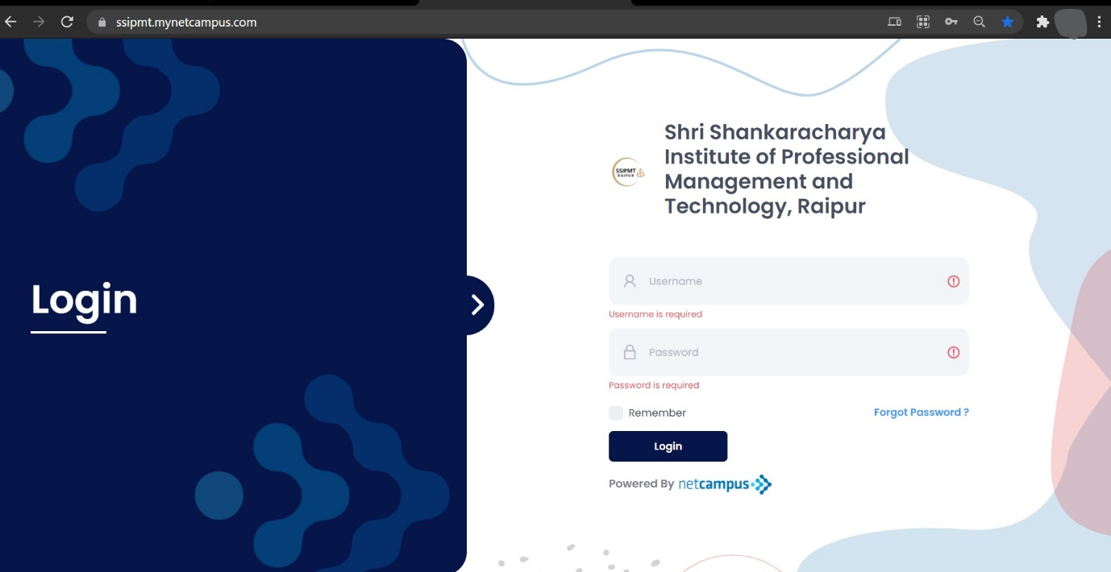

Step 2 Enter Username and Password which is provided

If you have forgot your password click on the forget password option



Step 3 Click on the Login button



Step 4 After successful login it will open the student portal dashboard as shown in the figure

