Deep Learning

6 questions

1. Which of the following statements are **true**? (*Check all that apply*)

**Linear classifiers are never useful, because they cannot represent XOR.**

**Linear classifiers are useful, because, with enough data, they can represent anything.**

**Having good non-linear features can allow us to learn very accurate linear classifiers.**

**none of the above**

2. A simple **linear** classifier can represent which of the following functions? (*Check all that apply*)

**x1 OR x2 OR NOT x3**

**x1 AND x2 AND NOT x3**

**x1 OR x2 AND NOT x3**

**none of the above**

3. Which of the the following neural networks can represent the following function:

(x1 AND x2) OR (NOT x1 AND NOT x2)



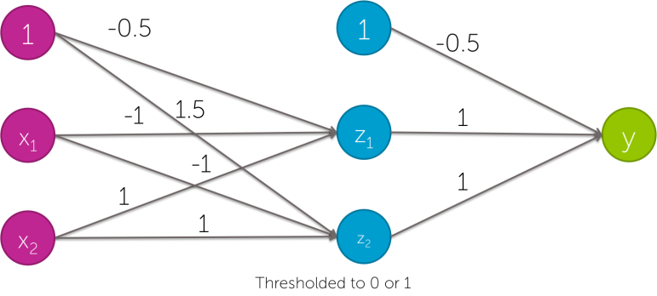



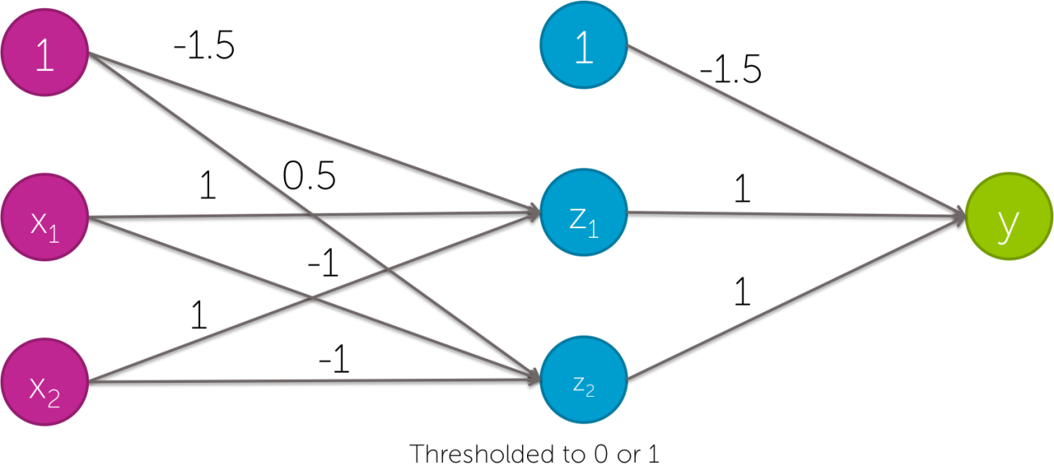



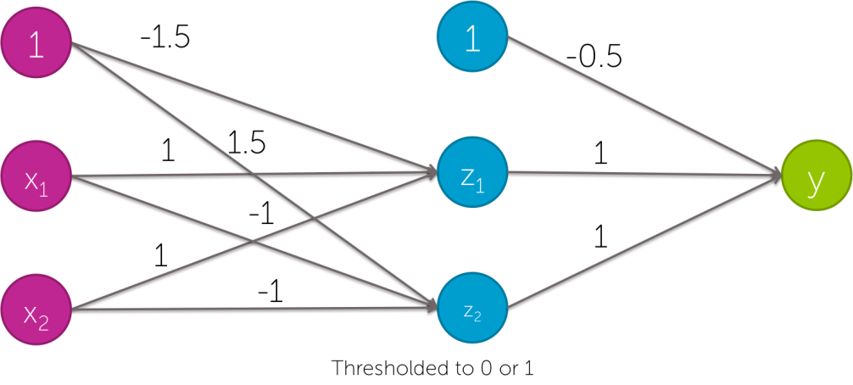



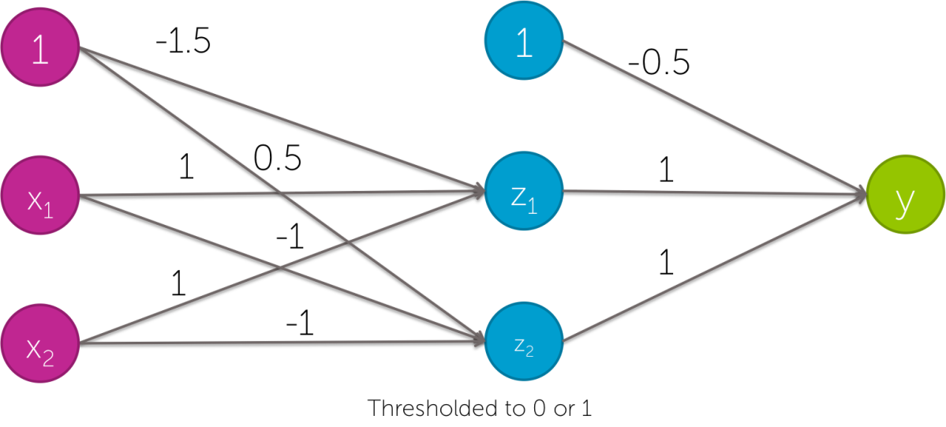



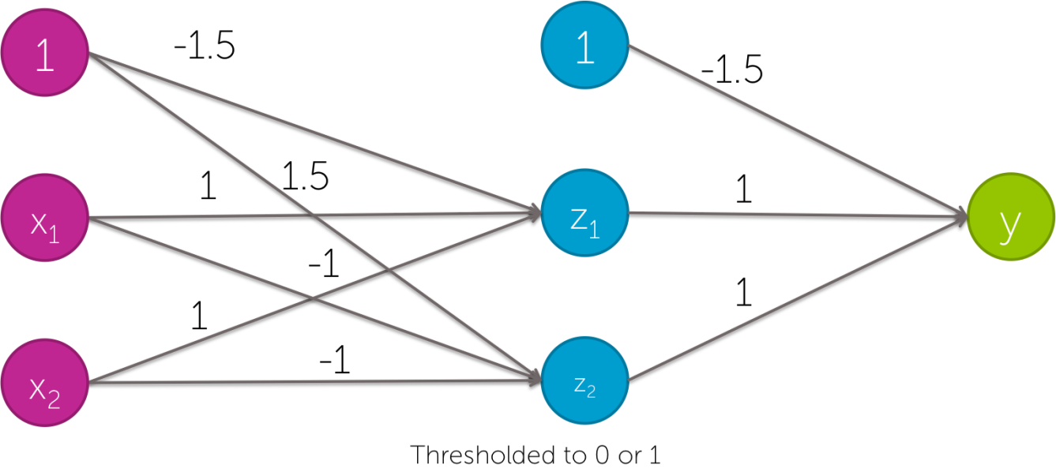

4.

Which of the following statements is **true**? (*Check all that apply*)

**Features in computer vision act like local detectors.**

**Deep learning has had impact in computer vision, because it’s used to combine all the different hand-created features that already exist.**

**By learning non-linear features, neural networks have allowed us to automatically learn detectors for computer vision.**

**none of the above**

5.

If you have lots of images of different types of plankton labeled with their species name, and lots of computational resources, what would you expect to perform better predictions:

**a deep neural network trained on this data.**

**a simple classifier trained on this data, using deep features as input, which were trained using ImageNet data.**

6.

If you have a few images of different types of plankton labeled with their species name, what would you expect to perform better predictions:

**a deep neural network trained on this data.**

**a simple classifier trained on this data, using deep features as input, which were trained using ImageNet data.**