Contents
PreDac 1
🎯 Title 1
Problem Statement: 1
Objectives 2
Foundational Paper : 2
A Comparative Game-Theoretic Framework for Machine Unlearning: Standardization, Strategy Mapping, and Scenario-Specific Recommendations 2
Game-Theoretic Feature Unlearning: Strategic Modeling and Verification 12
Federated Unlearning Games: Multi-Agent Strategy Design and Incentive Compatibility 12
Adversarial Verification Games for Machine Unlearning 13
Reinforcement Learning Unlearning: Trajectory Games and Policy Forgetting 13
Knowledge Unlearning in LLMs: Bayesian Stackelberg Games and Belief Updates 13
Comparative Simulation Framework for Strategic Unlearning 14
Meta-Game Design for Strategy Recommendation in Machine Unlearning 14
🧠 Other Future Research Directions: 15
📅 Timeline: 12 Months (Focused on Foundational Paper Only) 15
⚠️ Risk Mitigation Strategies 18

PreDac

🎯 Title
Game-Theory-Based Balance: Formalizing the Machine Unlearning Problem as a Game Between Model Provider and Data Provider.

Problem Statement:
Machine unlearning is a vital capability in modern AI systems, allowing models to selectively forget specific data to uphold privacy rights, correct biases, and comply with regulations like GDPR. Yet, the process is not merely technical—it involves strategic decisions between the model provider, who must weigh utility loss and compliance cost, and the data provider, who demands control over their personal data.
Game theory has emerged as a powerful tool in privacy-preserving techniques over the past decade, offering structured models to navigate the trade-off between data privacy and utility. Numerous schemes have leveraged game-theoretic principles to model interactions among stakeholders, such as hybrid encrypted cloud data deduplication and personalized differential privacy. In the context of machine unlearning, this intersection is particularly pertinent. For a model provider, unlearning inherently presents a trade-off: an over-unlearning strategy may degrade model performance, while insufficient protection risks privacy leaks.
This research formalizes the machine unlearning problem as a strategic game between two key players—the model provider and the data provider. By defining their strategies and utilities within a game-theoretic framework, we aim to identify equilibrium behaviors that balance performance preservation with privacy guarantees. This approach transforms unlearning from a reactive mechanism into a principled, auditable process, offering a logically cohesive solution to a complex and increasingly critical challenge in AI.

Objectives
- A Comparative Game-Theoretic Framework for Machine Unlearning: Standardization, Strategy Mapping, and Scenario-Specific Recommendations
- Game-Theoretic Feature Unlearning: Strategic Modeling and Verification
- Federated Unlearning Games: Multi-Agent Strategy Design and Incentive Compatibility
- Adversarial Verification Games for Machine Unlearning
- Reinforcement Learning Unlearning: Trajectory Games and Policy Forgetting
- Meta-Game Design for Strategy Recommendation in Machine Unlearning

Foundational Paper :

A Comparative Game-Theoretic Framework for Machine Unlearning: Standardization, Strategy Mapping, and Scenario-Specific Recommendations

Here’s a draft of the Introduction section for your research paper. It not only introduces the topic and motivation but also summarizes the broader approach used in defining this paper and how it lays the foundation for future research directions.

🔷 Introduction
In the era of data-driven intelligence, machine learning models have become central to decision-making across domains such as healthcare, finance, education, and personalized services. However, the increasing reliance on data-intensive models has raised critical concerns around privacy, fairness, and regulatory compliance. One emerging solution to these concerns is machine unlearning—the process of selectively removing the influence of specific data points from trained models. This capability is essential for complying with privacy laws (e.g., GDPR), mitigating bias, and enabling user control over personal data.
Machine unlearning spans a wide spectrum of models including deep neural networks (DNNs), large language models (LLMs), graph neural networks (GNNs), support vector machines (SVMs), tree-based ensembles, and federated learning architectures. It also encompasses diverse operational settings such as instance unlearning, class unlearning, feature unlearning, federated unlearning, and sequential unlearning. Despite its growing relevance, the field lacks a unified framework to model the strategic dynamics of unlearning—particularly the interactions between model providers, data owners, and verifiers.
This paper proposes a standardized and comparative game-theoretic framework for machine unlearning. Game theory, with its rich mathematical foundation for modeling strategic interactions, offers a powerful lens to formalize negotiation, verification, and equilibrium behavior in unlearning scenarios. By mapping each model-setting pair to suitable game-theoretic strategies (e.g., Nash, Stackelberg, Bayesian, cooperative games), and comparing their effectiveness, this framework aims to guide the selection of optimal strategies for different unlearning contexts.
🔍 Approach Summary
The approach taken in this paper is both foundational and extensible. It begins by constructing a taxonomy of machine unlearning models and settings, followed by the definition of a generic mathematical framework capturing players, strategies, payoffs, and equilibrium concepts. For each model-setting pair, multiple game-theoretic strategies are identified and compared based on logical reasoning, mathematical tractability, and simulation results. Verification protocols are designed to ensure that unlearning is both effective and auditable. Finally, a recommendation engine is proposed to guide strategy selection based on scenario-specific tradeoffs.
This methodology is not only intended to address current gaps in machine unlearning but also to serve as a launchpad for future research. The modular architecture of the framework allows for deep dives into specialized domains—for example, a follow-up study could focus exclusively on game-theoretic feature unlearning, federated unlearning, or adversarial unlearning verification. By establishing a rigorous foundation, this paper opens up new avenues for interdisciplinary research at the intersection of machine learning, privacy, and strategic decision-making.

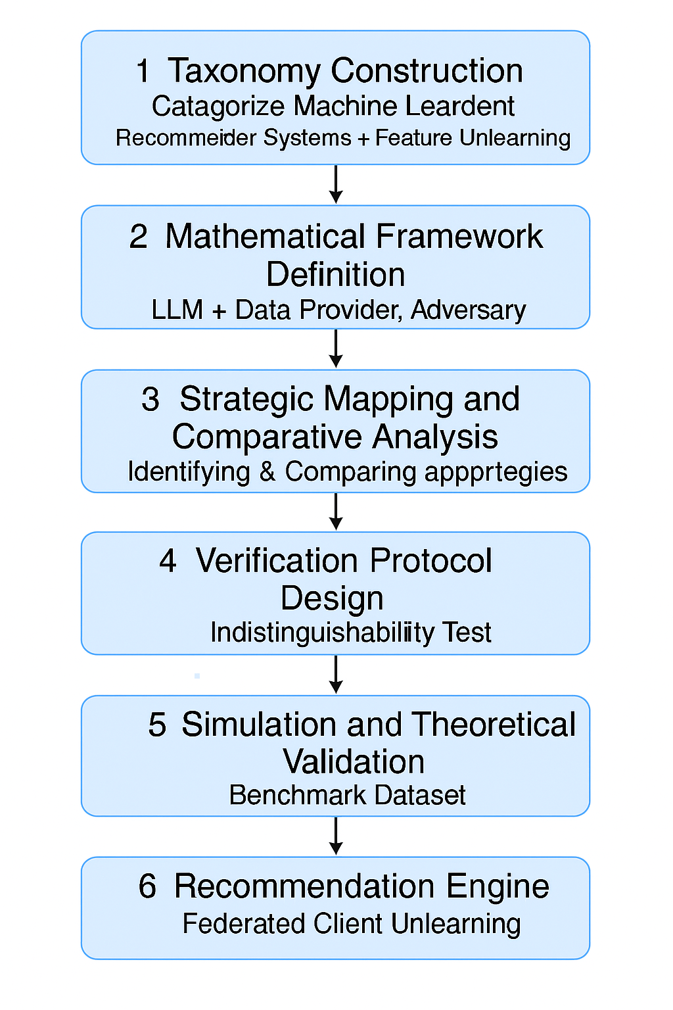

🧩 Problem Statement
Machine unlearning—the process of removing the influence of specific data from trained models—is essential for privacy compliance, fairness, and adaptability in modern AI systems. It applies to a wide range of models including DNNs, LLMs, GNNs, SVMs, tree-based ensembles, and federated learning architectures. Among the various unlearning scenarios, such as instance, class, trajectory, and feature unlearning, each presents unique challenges in terms of verification, efficiency, and strategic negotiation.
Despite the growing need, current approaches are fragmented and lack a unified framework to model strategic interactions between stakeholders (e.g., model providers, data owners, auditors). Game theory offers a rich toolkit to formalize these dynamics, but there is no standardized methodology to apply game-theoretic principles across diverse unlearning scenarios, nor a comparative analysis of which strategies work best in which contexts.

🎯 Research Objective
✅ Primary Objective
To develop a standardized and comparative game-theoretic framework for machine unlearning that maps diverse model-setting pairs to suitable game-theoretic strategies, evaluates their effectiveness, and provides scenario-specific recommendations.
✅ Secondary Objectives
- To construct a taxonomy linking machine unlearning models (e.g., LLMs, RL, recommender systems, GNNs, SVMs) and settings (e.g., federated, feature, sequential, distributed) to appropriate game-theoretic models.
- To define a generic mathematical framework capturing players, strategies, payoffs, and equilibrium concepts.
- To identify and compare multiple game-theoretic strategies (e.g., Nash, Stackelberg, Bayesian, cooperative) for each model-setting pair.
- To evaluate strategies based on logical reasoning, mathematical proofs, and simulation results.
- To provide scenario-specific recommendations for optimal strategy selection.
- To establish a modular architecture for future deep dives into specialized unlearning domains (e.g., game-theoretic feature unlearning).

🔍 Gaps Addressed
- Lack of unified strategic modeling across machine unlearning paradigms.
- Absence of comparative analysis of game-theoretic strategies per scenario.
- No formal methodology for recommending optimal strategies based on mathematical findings.
- Limited understanding of equilibrium behavior and incentive compatibility in unlearning.

🧪 Methodology (Step-by-Step with Examples)
Step 1: Taxonomy Construction
Goal: Build a structured mapping between machine unlearning models and operational settings.
Actions:
- Categorize models:
  - DNNs, LLMs, GNNs, SVMs, Tree-based Models, Federated Learning.
- Categorize unlearning settings:
  - Instance Unlearning, Class Unlearning, Feature Unlearning, Federated Unlearning, Sequential Unlearning, Distributed Unlearning.
- Create a matrix of model-setting pairs.
Example:
- Recommender System + Feature Unlearning
- LLM + Knowledge Unlearning
- RL Agent + Trajectory Unlearning
- Federated Learning + Client Unlearning

Step 2: Mathematical Framework Definition
Goal: Define the formal structure of unlearning games.
Actions:
- Define players:
  - Model Provider (e.g., platform), Data Provider (e.g., user), Verifier (e.g., auditor), Adversary (e.g., attacker).
- Define strategies:
  - Request Unlearning, Retain Data, Negotiate Terms, Verify/Audit, Challenge.
- Define payoffs:
  - Privacy Gain, Utility Loss, Compliance Cost, Verification Confidence.
- Define equilibrium concepts:
  - Nash Equilibrium, Stackelberg Equilibrium, Bayesian Nash, Correlated Equilibrium.
Example:
- In a federated learning setup, each client (data provider) decides whether to request unlearning. The server (model provider) decides whether to comply, considering utility loss and compliance cost. The verifier checks if the model has truly forgotten the data. The game reaches a Stackelberg equilibrium when the server commits to a strategy and clients respond optimally.

Step 3: Strategic Mapping and Comparative Analysis
Goal: Identify and compare game-theoretic strategies for each model-setting pair.
Actions:
- For each pair, identify multiple applicable game-theoretic models.
- Compare strategies based on:
  - Strategic expressiveness
  - Mathematical tractability
  - Computational feasibility
  - Privacy-utility tradeoff modeling
Detailed Examples:
Model + Unlearning Scenario | Game-Theoretic Strategy | Rationale
Recommender + Feature Unlearning | Bayesian Game, Cooperative Game | Users’ feature preferences are private; multiple users may form coalitions to demand fairness.
RL + Trajectory Unlearning | Dynamic Game, Exploration-Exploitation Game | Removing trajectories affects policy evolution; strategic modeling captures long-term tradeoffs.
LLM + Knowledge Unlearning | Stackelberg Game, Bayesian Stackelberg | Model provider commits to unlearning; data provider reacts based on trust and belief updates.
GNN + Node Unlearning | Extensive-Form Game | Interconnected data leads to cascading effects; imperfect information.
SVM + Support Vector Unlearning | Zero-Sum Game | Removing support vectors affects decision boundaries; adversarial probing tests residual influence.
Tree-Based Models + Instance Unlearning | Normal-Form Game | Each tree as a player; strategies involve pruning or reweighting.
Federated Learning + Client Unlearning | Multi-Stage Stackelberg Game | Clients negotiate removal; server commits to aggregation strategy.

Step 4: Verification Protocol Design
Goal: Ensure that unlearning has occurred and is verifiable.
Actions:
- Model verification as a sub-game or audit game.
- Design adversarial probing mechanisms.
- Define indistinguishability tests and utility shift metrics.
- Formalize verification payoffs and equilibrium conditions.
Example:
- In LLM unlearning, a verifier probes the model with prompts related to the forgotten knowledge. If the model’s responses are statistically indistinguishable from a model never trained on that data, verification is successful.

Step 5: Simulation and Theoretical Validation
Goal: Validate the framework through implementation and analysis.
Actions:
- Select 2–3 model-setting pairs for proof-of-concept.
- Implement simplified simulations using synthetic or benchmark datasets.
- Analyze equilibrium outcomes, tradeoffs, and strategy performance.
Example:
- Simulate a recommender system with feature unlearning requests from multiple users. Compare outcomes under Bayesian vs. cooperative game models. Measure privacy gain, utility loss, and coalition stability.

Step 6: Recommendation Engine
Goal: Provide actionable insights for strategy selection.
Actions:
- Based on comparative analysis, recommend optimal strategies per scenario.
- Include tradeoff analysis (e.g., privacy vs. utility, efficiency vs. completeness).
- Highlight applicability conditions and limitations.
Example:
- For federated client unlearning, recommend Stackelberg strategy when the server can commit to aggregation rules, and cooperative strategy when clients can form privacy coalitions.

📈 Anticipated Results
- A modular, extensible framework for game-theoretic machine unlearning.
- Comparative analysis of strategies across scenarios.
- Scenario-specific recommendations for optimal strategy selection.
- Identification of equilibrium behaviors and tradeoffs.
- Foundation for future deep-dive papers (e.g., game-theoretic feature unlearning).

🎁 Expected Contributions
- First comprehensive comparative game-theoretic standardization of machine unlearning.
- A reusable framework for researchers and practitioners.
- A roadmap for future research in strategic unlearning.
- Enhanced understanding of privacy-utility tradeoffs via strategic modeling.
- A foundation for building “forgetful” models with verifiable guarantees.

⚠️ Potential Challenges
- Complexity in modeling multi-agent dynamics in high-dimensional models.
- Difficulty in verifying unlearning in black-box systems.
- Scalability of game-theoretic simulations and equilibrium computation.
- Ensuring generalizability across diverse ML architectures.
- Balancing efficiency with unlearning guarantees (e.g., approximate vs. exact unlearning).

Based on foundational research objective — developing a standardized and comparative game-theoretic framework for machine unlearning—I’ve crafted a sequence of follow-up research objectives, each designed to be a standalone paper that logically builds upon the previous one. These objectives aim to solve the overarching problem cohesively and progressively.
Foundational Paper:
Focus:
Standardized game-theoretic modeling of machine unlearning across model-setting pairs.
Sets the Stage For:
- Taxonomy of models and settings
- Strategic mapping using game theory
- Modular architecture for specialized deep dives
Here’s the expanded visual roadmap with:
- Highlighted original objectives (in sky blue): your core research papers.
- Additional possible objectives (in light gray): future extensions that logically branch from your work.
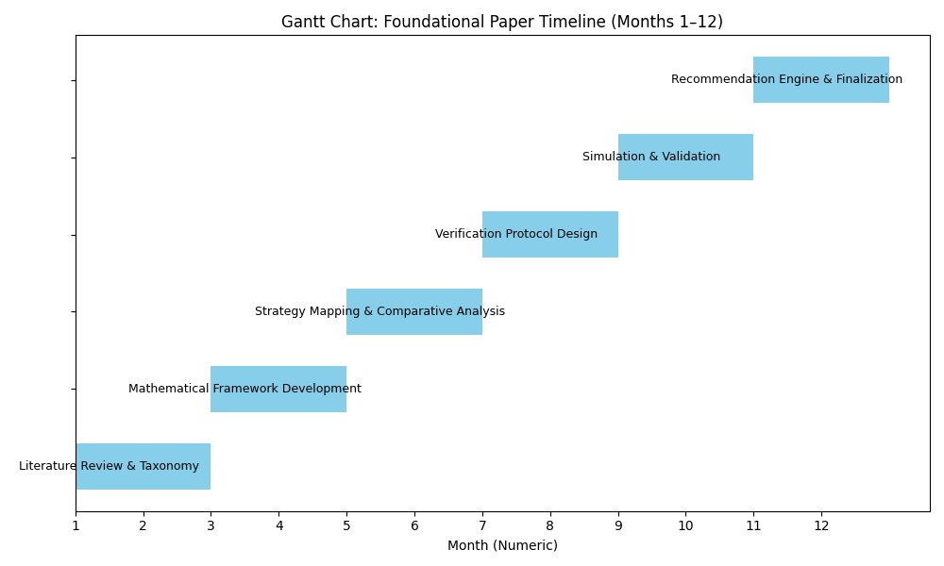

🧭 Axis Definitions:
- X-axis: Logical Progression of Research
Represents the sequential development of your research.
- Y-axis: Thematic Grouping of Objectives
Clusters objectives by their focus—model type, verification, legal, or human-centered.
Would you like a version of this diagram embedded in your proposal or exported in LaTeX/TikZ format?

🧩 Follow-Up Research Objectives (Each as a Separate Paper)

Game-Theoretic Feature Unlearning: Strategic Modeling and Verification
Objective:
To develop a specialized game-theoretic framework for feature unlearning across models like recommender systems, LLMs, and GNNs, focusing on strategic negotiation, coalition formation, and verifiable forgetting.
Why Next?
Feature unlearning is a granular and high-impact scenario. It builds directly on your taxonomy and strategic mapping, allowing deeper exploration of privacy-utility tradeoffs and coalition dynamics.
Feature unlearning is a fine-grained and high-impact scenario. It allows you to:
- Apply the taxonomy and strategic mapping from PREDAC
- Explore coalition formation and privacy-utility tradeoffs
- Validate the modularity of your framework
Logical Link:
Uses the matrix and strategy mapping from foundational paper to zoom into a specific scenario.

Federated Unlearning Games: Multi-Agent Strategy Design and Incentive Compatibility
Objective:
To formalize federated unlearning as a multi-stage game involving clients, servers, and verifiers, and to design incentive-compatible strategies that ensure privacy compliance and utility preservation.
Why Next?
Federated settings introduce distributed decision-making and strategic asymmetry. This paper extends your Stackelberg and cooperative game models into real-world federated architectures.
Federated learning introduces multi-agent, distributed dynamics. This paper:
- Extends Stackelberg and cooperative games from foundational paper
- Models incentive compatibility and negotiation
- Builds on feature unlearning by adding decentralization
Logical Link:
Adds complexity by moving from centralized to federated settings, using the same strategic foundation.

Adversarial Verification Games for Machine Unlearning
Objective:
To design and analyze adversarial probing and audit games that verify whether unlearning has occurred, using indistinguishability tests, utility shifts, and equilibrium-based guarantees.
Why Next?
Verification is a critical bottleneck. This paper deepens your Step 4 methodology and formalizes verification as a strategic sub-game, essential for trust and compliance.
RL introduces temporal dependencies and dynamic payoffs. This paper:
- Builds on dynamic games from PREDAC
- Explores trajectory forgetting and policy adaptation
- Adds sequential complexity to the framework
Logical Link:
Extends the strategic modeling to time-evolving systems, validating dynamic game theory use.

Reinforcement Learning Unlearning: Trajectory Games and Policy Forgetting
Objective:
To model trajectory unlearning in RL agents as dynamic games, capturing long-term exploration-exploitation tradeoffs and designing strategies for policy adaptation post-unlearning.
Why Next?
RL introduces temporal dependencies and dynamic payoffs. This paper builds on your dynamic game modeling and explores how forgetting affects learning trajectories.
Verification is a cross-cutting challenge. This paper:
- Formalizes Step 4: Verification Protocol Design (verification protocols)
- Models verification as a sub-game
- Supports both feature and federated unlearning
Logical Link:
Ensures that strategies proposed in earlier papers are auditable and trustworthy.

Knowledge Unlearning in LLMs: Bayesian Stackelberg Games and Belief Updates
Objective:
To model knowledge unlearning in LLMs using Bayesian Stackelberg games, where model providers commit to forgetting strategies and data providers update beliefs based on observed behavior.
Why Next?
LLMs are central to modern AI. This paper extends your LLM + Stackelberg modeling and explores belief dynamics, trust calibration, and strategic transparency.
LLMs are high-dimensional and opaque. This paper:
- Applies Bayesian Stackelberg games and other games from foundational paper
- Models belief updates and trust dynamics
- Builds on verification and federated strategies
Logical Link:
Tests the framework in a black-box, high-impact model, integrating verification and belief modeling.

Comparative Simulation Framework for Strategic Unlearning
Objective:
To build a simulation platform that implements and compares game-theoretic strategies across model-setting pairs, validating equilibrium outcomes, tradeoffs, and strategy performance.
Why Next?
This paper operationalizes your theoretical framework and provides empirical grounding for all previous objectives. It also supports your recommendation engine.
Simulation provides empirical grounding. This paper:
- Implements strategies from all previous papers
- Validates equilibrium outcomes and tradeoffs
- Supports the recommendation engine
Logical Link:
Operationalizes the theoretical models and connects all prior work through comparative analysis.

Meta-Game Design for Strategy Recommendation in Machine Unlearning
Objective:
To design a meta-game that selects optimal unlearning strategies based on scenario-specific parameters, tradeoffs, and stakeholder preferences.
Why Next?
This paper formalizes your recommendation engine as a strategic decision-making tool, completing the loop from theory to actionable insights.
This is the culmination of the framework. It:
- Formalizes the recommendation engine from PREDAC
- Uses insights from simulations and verification
- Provides actionable guidance for practitioners
Logical Link:
Synthesizes all previous work into a decision-support system, completing the research arc.

🧠 Other Future Research Directions:
- Privacy-Preserving Unlearning
(from Verification Games): Focuses on integrating cryptographic or differential privacy guarantees.
- Unlearning in Multi-Modal Models
(from Verification Games): Extends unlearning to models handling text, image, and audio jointly.
- Legal Compliance Modeling
(from LLM Knowledge Unlearning): Models legal constraints (e.g., GDPR, HIPAA) as strategic payoffs.
- Human-in-the-Loop Unlearning
(from RL Trajectory Unlearning): Incorporates human feedback in deciding what and how to forget.

Here’s a detailed timeline and milestone plan specifically for foundational paper titled:
“A Comparative Game-Theoretic Framework for Machine Unlearning: Standardization, Strategy Mapping, and Scenario-Specific Recommendations”

📅 Timeline: 12 Months (Focused on Foundational Paper Only)

Here is the updated Gantt chart for your foundational paper timeline, now using numeric months (1 to 12) on the x-axis:
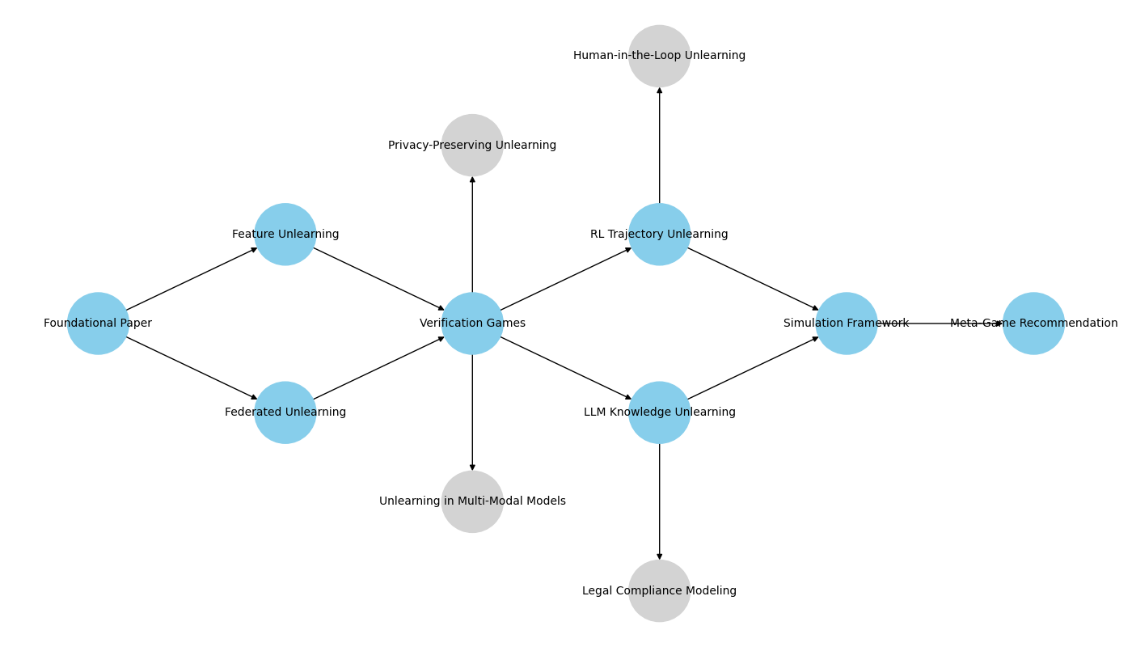

📅 Month-by-Month Breakdown
Month | Phase
1–2 | Literature Review & Taxonomy
3–4 | Mathematical Framework Development
5–6 | Strategy Mapping & Comparative Analysis
7–8 | Verification Protocol Design
9–10 | Simulation & Validation
11–12 | Recommendation Engine & Finalization

🔹 Month 1–2: Literature Review & Taxonomy Construction
Milestones:
- Conduct comprehensive literature review on machine unlearning and game theory.
- Identify gaps in current unlearning strategies and strategic modeling.
- Construct taxonomy of models (DNNs, LLMs, GNNs, etc.) and unlearning settings (feature, federated, sequential, etc.).
Deliverables:
- Annotated bibliography.
- Taxonomy matrix of model-setting pairs.

🔹 Month 3–4: Mathematical Framework Development
Milestones:
- Define game-theoretic components: players, strategies, payoffs, equilibrium concepts.
- Formalize generic game structure applicable across unlearning scenarios.
Deliverables:
- Mathematical model document.
- Formal definitions of strategic components.

🔹 Month 5–6: Strategy Mapping & Comparative Analysis
Milestones:
- Map each model-setting pair to suitable game-theoretic strategies (e.g., Nash, Stackelberg, Bayesian).
- Compare strategies based on expressiveness, tractability, and privacy-utility tradeoffs.
Deliverables:
- Strategy mapping tables.
- Comparative analysis report.

🔹 Month 7–8: Verification Protocol Design
Milestones:
- Design verification mechanisms (audit games, adversarial probing, indistinguishability tests).
- Formalize verification payoffs and equilibrium conditions.
Deliverables:
- Verification protocol specification.
- Example verification scenarios.

🔹 Month 9–10: Simulation & Validation
Milestones:
- Select 2–3 model-setting pairs for simulation.
- Implement simplified simulations using synthetic or benchmark datasets.
- Analyze equilibrium outcomes and strategy performance.
Deliverables:
- Simulation codebase.
- Evaluation report with graphs and metrics.

🔹 Month 11–12: Recommendation Engine & Finalization
Milestones:
- Build a rule-based or meta-game-based recommendation engine.
- Integrate all findings into a cohesive framework.
- Write and submit the final paper.
Deliverables:
- Recommendation engine prototype.
- Final research paper.
- Presentation slides for defense or publication.

⚠️ Risk Mitigation Strategies
The following table outlines key risks associated with the foundational research and the corresponding mitigation strategies.
Risk | Description | Mitigation Strategy
Modeling Complexity | Difficulty in modeling multi-agent dynamics in high-dimensional ML models. | Use simplified models, modular design, and consult experts.
Verification Challenges | Hard to verify unlearning in black-box models like LLMs. | Use adversarial probing, synthetic datasets, and statistical metrics.
Scalability of Simulations | Simulations may be computationally expensive. | Use sampling, surrogate models, and parallel computing.
Generalizability Across Models | Framework may not generalize across diverse ML architectures. | Design modular framework, include model-specific adaptations, and validate broadly.
Ambiguity in Strategic Behavior | Stakeholders may not behave rationally. | Use bounded rationality, Bayesian games, and human-in-the-loop feedback.
Ethical and Legal Compliance | Risk of misalignment with privacy laws and ethics. | Consult legal experts, model compliance costs, and plan legal modeling extensions.
Publication and Peer Review Risks | Framework may be seen as too theoretical. | Include strong simulations, case studies, and seek early peer feedback.

✅ Methodology Enhancements for Risk Mitigation – Foundational Paper
To mitigate the risk that foundational paper—“A Comparative Game-Theoretic Framework for Machine Unlearning”—may be perceived as too theoretical, here are concrete steps to include in your methodology that align with your risk mitigation strategy of incorporating strong simulations, case studies, and early peer feedback:

1. Simulation-Driven Validation
Goal: Ground theoretical models in empirical evidence.
Steps:
- Select 2–3 representative model-setting pairs (e.g., LLM + Knowledge Unlearning, Recommender + Feature Unlearning).
- Implement simplified simulations using synthetic or benchmark datasets.
- Measure key metrics: privacy gain, utility loss, equilibrium stability, verification confidence.
- Use visualizations (e.g., payoff matrices, strategy evolution graphs) to demonstrate outcomes.
Tools: Python, PyTorch/TensorFlow, game-theoretic simulation libraries (e.g., Gambit, OpenSpiel).

2. Case Study Integration
Goal: Demonstrate real-world applicability.
Steps:
- Identify realistic use cases (e.g., GDPR-driven unlearning in recommender systems, policy forgetting in RL agents).
- Map each case to a specific game-theoretic strategy (e.g., Stackelberg for LLMs, Bayesian for feature unlearning).
- Include narrative walkthroughs showing how the framework guides decision-making.
- Highlight tradeoffs and stakeholder incentives in each case.
Sources: Public datasets (e.g., MovieLens, OpenAI Gym), anonymized institutional data (if available).

3. Early Peer Feedback Loop
Goal: Refine theoretical constructs and validate relevance.
Steps:
- Share draft framework and simulation results with domain experts in ML, privacy, and game theory.
- Conduct structured feedback sessions (e.g., surveys, interviews, workshops).
- Document feedback and incorporate revisions into strategy mapping, equilibrium modeling, and verification protocols.
- Optionally, include a “Peer Feedback Summary” section in the paper.
Channels: Academic mailing lists, research forums, internal lab reviews, conferences (e.g., NeurIPS, AIES).

4. Comparative Strategy Performance Table
Goal: Make theoretical insights actionable.
Steps:
- Create a summary table comparing game-theoretic strategies across model-setting pairs.
- Include columns for: expressiveness, tractability, simulation results, verification feasibility, stakeholder alignment.
- Use this table to support the recommendation engine and scenario-specific strategy selection.

5. Modular Framework Demonstration
Goal: Show extensibility and practical utility.
Steps:
- Highlight how the framework supports plug-and-play modules for different models and settings.
- Demonstrate how future papers (e.g., federated unlearning, adversarial verification) build on this foundation.
- Include a visual roadmap or meta-game design sketch to illustrate modularity.

Would you like help drafting simulation designs or creating a peer feedback survey template? I can also assist in building the comparative strategy table or visualizing the roadmap.

Here’s a draft simulation design tailored to your foundational paper on the game-theoretic framework for machine unlearning. These steps aim to empirically validate your theoretical constructs and mitigate the risk of the framework being perceived as overly abstract.

🧪 Simulation Design Steps – Risk Mitigation – Foundational Paper
Step 1: Select Model-Setting Pairs
Choose 2–3 representative combinations from your taxonomy:
- LLM + Knowledge Unlearning
- Recommender System + Feature Unlearning
- Federated Learning + Client Unlearning
These should reflect diversity in architecture, strategic complexity, and verification challenges.

Step 2: Define Game-Theoretic Models
For each pair:
- Specify the players (e.g., model provider, data provider, verifier).
- Define strategies (e.g., request unlearning, retain data, verify).
- Assign payoffs (e.g., privacy gain, utility loss, compliance cost).
- Choose appropriate game models:
  - LLM: Stackelberg or Bayesian Stackelberg
  - Recommender: Bayesian or Cooperative
  - Federated: Multi-stage Stackelberg or Extensive-form

Step 3: Implement Synthetic Data Scenarios
Create synthetic datasets that simulate:
- User preferences (for recommender systems)
- Knowledge embeddings (for LLMs)
- Client contributions (for federated learning)
Ensure datasets are small enough for tractable simulation but rich enough to reflect realistic dynamics.

Step 4: Simulate Strategic Interactions
Use a simulation framework (e.g., Python + OpenSpiel or custom logic) to:
- Run multiple rounds of strategic interaction.
- Track equilibrium emergence (e.g., Nash, Stackelberg).
- Measure outcomes: privacy gain, utility loss, verification success.
Include adversarial probes to test unlearning effectiveness.

Step 5: Analyze Results
For each simulation:
- Plot payoff distributions and strategy evolution.
- Compare outcomes across game models.
- Evaluate tradeoffs (e.g., privacy vs. utility, verification confidence vs. cost).
Use metrics like:
- KL divergence for indistinguishability
- Accuracy drop for utility loss
- Coalition stability for cooperative games

Step 6: Document and Visualize
- Create tables comparing strategy performance.
- Include graphs showing equilibrium convergence.
- Summarize findings in a simulation report.

OpenSpiel
OpenSpiel is an open-source framework developed by DeepMind for research and development in game theory, reinforcement learning, and multi-agent learning. It provides a unified platform to simulate and analyze various types of games, including:
🎮 Key Features of OpenSpiel
- Supports many game types: Normal-form, extensive-form, stochastic games, matrix games, and more.
- Implements classic games: Prisoner's Dilemma, Tic-Tac-Toe, Go, Poker, and custom strategic games.
- Multi-agent learning: Useful for simulating interactions between multiple players with different strategies.
- Integration with ML frameworks: Compatible with TensorFlow and PyTorch for learning-based simulations.
- Equilibrium computation: Includes algorithms for computing Nash equilibria and other solution concepts.

🧠 Why It's Relevant to Your Research
For your foundational paper on machine unlearning as a strategic game:
- You can model interactions between model providers, data providers, and verifiers.
- Simulate Stackelberg, Bayesian, and cooperative games.
- Analyze equilibrium outcomes and strategy performance.
- Validate your framework with empirical simulations.

🧪 OpenSpiel Simulation Setup for Machine Unlearning
✅ Step 1: Install OpenSpiel
You’ll need Python and CMake installed. Then run:
git clone https://github.com/deepmind/open_spiel.git
cd open_spiel
mkdir build &amp;&amp; cd build
cmake -DCMAKE_BUILD_TYPE=Release ..
make -j$(nproc)
To use Python bindings:
pip install -e open_spiel

✅ Step 2: Define Your Game
You’ll create a custom game to simulate unlearning dynamics. For example:
- Players: Model Provider, Data Provider, Verifier
- Actions:
  - Model Provider: Unlearn, Retain
  - Data Provider: Request, Accept, Challenge
  - Verifier: Probe, Certify
- Payoffs:
  - Privacy Gain, Utility Loss, Compliance Cost
Use OpenSpiel’s Python API to define this as a normal-form or extensive-form game.

✅ Step 3: Implement Game Logic
Here’s a simplified Python sketch using OpenSpiel’s matrix game API:
import pyspiel

# Define a 2-player matrix game (Model Provider vs Data Provider)
game = pyspiel.create_matrix_game(
"unlearning_game",
"Unlearning Game",
["Unlearn", "Retain"], # Model Provider actions
["Request", "Challenge"], # Data Provider actions
[[3, 1], [0, 2]], # Model Provider payoffs
[[2, 0], [3, 1]] # Data Provider payoffs
)

# Simulate a single play
state = game.new_initial_state()
print("Initial state:", state)
You can extend this to multi-player or sequential games using pyspiel.GameType and pyspiel.GameParameters.

✅ Step 4: Run Equilibrium Analysis
Use built-in solvers to compute equilibria:
from open_spiel.python.algorithms import lp_solver

solution = lp_solver.solve_zero_sum_matrix_game(game)
print("Nash Equilibrium:", solution)
For non-zero-sum or Stackelberg games, you’ll need custom logic or external solvers.

✅ Step 5: Visualize and Analyze
Export results:
- Strategy profiles
- Payoff distributions
- Equilibrium stability
Use Python libraries like matplotlib, seaborn, or networkx for visualization.

Would you like me to generate a full Python script for one of your model-setting pairs (e.g., LLM + Knowledge Unlearning using Stackelberg dynamics)?

