

A Project Report On

**Online Book Shop**

**By**

**Abhishek Irudhaya Raj**

**Batch:** 2022 – 6518

**Center: Chennai**

Under the Guidance of,

**Chittaranjan Ghosh.**

**Technical Trainer**

**EduBridge**

(School of coding)

## Introduction:

Online Book Shop is an Online Web Application. It is developed for the people, who wants to buy a books.It manages the data of the books which is in the bookshop. It is helpful for the customer to buy a book through online, So it will reduce their time and energy. It also reduces the load on the shop owner of knowing the quantity of books available in which books are available and keeps the record of how many books are purchased and sold sold. It is very easy for the customer to access.

. **Modules:-**

* Admin Module
* Customer Module

I have developed this Application in **Java, MySQL.** It’s a web-based projects

The main objective of the Online Book Shop is to reduce manual work and time. It is difficult and time-consuming for the customer to go shop and buy a book. To avoid this problem, we have planned to develop a web-based Online Book Shop .

**Admin Module** - Admin can add or remove a book from the database. he can view the order details and update it.

**Customer Module** - Customer can order a book and that details will be save in a order details, and they can add a book to a cart. so that they can find it easier to buy later.

**Software Requirements:**

**Front end:** Java

**Back end**: MySQL workbench 8.0 CE.

# 

# DataBase(Online Book Shop)

**Tables:**

**Admin Details:**

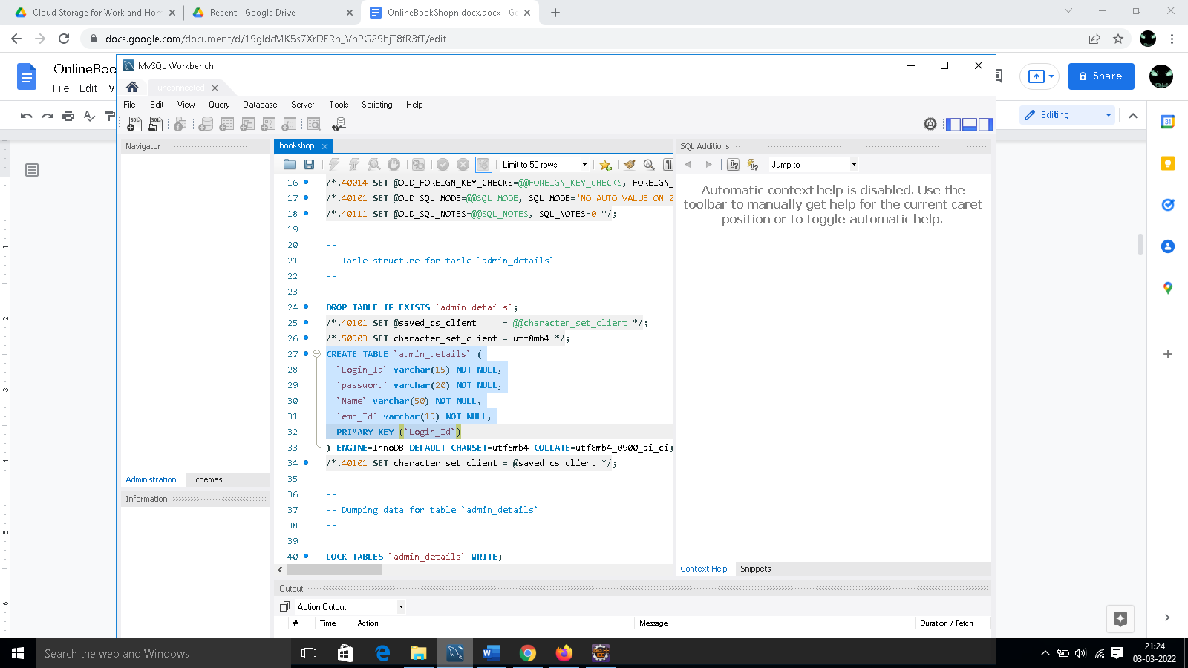

**Customer Details:**

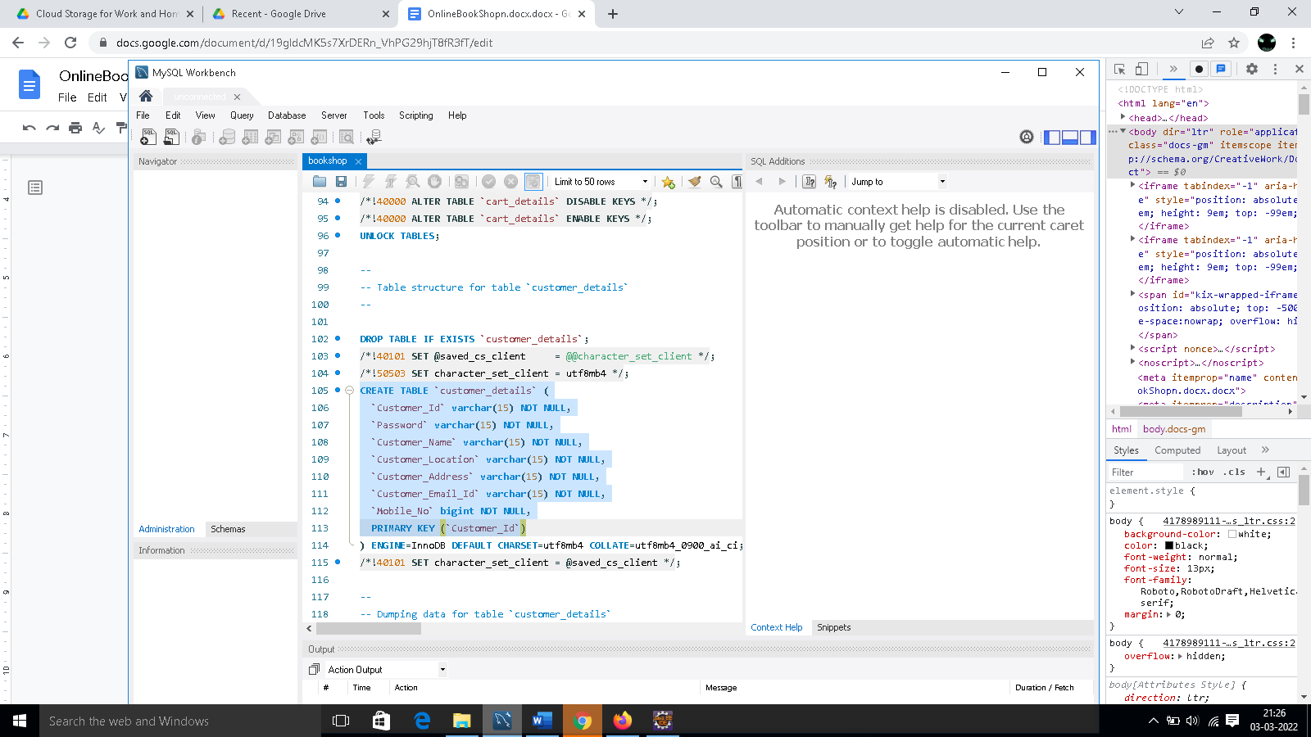

**Order Details:**

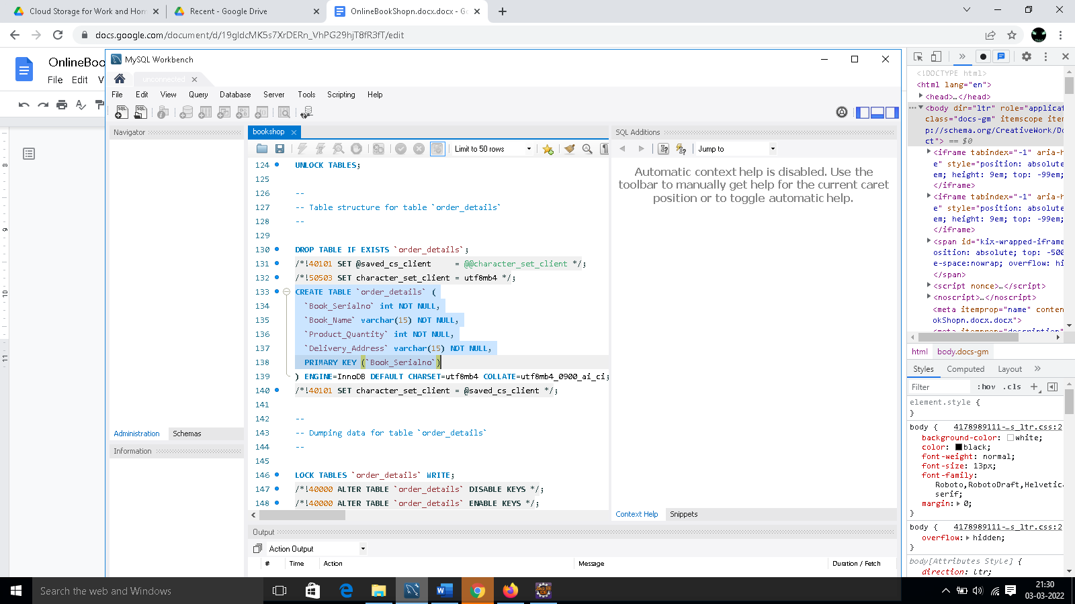

**Book Details:**

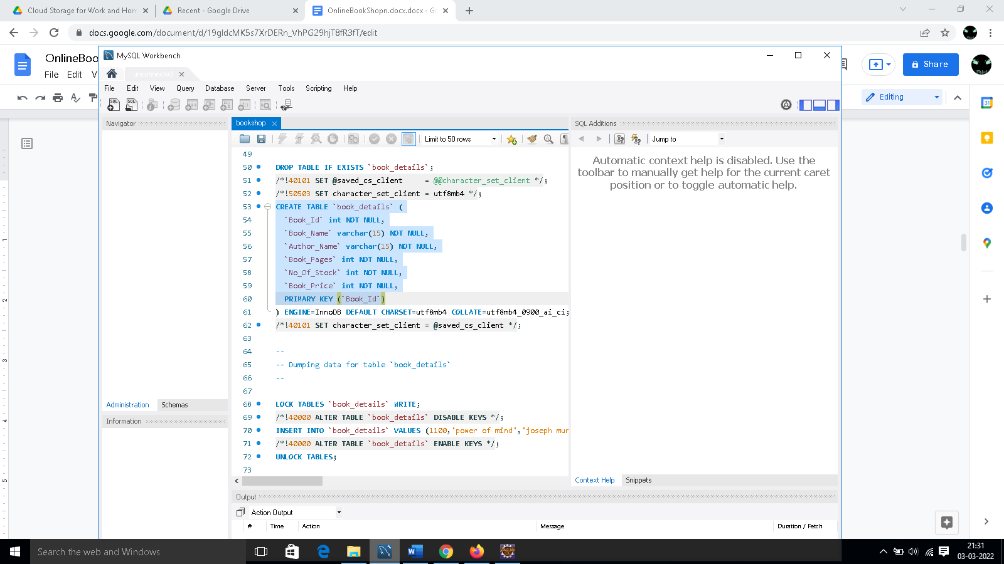

**Cart Details:**

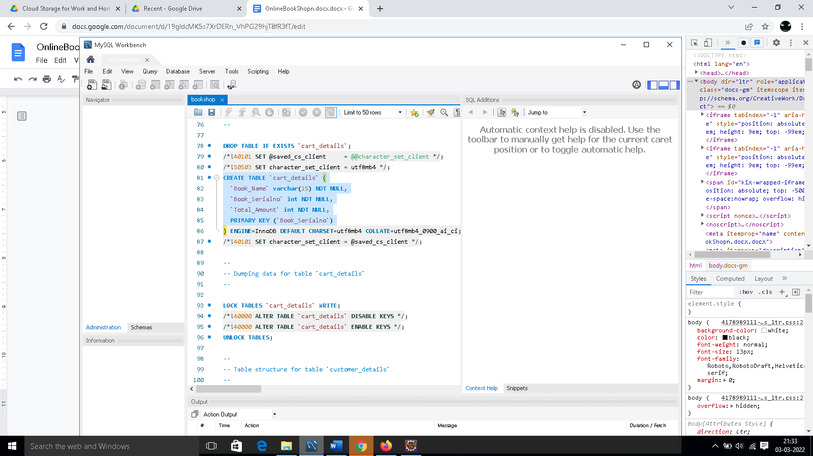

**Console Outputs:**

1. **Login Page:**

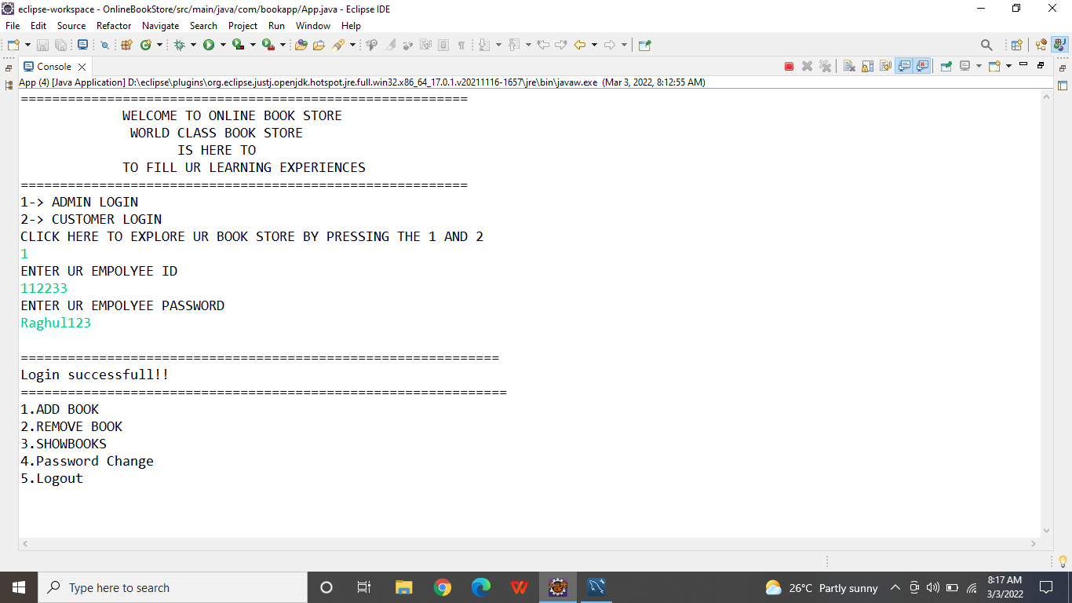

1. **Add Book Page:**

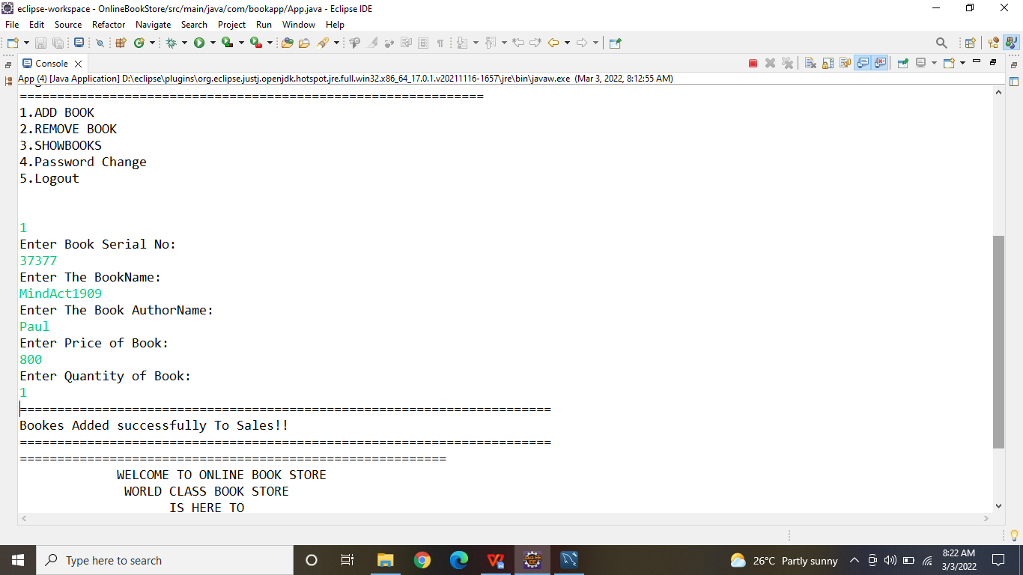

1. **Delete Book page:**

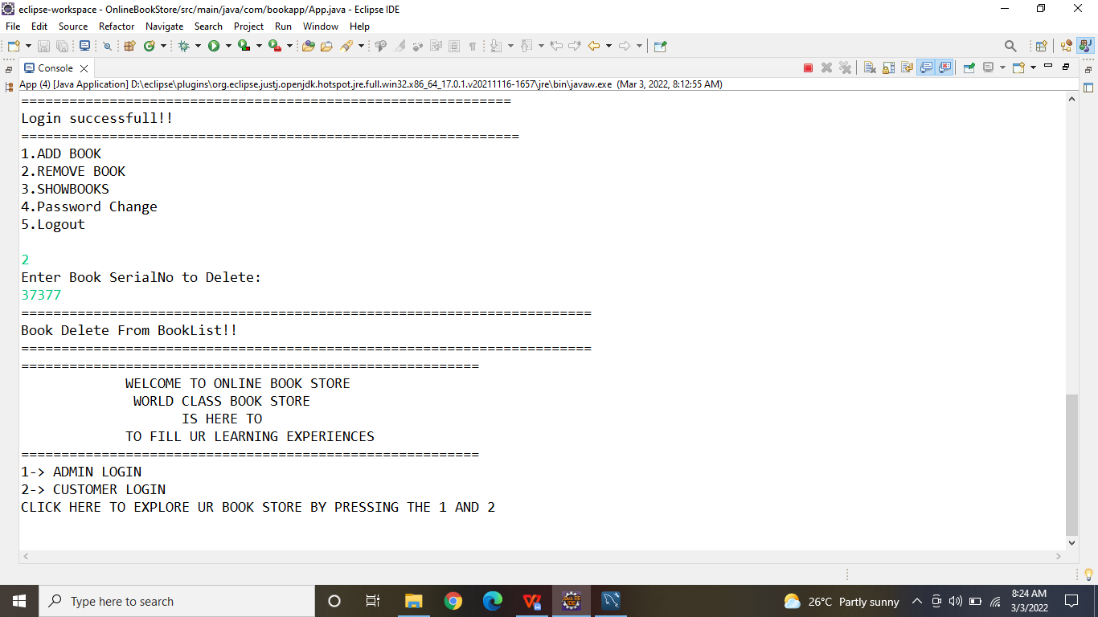

1. **Logout :**

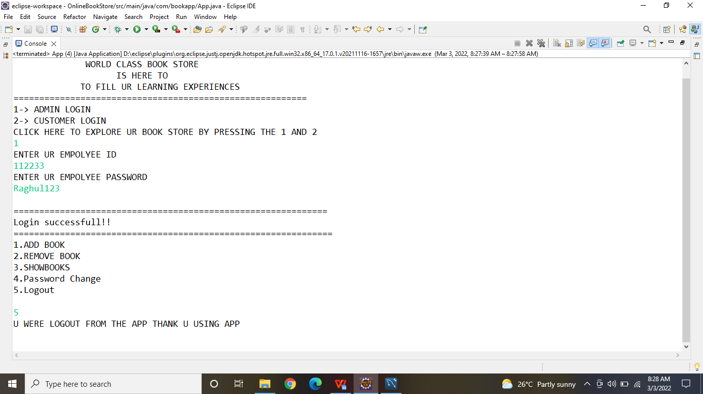

**Customer Page:**

1. **Regitration page :**

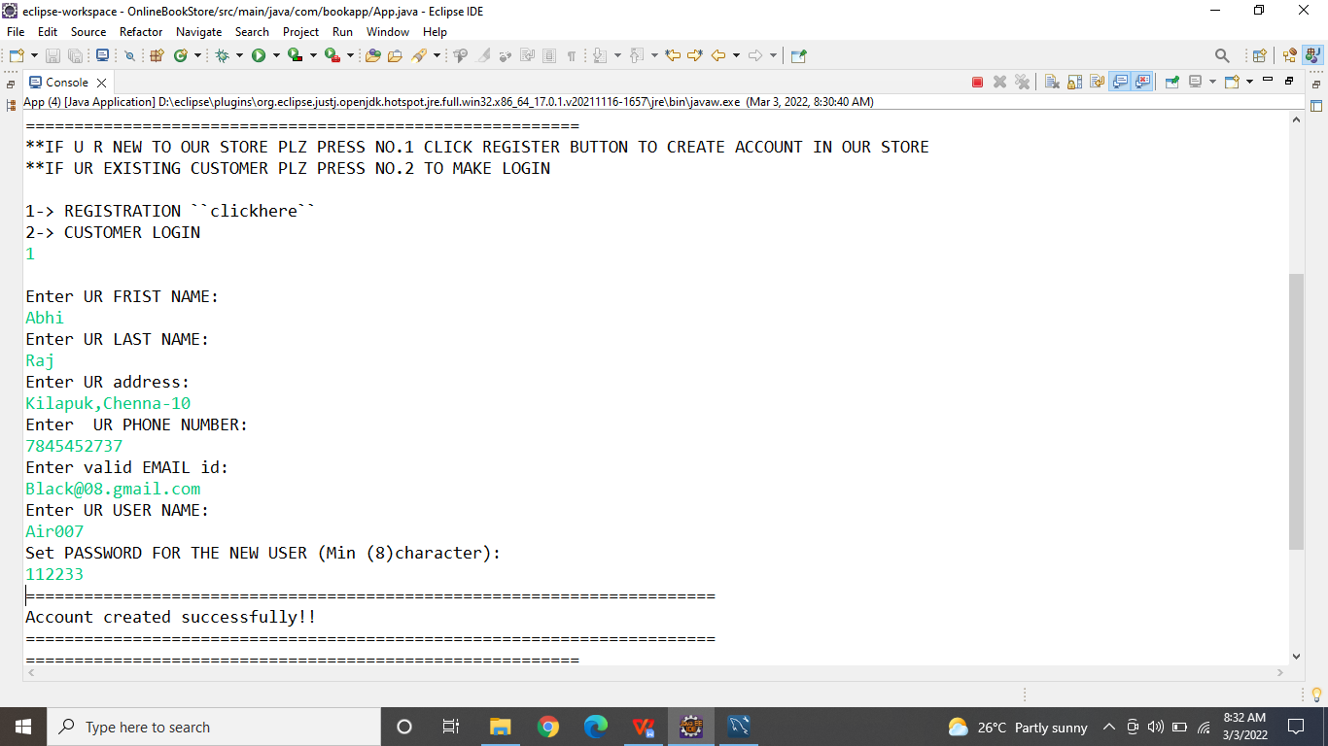

**2.Login Page:**

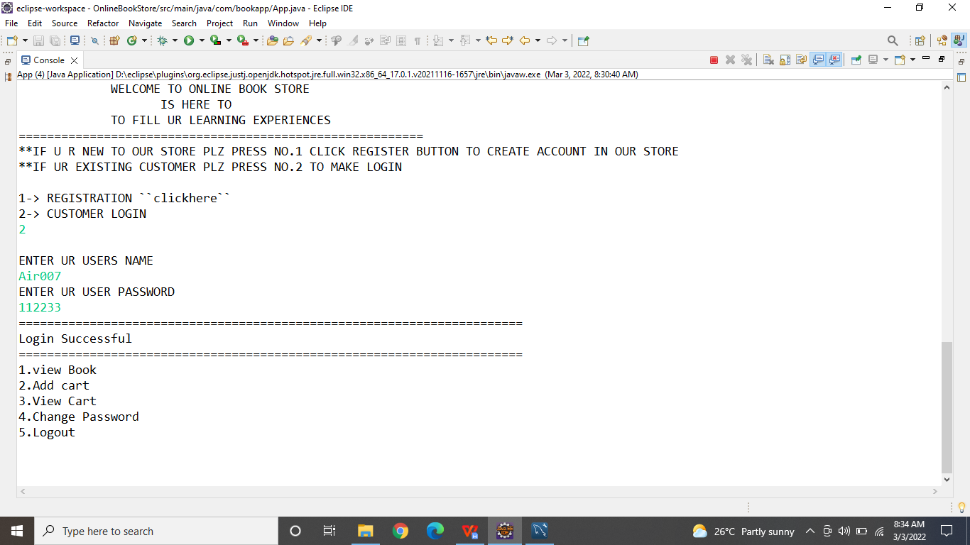

**3.BookList page:**

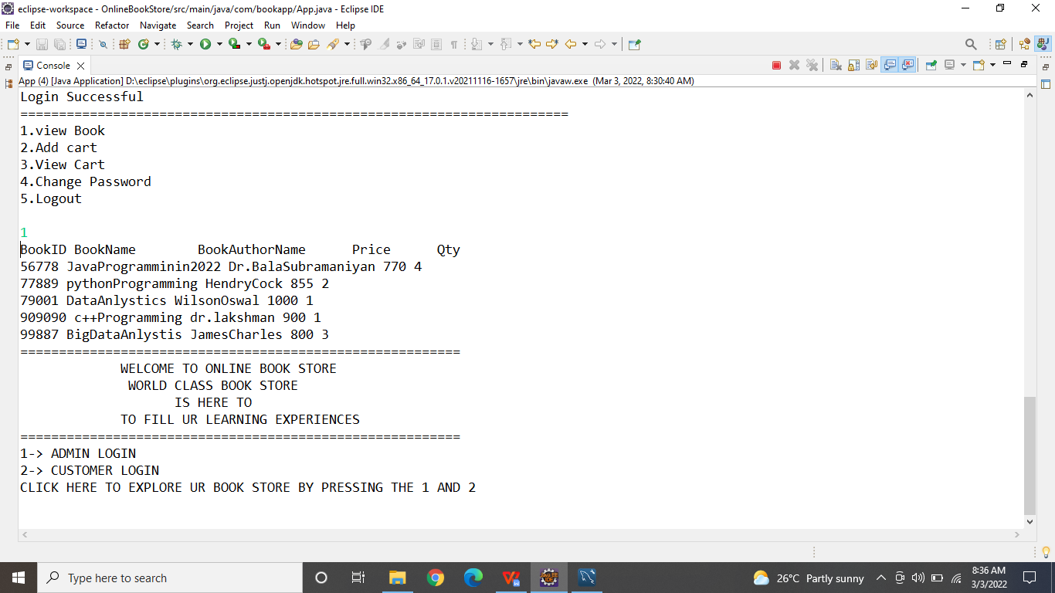

**4.Add TO Cart page:**

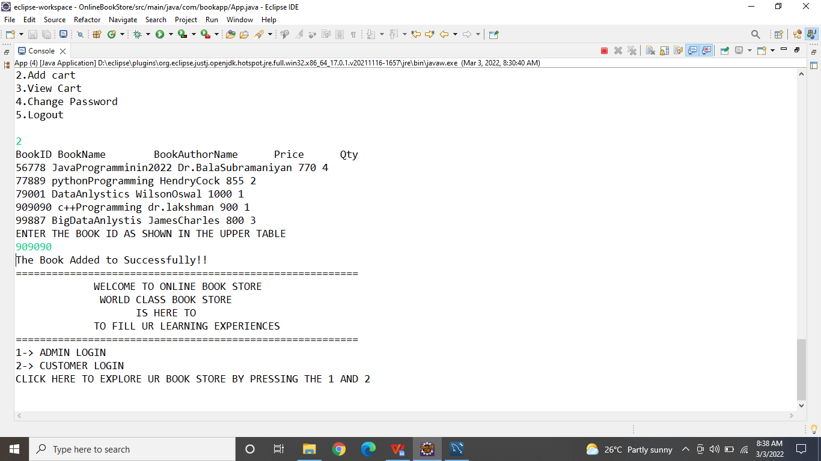

1. **View Cart:**

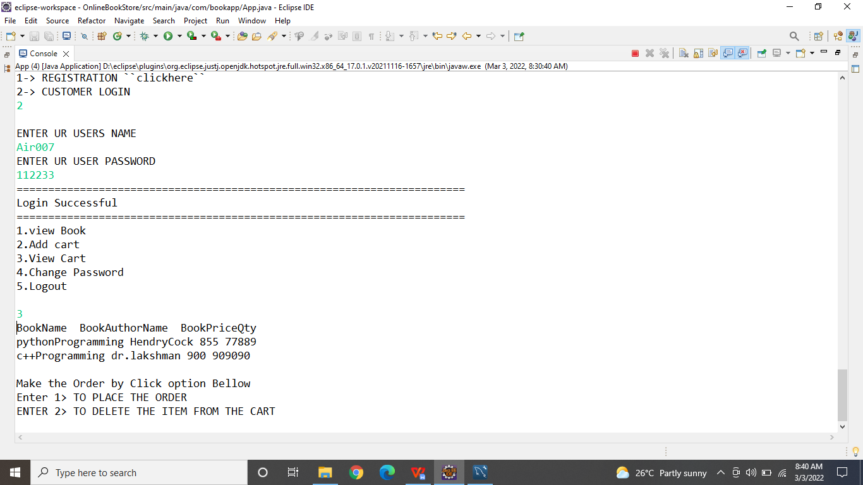

1. **Delete From Cart:**

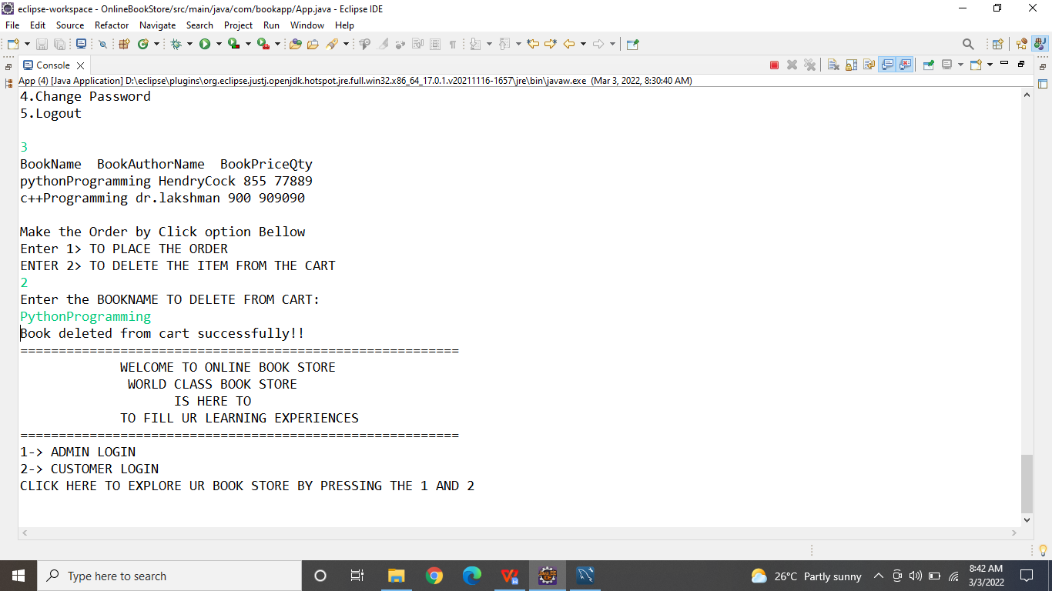

1. **Place Order:**

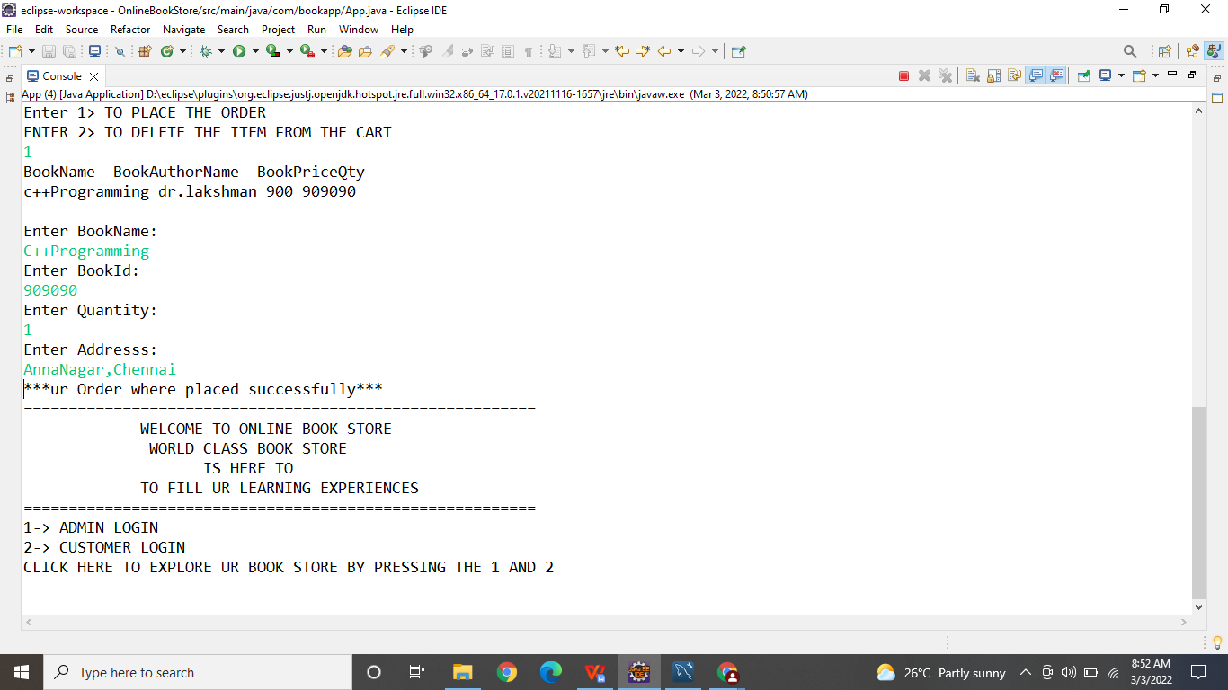

1. **Logout Customer:**

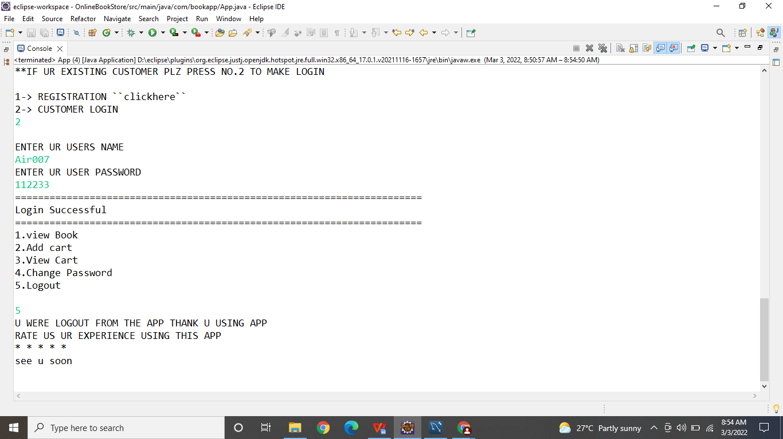

**Conclusion:**

**This Web Application will reduce the load for the shop owner to maintain the book records**. And also useful for the customer to order in simple to purchase a book and save their time and energy.

**Thank you !**