Movie App CICD

Step1:- Create Security Groups on AWS

Ports to be Enable in Security Group
Service | Port
HTTP | 80
HTTPS | 443
SSH | 22
Jenkins | 8080
SonarQube | 9000
Prometheus | 9090
Node Exporter | 9100
Grafana | 3000

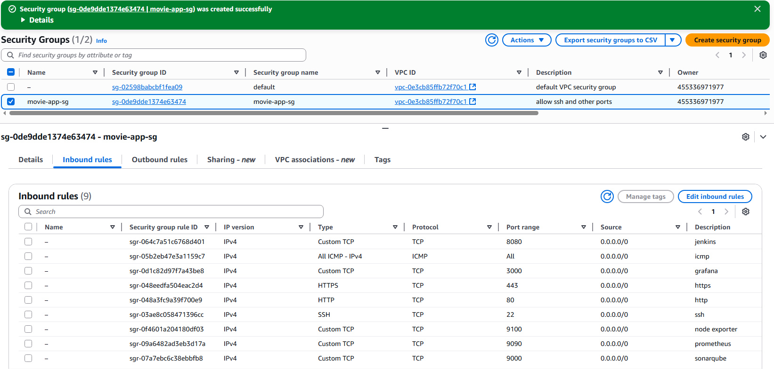
Step2:- Create EC2 instance using t3.medium and storage with min 16 GiB.
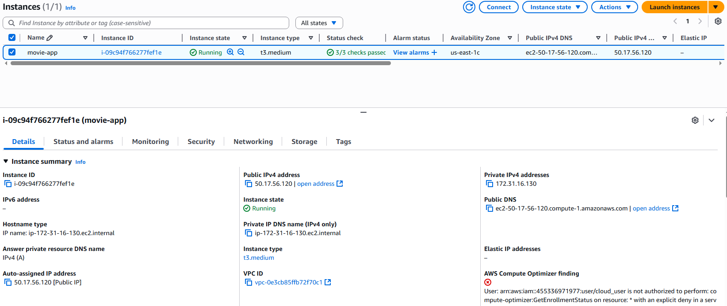
Step3:- Connect using EC2 Instance Connect
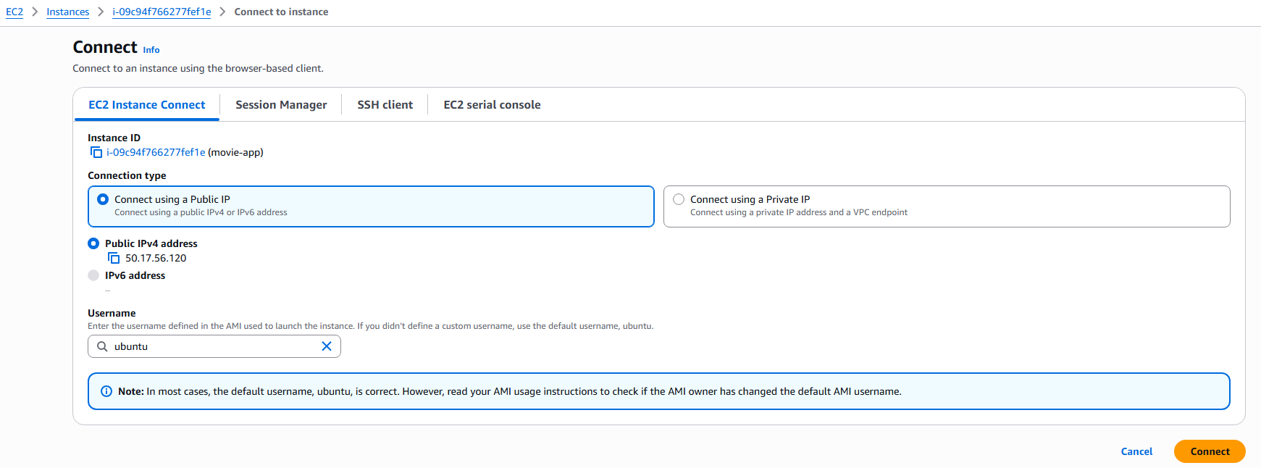
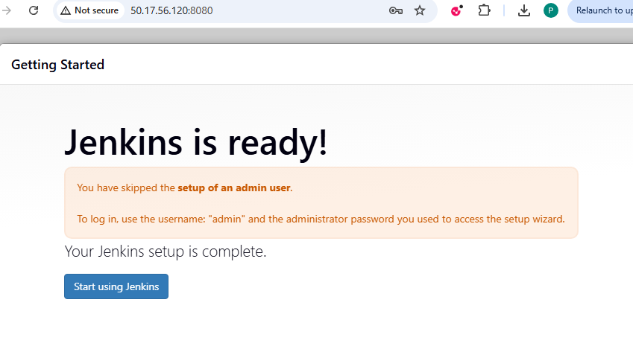
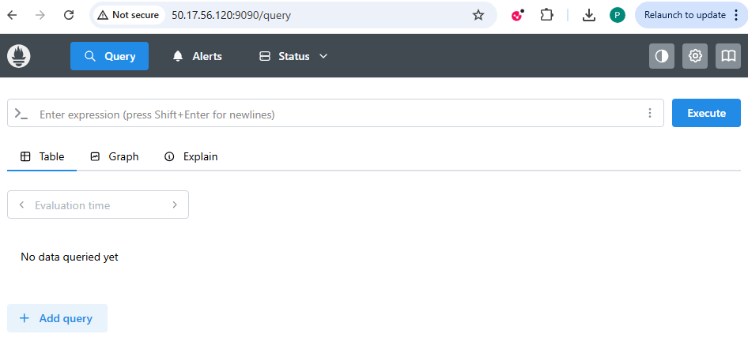
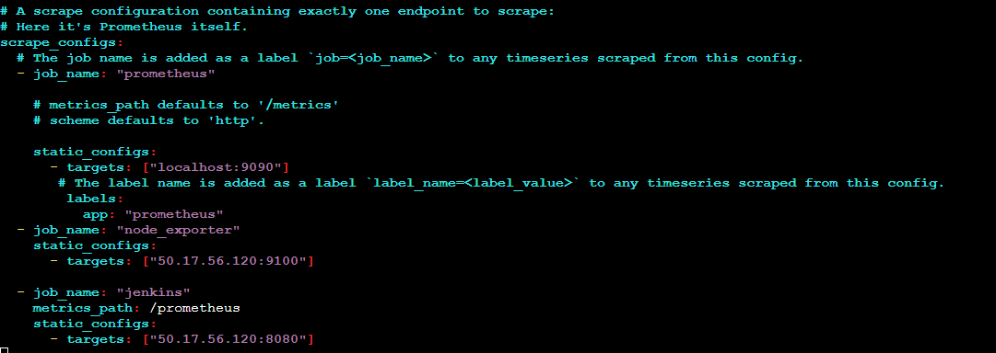
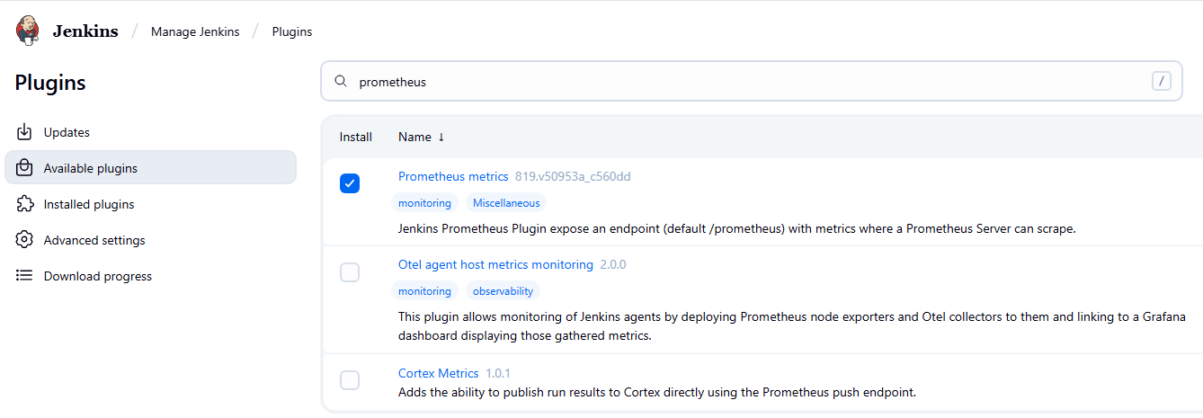
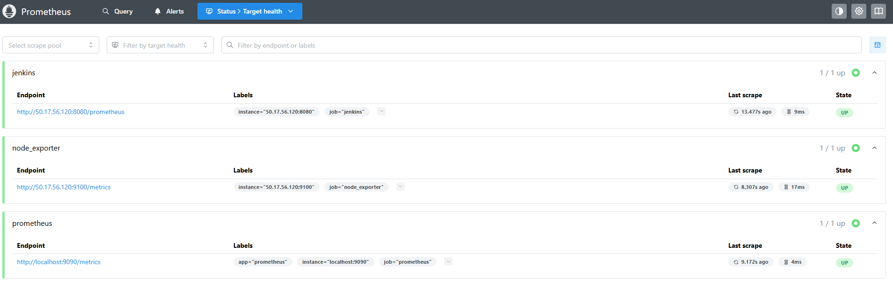
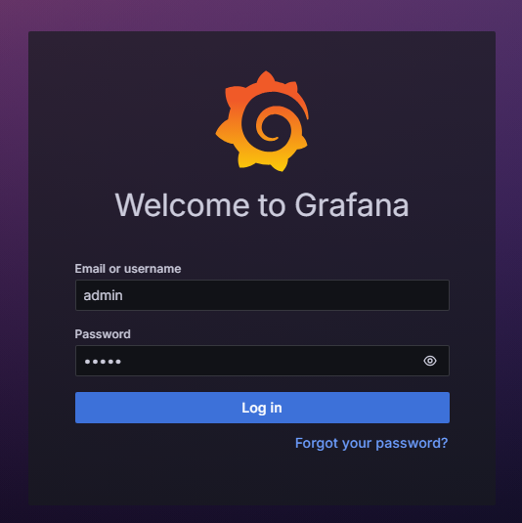
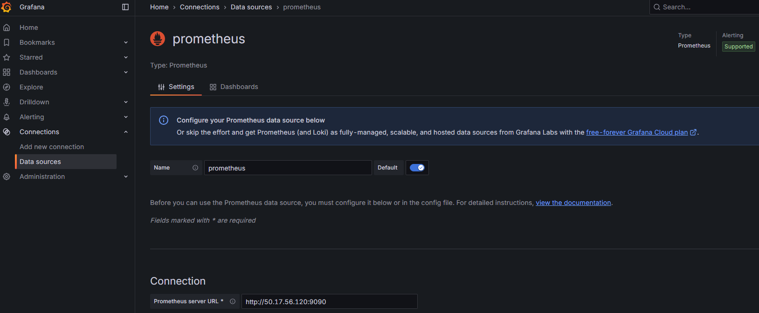
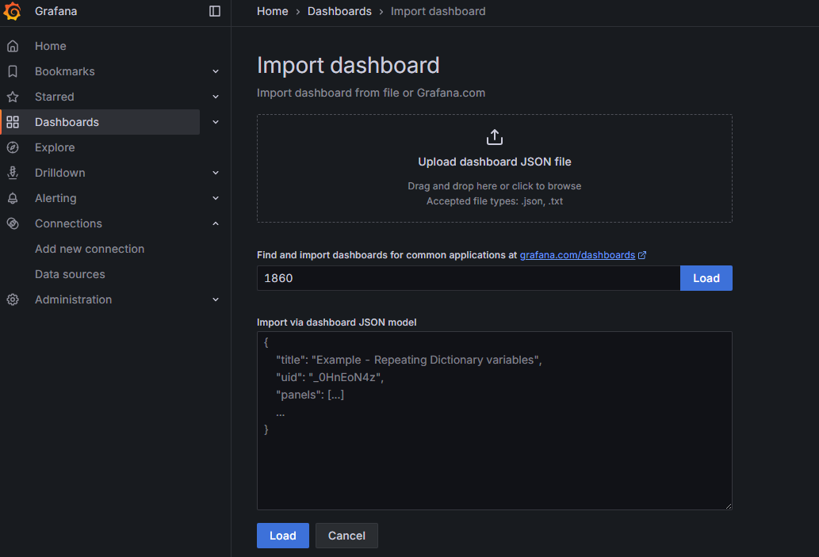
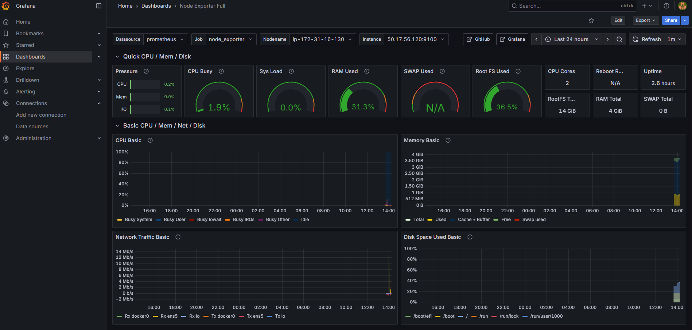

Jenkins Plugins to Install
- Eclipse Temurin installer Plugin
- NodeJS
- Email Extension Plugin
- OWASP Dependency-Check Plugin
- Pipeline: Stage View Plugin
- SonarQube Scanner for Jenkins
- Prometheus metrics plugin
- Docker API Plugin
- Docker Commons Plugin
- Docker Pipeline
- Docker plugin
- docker-build-step

