DETECTION OF LUNG PNEUMONIA USING ARTIFICIAL INTELLIGENCE

Vishwash Sharma¹, Vinay K², T.Devendranath Reddy³, P Mokshith⁴ , Sudha Yadav⁵, M. Nithya⁶,Surekha.p⁷
Department of Electrical and Electronics Engineering,

Amrita School of Engineering, Bengaluru,
Amrita Vishwa Vidyapeetham, India.
¹bl.en.u4aie21144@bl.students.amrita.edu,² bl.en.u4aie21142@bl.students.amrita.edu,³ bl.en.u4aie21129@bl.students.amrita.edu,
⁴ bl.en.u4aie21094@bl.students.amrita.edu, ⁵sy_sudha@blr.amrita.edu, ⁶m_nithya@blr.amrita.edu, ⁷p_surekha@blr.amrita.edu

Abstract— Pneumonia is a condition that affects the lungs and is brought on by a bacterial infection. Early diagnosis is a key component of a successful treatment approach. An experienced radiologist will typically identify the condition using chest X-ray images. When determining the existence of diseases that may not be obvious in chest X-ray pictures or may be mistaken with other diseases, for example, a diagnosis may be subjective. Therefore, computer-aided diagnostic technologies are required to guide the practitioners. This study analyzed a number of research publications on the automated computer-aided identification of pneumonia using deep learning and convolutional neural networks. It then compared several models based on their effectiveness and conclusions.

Keywords— Deep learning, Machine learning, Convolution Neural Network.

- INTRODUCTION

Pneumonia is a viral or bacterial disease found in the lungs. It primarily affects the small air sacs known as Alveoli and dry cough, chest pain, fever, and difficulty breathing are symptoms of pneumonia. To identify the disease, the patient undergoes the diagnosis test like chest X-rays (CXR), blood tests and culture of sputum to conform presence or absence of disease. The risk factors of the pneumonia include cystic fibrosis, chronic obstructive pulmonary disease (COPD), sickle cell disease, asthma, diabetes, heart failure, finally, a weak immune system.

Pneumonia is one of the diseases that would affect our breathing system and even could cause death if it is in outburst stage. For detection of this disease, the doctors would take time for identification. The output of this disease would

threat entire world and grabs the entire medicine researcher’s sight. The deaths, children who are under 5, because of pneumonia were outbroken around 800,000 in 2017 and this continuous for future years. Even though there were diagnosis processes for this disease, the deaths are recording at peak.

The concept of deep learning evolves from machine learning. The machine learning was first introduced by Donald Hebb on his book titled The Organization of Behavior. From then, the implementation of machine learning algorithms took place. Besides researchers had undergone numerous implementations and build steps for future through their success. Through deep learning, researchers had outputs which have various benefits in real world. There is no particular area which is dedicated for implementing this domine. At present, each and every industry adopting machine learning and deep learning technologies into their products, which turns-out user friendly.

For treating pneumonia is different for children and adults because of their different symptoms. Moreover, the children are so sensitive to treat. The Antibiotics, antivirals, antifungals, analgesics, cough suppressants will be used in medication for pneumonia prevention. If it reaches to beast mode, then the patient undergoes oxygen therapy. Moreover, the patient should take self-care like taking rest, drink plenty of liquids, and do not overstrain body. To overcome from pneumonia a patient should undergo for these treatments.

II. CODE

The code starts with the importing of all the libraries such as keras ,VGG16, Image processing,numpy,glob and matplot lib.

The dataset consists of 3000 images, divided into two parts Test and Train function in the ratio
75-25 Each file consists of Normal and Pneumonia Lung.

With the help of VGG-16, each image is given a weight, using Keras image is layered into 16parts each layer has a weight which helps in differentiating between each and every layer.
Once this is done we start training the Model to learn how to predict between the different lungs.
This involves 16 layers of Convolution, RELU(rectified linear unit), Pooling, and softmax.
Convolution does Sharpening of the image, Denoises it, and Filters an Image.
Rectified Linear Unit basically returns a value. If Input is positive and returns zero if it is negative.
Pooling Layers provide an approach to Down Sampling. Softmax Converts a numbers of vectors into a vector of probabilities.

We do 2 Epcohs , which gives us an accuracy of 93.2% which is a very good accuracy keeping in mind the number of Epchos done.using Model Fit generator.

Finally after the completion of model we use Tkinter to make a user interface to use the model,the model file can be saved and stored as .h5 or hf5f extension mainly used for AI models.

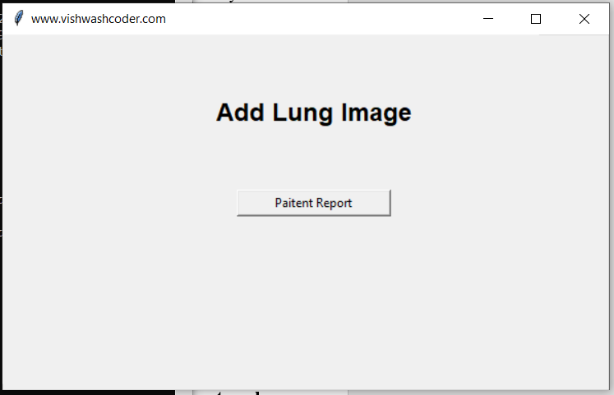

On Uploading a Paitent Lung X-Ray it gives the Result if the paitent is infected by Pneumonia or not this helps in Quick diagnosis and can be used at places where there is unavailability of doctors

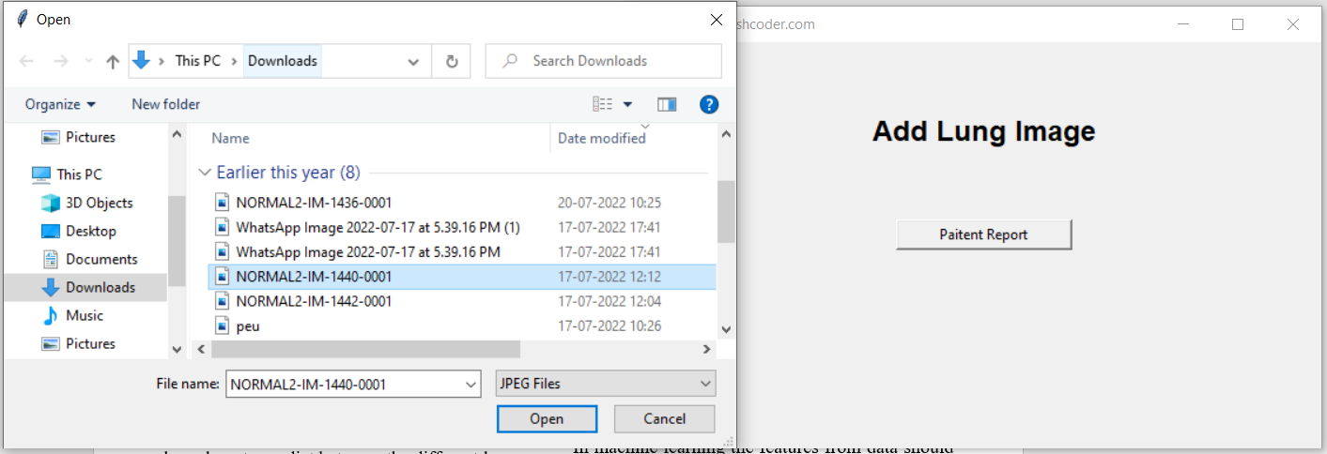

The final Reported Generated looks like the following in the User Interface.
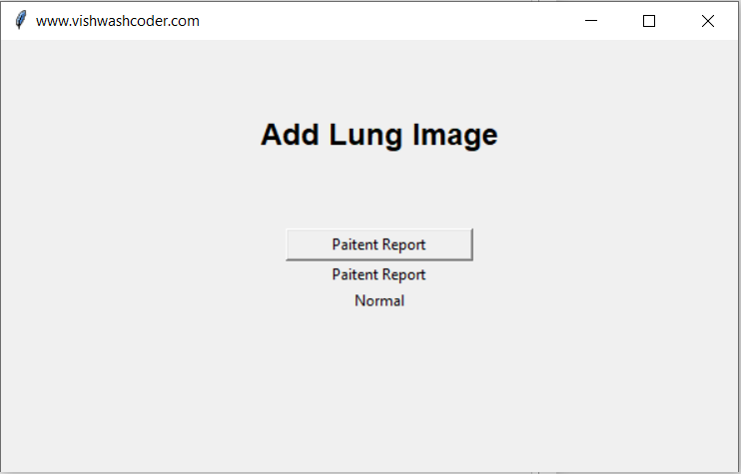

III. DEEP LEARNING

Deep learning is a subset of machine learning which is essentially a neural network with three or more layers. These neural networks attempt to simulate the behavior of the human brain. The concept of deep learning evolves from machine learning. Machine learning was first introduced by Donald Hebb from then, the implementation of machine learning algorithms took place.

Machine learning and Deep learning refer same. In machine learning the features from data should be explicitly given by the user but in deep learning the algorithm itself took the main features in the data. In other words, machine learning has lower computational power compared to deep learning.

Deep learning drives many artificial intelligence (AI) applications and services that improve automation, performing analytical and physical tasks without human intervention.

There are some deep learning algorithms which had already been made to solve the complex problem. Some deep learning algorithms are the feed-forward neural network, convolutional neural network, recurrent neural network, long short-term memory networks, autoencoders, and etc. In all algorithms, there are three types of layers: input layer, hidden layer, and output layer. The major computational part will be done in the hidden layer. Before knowing deep learning algorithms, one should know about the perceptron, basic cell or neuron, in machine learning.

Artificial neural networks, also known as deep learning neural networks, make an effort to imitate the human brain through the use of data inputs, weights, and bias. Together, these components accurately identify, categorise, and characterise items in the data.

Deep neural networks consist of numerous layers of interconnected nodes, each building upon the preceding layer to refine and optimise the prediction or categorization.

IV. Convolutional neural network

A convolutional neural network (CNN/ConvNet) is a deep learning algorithm that takes in images as input and assigns importance to various aspects of the image. CNN requires very little pre-processing. CNN image classifier takes an input, processes it, and classifies it under certain categories. The architecture of CNN is analogous to the neurons of the human brain.

The applications like image recognition, document analyzing, understanding climate come under convolution networks. Here, convolution neural network the extraction of main features, like edge detection, will be automatically takes place. For running these deep learning algorithms, we should have more computational power for boosting in time.

The activation function play has its unique role in decision making during data manipulation. There are several activation functions in convolution neural network. The most common and popular function is Rectified Linear Unit (ReLU). Because, it has its own path while dealing with negative values during computation. The most used activation function at the output layer is SoftMax, which deals with cumulative probability. It works like, the output with most cumulative probability value is considered.

We can say that the dimension reduction takes place from the padding. Here the padding is the process to create data groups in which the pooling applies.

Pooling layer helps in the dimension reduction. There is no loss in the features by extracting form data. There are two types of pooling in convolution layers: max pooling, Average or mean pooling. In max pooling, the highest value will be taken from group of selected data. As similar, in mean pooling the mean of all data which will be taken from selected data. These two pooling types plays a significance role in gather features from data.

Dropout layer can make the perceptron idle in hidden layer. As in convolution layers, we basically do manipulations thousands in number which may be enrouted to over-training. So, dropout layer prevents this glitch and can used to reduce overfitting in model while training the data.

Fully Connected layer, in general, the two-dimensional data is used during training in convolution layers. But the problem is these algorithms like feed forward, recurrent neural network or any algorithms does not support the multidimensional data while training or testing. But, the fully connected layer helps in converting the multi-dimension data to the single dimension data, which is used to train model.

Padding layer, We can say that the dimension reduction takes place from the padding. Here the padding is the process to create data groups in which the pooling applies.

CONCULSION

The main motto of this paper is to visualize the different convolution neural network frameworks and their respective performances towards the disease: pneumonia. More than couple of techniques, Vgg16, Vgg19, ResNet50, Inception, Modified CNN, ChexNet, R-CNN, CNN, Mask-RCNN, Transfer Learning (CNN), Dual Net architecture, were discussed in this paper including some transfer learning algorithms. From our work, Mask-RCNN showed better results in pneumonia detection with max accuracy. The deep learning algorithms has its benefits when comparative to machine learning algorithms. But the main problem is computational cost and is high. In each and every problem, like detection, prediction, classification, recommendation systems in medical industry adopting deep learning algorithms for better precise decisions. Moreover, the deep learning algorithms gives the results in no less than time which could be helpful to doctors in case of treatments.

REFERENCES

- Nadpara H, Kushwaha K, Patel R, Doshi N. A Survey of Cryptographic Techniques to Secure Genomic Data. Vol. 121, Lecture Notes in Networks and Systems. 2020. 777–789 p.
- Jaiswal AK, Tiwari P, Kumar S, Gupta D, Khanna A, Rodrigues JJPC. Identifying pneumonia in chest X-rays: A deep learning approach. Meas J Int Meas Confed. 2019;145:511–8.
- Kim DH, MacKinnon T. Artificial intelligence in fracture detection: transfer learning from deep convolutional neural networks. Clin Radiol. 2018;73(5):439–45.
- Rubin J, Sanghavi D, Zhao C, Lee K, Qadir A, Xu-Wilson M. Large scale automated reading of frontal and lateral chest x-rays using dual convolutional neural networks. arXiv. 2018.
- Rahmat T, Ismail A, Aliman S. Chest X-Ray Image Classification Using Faster R-Cnn. Malaysian J Comput. 2019;4(1):225–36.
- Jain R, Nagrath P, Kataria G, Sirish Kaushik V, Jude Hemanth D. Pneumonia detection in chest X-ray images using convolutional neural networks and transfer learning. Meas J Int Meas Confed. 2020;165:108046.
- Rajpurkar P, Irvin J, Zhu K, Yang B, Mehta H, Duan T, et al. CheXNet: Radiologist-level pneumonia detection on chest X-rays with deep learning. arXiv. 2017;3–9.
- [Ypsilantis PP, Montana G. Learning what to look in chest X-rays with a recurrent visual attention model. arXiv. 2017;(Nips):1–5.
- Mangal A, Kalia S, Rajgopal H, Rangarajan K, Namboodiri V, Banerjee S, et al. CovidAID: COVID-19 detection using chest X-ray. arXiv. 2020;1–10.
- Fourcade A, Khonsari RH. Deep learning in medical image analysis: A third eye for doctors. J Stomatol Oral Maxillofac Surg. 2019;120(4):279–8.

