**Data worked on:** Aral, dead sea, Lake powell

**Procedure**: output are based on Aral

1. The images were delineated into RBG formats. Red, green and blue, also the original photo was also shown so that user can clearly see the river or the lake part clearly.

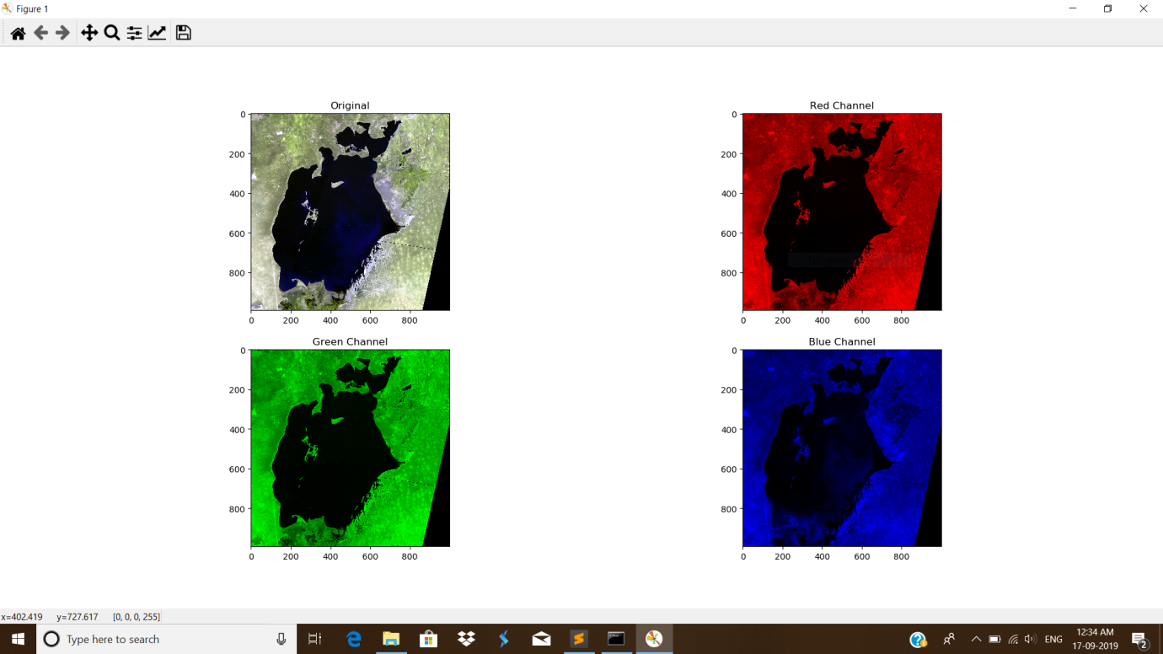

1. Various process of edge detection was programmed – Roberts, sobel, wistia, prewitt and canny…this help us to see the edges of rivers and other unsmoothing part of the image. But mainly it focused on the rivers and due to colouring display of these edge detection pictures on the surrounding parts, mainly the rivers dem onstrated its view at its best.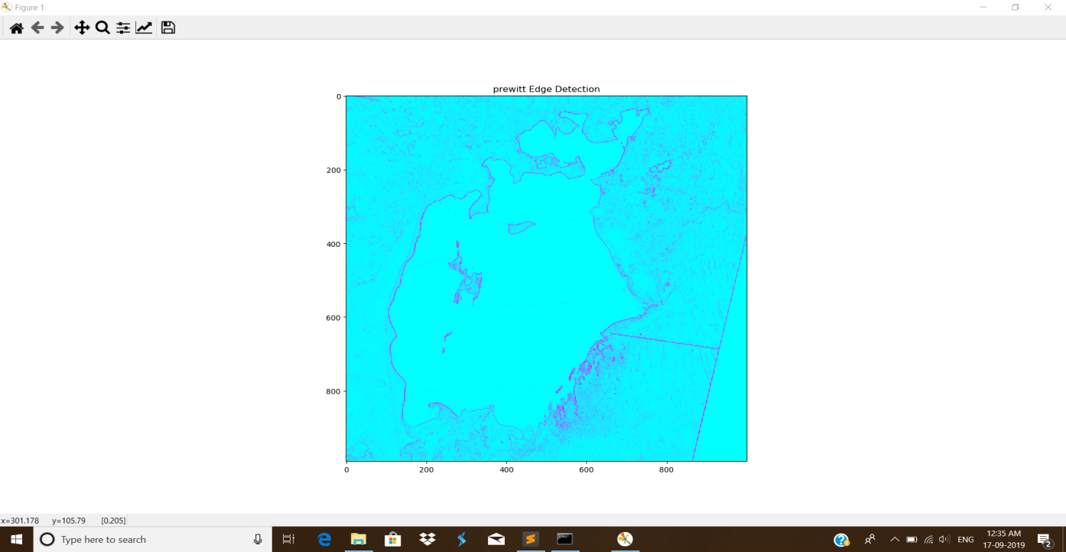

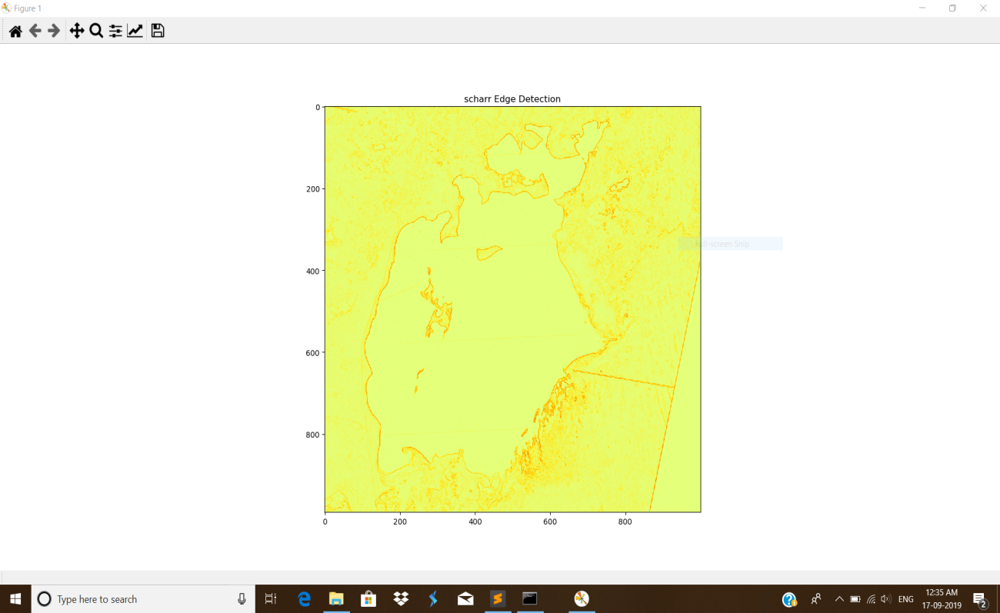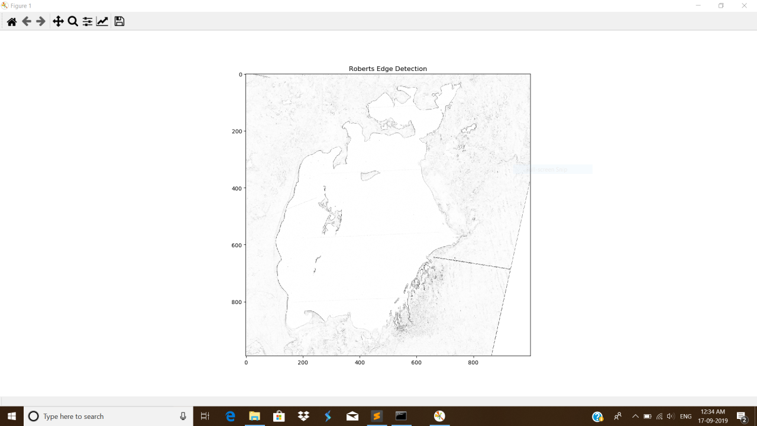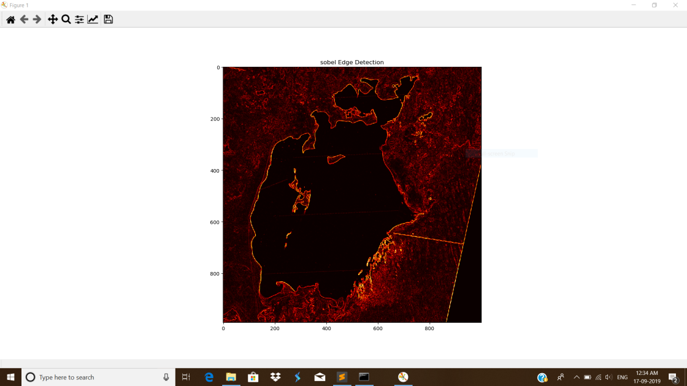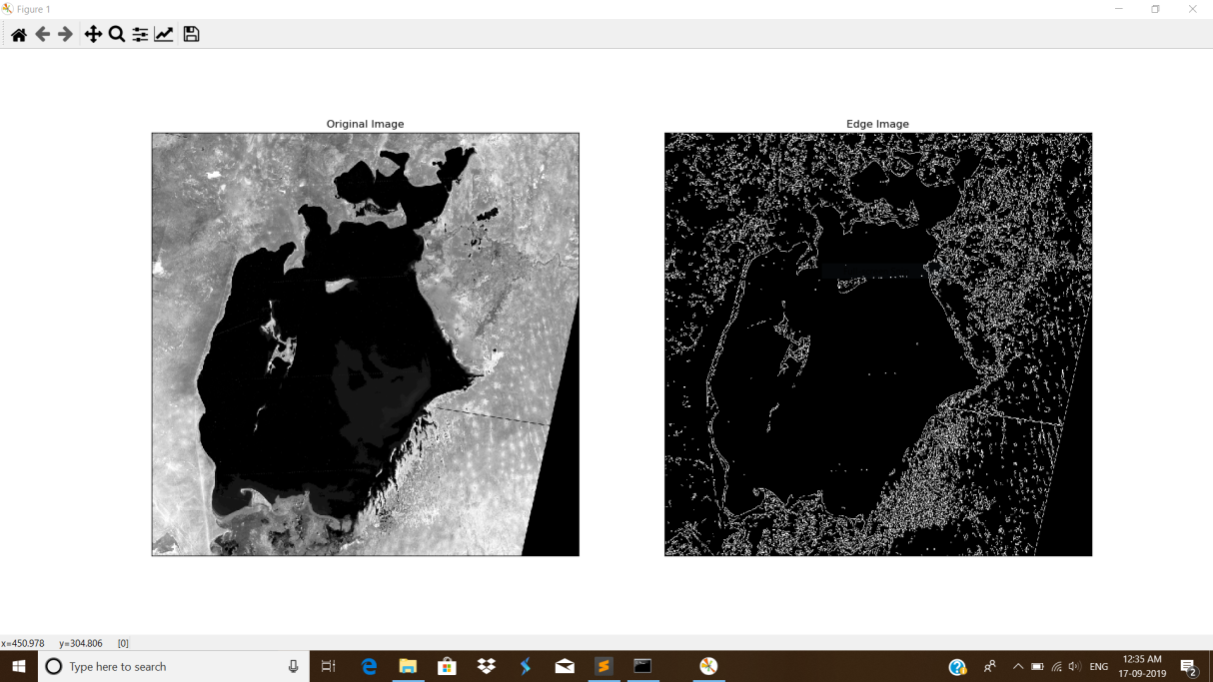

1. Lastly two difference has been taken…1) the difference ( changes on the picture of the original images like 1977_aral and 2006_aral) to see the changes on over all image. 2) After detection of rivers, best result shown by Prewitt edge detection, we study the changes on it. We studied the difference on other methods too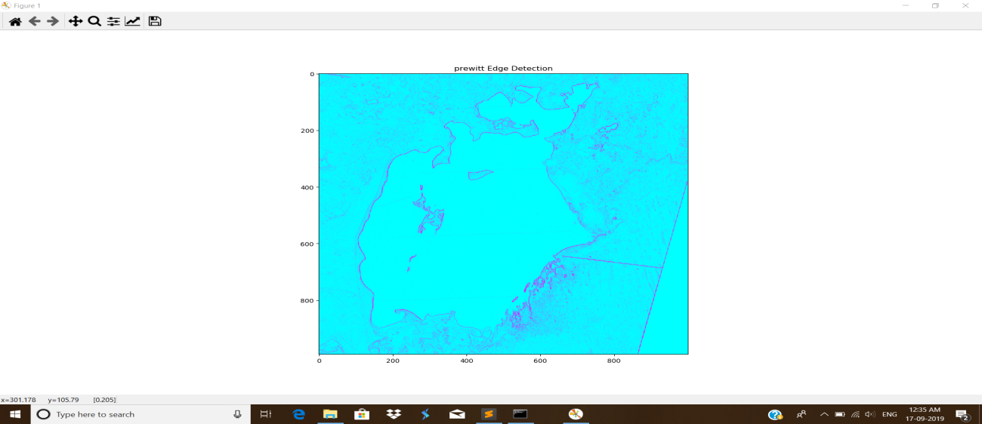 but the prewitt displayed the best.

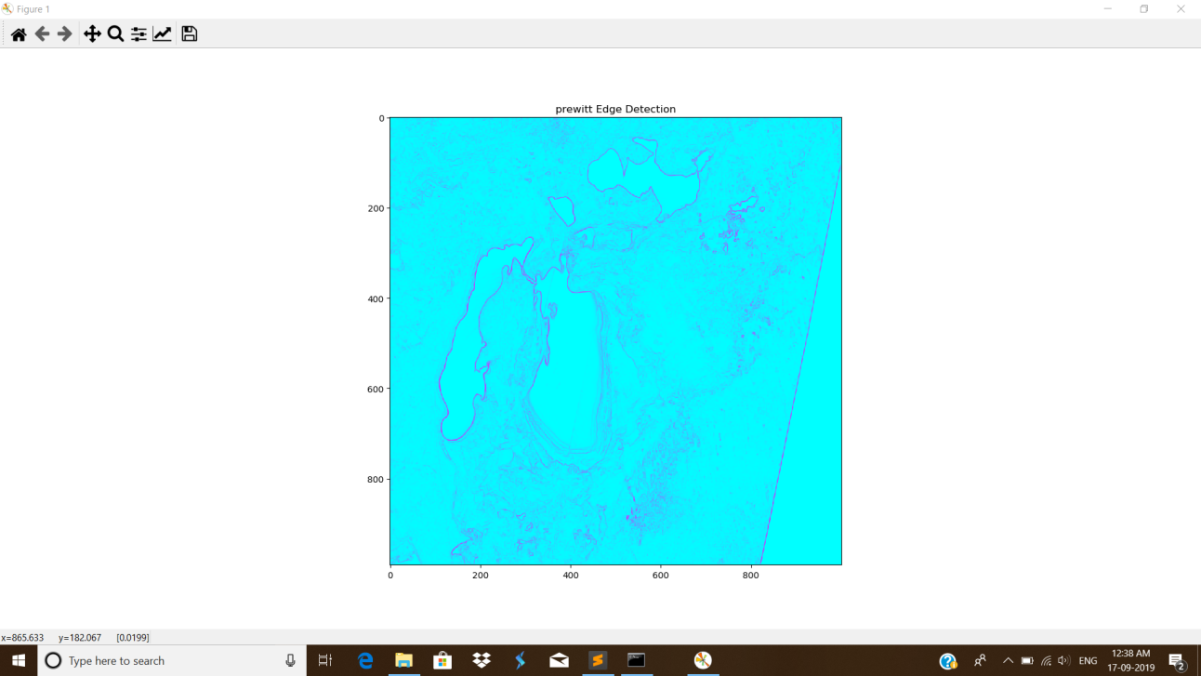

1. So we can now compare the difference on the actual image….the changes on the image on the course of time, as well as the difference on the rivers abstracted.

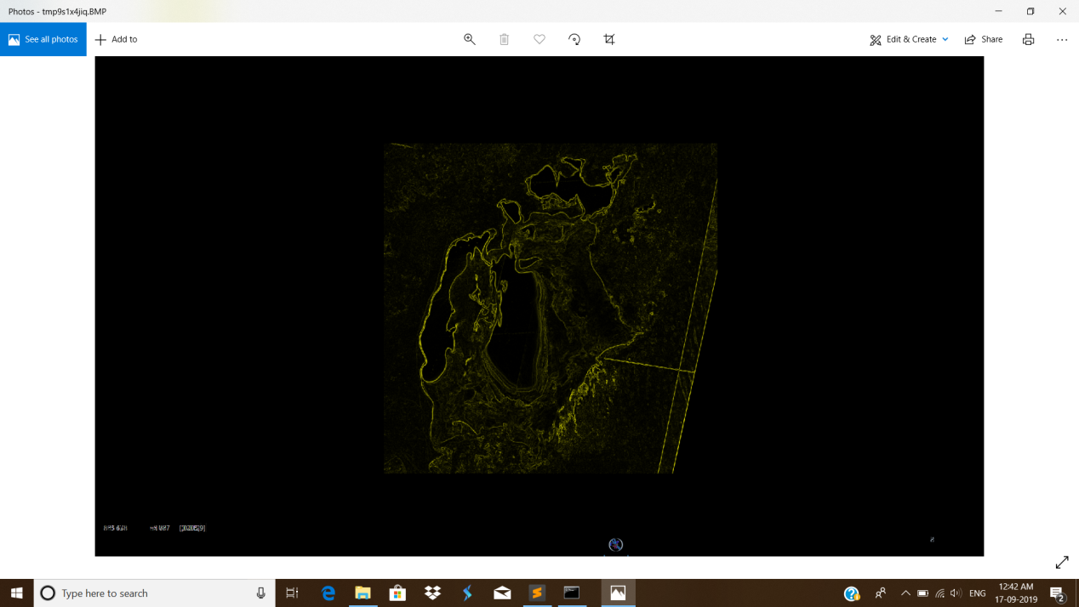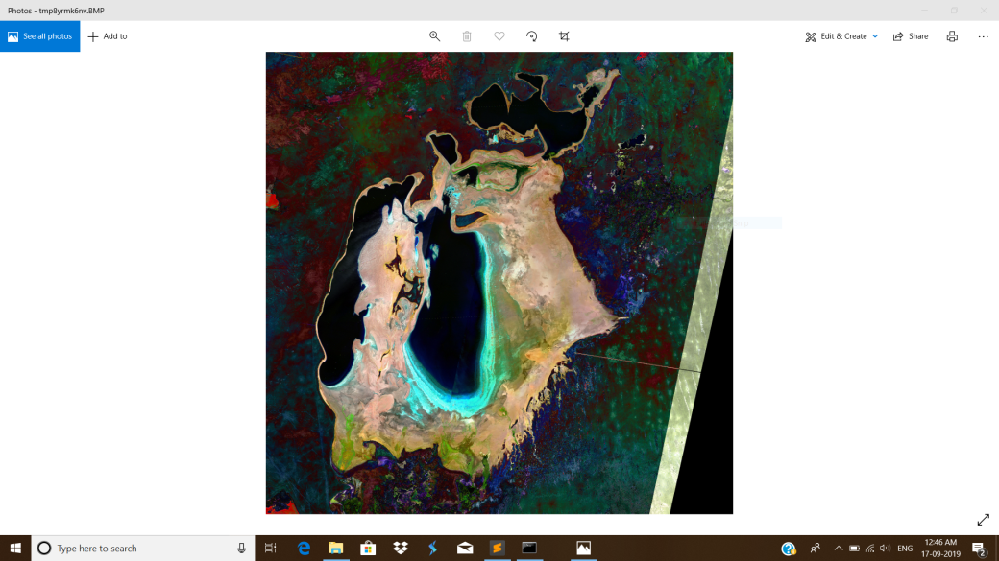

**Benefits:**

For some pictures Roberts methods shows the best result, for some sobel, and for some wista..etc. So instead of restricting only on one process, we can see the various images being changed over the course of time and then, we can differentiate it beautifully. In case of Prewitt edge detection and then studying the changes - Black demonstrated no change and dark green demonstrated little change and green clearly shown large amount of change i.e. either shrinking of river or expansion of river. (REFER TO PICTURES SIMULTANEOUSLY.)