1a

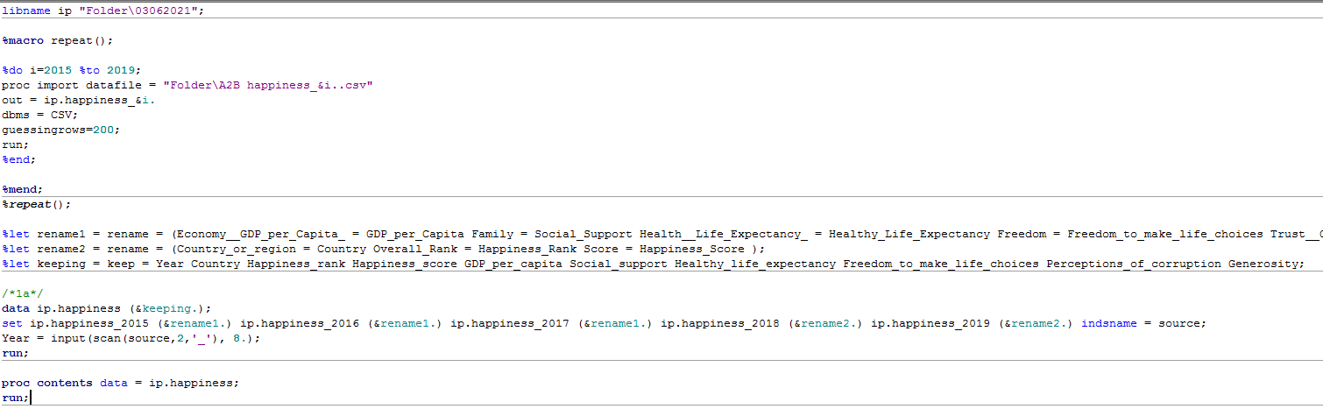

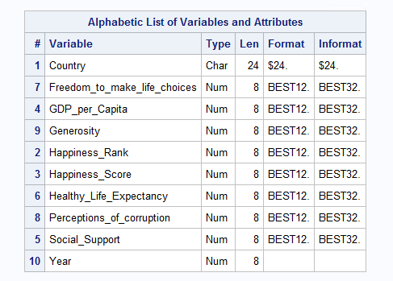

1b

Renaming the country names to new.

The following countries are renamed to new names.

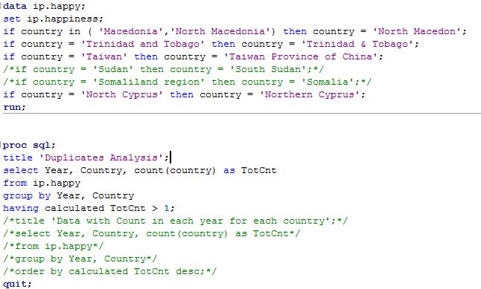

There are No duplicate records. It returned empty result.

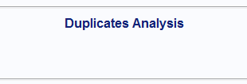

1c

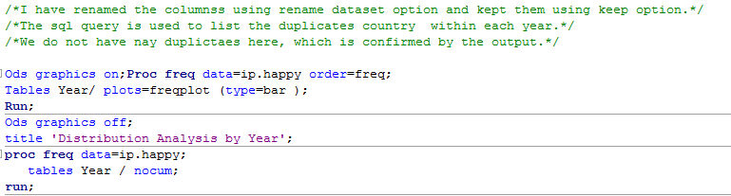

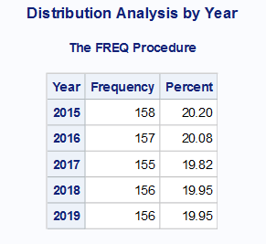

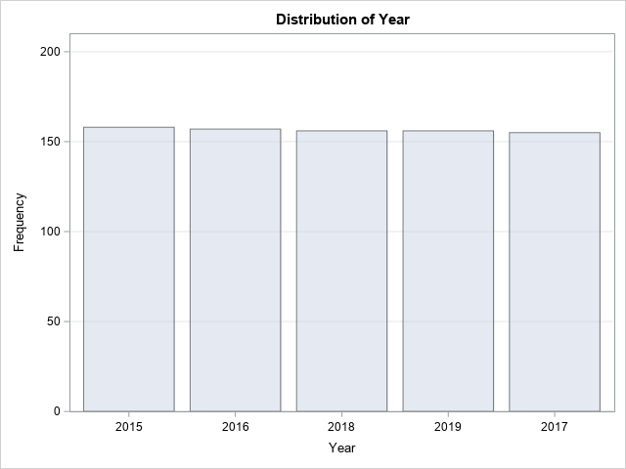

All the year have almost equal countries and have uniform distribution.

2a

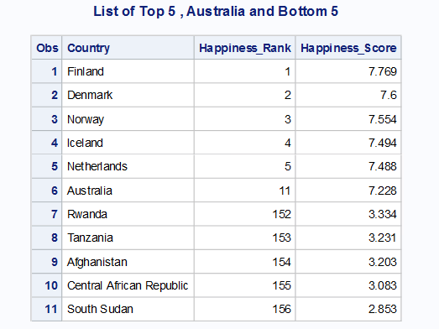

2b

Top 5 countries with Australia

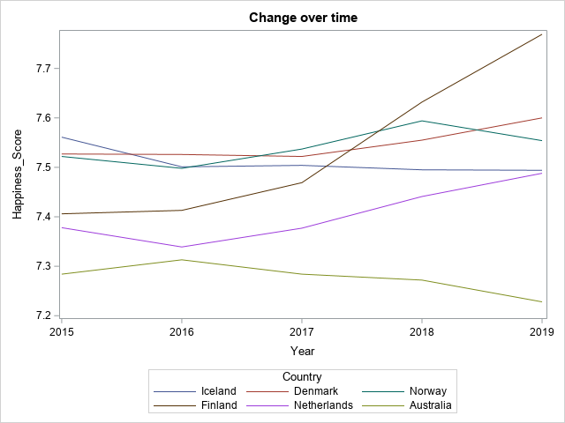

Bottom 5 countries

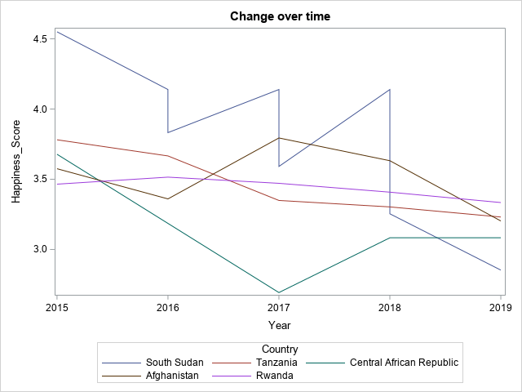

All the 11 countries, top 5 , Australia and Bottom 5

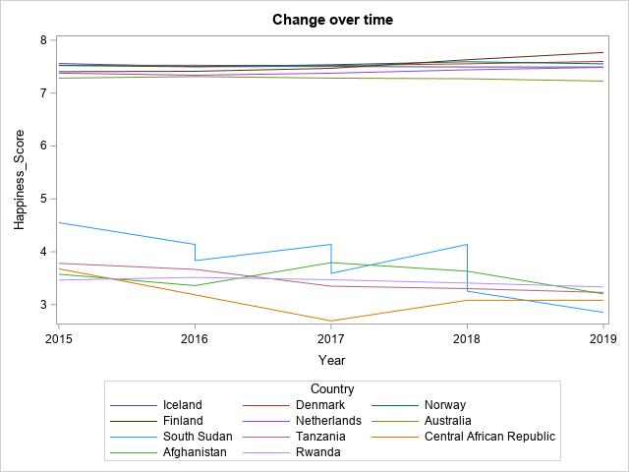

The top5 countries have higher Happiness score which is consistenstly high while for the bottom 5 the deviation is quite high but consistently remains in the lower side.

Due to this differencec, the series lines have a huge gap among the two groups.

2c

The Life Expectancy as well GDP_per_Capita of Hong-Kong is better than Saudi Arabia.

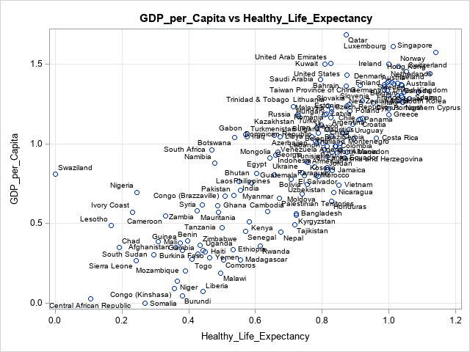

2d

Pairplot of other parameters with GDP per Capita

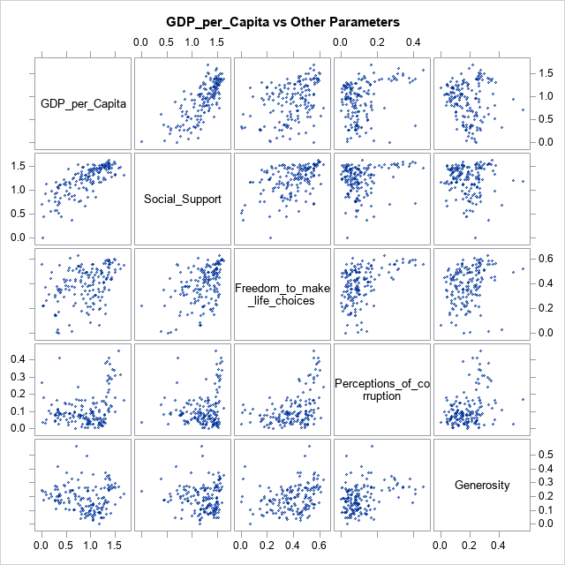

1. With Higher GDP per Capita, Social Support is higher
2. Freedom to make life choices has no correlation with GDP
3. With Very High GDP per capita, the Rate of corruption goes higher.
4. Generosity tends to negatively correlate with gDP per capita. It decreases with more developed nation.

This can be visualized better with separate heatmaps. Find them below.

Heatmap with each parameter

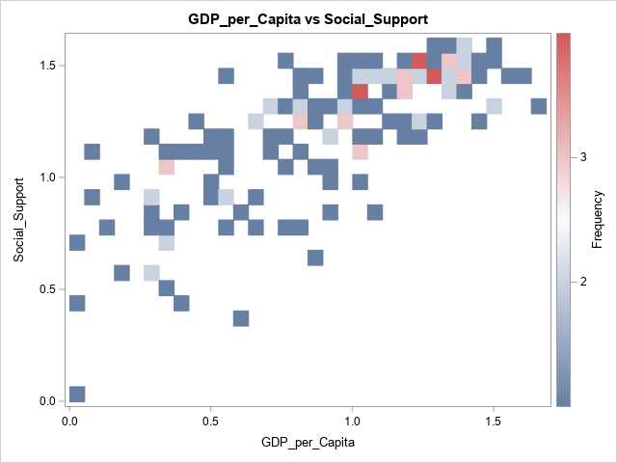

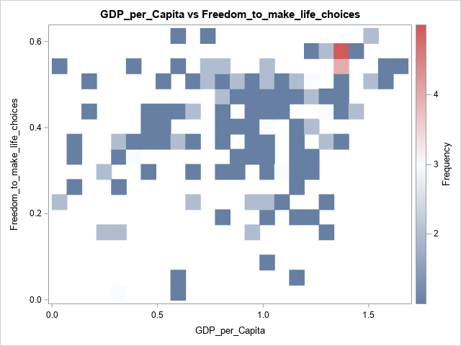

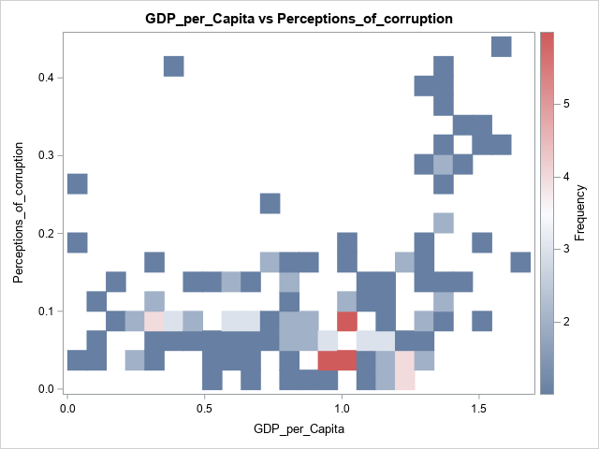

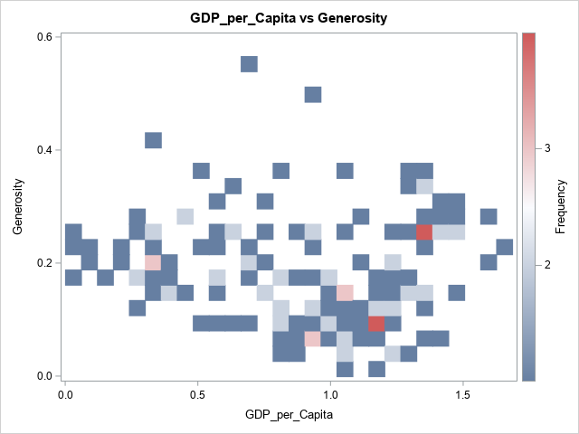

2e

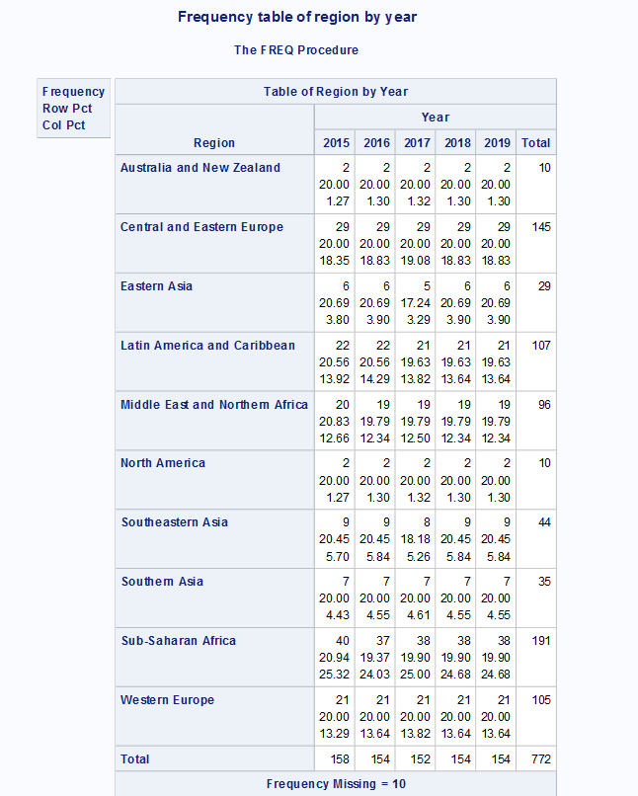

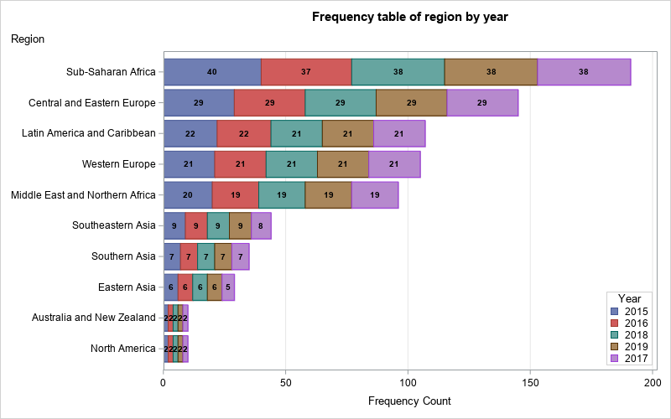

2f

