1a

No, it does not contain all 12 records.

There is only one record for it.

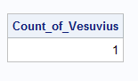

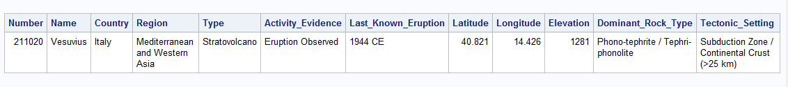

1b

There is no null in s Latitude, Longitude, Elevation, shown by NullPct

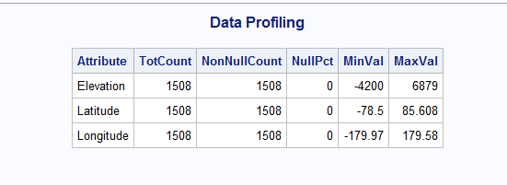

But Last Known Eruption has many missing values which are represented by ‘Unknown’. This is cleaned at a later stage.

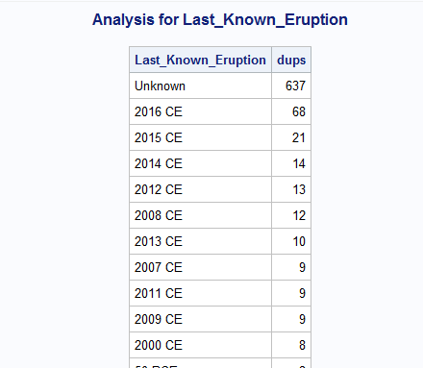

1c

Below is the code to create numeric variable ‘Last_Erruption_Date’

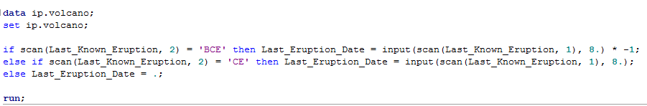

Screenshot of the new Data

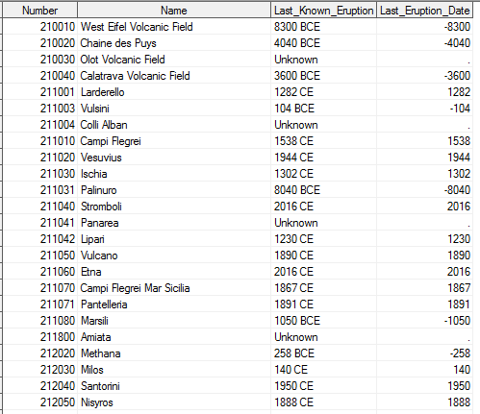

1d

The sas code to create bins.

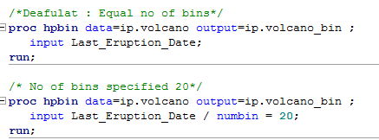

We can observe that over each bin as we move towards present, the Volcanic Eruptions is on a rise. Here the Number of bins is taken by default as 16

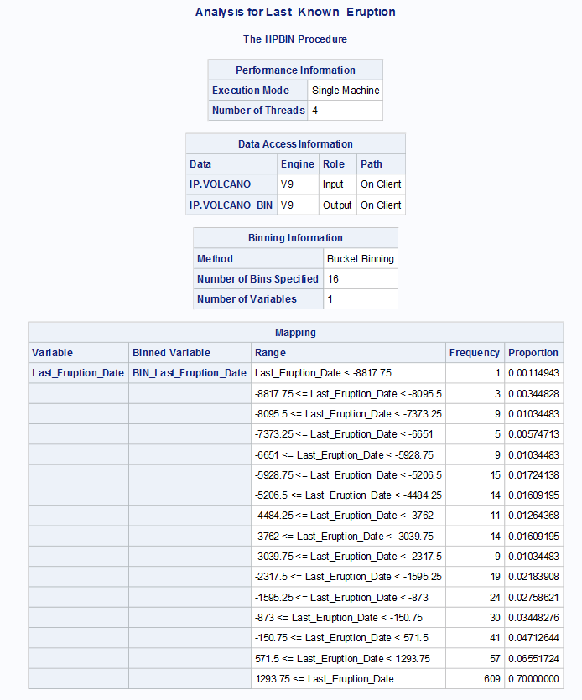

To dive deeper, I have increased no of bins as 20. Again , there is a rise in eruptions.

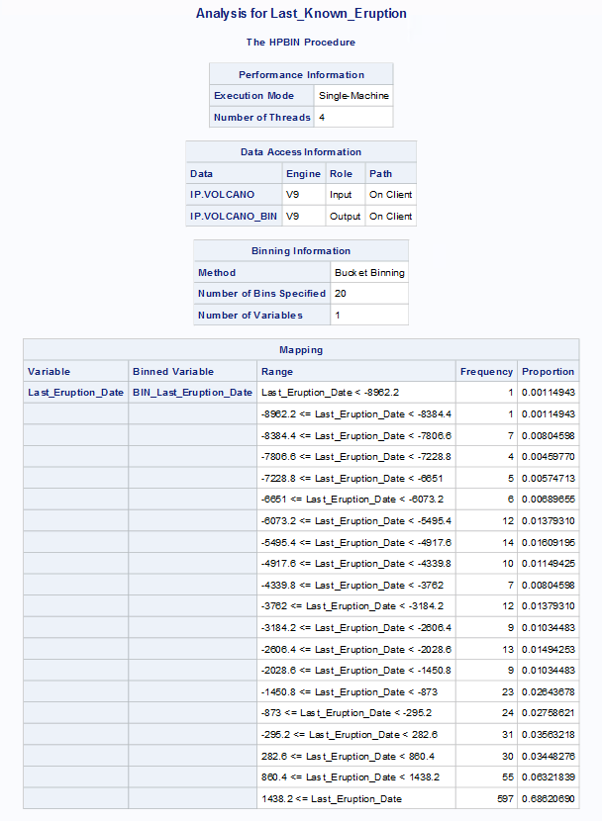

1e

SAS Code to create and apply formats

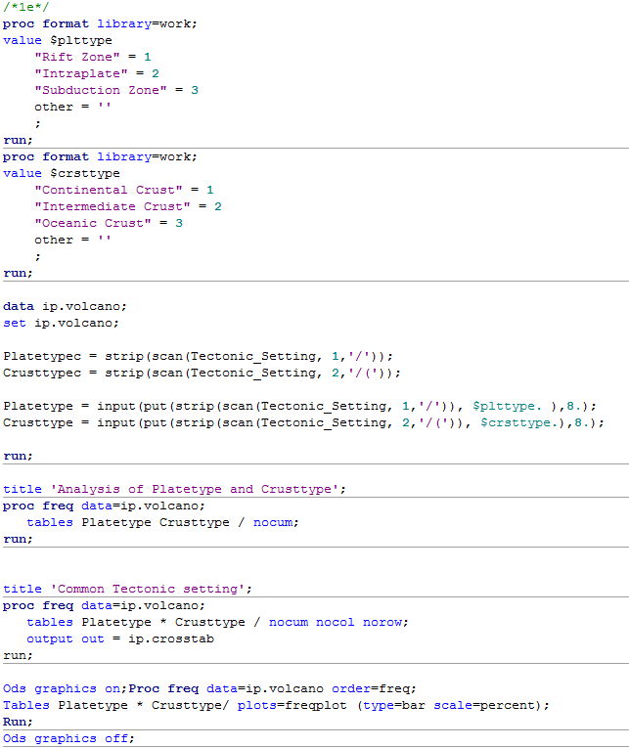

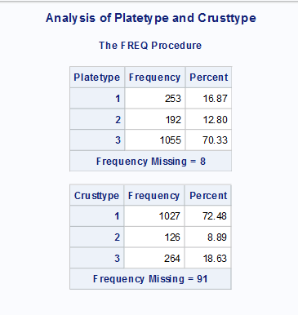

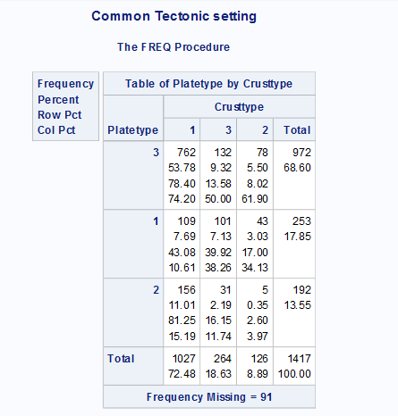

The most common type is ‘Subduction Zone Platetype with Continental Crust”

1f

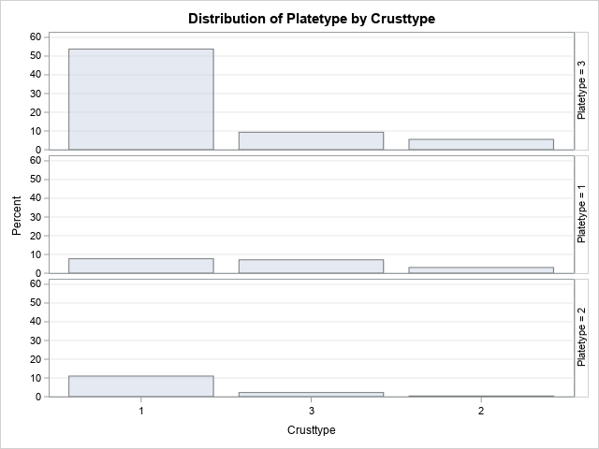

The most common type is ‘Subduction Zone Platetype with Continental Crust”

1g

Summary Statistics

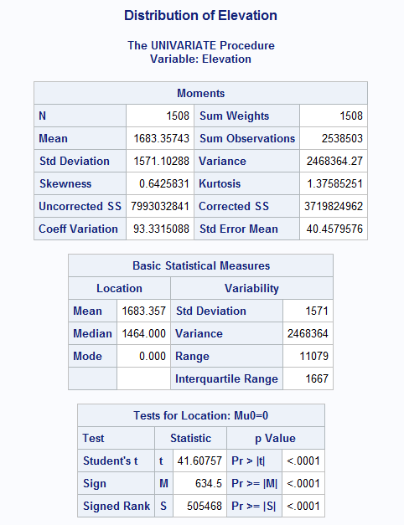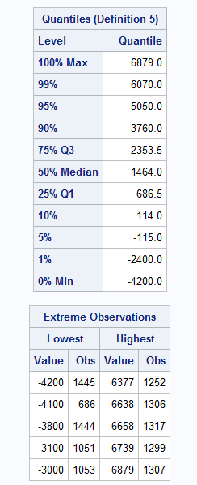

Chart to depict

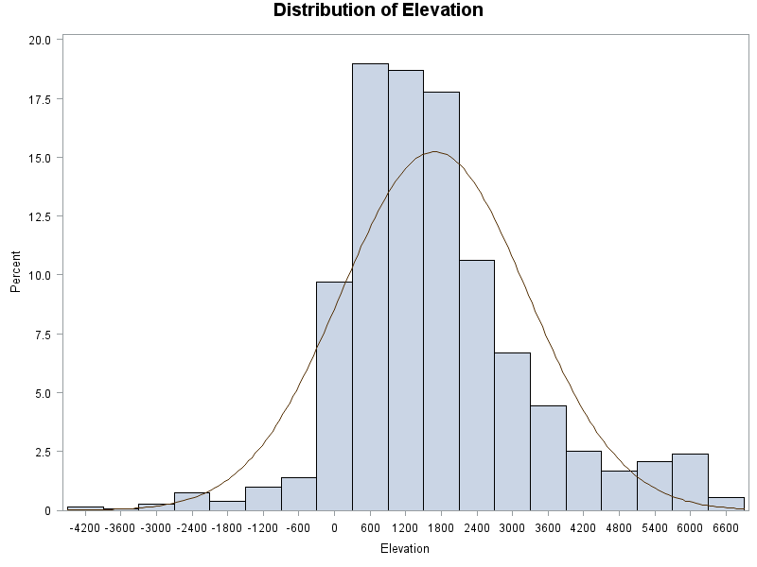

We can observe the majority of volcanic eruption is in Interquartile range with values between 686 and 2500 m.

1h

The subduction zone has high number of Valcanoes with high Elevations.

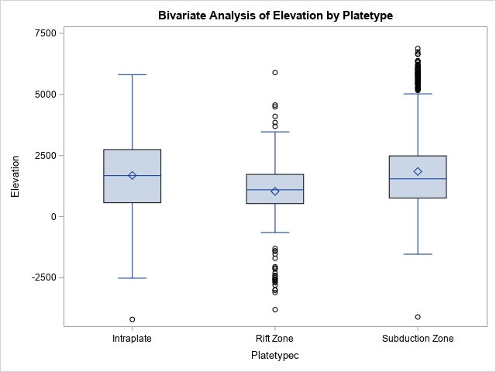

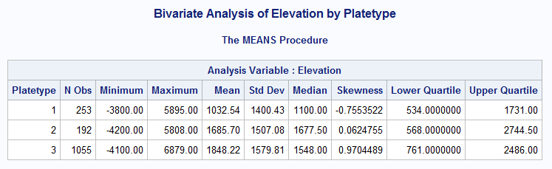

We can clearly see, the number of volacoes with Platetype = 3 is very high with maximum elevation.

1i

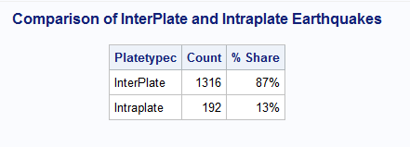

Inter-plate earthquakes are responsible for around 90% of the total seismic energy produced globally each year.

Thhis is clearly visible with the chart above. And hence our data is consistent with the analysis.