AI24300 / CS24300 PROJECT-I
HELIOS: An Alpha Driven Quantitative Trading System with
Fault Tolerant and Low Latency Infrastructure
SRS + SDS Report
BY
Abhishek Kumar BTECH/25002/24
Anuj Sharma BTECH/25011/24
Indra Shikari BTECH/25028/24
Under the supervision of
Dr. Shripal Vijayvargiya
---------------------------
(Designation)

DEPARTMENT OF COMPUTER SCIENCE & ENGINEERING
BIRLA INSTITUTE OF TECHNOLOGY, MESRA
JAIPUR CAMPUS, JAIPUR
MO-2025

1. Introduction

1.1 Purpose
Most people who trade in the market use some rule to decide when to buy and when to sell. In quantitative trading this rule is written as a formula or as a model, and it is called an alpha. An alpha is simply a number that tells us what the model believes will happen next in the market.
The purpose of this project is to build a complete system that can create such alphas, test them properly on old market data, and find out whether they would actually have made money. The system does not stop at the alpha. It also converts the alpha into real buy and sell orders, checks those orders against risk rules, sends them to a simulated exchange, and finally reports the profit or loss.
We are not using real money in this project. All trading is paper trading, which means the orders are executed inside our own software and no order goes to any real exchange.
The project also has two supporting parts. The first is to make the trading system fault tolerant, so that it keeps working correctly even if one of the machines fails. The second is to make the system fast and to actually measure how fast it is, instead of only claiming that it is fast.

1.2 Scope

1.2.1 The problem we are working on
Many student projects in this area train a model to predict whether the price will go up or down, and then report the accuracy of that model. The problem is that a model with good accuracy can still lose money. This happens because the profit from a correct prediction can be smaller than the cost of trading. Prediction accuracy and profit are not the same thing.
Our project addresses this gap. We check every alpha using trading measures such as Sharpe ratio, turnover, drawdown and profit after costs, and not just accuracy.

1.2.2 What the system will do
- Read historical order book data and rebuild the order book from it.
- Calculate market features such as order book imbalance, spread, microprice and volatility.
- Create alphas in two ways: by writing formulas ourselves, and by training a machine learning model.
- Test every alpha in a simulator and calculate its performance measures.
- Keep only the alphas that pass our selection criteria and reject the rest.
- Run a full backtest on the selected alpha with trading costs included.
- Convert the alpha into continuous buy and sell quotes through a strategy module.
- Check every order in a separate risk module before sending it.
- Execute the orders in a paper trading module and calculate profit and loss.
- Run the matching engine on more than one machine so that it survives a machine failure.
- Measure the delay at each stage of the system.

1.2.3 Expected outcome
At the end of the project we expect to have a working pipeline, a record of every alpha we tried along with its results, at least one alpha that passes all the selection criteria on data it has never seen, a backtest report with profit and loss and risk figures, a matching engine that continues to work when a node fails, and a table of measured delays.
It is possible that no alpha passes the criteria. If that happens we will report it honestly. A negative result is still a result, and hiding it would make the whole project worthless.

1.2.4 Application area
The application area is finance, mainly electronic trading and market microstructure. The design ideas used here, such as event driven processing and replicated state machines, are also used wherever correctness and speed both matter.

1.3 Motivation
There were three things that pushed us towards this problem.
- Published work on limit order book prediction usually reports classification accuracy on a fixed dataset. Very few papers connect that accuracy to actual trading profit. We wanted to build the missing part.
- Real trading systems are not only models. They have risk checks, order management, and execution logic. These parts decide whether a good idea survives contact with the market. They are rarely covered in academic projects.
- Trading systems must not lose orders when a machine fails, and they must respond quickly. These are classic distributed systems problems, and they let us combine finance with our core computer science subjects.

1.4 Technology and Tools Used
The dataset is the most important item below. Without message level order book data the main part of the project cannot be done, so arranging the data is our first task.
Item | Choice | Where it is used
Language | C++ | Fast path: parsing, order book, features, strategy
Language | Python | Research, alpha testing, backtesting, reports
Language | Go or Rust | Cluster services (to be finalised)
ML library | PyTorch, PyTorch Geometric | Training the graph based model
Formal tool | TLA+ with TLC | Checking the replication protocol
Messaging | Kafka or Redpanda | Append only event log
Database | PostgreSQL | Alpha records, orders, fills, audit log
Cache | Redis type store | Live order book state
Monitoring | Prometheus, Grafana | Metrics and dashboards
Deployment | Docker, Kubernetes | Running the services
Dataset | Message level order book data (LOBSTER or similar) | Main input to the pipeline
Dataset | Our own synthetic generator | Backup data, stress testing

2. Literature Review

2.1 Summary of existing work
Work in this area can be grouped into three groups.

(a) Deep learning models for the limit order book
DeepLOB used convolution layers followed by an LSTM to predict short term price movement from order book snapshots. HLOB added a structure based on the hierarchy of price levels. TLOB used a transformer with attention over both time and price levels. LiT is a more recent model that focuses on learning a representation that transfers from one stock to another.
These models are trained with labels, which means someone has to mark whether the price went up or down after each snapshot. Getting a large amount of such labelled data is difficult.

(b) Simulated markets
Simulated exchanges have been used to generate order flow when real data is not available. Hawkes processes are commonly used for this because real order arrivals come in bursts, and a Hawkes process naturally produces bursts. Cont and de Larrard described the statistical properties that a good order book simulator should reproduce.

(c) Fault tolerant replication
Paxos and Raft are the standard protocols for keeping several copies of the same state in agreement. They both apply a command only after a majority of machines have agreed on it. Some later protocols try to reduce the delay by doing the work early and undoing it if the agreement fails.

2.2 Gaps we found
- Prediction accuracy is reported, but profit after trading cost is usually not.
- Most models need a lot of labelled data, and label efficiency is rarely tested.
- The published ablation study of TLOB itself showed that a plain MLP could match its performance on one dataset. This suggests that complicated models are not always doing more than simple ones, and that ablations matter.
- Detection of market manipulation is hard to study because real data does not tell us which orders were manipulative. There is no public dataset with correct labels.
- General purpose replication protocols are not designed for the specific pattern of a matching engine, where one machine writes to one symbol at a time and the matching rule is fully deterministic.

2.3 How our work is different
We do not claim that any of the individual ideas here are new. Existing work has focused mainly on prediction accuracy, and comparatively less attention has been given to whether those predictions survive as trading strategies after costs are included. That connection is what our project tries to build.
Our differences can be listed as follows.
- Every alpha, whether it comes from a formula or from a model, is judged by the same trading measures, not by accuracy.
- Our model is trained without labels first, using two self supervised tasks, and then tested to see how few labels it needs afterwards.
- We build a simulator that injects manipulation patterns that we ourselves created, so the correct labels are known by construction.
- Our replication protocol uses the fact that matching is deterministic and single writer, which general protocols cannot assume.

3. Research Requirements (SRS Part)

3.1 Functional Requirements

3.1.1 Data collection and preprocessing
- The system shall read message level order book data and convert it into one common event format.
- The system shall rebuild the full order book from these events and keep price and time priority.
- The system shall detect missing, duplicate and out of order messages and report them. It shall not fill the missing part by guessing.
- The system shall calculate features only from data available up to that moment. No future value may be used.
- All scaling of features shall use past data only. Using the mean of the whole dataset is not allowed, because the whole dataset includes the future.

3.1.2 Alpha generation
- The system shall support alphas written as formulas over the features.
- The system shall support alphas produced by a trained model.
- Every alpha shall be saved with a version number, its formula or model reference, its time horizon and the name of the person who wrote it.
- Every alpha shall subtract the expected trading cost before it is treated as a signal.

3.1.3 Training and validation
- The data shall be split by time into training, validation and test parts. Random splitting is not allowed for time series data.
- There shall be a gap between the splits, at least as long as the prediction horizon, so that a label from one split does not overlap into the next.
- The model shall be trained only on the training split. This applies to the unlabelled pre-training also.
- The test split shall be used at most twice and every use shall be recorded.

3.1.4 Evaluation
- The system shall calculate Sharpe ratio, Fitness, turnover, profit and loss, drawdown, volatility and hit rate for every alpha.
- The system shall report results both before and after trading costs.
- The system shall apply the selection criteria automatically and record a pass or fail for each one.
- Rejected alphas shall also be stored, along with the reason for rejection.
The selection criteria are given below. These are the targets an alpha has to meet before we accept it. They are not results and we are not promising that any alpha will meet them.
Measure | Condition | Reason
Sharpe ratio | Greater than 1 | Return should be reasonable compared to the risk taken
Fitness | Greater than 1 | Return should not depend on trading a very large amount
Turnover | Between 1% and 70% | Below 1% the alpha is barely doing anything; above 70% the cost eats the profit

3.1.5 Strategy, risk and execution
- The strategy shall keep a buy quote and a sell quote in the market at the same time and update them as conditions change. It shall not place a single buy order and a single sell order.
- The strategy shall change its quotes based on the position it is holding, so that the position is pulled back towards zero.
- Every order shall pass through the risk module before it is sent. There shall be no way to skip this.
- The risk module shall check order size, price band, position limit, exposure limit and order rate.
- The risk module shall have a kill switch that stops all new orders, and a circuit breaker that trips automatically when the order rate or loss becomes abnormal.
- The order management module shall track each order through its full life: new, accepted, partly filled, fully filled, cancelled or rejected.
- Profit and loss shall be calculated only when a fill is received, never when an order is sent.

3.1.6 Fault tolerance
- The matching engine shall match orders continuously, across several price levels, in price and time order, and shall allow partial fills against several counterparties.
- The engine state shall be copied to more than one machine, and a command shall be treated as final only after a majority of machines agree.
- If agreement fails, the machine shall undo the early work and rebuild its state by replaying the agreed commands.
- The result of early work shall never be shown outside the machine before agreement is reached.
- Replaying the same commands from the same starting state shall always give exactly the same result.

3.2 Non-Functional Requirements
Type | Requirement
Performance | The delay of each stage shall be measured and reported at the 50th, 95th and 99th percentile along with the variation. A single average value is not acceptable because it hides the worst cases.
Performance | The backtest shall finish one day of data for one instrument in a few minutes, so that we can try many ideas.
Correctness | No agreed trade shall be lost, duplicated or reordered when a minority of machines fail.
Correctness | The profit and loss account shall balance at every checkpoint.
Scalability | Adding a new instrument shall need only a configuration change, not a code change.
Scalability | Alphas shall be testable in parallel.
Reproducibility | Every reported number shall be reproducible from the same code version, same data and same random seed.
Reproducibility | The same feature calculated in Python and in C++ shall give the same value within a small tolerance.
Reliability | If the risk module fails, it shall reject every order rather than allow every order.
Security | Changing a risk limit or using the kill switch shall need a specific role and shall be written to an audit log.
Maintainability | Each module shall have one owner in the team.
Hardware | A GPU is needed for model training. The fast path needs a machine where we can fix threads to particular CPU cores.

3.3 Assumptions and Constraints

3.3.1 Assumptions
- Message level order book data will be available for a few instruments over a few weeks of trading.
- A GPU will be available for training the model.
- Simulated execution with a clearly described fill rule is acceptable for an academic evaluation.
- Machines can crash and messages can be lost or delayed, but no machine will behave dishonestly.
- System clocks are roughly in agreement, and correctness never depends on them being exact.

3.3.2 Constraints
- No real money and no connection to a real exchange. All execution is simulated.
- We do not have space inside an exchange building, so we cannot claim colocation. We can only build a similar arrangement in the cloud and measure it.
- We do not have FPGA or special network cards, so no hardware acceleration is claimed.
- Formal checking covers the safety properties of the protocol model on small configurations. It does not prove that the actual code is correct.
- Three team members working part time along with regular coursework.
- Cloud machines are shared with other users, so some part of the delay we measure is outside our control. This will be stated with the results.

3.3.3 Points still to be decided
No. | Open point | Needed by
1 | Which dataset we will use, and whether the paid version is required | Immediately
2 | Which time horizon the alpha is aimed at, since the turnover limit means different things for a one day alpha and a one second alpha | Before the first alpha is tested
3 | The exact formula for Fitness, including its constants | Before the first alpha is accepted
4 | Which language is used for which service | Before coding the trading path
5 | The fill rule used in the backtest | Before the first backtest is reported

4. System Design (SDS Part)

4.1 Research Workflow and System Architecture
The system works as one long pipeline. Data comes in at the top, and a profit and loss figure comes out at the bottom. The important point is the check in the middle. An alpha only moves forward into the trading part if it passes the three selection criteria. If it does not pass, it is stored with its results and we move on to the next idea.
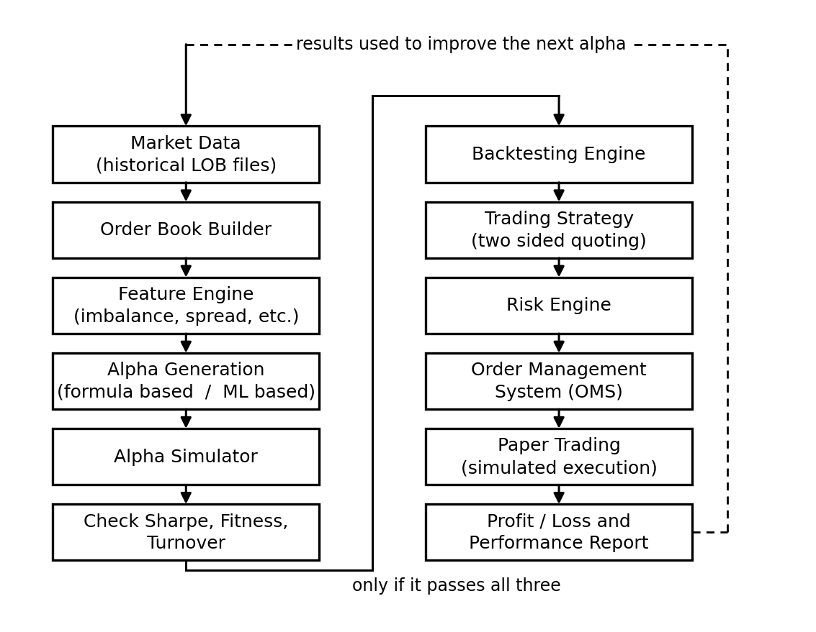
Figure 1: Overall workflow of HELIOS
The dashed line at the top shows that the results are fed back into our research. If an alpha fails because of high turnover, for example, the next version of that alpha is written with a rule that reduces how often it changes its mind.
At present the orders go to the paper trading module. Later in the project the same orders will go to the fault tolerant matching engine instead. Both of them accept orders in exactly the same format, so we can switch between them by changing one setting and without rewriting the strategy.

4.2 Module Design
The system is divided into ten modules. Each module does one job and passes its output to the next one.
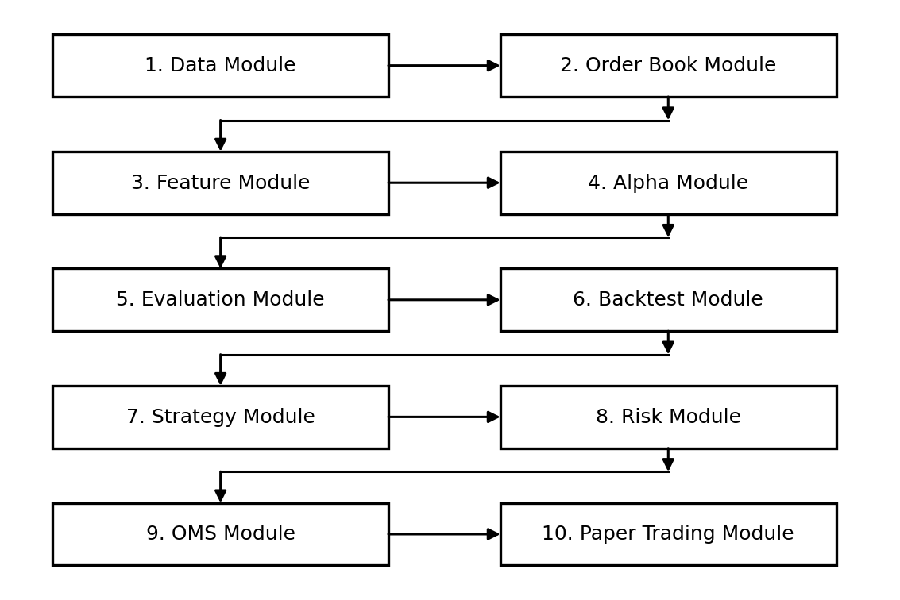
Figure 2: Module block diagram
No. | Module | What it does
1 | Data Module | Reads the data files, converts every message into one common format, checks for gaps
2 | Order Book Module | Builds and updates the order book, keeps price and time priority
3 | Feature Module | Calculates imbalance, spread, microprice, volatility and other features from the book
4 | Alpha Module | Calculates the alpha value, either from a formula or from the trained model
5 | Evaluation Module | Runs the alpha through the simulator, calculates the measures, applies the criteria
6 | Backtest Module | Replays history through the full strategy with costs and simulated fills
7 | Strategy Module | Decides the buy and sell quote prices and sizes, and when to change them
8 | Risk Module | Checks every order, rejects unsafe ones, runs the kill switch and circuit breaker
9 | OMS Module | Gives each order an identity and tracks it until it is filled or cancelled
10 | Paper Trading Module | Decides the fills using a queue based rule and updates position and profit
Two of these modules are often confused, so we state the difference clearly. The Alpha Module answers the question "what do we think will happen". The Strategy Module answers the question "given that, what orders should we place". They are not the same. It is quite possible for the alpha to be positive while the strategy still places a lower buy price, because we are already holding a large long position and want to reduce it.

4.3 Algorithm and Model Design

4.3.1 Feature calculation
The features are simple quantities calculated from the order book. Some examples are given below.
mid price = (best bid + best ask) / 2
spread = best ask - best bid
microprice = (best bid * ask size + best ask * bid size)
/ (bid size + ask size)
imbalance (k) = (bid size(k) - ask size(k))
/ (bid size(k) + ask size(k))
A small numerical example makes the imbalance clear. Suppose the best bid is 100.02 with 800 shares and the best ask is 100.03 with 200 shares. Then the imbalance is (800 - 200) / (800 + 200) = 0.60. There is much more size waiting to buy than to sell, so there is pressure towards the upper side. The microprice comes out as 100.028, which is above the mid price of 100.025, and it leans towards the thin side of the book.

4.3.2 Example alpha (for illustration only)
The following is an example of how a formula based alpha is written. It is only an example to show the form. It is not our final alpha and we have not tested it yet.
z1 = zscore(imbalance, past window)
z2 = zscore(order flow imbalance, past window)
z3 = zscore(spread, past window)

alpha = w1*z1 + w2*z2 - w3*z3
alpha = clip(alpha, -1, +1)
alpha = alpha - expected trading cost
The z-score uses only past data. The clip keeps the alpha inside a fixed range so that the position never becomes unlimited. The last line removes the expected trading cost, because a signal that is smaller than the cost of trading is not useful even if it is correct.

4.3.3 Alpha selection procedure
The following flowchart shows how a candidate alpha is either accepted or rejected.
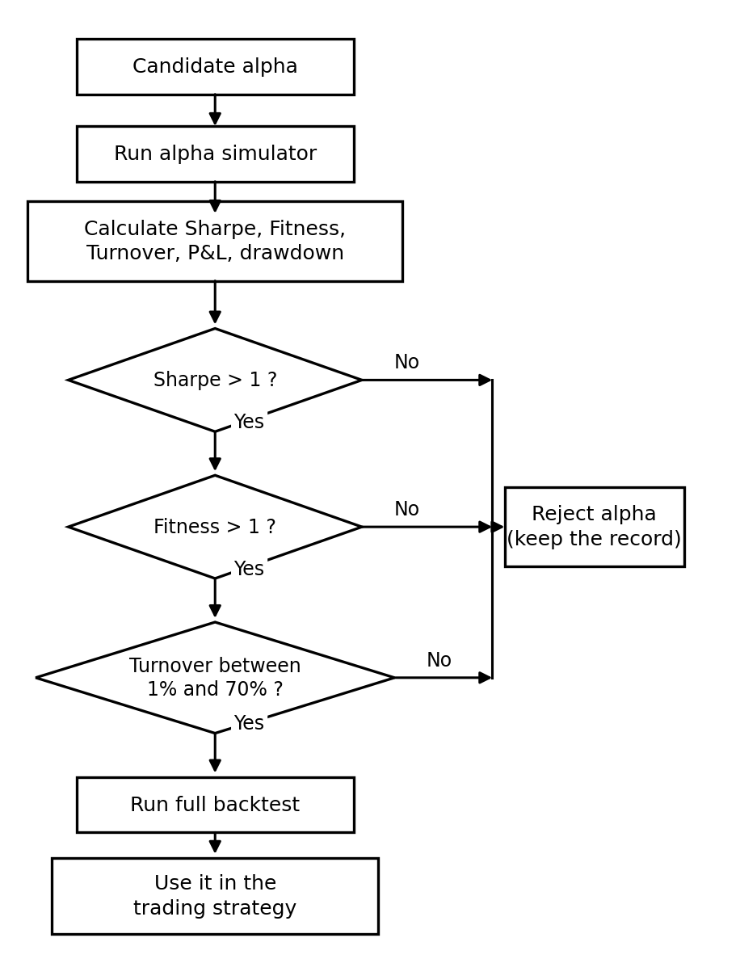
Figure 3: Alpha selection flowchart
Two checks are run on the simulator itself before we trust any of its output. First we feed it a random alpha, which should give a Sharpe close to zero. Then we feed it an alpha that is deliberately allowed to see the future, which should give an impossibly high Sharpe. If either test gives the wrong answer, the simulator has a bug and every result from it is meaningless.

4.3.4 Order path and risk check
Every order created by the strategy goes through the risk module. The strategy cannot overrule a rejection.
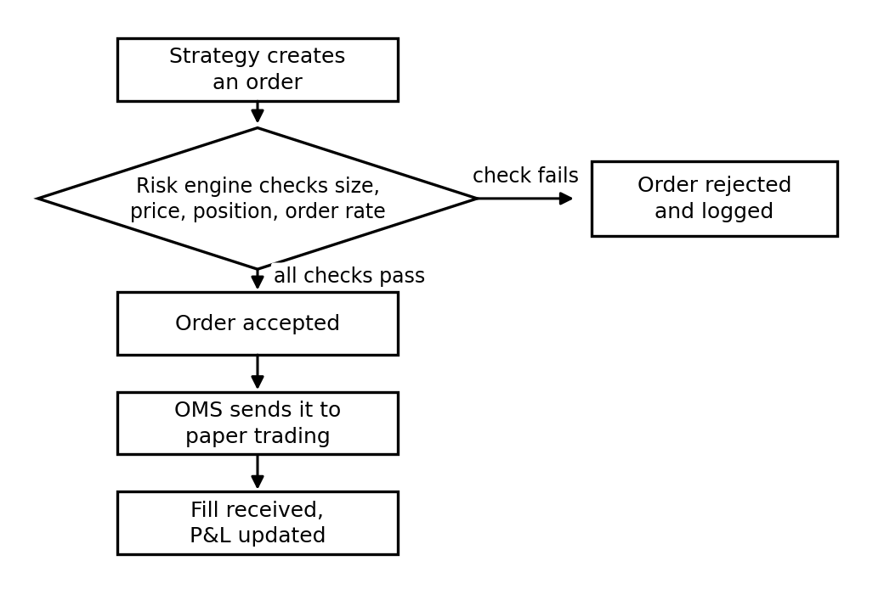
Figure 4: Path of an order from strategy to fill
One point in the position check is worth explaining. The check is done on the projected position, which is the current position plus the orders already waiting in the market plus the new order. If we checked only the current position, the strategy could send many orders that are each within the limit but together cross it when they all get filled.

4.3.5 Machine learning model
For the machine learning route we treat each order book snapshot as a small graph. Each price level is a node, and neighbouring price levels are joined by edges. A graph neural network processes this graph, and a transformer with a causal mask processes the sequence of these graphs over time. The causal mask makes sure that the model at time t cannot look at time t+1.
The model is first trained without labels using two tasks. In the first task, part of the event stream is hidden and the model has to predict what was hidden. In the second task, the model is trained to place snapshots with similar queue positions close to each other in its output space.
After this, the output of the model is used in two ways. We test how good the learned representation is by comparing it with DeepLOB, HLOB, TLOB and LiT. Separately, we convert the model output into an alpha and send it through the same simulator and the same criteria as a formula based alpha. Both results will be reported, because a better representation does not automatically mean a better trading result.

4.3.6 Replication protocol
The matching engine runs on three machines. One machine is the leader and the other two are followers. The steps are given below.
- The leader receives an order command and gives it a position number in its log.
- The leader applies the command to its own copy of the order book straight away, but keeps the result inside itself. Nothing is sent out yet.
- The leader sends the command to the two followers.
- When at least two out of three machines have stored the command, it is treated as final.
- Only now the leader sends out the trade reports.
- If agreement is not reached, the leader throws away the early result, goes back to the last agreed state, and rebuilds by replaying the agreed commands in order.
Step 2 saves time because the matching work happens at the same time as the network round trip. Step 5 is the safety rule. If a trade result escaped in step 2 and was then thrown away in step 6, we would have reported a trade that never happened. This is the property we will describe in TLA+ and check with TLC.
For replay to be safe, applying the same command must always give the same answer. This means the matching code cannot read the clock, cannot use random numbers, and must use whole numbers for prices and sizes instead of decimals.

4.4 Database and Storage Design
Different kinds of data have different needs, so we use different stores.
Data | Where it is stored | Reason
Raw and cleaned market events | Parquet files on disk, one folder per instrument and date | Large volume, read in bulk during research
Live order book | Memory, with a Redis type store for other processes | The fast path cannot wait for disk
Engine event log | Kafka or Redpanda | Append only and can be replayed in order
Alpha records, orders, fills, positions, audit | PostgreSQL | Needs relations, transactions and easy querying
Model outputs | Vector store, one version at a time | Used for similarity search and kept separate for each model version
Trained models and reports | Object storage | Needed for reproducing results later
The main table is the alpha record table. Its columns are listed below.
Column | Meaning
alpha_id, version | Identity of the alpha. A new version is created for every change.
type | Formula based or model based
formula or model_ref | The actual expression, or the model name and version
horizon | How far ahead the alpha is predicting
train, validation, test periods | The exact date ranges used
sharpe, fitness, turnover | The three selection measures
pnl, drawdown, volatility | Profit and risk figures
cost assumed, pnl after cost | Trading cost used and profit after it
result per gate | Pass or fail for each criterion, with the value
status | Draft, tested, accepted, rejected or retired
test uses | How many times the test data has been used for this alpha
code version, data version, seed | Everything needed to reproduce the result
author, date | Who created it and when

4.5 Experimental Design

4.5.1 Data split
The data is divided by time, in the order shown below. Random splitting is not used because the data is a time series and shuffling it would let information from the future leak into the training set.
|<---- TRAINING ---->|gap|<-- VALIDATION -->|gap|<-- TEST -->|
The training part is used to fit the model or the weights of the formula. The validation part is used to choose settings and to compare alphas. The test part is only used at the end to confirm the result, and it may be used at most twice. Every use is recorded in the alpha table. The gap between the parts is at least as long as the prediction horizon, so that a label belonging to one part does not overlap into the next part.

4.5.2 Settings to be recorded
Setting | What we will record
Alpha settings | Window lengths, weights, clipping limits, number of free parameters
Model settings | Number of layers, hidden size, learning rate, batch size, number of epochs, random seed
Cost settings | Assumed cost in basis points, fee, and the range used in the sensitivity test
Fill rule | Which of the three fill rules was used: optimistic, queue based or pessimistic
Delay setting | The decision delay added in the backtest, so the strategy is not treated as infinitely fast

4.5.3 Hardware
Part | Requirement
Training | One GPU machine with at least 16 GB of GPU memory
Fast path | A machine where we can reserve CPU cores and fix threads to them
Cluster | Three machines so that a majority is two, and one failure can be survived
Storage | Enough disk for the raw data files and the event log

4.5.4 What we will measure
The table below lists what will be measured. None of these numbers exist yet. The last column is left as "to be measured" and will be filled in only after the experiment is actually run.
Area | Measure | Result
Alpha quality | Sharpe, Fitness, turnover on test data | To be measured
Alpha robustness | Sharpe at higher assumed cost, results per week | To be measured
Trading result | Profit and loss, drawdown, fill rate | To be measured
Risk | Orders rejected, time taken by the kill switch | To be measured
Matching engine | Property tests, invariant violations | To be measured
Replication | Agreement delay at 50th, 95th and 99th percentile, compared with Raft | To be measured
Fault tolerance | Behaviour and recovery time under injected faults | To be measured
Model | Comparison with DeepLOB, HLOB, TLOB and LiT | To be measured
Model | Accuracy with 1%, 5%, 10%, 25% and 100% of the labels | To be measured
Delay | Delay at each stage at 50th, 95th and 99th percentile | To be measured

4.5.5 Plan of work
Stage | Work | Finished when
1 | Data, order book, features | Order book rebuilt correctly for a full day of data
2 | Alpha, simulator, criteria, records | One alpha tested end to end with all measures
3 | Backtest, strategy, risk, OMS, paper trading | An accepted alpha trades on paper with correct profit and loss
4 | Machine learning model | Model trained and its output tested as an alpha
5 | Matching engine on one machine | Continuous matching with partial fills works correctly
6 | Replication, TLA+, fault injection | Cluster survives a node failure and replay gives the same state
7 | Delay measurement | Delay table filled with measured values
8 | Report and final submission | Results written up, including anything that did not work

5. References
[1] Z. Zhang, S. Zohren and S. Roberts, "DeepLOB: Deep Convolutional Neural Networks for Limit Order Books," IEEE Transactions on Signal Processing, vol. 67, no. 11, pp. 3001-3012, 2019.
[2] A. Briola, S. Bartolucci and T. Aste, "HLOB: Information Persistence and Structure in Limit Order Books," Expert Systems with Applications, 2025.
[3] L. Prata et al., "TLOB: A Novel Transformer Model with Dual Attention for Price Trend Prediction with Limit Order Book Data," arXiv preprint, 2025.
[4] R. Cont and A. de Larrard, "Price Dynamics in a Markovian Limit Order Market," SIAM Journal on Financial Mathematics, vol. 4, no. 1, pp. 1-25, 2013.
[5] R. Cont, S. Stoikov and R. Talreja, "A Stochastic Model for Order Book Dynamics," Operations Research, vol. 58, no. 3, pp. 549-563, 2010.
[6] M. Avellaneda and S. Stoikov, "High-frequency Trading in a Limit Order Book," Quantitative Finance, vol. 8, no. 3, pp. 217-224, 2008.
[7] D. Ongaro and J. Ousterhout, "In Search of an Understandable Consensus Algorithm," USENIX Annual Technical Conference, pp. 305-319, 2014.
[8] L. Lamport, "Paxos Made Simple," ACM SIGACT News, vol. 32, no. 4, pp. 51-58, 2001.
[9] L. Lamport, Specifying Systems: The TLA+ Language and Tools for Hardware and Software Engineers, Addison-Wesley, 2002.
[10] N. Hayashibara, X. Defago, R. Yared and T. Katayama, "The phi-accrual Failure Detector," IEEE Symposium on Reliable Distributed Systems, pp. 66-78, 2004.
[11] A. G. Hawkes, "Spectra of Some Self-exciting and Mutually Exciting Point Processes," Biometrika, vol. 58, no. 1, pp. 83-90, 1971.
[12] R. Huang and T. Polak, "LOBSTER: Limit Order Book Reconstruction System," Humboldt University Berlin, Technical Report, 2011.
[13] I. Jericevich, P. Chang and T. Gebbie, "CoinTossX: An Open-source Low-latency High-throughput Matching Engine," arXiv preprint, 2021.
[14] A. Vaswani et al., "Attention Is All You Need," Advances in Neural Information Processing Systems, vol. 30, 2017.
[15] T. N. Kipf and M. Welling, "Semi-Supervised Classification with Graph Convolutional Networks," International Conference on Learning Representations, 2017.
[16] A. van den Oord, Y. Li and O. Vinyals, "Representation Learning with Contrastive Predictive Coding," arXiv preprint, 2018.
Note: reference numbers 2, 3 and 13 are recent papers and we are still verifying the full author list and page numbers for the final report.

