# Assignment Report on

# ARDUINO SOLAR TRACKER

submitted for the subject Microprocessor and Interfacing

by

**ABHISHEK M** (Reg. No: 16030141CSE006)

**AVINASH MJ** (Reg. No: 16030141CSE018)

**AYUSH GARG** (Reg. No: 16030141CSE019)

**JAY DEV RAI M** (Reg. No: 16030141CSE037)

Under the guidance of

Prof. Dr. A.Pranayanath Reddy

Assistant Professor

CSE Department, Alliance University



Department of Computer Science and Engineering

Alliance University

Bangalore

May 2018

**CONTENTS**

Acknowledgement i

List of Figures

List of Tables

**1. Introduction 1**

1.1 About the project **3**

1.2 Hardware and Software Requirements

1.3 Components description **5**

**2. System Requirements**

2.1 Functionality of project

**3.Design**

3.1 Schematic circuit Diagram

3.2 Data Flow chart

**4. Implementation**

4.1 Code snippet

**5. Testing**

5.1 Test Cases

**Conclusions and Further Scope 60**

**References 62**

**ACKNOWLEDGEMENT**

In performing our assignment, we had to take the help and guideline of some respected persons, who deserve our greatest gratitude. The completion of this assignment gives us much Pleasure. We would like to show our gratitude to Prod. Dr. A.Pranayanath Reddy, Course Instructor, University Name for giving us a good guideline for assignment throughout numerous consultations. We would also like to expand our deepest gratitude to all those who have directly and indirectly guided us in writing this assignment.

**LIST OF FIGURES**

|  |  |
| --- | --- |
| Figure | Name |
|  |  |
|  | SERVO MOTOR |
| Figure1.3.1 |  |
|  |  |
| Figure1.3.2 | LDR |
| Figure1.3.3 | ARDUINO UNO |
|  |  |
|  |  |
| Figure1.3.4 | SOLAR PANEL |
|  |  |
| Figure1.3.5 | RESISTOR |
|  |  |
| Figure1.3.6 | BATTERY |
|  |  |
| Figure2.1.1 | CIRCUICT DIAGRAM |
|  |  |
| Figure3.1.1 | CODE FOR LDR OPERATIONS |
| Figure3.1.2 | CODE FOR MAIN LOGIC |
| Figure3.1.3 | COMPLETE CODE |

**CHAPTER 1**

**INTRODUCTION**

**1.1 About the project**

Solar energy is rapidly gaining notoriety as an important means of expanding renewable energy resources. As such, it is vital that those in engineering fields understand the technologies associated with this area. Our project will include the design and construction of a microcontroller-based solar panel tracking system. Solar tracking allows more energy to be produced because the solar array is able to remain aligned to the sun. This system builds upon topics learned in this course. A working system will ultimately be demonstrated to validate the design. Problems and possible improvements will also be presented.

The aim of this solar tracker project is to keep the solar photovoltaic panel perpendicular to the sun throughout the year in order to make it more efficient. The dual axis solar photovoltaic panel takes astronomical data as reference and the tracking system has the capability to always point the solar array toward the sun and can be installed in various regions with minor modifications. The vertical and horizontal motion of the panel is obtained by taking altitude angle and azimuth angle as reference. The fuzzy controller has been used to control the position of DC motors. The mathematical simulation control of dual axis solar tracking system ensures the point to point motion of the DC motors while tracking the sun. Solar Tracker is a Device which follows the movement of the sun as it rotates from the east to the west every day. The main function of all tracking systems is to provide one or two degrees of freedom in movement. Trackers are used to keep solar collectors/solar panels oriented directly towards the sun as it moves through the sky every day. Using solar trackers increases the amount of solar energy which is received by the solar energy collector and improves the energy output of the heat/electricity which is generated. Solar trackers can increase the output of solar panels by 20-30% which improves the economics of the solar panel project.

**THE NEED FOR A SOLAR TRACKER**

The energy contributed by the direct beam drops off with the cosine of the angle between the incoming light and the panel. The table no. 2.1 shows the

Direct power lost (%) due to misalignment (angle *i*).

Table: Direct power lost (%) due to misalignment (angle *i*)

|  |  |
| --- | --- |
| Misalignment (angle *i* ) | Direct power lost (%)=1-cos(i) |
|  |  |
| 00 | 0 |
|  |  |
| 10 | .015 |
|  |  |
| 30 | .14 |
|  |  |
| 80 | 1 |
|  |  |
| 23.40 | 8.3 |
|  |  |
| 300 | 13.4 |
|  |  |
| 450 | 30 |
|  |  |
| 750 | >75 |
|  |  |

The sun travels through 360 degrees east-west a day, but from the perspective of any fixed location the visible portion is 180 degrees during a 1/2 day period. Local horizon effects reduce this somewhat, making the effective motion about 150 degrees. A solar panel in a fixed orientation between the dawn and sunset extremes will see a motion of 75 degrees on either side, and thus, according to the table above, will lose 75% of the energy in the morning and evening. Rotating the panels to the east and west can help recapture these losses. A tracker rotating in the east-west direction is known as a single-axis tracker.

The sun also moves through 46 degrees north-south over the period of a year. The same set of panels set at the midpoint between the two local extremes will thus see the sun move 23 degrees on either side, causing losses of 8.3% A tracker that accounts for both the daily and seasonal motions is known as a dual-axis tracker.

**1.2 Hardware and Software Requirements**

Components required:

Hardware requirements:

1. Servo Motor (sg90)

2. Solar panel

3. Arduino Uno

4. LDR’s X 2 (Light Dependent Resistor)

5. 10K resistors X 2

6. Battery (6 to 12V)

Software requirements:

1. A compiler and text editor of choice

2. A working PC

**1.3 Components description**

**SERVO MOTORS**

A servomotor is a rotary actuator or linear actuator that allows for precise control of angular or linear position, velocity and acceleration. It consists of a suitable motor coupled to a sensor for position feedback. It also requires a relatively sophisticated controller, often a dedicated module designed specifically for use with servomotors.

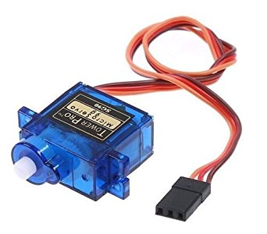

Figure1.3.1

**LDR**

A photoresistor (or light-dependent resistor, LDR, or photo-conductive cell) is a light-controlled variable resistor. The resistance of a photoresistor decreases with increasing incident light intensity; in other words, it exhibits photoconductivity. A photoresistor can be applied in light-sensitive detector circuits, and light-activated and dark-activated switching circuits

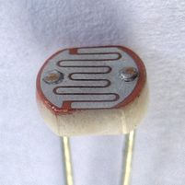

Figure1.3.2

**ARDUINO UNO**

The Arduino UNO is a widely used open-source microcontroller board based on the ATmega328P microcontroller and developed by Arduino.cc. The board is equipped with sets of digital and analog input/output (I/O) pins that may be interfaced to various expansion boards (shields) and other circuits. The board features 14 Digital pins and 6 Analog pins. It is programmable with the Arduino IDE(Integrated Development Environment) via a type B USB cable. It can be powered by a USB cable or by an external 9 volt battery, though it accepts voltages between 7 and 20 volts.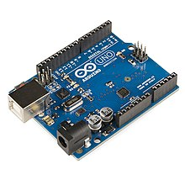

Figure1.3.3

**SOLAR PANEL**

Photovoltaic solar panels absorb sunlight as a source of energy to generate electricity.

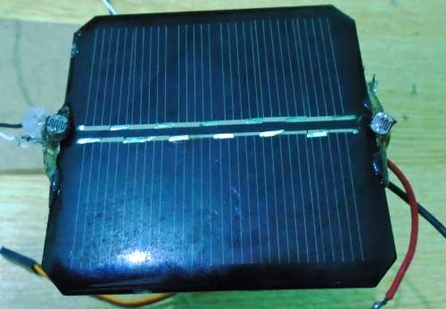

Figure1.3.4

**RESISTORS**

A resistor is a passive two-terminal electrical component that implements electrical resistance as a circuit element

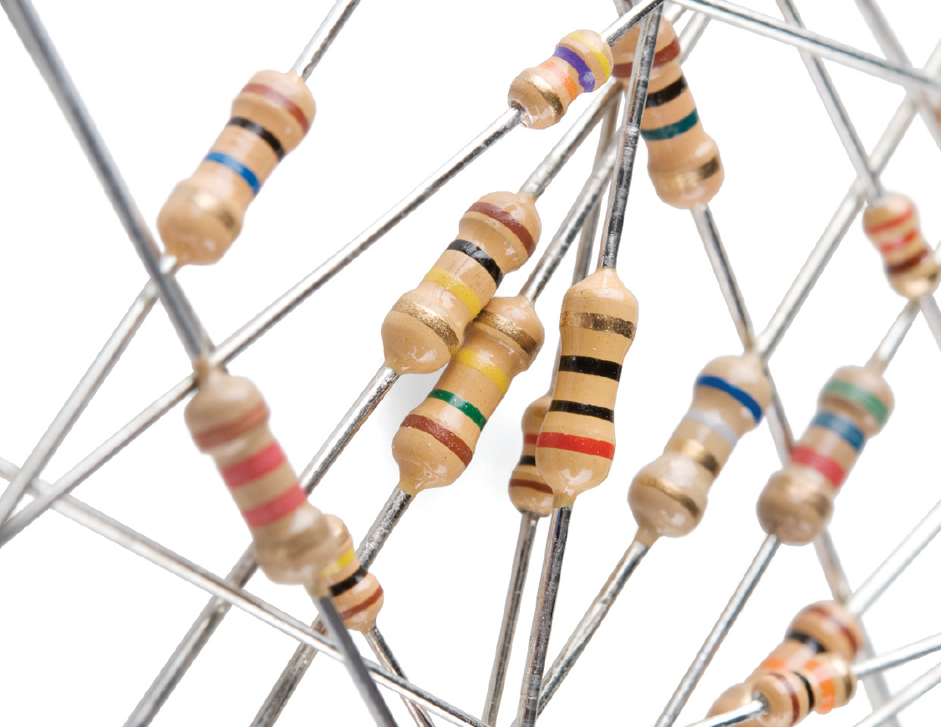

Figure1.3.5

**BATTERY**

Power source (6v – 12v)

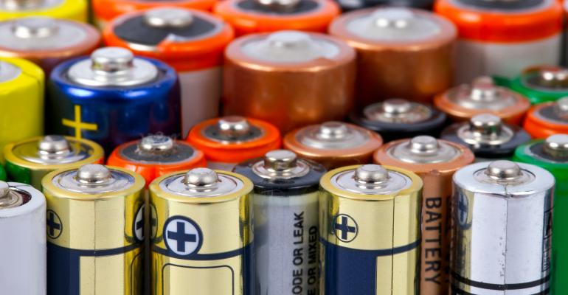

Figure1.3.6

**CHAPTER 2**

**Functionality of the project**

**How it Works:**

LDR’s are working as light detector. LDR (Light Dependent Resistor) also known as photo resistor is the light sensitive device. Its resistance decrease when the light falls on it and that’s why it is frequently used in Dark or Light Detector Circuit.

The two LDR’s are placed at the two sides of solar panel and the Servo Motors is used to rotate the solar panel. The servo will move the solar panel towards the LDR whose resistance will be low, mean towards the LDR on which light is falling, that way it will keep following the light. And if there is same amount of light falling on both the LDR, then servo will not rotate. The servo will try to move the solar panel in the position where both LDR’s will have the same resistance means where same amount of light will fall on both the resistors and if resistance of one of the LDR will change then it rotates towards lower resistance LDR.

**Explanation:**

* In this Arduino Solar Panel Tracker, Arduino is powered by the 9V battery and all the other parts are powered by the Arduino. Arduino recommended input voltage is from 7 to 12 volts but you can power it within the range of 6 to 20 volts which is the limit. Try to power it within the recommended input voltage. So connect the positive wire of the battery to the Vin of the Arduino and the negative wire of the battery to the ground of the Arduino.
* Next connect the servo to arduino. Connect the positive wire of the servo to the 5V of Arduino and ground wire to the ground of the Arduino and then connect the signal wire of Servo to the digital pin 9 of Arduino. The servo will help in moving the solar panel.
* Now connect the **LDRs to the Arduino**. Connect one end of the LDR to the one end of the 10k resistor and also connect this end to the A0 of the Arduino and connect the other end of that resistor to the ground and connect the other end of LDR to the 5V. Similarly, connect the one end of second LDR to the one end of other 10k resistor and also connect that end to the A1 of Arduino and connect the other end of that resistor to ground and connect the other end of LDR to 5V of Arduino.

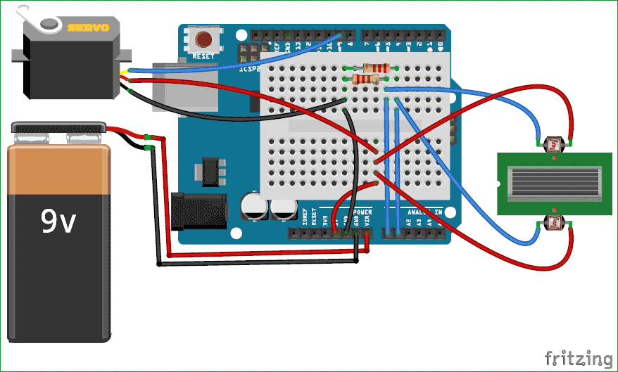

Figure2.1.1

**CHAPTER 3**

**Implementation**

**Code Explanation**

First of all, we will include the library for servo motor. Then we will initialize the variable for the initial position of the servo motor. After that, we will initialize the variables to read from the LDR sensors and Servo.

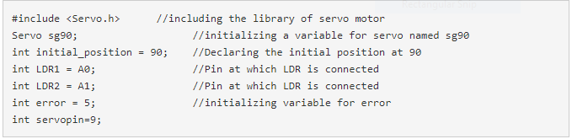

Figure3.1.1

Then we will read the values from the LDRs and will save in R1 and R2. Then we will take the difference between the two LDRs to move the servo accordingly. If the difference between them will be zero that it means that same amount of light is falling on both the LDR’s so the solar panel will not move. We have used a variable named error and its value is 5, the use of this variable is that if the difference between the two LDRs will be under 5 then the servo will not move. If we will not do this then the servo will keep on rotating. And if the difference is greater than error value (5) then servo will move the solar panel in the direction of the LDR, on which light is falling.

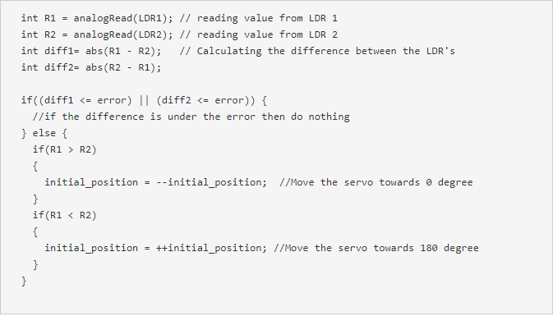

Figure3.1.2

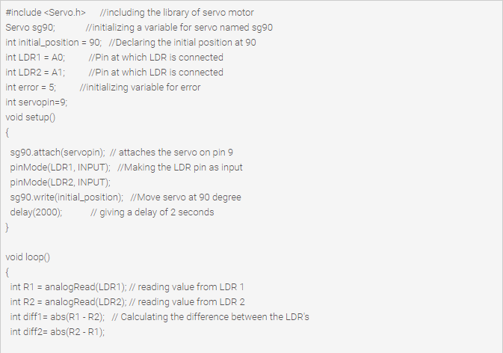

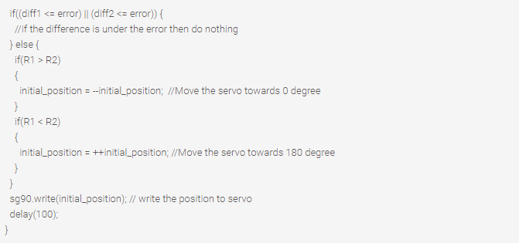

Figure3.1.3

**Conclusions And Further Scope**

**Conclusion**

After executing this project we learned the basics of arduino and its uses in various electronic devices used in our daily life. We even learned to program the arduino to use it as per our project requires. We learned about various electronic components such as LDR and Servo motor. Solar tracking allows more energy to be produced because the solar array is able to remain aligned to the sun. This system builds upon topics learned in this course. A working system will ultimately be demonstrated to validate the design. Problems and possible improvements will also be presented.

**Aim of the Project**

The aim of this solar tracker project is to keep the solar photovoltaic panel perpendicular to the sun throughout the year in order to make it more efficient. The dual axis solar photovoltaic panel takes astronomical data as reference and the tracking system has the capability to always point the solar array toward the sun and can be installed in various regions with minor modifications. The vertical and horizontal motion of the panel is obtained by taking altitude angle and azimuth angle as reference. The fuzzy controller has been used to control the position of DC motors. The mathematical simulation control of dual axis solar tracking system ensures the point to point motion of the DC motors while tracking the sun. Solar Tracker is a Device which follows the movement of the sun as it rotates from the east to the west every day. The main function of all tracking systems is to provide one or two degrees of freedom in movement. Trackers are used to keep solar collectors/solar panels oriented directly towards the sun as it moves through the sky every day. Using solar trackers increases the amount of solar energy which is received by the solar energy collector and improves the energy output of the heat/electricity which is generated. Solar trackers can increase the output of solar panels by 20-30% which improves the economics of the solar panel project. Usually fixed solar panels cannot absorb entire sunlight throughout the day time so this system helps the solar panel to rotate such that it faces the sun throughout the day which results in maximum usage and productivity of the solar panels to produce electricity

**REFERENCES**

[1]Jeremy Blum, Exploring Arduino: Tools and Techniques for Engineering Wizardry., 3rd Edition, Wiley, 1998,

ISBN:81-265-0280-0.

[2] Massimo Banzi, “Arduino for Dummies”, John Nussey, September 1999.

[3] [online] http://www.vicomsoft.com/knowledge/reference/firewalls1.html.