**Overview**

*TOTAL DURATION –* ***180 MINS***

*MAX SCORE* ***– 35 POINTS***

“India Lever” is a Fast Moving Consumers Goods (FMCG) company that manufactures consumer products such as Hair Oils, Shampoos, Perfumes, Deodorant, Soaps, Beverages and Instant Food mixes.

* Each product has a product code *(product_code),* description *(product_desc)*, size *(sku_size)*, shelf life *(shelf_life_days)* and belong to a brand *(brand)*. For example, Cinthol is a brand, Cinthol 75ml Soap is a product. **The product details are stored in a PRODUCT table**
* It works with “distributors” who in turn help sell their products to stores all over the country. There are 1000 + distributors, with each distributor catering to a fixed number of stores within a city. **Each Distributor and Retailer combination identifies a single STORE.**
* Each Distributor employs sales representatives a.k.a. Distributor Sales Rep (DSR) who go store-to-store to take orders for India Lever products. These sales representatives have a pre-defined outlet coverage frequency and route called “beats” based on which they make visits to stores for taking orders
* Each store has a store identifier *(retailer_code),* its distributor’s identifier *(distributor_code, distributor_name)*,name of the store *(retailer_name)*, sales representative information *(dsr_id, dsr_name)*, beat information *(beat_id, beat_name)*. Each store can be of one type a.k.a. channel: CHEMIST, GROCERS, COSMETIC, WHOLESALE or SUPERMARKETS *(channel)*. India Lever tracks the average monthly business provided by each store *(avg_bpm)*
* 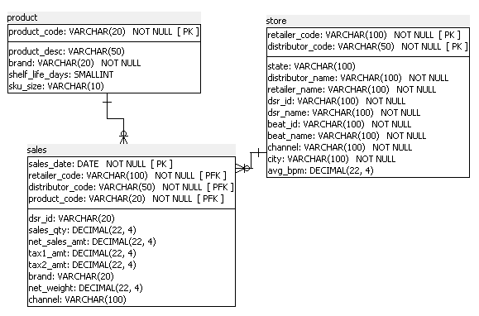Once order is taken by the DSRs from the stores during their beats, products are delivered to the store within a stipulated date and a transaction is recorded against the store for each product bought in a given day. **These transactions are maintained in a SALES table** *(sales_date, retailer_code, distributor_code, sales_date, product_code, sales_qty, net_sales_amt etc)*
* Write appropriate SELECT queries to answer each of them **WITHOUT USING JOINS**
* For each question, the expected query fields have been included. Ensure that only these columns are part of your query. If field list in the query is partial, half the points will be cut
* There are no negative points

**PART 1 – THESE QUESTIONS CARRY 1 POINT EACH**

1. List all the products from highest to the lowest days of their shelf life

|  |  |  |
| --- | --- | --- |
| product_code | product_desc | shelf_life_days |

1. List out 10 most recent transactions that happened for the brand 'Parachute' (Hint: Use now() function) with oldest one on top

|  |  |  |  |
| --- | --- | --- | --- |
| sales_date | retailer_code | distributor_code | product_code |

1. List the number of stores that are in the city 'bangalore'

|  |
| --- |
| count_of_stores |

1. Find the number of stores present in each city

|  |  |
| --- | --- |
| city | count_of_stores |

1. Find the retailer wise total net sales amount in the last 2 years (HINT: Use GETDATE)

|  |  |
| --- | --- |
| retailer_code | total_net_sales_amt |

**PART 2 – THESE QUESTIONS CARRY 2 POINTS EACH**

1. Find all the sales date for retailer 'Udupi General Store' in the last 1 year with the net sales amount above Rs. 10,000

|  |  |
| --- | --- |
| **sales_date** | **net_sales_amt** |

1. Find the sales for each distributor for the month of Jan 2016 and Feb 2016 (NOTE: In the same row, display the sales for Jan and Feb for the respective distributor)

|  |  |  |
| --- | --- | --- |
| **distributor_code** | **Jan_2016_sales_amt** | **Feb_2016_sales_amt** |

1. List the total sales for each distributor, month wise, ordered alphabetically in ascending order of distributor_code and month (from newest on top to oldest)

|  |  |  |
| --- | --- | --- |
| **distributor_code** | **month** | **total_sales** |

1. Bucket the products according to their shelf life into following buckets

(a) Bucket 1: 1-5 days (b) Bucket 2: 6-15 days (c) Bucket 3: 16-30 days

d) Bucket 4: 31-100 days

**Display Product Code, Product Description, Shelf Life and Shelf Life Bucket**

1. Find the retailers who are associated with more than one dsr_id. **Display retailer_code and number_of_distinct_dsr**
2. List the channels in the Sales table for which the total sales is greater than Rs.1,00,000
3. Find the most popular product in terms of number of transactions i.e. **display the product code** for the product with highest number of transactions
4. Rank the retailers according to the overall sales amount. **Display retailer_code, overall_net_sales_amount** by descending order of overall_net_sales_amount
5. Generate a derived column **“parent_tran_id”** for the sales table. It should contain data in the below format

"<salesdate_in_YYYYMMDD format>_<distributor_code>_<first 4 characters of the retailer code>_<product_code_with last 2 characters masked>"

**For example:** 20160331_6743_15YM_7001xx

1. For each brand, displays the first and the most recent sales_date only if first transaction happened in 2015 or older

|  |  |  |
| --- | --- | --- |
| **brand** | **first_sales_date** | **recent_sales_date** |

**PART 3 – THESE QUESTIONS CARRY 5 POINTS EACH**

1. Find the dsr who does the highest sales amongst stores which have the avg_bpm above Rs.1,00,000. **Display dsr_id, total_net_sales_amt**
2. List all the product codes whose sales for the month of January and February 2016 combined, is greater than or equal to the average sales of the same brand in those 2 months. **Display product_code and total_sales_for_jan_feb**