MINI PROJECT

ON

CUSTOMER REVIEW SENTIMENT ANALYSIS
A Machine Learning and TF-IDF Based Review Sentiment Classification Application

Submitted by
Omkar Shingote - VU2F234012

Submitted to
Prof. Ganesh Patil

Vasantdada Patil Pratishthan's College of Engineering & Visual Arts
Department of Artificial Intelligence and Data Science
Academic Year: 2026-27

ABSTRACT
Online platforms receive large volumes of customer reviews, and manually reading and categorizing every review to understand customer opinion is time-consuming and difficult to scale. Natural Language Processing (NLP) and Machine Learning offer a way to automatically classify review text by the sentiment it expresses, helping to summarize large volumes of feedback into actionable categories.
The proposed project, Customer Review Sentiment Analysis, is a machine-learning application that classifies customer review text as expressing positive or negative sentiment. Reviews from the Amazon Fine Food Reviews dataset (568,454 records) are labeled using their star ratings, with ratings of 1–2 mapped to negative sentiment, ratings of 4–5 mapped to positive sentiment, and rating 3 excluded from the binary classification task. Review text is cleaned and normalized through a preprocessing pipeline — lowercasing, HTML and URL removal, tokenization, stopword removal, and lemmatization — and converted into numerical features using TF-IDF (Term Frequency–Inverse Document Frequency) vectorization with unigrams and bigrams.
Multinomial Naive Bayes and Logistic Regression classifiers were trained and evaluated on the resulting features, with a Linear Support Vector Classifier (LinearSVC) implemented for further evaluation. Logistic Regression was selected as the preferred model, reporting an accuracy of 93.74%, precision of 94.87%, recall of 97.88%, and an F1 score of 96.35% on the evaluated test data; these figures are presented as reported experimental results. The trained model and TF-IDF vectorizer were saved and deployed through an interactive Streamlit web application that accepts a customer review and returns a predicted sentiment with a confidence score.
The project demonstrates the practical application of text preprocessing, TF-IDF feature extraction, and traditional machine-learning classification to the problem of customer review sentiment analysis. It can be useful for summarizing customer opinion and highlighting positive or negative feedback at scale. The system also has limitations: it performs binary classification only, it does not model neutral or mixed-sentiment reviews, and its reported performance has not been independently re-verified against the original project files beyond the figures documented in the project's own records.
Keywords: Sentiment Analysis, Natural Language Processing, Machine Learning, TF-IDF, Text Classification, Logistic Regression, Naive Bayes, Customer Reviews.

TABLE OF CONTENTS

1. Problem Definition | 4
2. Introduction | 4
3. Literature Review and Background | 6
4. Motivation | 7
5. Objectives and Scope | 8
6. Methodology Used | 9
7. System Architecture and Modules | 11
8. Development and Testing Plan | 13
9. Expected Outcomes, Limitations and Future Scope | 16
10. Conclusion | 18
11. References | 18

1. PROBLEM DEFINITION
Online platforms such as e-commerce and food-delivery sites receive very large volumes of customer reviews. These reviews contain valuable information about product quality, customer satisfaction, and recurring complaints, but manually reading and categorizing every review is time-consuming and does not scale to datasets containing hundreds of thousands of records.
The primary problem is to develop a system that can automatically read a customer review and determine whether it expresses a positive or negative opinion, without requiring a human reader to examine each review individually.
Review text is unstructured and varies widely in length, vocabulary, and style, which makes simple keyword-matching approaches unreliable. A review's star rating is often used as a proxy for sentiment, but the review text itself is what most directly expresses the customer's opinion, so a system that learns to classify sentiment directly from the text can be useful even when a rating is missing or when the text and rating appear inconsistent.
The major problems addressed by the project are:
- Manual reading and categorization of large volumes of customer feedback.
- Lack of a consistent, automated way to classify review text as positive or negative.
- The need to convert unstructured review text into a numerical form suitable for machine-learning models.
- Comparing candidate classification algorithms to select one suitable for deployment.
- Presenting a sentiment prediction to a user in a simple, interactive interface.
The proposed Customer Review Sentiment Analysis project addresses these problems by preprocessing review text, extracting TF-IDF features, training and comparing machine-learning classifiers, and deploying the best-performing model through an interactive Streamlit application. It performs binary (positive/negative) classification only and does not attempt to resolve every nuance of customer opinion, such as sarcasm, mixed sentiment, or reviews with a neutral rating.
2. INTRODUCTION
2.1 Background
Natural Language Processing (NLP) is a branch of Artificial Intelligence that enables computers to process, analyze, and interpret human language. Sentiment analysis, also known as opinion mining, is an NLP application that identifies the emotional orientation of a piece of text, typically classifying it as positive, negative, or neutral.
Machine learning allows a sentiment classifier to be trained on labeled examples — in this project, reviews labeled using their star ratings — rather than relying on hand-written rules. Once trained, the model can be applied to new, unseen review text to predict its sentiment.
2.2 Project Overview
The Customer Review Sentiment Analysis project classifies customer review text as expressing positive or negative sentiment. The underlying model is trained on the Amazon Fine Food Reviews dataset using TF-IDF features and traditional machine-learning classifiers, and the trained model is deployed through an interactive Streamlit web application.
As illustrated in the supplied screenshots, the deployed application includes an overview page describing the system's key capabilities, and a Sentiment Analyzer page where a user can enter or paste a customer review and receive a predicted sentiment label together with a model confidence score.
2.3 Existing Approach and Proposed Approach
Existing Approach
In a conventional approach, customer reviews are read manually, or sentiment is approximated only from the numeric star rating attached to each review. Manual reading does not scale to large datasets, and rating-only approaches ignore the information contained in the review text itself, which can disagree with or add nuance to the numeric rating.
Proposed Approach
The proposed system trains a machine-learning classifier directly on review text, using TF-IDF features derived from the cleaned and normalized text, and makes the trained model available through an interactive web interface.
Existing approach | Proposed approach
Manual reading of individual reviews | Automated sentiment classification of review text
Sentiment approximated from star rating alone | Sentiment predicted directly from review text using TF-IDF features
No consistent, repeatable classification method | Trained and compared machine-learning classifiers (Naive Bayes, Logistic Regression, LinearSVC)
No interactive way to test a new review | Interactive Streamlit application with instant prediction and confidence score
The proposed approach improves consistency and scale compared to manual reading, while remaining limited to the binary positive/negative distinction learned from the rating-derived labels used during training.
3. LITERATURE REVIEW AND BACKGROUND
3.1 Natural Language Processing and Text Classification
Natural Language Processing combines linguistic principles, statistical methods, and machine-learning techniques to process human language, enabling computers to identify patterns, extract information, and classify text. Medhat, Hassan, and Korashy [1] survey sentiment-analysis algorithms and applications, categorizing approaches into lexicon-based, machine-learning-based, and hybrid methods, and noting that machine-learning approaches generally require labeled training data and a suitable feature representation of the text — the approach followed in this project through TF-IDF features and rating-derived labels.
3.2 Sentiment Analysis and Customer Reviews
Pang and Lee [2] provide a comprehensive survey of opinion mining and sentiment analysis, covering document-level, sentence-level, and feature-level sentiment classification and the challenges specific to review text, such as negation and comparative statements. Pang, Lee, and Vaithyanathan [3] conducted an early and influential study applying machine-learning classifiers — including Naive Bayes and support vector machines — to sentiment classification of movie reviews, reporting that standard text-classification techniques adapted from topic categorization perform reasonably well but face challenges specific to sentiment, such as the influence of individual, highly polarized phrases. This project applies a comparable set of classifiers (Multinomial Naive Bayes, Logistic Regression, and LinearSVC) to a different review domain — food product reviews — using rating-derived sentiment labels. Hu and Liu [4] examine the related task of mining and summarizing customer reviews, including the extraction of product features and the orientation of opinions expressed about them; while this project performs document-level rather than feature-level sentiment classification, Hu and Liu's observation that customer reviews are a rich and widely used source of opinion data motivates the choice of a large, real-world review dataset for this project.
3.3 TF-IDF and Traditional Machine Learning Classifiers
Salton and Buckley [5] introduced term-weighting approaches for automatic text retrieval, including the term frequency–inverse document frequency (TF-IDF) weighting scheme used in this project to convert cleaned review text into numerical features. TF-IDF weights a term by how frequently it appears in a given document relative to how common it is across the whole collection, which tends to emphasize words that are distinctive to a particular review. Pedregosa et al. [6] describe the scikit-learn library, which provides the TF-IDF vectorizer, Multinomial Naive Bayes, Logistic Regression, and LinearSVC implementations used in this project, along with the standard train–test evaluation workflow followed here. Zhang, Wang, and Liu [7] survey deep-learning approaches to sentiment analysis and note that, while neural and transformer-based models can capture more contextual information than bag-of-words representations such as TF-IDF, traditional feature-based classifiers remain a practical and computationally inexpensive choice for many applications — a trade-off consistent with this project's use of TF-IDF with traditional classifiers rather than a deep-learning model.
3.4 Related Applications
Automated review-sentiment classification is used in several practical domains:
- E-commerce: summarizing product reviews and customer satisfaction at scale.
- Food and hospitality: analyzing feedback on food quality and service.
- Customer support: identifying recurring complaints in support tickets and feedback forms.
- Market research: understanding customer preferences and product perception.
- Social media monitoring: tracking public sentiment toward a brand or product.
These applications illustrate the broader relevance of text-based sentiment classification, which this project implements at prototype scale using a single, well-documented customer-review dataset.
4. MOTIVATION
The motivation behind this project is to build a simple, interactive application that automatically classifies the sentiment of a customer review, reducing the manual effort required to read and categorize large volumes of feedback.
The increasing volume of online reviews creates a need for methods that can process textual opinions efficiently. A rating-only view of customer feedback discards the information contained in the review text itself, and manual reading is impractical at the scale of hundreds of thousands of reviews, such as the Amazon Fine Food Reviews dataset used in this project.
The major motivations are:
- To reduce the effort required for manual review analysis.
- To classify sentiment directly from review text rather than from rating alone.
- To compare traditional machine-learning classifiers on a real-world review dataset.
- To provide a convenient, interactive interface for testing new reviews.
- To apply NLP and text-classification concepts to a practical, large-scale problem.
5. OBJECTIVES AND SCOPE
5.1 Objectives
The main objectives of the Customer Review Sentiment Analysis project are:
- To label reviews as positive or negative using their star ratings, excluding neutral (rating 3) reviews from the binary classification task.
- To clean and normalize review text through lowercasing, HTML and URL removal, tokenization, stopword removal, and lemmatization.
- To extract numerical features from review text using TF-IDF vectorization with unigrams and bigrams.
- To train and compare Multinomial Naive Bayes, Logistic Regression, and LinearSVC classifiers on the extracted features.
- To select the best-performing classifier based on accuracy, precision, recall, and F1 score.
- To save the trained model and TF-IDF vectorizer for reuse in a deployed application.
- To provide an interactive Streamlit interface that predicts the sentiment of a user-entered review.
5.2 Scope
The scope of the project covers binary sentiment classification of customer review text. The application is intended to support the following activities:
- Classifying individual customer reviews as positive or negative.
- Displaying the predicted sentiment and the model's confidence score.
- Training and comparing candidate classifiers on a labeled review dataset.
- Supporting review text from the food-product domain represented in the training dataset.
The current scope, based on the project's documented implementation, does not establish support for neutral or mixed-sentiment classification, aspect-level sentiment analysis, multilingual reviews, or domains substantially different from food-product reviews. These may be considered as future extensions if required.
6. METHODOLOGY USED
The Customer Review Sentiment Analysis project follows a standard text-classification workflow in which labeled review text is cleaned, converted into numerical features, and used to train and compare machine-learning classifiers.
6.1 Overall Methodology
The general workflow of the project is as follows:
Dataset Collection
Amazon Fine Food Reviews dataset (568,454 records)
Sentiment Labeling
Ratings 1–2 mapped to negative, 4–5 to positive, rating 3 excluded
Text Preprocessing
Lowercasing, HTML/URL/number/punctuation removal, tokenization, stopword removal, lemmatization
Feature Extraction
TF-IDF vectorization with unigrams and bigrams (max 10,000 features)
Model Training
Multinomial Naive Bayes, Logistic Regression, LinearSVC
Model Evaluation
Accuracy, precision, recall, and F1 score on held-out data
Model Selection and Deployment
Best model and vectorizer saved with Joblib and served through Streamlit
6.2 Data Collection and Sentiment Labeling
The project uses the Amazon Fine Food Reviews dataset, reported to contain 568,454 customer reviews with fields including ProductId, UserId, ProfileName, Summary, Text, and Score. Exploratory data analysis reported 26 missing ProfileName values and 27 missing Summary values, no fully duplicate rows, and 174,875 instances of duplicate review text, which were further investigated using other attributes such as product ID, user ID, score, and timestamp.
Each review's star rating (Score) was used to derive a binary sentiment label: ratings of 1–2 were mapped to negative sentiment, ratings of 4–5 were mapped to positive sentiment, and reviews with a rating of 3 were excluded from the binary classification labels, consistent with treating a 3-star rating as ambiguous rather than clearly positive or negative.
6.3 Text Preprocessing
Review text was cleaned using the following sequence of steps:
- Lowercasing: converting all text to lowercase to reduce variation caused by capitalization.
- HTML tag removal: removing HTML markup present in some review text.
- URL removal: removing web links that do not contribute to sentiment.
- Number and punctuation removal: removing numeric and punctuation characters not required for classification.
- Tokenization: splitting text into individual tokens (words).
- Stopword removal: removing common words that contribute little to sentiment classification.
- Lemmatization: reducing words to their base or dictionary form.
For example, a raw review such as “This coffee is AMAZING!! I absolutely loved it.” is reduced through this pipeline to a cleaned form such as “coffee amazing absolutely loved.”
6.4 Feature Extraction Using TF-IDF
Cleaned review text was converted into numerical features using TF-IDF (Term Frequency–Inverse Document Frequency) vectorization, configured with a maximum of 10,000 features and an n-gram range of (1, 2), so that both unigrams (individual words) and bigrams (two consecutive words) contribute to the feature set. TF-IDF weights a term according to how frequently it appears in a given review relative to how common it is across the whole dataset, which emphasizes terms that are distinctive to a particular review rather than terms that are common throughout the corpus.
6.5 Model Training and Comparison
Three classifiers were used in the project: Multinomial Naive Bayes, Logistic Regression, and a Linear Support Vector Classifier (LinearSVC). Multinomial Naive Bayes and Logistic Regression were trained and evaluated with full performance metrics reported; LinearSVC was implemented and is documented as included for further evaluation before a production model is finalized, and its evaluation metrics are not reported as complete at this stage.
6.6 Evaluation Metrics
Classifier performance was evaluated using accuracy, precision, recall, and F1 score, defined as follows, where TP, TN, FP, and FN denote true positives, true negatives, false positives, and false negatives:
Accuracy = (TP + TN) / (TP + TN + FP + FN)
Precision = TP / (TP + FP)
Recall = TP / (TP + FN)
F1 Score = 2 × (Precision × Recall) / (Precision + Recall)
These metrics were computed on the evaluated test split for each trained classifier, and are reported in Section 8.4 exactly as documented in the project's own records, without independent re-verification beyond that documentation.
6.7 Deployment via Streamlit
The selected model and its TF-IDF vectorizer were serialized using Joblib and loaded into an interactive Streamlit web application. The application accepts a customer review as text input, applies the same preprocessing and TF-IDF transformation used during training, and displays the predicted sentiment label together with the model's confidence score.
7. SYSTEM ARCHITECTURE AND MODULES
7.1 High-Level Architecture
The architecture of the application consists of a data-preparation pipeline, a model-training pipeline, and a deployed inference interface. The general architecture is:
Raw Review Dataset
Amazon Fine Food Reviews (568,454 records)
Preprocessing Pipeline
Cleaning, tokenization, stopword removal, lemmatization
TF-IDF Vectorizer
Converts cleaned text into numerical features
Trained Classifier
Multinomial Naive Bayes / Logistic Regression / LinearSVC
Saved Model and Vectorizer
Serialized with Joblib (.pkl files)
Streamlit Application
Accepts a review, applies the saved pipeline, and displays the predicted sentiment
This separation keeps the offline training pipeline independent of the deployed inference interface, so that the application serves predictions using a fixed, previously trained model and vectorizer rather than retraining on each request.
7.2 Main Modules
Module | Description
Data Loading Module | Loads the Amazon Fine Food Reviews dataset and performs exploratory data analysis.
Labeling Module | Derives binary sentiment labels from star ratings, excluding neutral (rating 3) reviews.
Preprocessing Module | Cleans and normalizes review text through the preprocessing pipeline described in Section 6.3.
Feature Extraction Module | Converts cleaned text into TF-IDF features using unigrams and bigrams.
Model Training Module | Trains and evaluates Multinomial Naive Bayes, Logistic Regression, and LinearSVC classifiers.
Model Persistence Module | Saves the selected model and TF-IDF vectorizer using Joblib.
Sentiment Analyzer Module | Accepts a user-entered review and displays the predicted sentiment and confidence score.
7.3 Technology Stack
Category | Technology / Tool
Programming language | Python
Data handling | Pandas, NumPy
Text preprocessing | NLTK
Machine learning | Scikit-learn
Feature extraction | TF-IDF (Scikit-learn TfidfVectorizer)
Classifiers | Multinomial Naive Bayes, Logistic Regression, LinearSVC
Model persistence | Joblib
Web application | Streamlit
7.4 User Interface Design
As shown in the supplied screenshots, the deployed application (titled “ReviewSense AI”) uses a dark navy sidebar with a light main content area. The sidebar provides navigation between an Overview page, a Sentiment Analyzer page, and an About page. The Overview page summarizes the system's key capabilities — text preprocessing, TF-IDF vectorization, and ML classification — while the Sentiment Analyzer page provides a text box for entering a review, an “Analyse Sentiment” button, and a colored result panel (green for positive, red for negative) showing the predicted sentiment and the model's confidence score.
8. DEVELOPMENT AND TESTING PLAN
8.1 Development Plan
The development process was divided into the following stages:
- Data Collection and Exploration: load the Amazon Fine Food Reviews dataset and perform exploratory data analysis, including missing-value and duplicate analysis.
- Sentiment Labeling: derive binary sentiment labels from star ratings, excluding neutral reviews.
- Text Preprocessing: implement the cleaning, tokenization, stopword-removal, and lemmatization pipeline.
- Feature Extraction: implement TF-IDF vectorization with unigrams and bigrams.
- Model Training and Comparison: train Multinomial Naive Bayes, Logistic Regression, and LinearSVC, and compare their evaluation metrics.
- Model Selection and Persistence: select the best-performing classifier and save it with its vectorizer using Joblib.
- Application Development: build the Streamlit interface for interactive sentiment prediction.
- Testing: verify predictions using representative positive and negative review inputs.
8.2 Testing Plan
Testing was planned to verify that the application processes valid review input and produces a sentiment prediction in the expected format.
Test case | Input or action | Expected result
Positive review | Clearly positive review text | Positive sentiment prediction
Negative review | Clearly negative review text | Negative sentiment prediction
Empty input | Submit without entering text | Validation message or no prediction
Model loading | Application startup | Saved model and vectorizer load successfully
Confidence display | Analyze a review | Predicted label and confidence score displayed
8.3 Results Reporting
The following screenshots, captured from the deployed Streamlit application, show the overview page and two example sentiment predictions.
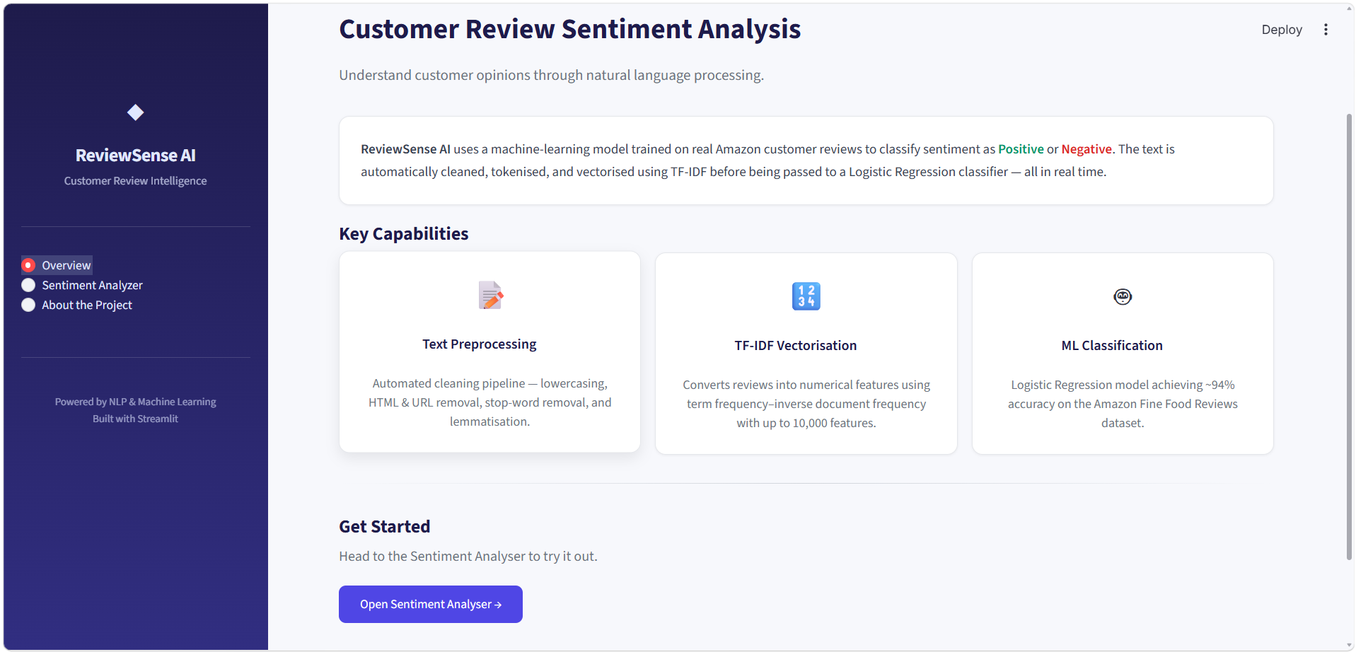
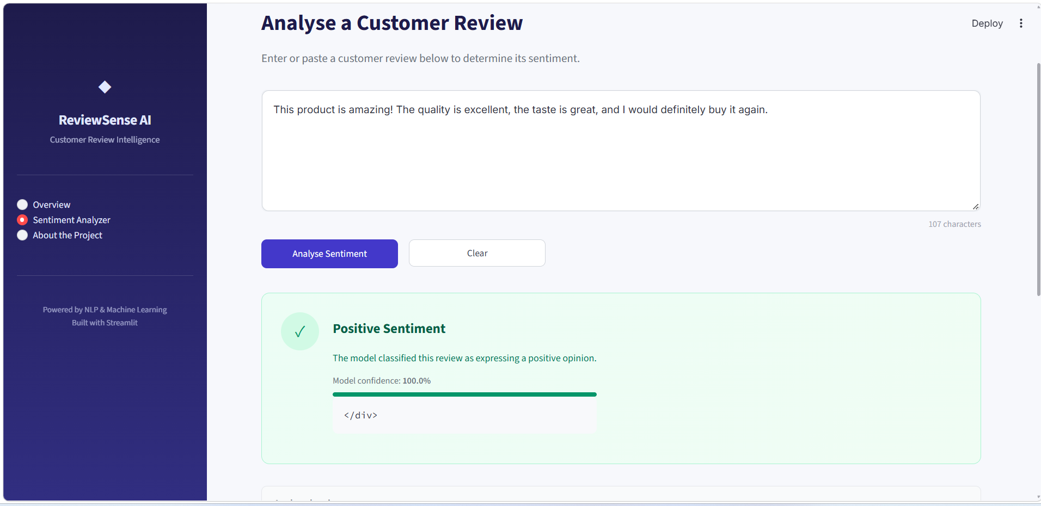
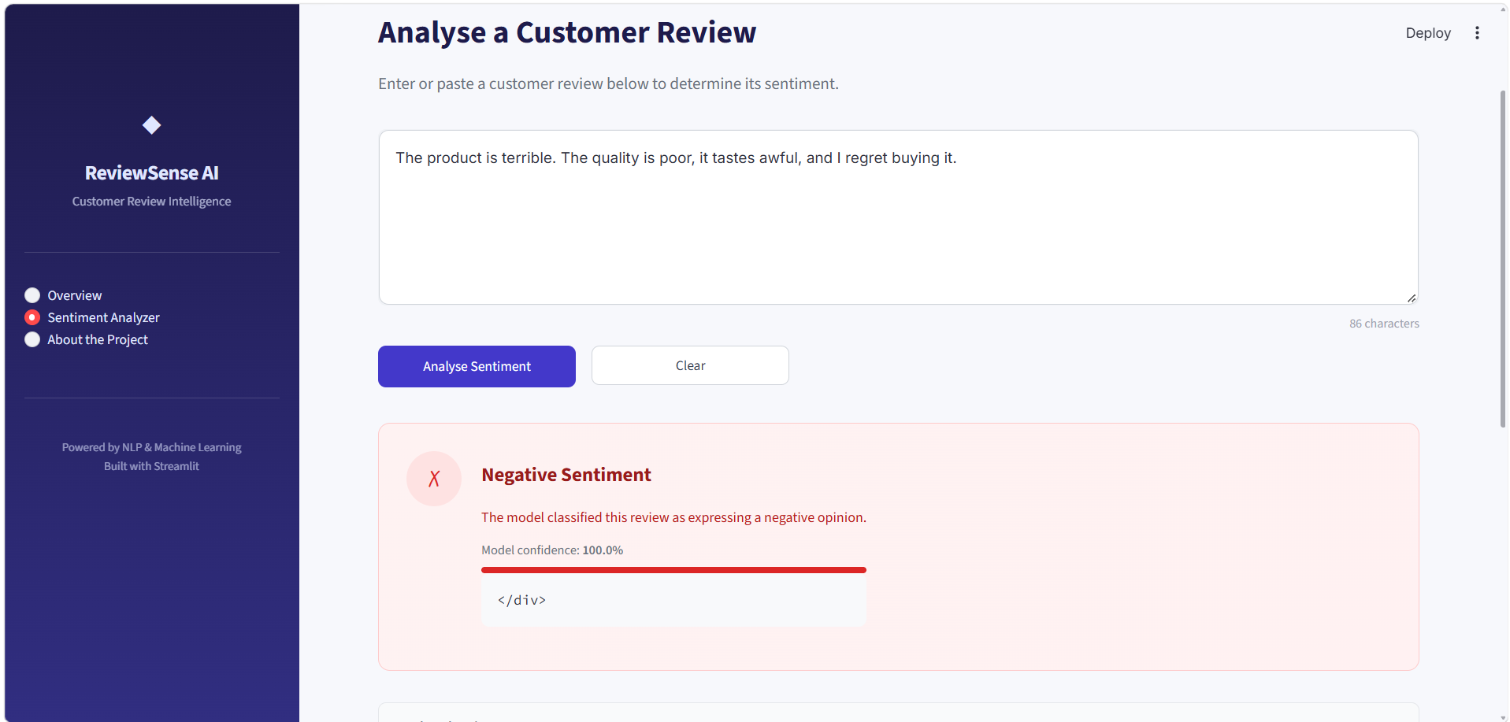
8.4 Result Analysis
The first screenshot shows the application's overview page, describing the system's text-preprocessing pipeline, TF-IDF vectorization, and the Logistic Regression classifier's reported accuracy of approximately 94%. The second screenshot shows the Sentiment Analyzer page classifying the review “This product is amazing! The quality is excellent, the taste is great, and I would definitely buy it again” as Positive Sentiment with a reported model confidence of 100.0%. The third screenshot shows the same interface classifying the review “The product is terrible. The quality is poor, it tastes awful, and I regret buying it” as Negative Sentiment, also with a reported model confidence of 100.0%.
The evaluation metrics reported for the two fully evaluated classifiers are summarized in Table 1, exactly as documented in the project's own records:
Model | Accuracy | Precision | Recall | F1 Score
Multinomial Naive Bayes | 90.11% | 90.10% | 99.18% | 94.42%
Logistic Regression (selected) | 93.74% | 94.87% | 97.88% | 96.35%
Logistic Regression was selected as the preferred model based on these reported figures. LinearSVC was implemented but is documented as included for further evaluation before a production model is finalized, so its performance is not reported here. These figures are presented as reported experimental results from the project's own documentation; they have not been independently reproduced or re-verified in the course of preparing this report, and no additional performance claims are made beyond what is documented.
9. EXPECTED OUTCOMES, LIMITATIONS AND FUTURE SCOPE
9.1 Expected Outcomes
The project is expected to provide the following outcomes:
- A trained classifier that predicts positive or negative sentiment from customer review text.
- A documented comparison of Multinomial Naive Bayes and Logistic Regression on a large, real-world review dataset.
- A reusable, saved model and TF-IDF vectorizer suitable for deployment.
- An interactive Streamlit application for classifying new customer reviews.
- A practical demonstration of text preprocessing, TF-IDF feature extraction, and traditional machine-learning classification.
9.2 Limitations
Although the system demonstrates a working sentiment-classification pipeline, it has several limitations.
Binary classification only: the system distinguishes only positive and negative sentiment; neutral and mixed-sentiment reviews (including 3-star ratings) are excluded from the labeled training data rather than modeled directly.
Rating-derived labels: sentiment labels are derived from star ratings rather than independent human annotation, so a rating that does not match the sentiment expressed in the text would propagate a mislabeled example.
Domain dependence: the model is trained on food-product reviews and may not generalize equally well to other review domains.
Bag-of-words representation: TF-IDF with unigrams and bigrams does not capture longer-range context, sarcasm, or negation as effectively as more complex language models.
Reported-only evaluation: the performance figures in this report are taken from the project's own documentation and have not been independently reproduced.
9.3 Future Scope
- Neutral and Mixed-Sentiment Classification: extend the model to a three-class (positive/neutral/negative) or multi-label task.
- Independent Evaluation of LinearSVC: complete and report evaluation metrics for the LinearSVC classifier.
- Aspect-Based Sentiment Analysis: identify sentiment toward specific product aspects rather than the review as a whole.
- Deep Learning and Transformer Models: explore context-sensitive models such as BERT for improved accuracy.
- Cross-Domain Evaluation: test the model's performance on review domains other than food products.
- Explainability: highlight the words or phrases that most influenced a given prediction.
- Batch Analysis: extend the application to accept and summarize a file of multiple reviews.
10. CONCLUSION
This report has described the Customer Review Sentiment Analysis project, which classifies customer review text as positive or negative using TF-IDF features and traditional machine-learning classifiers trained on the Amazon Fine Food Reviews dataset. Review text is cleaned through a preprocessing pipeline, converted into TF-IDF features using unigrams and bigrams, and classified using Logistic Regression, selected as the preferred model based on its reported accuracy, precision, recall, and F1 score relative to Multinomial Naive Bayes. The trained model is deployed through an interactive Streamlit application that predicts the sentiment of a user-entered review with an associated confidence score.
These results demonstrate a practical, well-scoped application of NLP and machine-learning techniques to a large, real-world dataset of customer reviews. They do not establish that the system understands every nuance of customer opinion: the system performs binary classification only, relies on rating-derived labels rather than independent annotation, and has not been evaluated outside the food-product review domain represented in its training data. Future improvements such as neutral-sentiment modeling, aspect-based analysis, and more context-sensitive language models could extend the system's capabilities beyond the current prototype.
11. REFERENCES
The following references are verified sources relevant to the NLP, sentiment-analysis, and machine-learning techniques used in this project.
1. W. Medhat, A. Hassan, and H. Korashy, “Sentiment analysis algorithms and applications: A survey,” Ain Shams Engineering Journal, vol. 5, no. 4, pp. 1093–1113, 2014. https://doi.org/10.1016/j.asej.2014.04.011
2. B. Pang and L. Lee, “Opinion Mining and Sentiment Analysis,” Foundations and Trends in Information Retrieval, vol. 2, no. 1–2, pp. 1–135, 2008. https://doi.org/10.1561/1500000011
3. B. Pang, L. Lee, and S. Vaithyanathan, “Thumbs up? Sentiment classification using machine learning techniques,” in Proc. 2002 Conf. on Empirical Methods in Natural Language Processing (EMNLP), 2002, pp. 79–86. https://aclanthology.org/W02-1011/
4. M. Hu and B. Liu, “Mining and summarizing customer reviews,” in Proc. 10th ACM SIGKDD Int. Conf. on Knowledge Discovery and Data Mining (KDD), 2004, pp. 168–177. https://doi.org/10.1145/1014052.1014073
5. G. Salton and C. Buckley, “Term-weighting approaches in automatic text retrieval,” Information Processing & Management, vol. 24, no. 5, pp. 513–523, 1988. https://doi.org/10.1016/0306-4573(88)90021-0
6. F. Pedregosa et al., “Scikit-learn: Machine Learning in Python,” Journal of Machine Learning Research, vol. 12, no. 85, pp. 2825–2830, 2011. https://www.jmlr.org/papers/v12/pedregosa11a.html
7. L. Zhang, S. Wang, and B. Liu, “Deep learning for sentiment analysis: A survey,” WIREs Data Mining and Knowledge Discovery, vol. 8, no. 4, e1253, 2018. https://doi.org/10.1002/widm.1253
Include the actual project repository URL, dataset link, and any additional implementation-specific references, where applicable.

