E&TC Dept, AIT, Pune

A Project Report on

**SMS BASED WATER PUMP**

**CONTROL**

Submitted by

Shrihari Nimbalkar

Abhishek Mitra

Sunil kumar Manth

A Seminar report submitted as a partial fulfilment towards term

V of

B.E. (***Electronics & Telecommunication)***

University of Pune, Pune



Guide

Mr. Avinash Patil

Department of E&TC Engineering

Army Institute of Technology, Dighi, Pune-411 015

**2012-13**

E&TC Dept, AIT, Pune

**C E R T I F I C A T E**

*This is to certify that*

***Shrihari Nimbalkar (1361)***

***Abhishek Mitra (1304)***

***Sunil Kumar Manth (1353)***

*of Army Institute of Technology, Dighi, Pune*

*has submitted Seminar report on*

*“****SMS Based Water Pump Control****”*

as a partial *as a partial fulfilment of Term –I for award of degree*

*of Bachelor of E&TC, from University of Pune, Pune, during the*

*Academic Year 2012-13.*

**Index**

Acknowledgement

Abstract

**CHAPTER TITLE PAGE NO.**

1 **INTRODUCTION**

1.1 Problem Definition 6

1.2 Historical Background

1.3 Relevance 7

2 **LITERATURE SURVEY/MARKET SURVEY 8**

2.1 Introduction

2.1.1 International Status

2.1.2 National Status.

3 **BLOCK DIAGRAM / DESCRIPTION/ FLOW CHART / 10**

**ALGORITHM**

**4 METHODOLOGY 27**

**5 EXPERIMENTATAION 28**

**6. PROJECT SCHEDULE 30**

**CONCLUSION 32**

**REFERENCES 33**

**ACKNOWLEDGEMENT**

We should like to express our heartfelt gratitude to Mr.B.P.Patil, Head of Department of  Electronics and telecommunication for providing the best facility and atmosphere for this Project work.

We are greatly thankful to Prof. Avinash Patil for all necessary technical help extended by him in the fulfilment of this Project.

We would also like to thank our colleagues for their co-operation and  support  during  the  collection  of  materials and also during our Project. All of your support has motivated usin many instances. All of the experience has been educating, humbling and very nostalgic.

Thank you all.

**Abstract**

**In this project , a SMS based water pump control (generally used agriculture purposes) is being controlled (switched ‘ON’ and ‘OFF’) using SMS. So , farmer can actually control his motor (in farm) using in mobile phone sitting at home.**

A modern world contains varieties of electronic equipment andsystems like : TV, security system, Hi-fi equipment, central heating systems, fire alarm systems, security alarm systems , lighting systems, SET Top Box, AC (Air Conditioner) etc., weneed to handle, ON/OFF or monitor these electrical devicesremotely or to communicate with these but, if you are not at thehome or that place and you want to communicate with thesedevice. So the new technology for handled these devicesremotely and for communication to required the GSM , mobiletechnology, SMS (short message service) and some hardwareresources. SMS based remote control for home appliances isbeneficial for the human generation , water pump control because mobile is mostrecently used technology nowadays.

This project based on assembly language programming. The software platform used in this project PROTEUS 7.4.

***Keyword:*** *Mobile Phone, Micro-Controller, Short Message Service (SMS), Global System for Mobile Communication*

**1 .INTRODUCTION**

* PROBLEM DEFINITION :

This project is attempt to::

1.1.1 The aim of our project is to control water pump using SMS. In this project user can write specific message from any mobile or landline phone to control water pump.This project generally used in agriculture purposes. Once the user can used the SMS for connected GSM module to the water pump using microcontroller. He entered his ‘START’ or ‘STOP’ MSG and send it on the GSM module SIM number then switch ON or OFF the motor of the water control.

If the user has entered valid choice for specified number only then he can proceed further of switching ON or OFF the motor. For invalid choice, motor cant be operated…

* **HISTORICAL BACKGROUND**

*Adding text messaging functionality to mobile devices began to gain traction in the mobile communication services community in the early 1980s. The first action plan of the CEPT Group  GSM was approved in December 1982, requesting "The services and facilities offered in the public switched telephone networks and public data networks... should be available in the mobile system".This plan included the exchange of text messages either directly between mobile stations, or transmitted via  Message Handling Systems widely in use at that time.*

*The SMS concept was developed in the Franco-German GSM cooperation in 1984 by Friedhelm Hillebrand and Bernard Ghillebaert The innovation in SMS is  Short . The GSM is optimized for telephony, since this was identified as its main application. The key idea for SMS was to use this telephone-optimized system, and to transport messages on the signaling paths needed to control the telephone traffic during time periods when no signaling traffic existed. In this way, unused resources in the system could be used to transport messages at minimal cost. However, it was necessary to limit the length of the messages to 128 bytes (later improved to 140 bytes, or 160 seven-bit characters) so that the messages could fit into the existing signalling formats.*

* **RELEVANCE**

SMS was originally designed as part of GSM, but is now available on a wide range of networks, including 3G networks. However, not all text messaging systems use SMS, and some notable alternative implementations of the concept include J-Phone's *SkyMail* and NTT Docomo's *Short Mail*, both in Japan. Email messaging from phones, as popularized by NTT Docomo's i-mode and the RIM BlackBerry, also typically uses standard mail protocols such as SMTP over TCP/IP

In 2010, 6.1 trillion SMS text messages were sent. This translates into 193000 SMS per second. SMS has become a massive commercial industry, earning $114.6 billion globally in 2010.The global average price for an SMS message is $0.11, while mobile networks charge each other interconnect fees of at least $0.04 when connecting between different phone networks.

* **LITERATURE SURVEY**

**2.1 INTERNATIONAL STATUS**

**AT commands**

Many mobile and satellite  [transceiver](http://en.wikipedia.org/wiki/Transceiver)  units support the sending and receiving of SMS using an extended version of the  [Hayes command set](http://en.wikipedia.org/wiki/Hayes_command_set), a specific  [command language](http://en.wikipedia.org/wiki/Command_language)  originally developed for the  [Hayes](http://en.wikipedia.org/wiki/Hayes_Microcomputer_Products)  Smartmodem 300-[baud](http://en.wikipedia.org/wiki/Baud)  modem in 1977.]

The connection between the terminal equipment and the transceiver can be realized with a serial cable (e.g., [USB](http://en.wikipedia.org/wiki/USB)), a [Bluetooth](http://en.wikipedia.org/wiki/Bluetooth)  link, an [infrared](http://en.wikipedia.org/wiki/Infrared) link, etc. Common AT commands include AT+CMGS (send message), AT+CMSS (send message from storage), AT+CMGL (list messages) and AT+CMGR (read message).

However, not all modern devices support receiving of messages if the message storage (for instance the device's internal memory) is not accessible using AT commands.

**NATIONAL STATUS**

The technical development of SMS was a multinational collaboration supporting the framework of standards bodies. Through these organizations the technology was made freely available to the whole world.

The first proposal which initiated the development o f SMS was made by a contribution of Germany and France into the GSM group meeting in February 1985 in Oslo. This proposal was further elaborated in GSM subgroup WP1 Services (Chairman Martine Alvernhe, France Telecom) based on a contribution from Germany. There were also initial discussions in the subgroup WP3 network aspects chaired by Jan Audestad (Telenor). The result was approved by the main GSM group in a June '85 document which was distributed to industry.  The input documents on SMS had been prepared by Friedhelm Hillebrand ([Deutsche Telekom](http://en.wikipedia.org/wiki/Deutsche_Telekom)) with contributions from Bernard Ghillebaert ([France Télécom](http://en.wikipedia.org/wiki/France_T%C3%A9l%C3%A9com)).

SMS was considered in the main GSM group as a possible service for the new digital cellular system. In GSM document “*Services and Facilities to be provided in the GSM System.*  Both mobile -originated and mobile-terminated short messages appear on the table of GSM teleservices.

The discussions on the GSM services were concluded in the recommendation GSM 02.03 “*TeleServices supported by a GSM* [*PLMN*](http://en.wikipedia.org/wiki/Public_land_mobile_network)*.*” Here a rudimentary description of the three services was given:

* Short message Mobile Terminated (SMS-MT)/ Point-to-Point: the ability of a network to transmit a Short Message to a mobile phone. The message can be sent by phone or by a software application.
* Short message Mobile Originated (SMS-MO)/ Point-to-Point: the ability of a network to transmit a Short Message sent by a mobile phone. The message can be sent to a phone or to a software application.
* Short message [Cell Broadcast](http://en.wikipedia.org/wiki/Cell_Broadcast).

**Major Blocks :**

**1)MICROCONTROLLER**

**2)GSM MODEM**

**3)MOBILE PHONE**

**4)WATER PUMP**

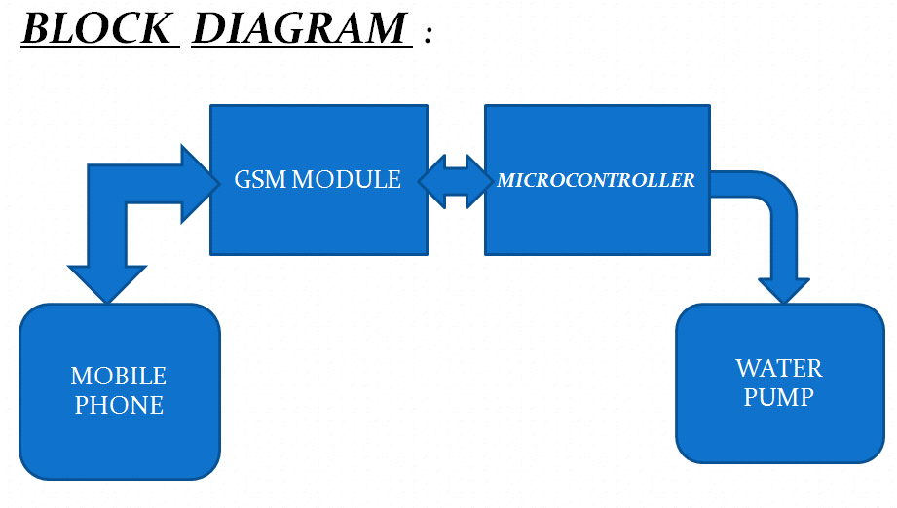

**MICROCONTROLLER :**

**Microcontroller is basic programmable controller .It is directly connected to the GSM module and the motor of water pump through relay.**

**Microcontroller also read MSG from GSM module by using ‘AT’ & ‘ATX’ command. It also used for interfacing of LCD display .LCD display used for displaying the result, what are actually going in the project.**

**In this project all information transmitted through SMS using ‘AT’ & ‘ATX’ command.**

**GSM MODEM**

**GSM modem is mainly used for receiving as well as transmitting message .**

**This GSM modem is also interfaced with microcontroller .Microcontroller read message from GSM module by using ‘AT’ & ‘ATX ’ COMMAND.**

***Subscriber Identity Module (SIM)***

One of the key features of GSM is the  [Subscriber Identity Module](http://en.wikipedia.org/wiki/Subscriber_Identity_Module), commonly known as a  **SIM card**. The SIM is a detachable  [smart card](http://en.wikipedia.org/wiki/Smart_card)  containing the user's subscription information and phone book. This allows the user to retain his or her information after switching handsets. Alternatively, the user can also change operators while retaining the handset simply by changing the SIM. Some operators will block this by allowing the phone to use only a single SIM, or only a SIM issued by them; this practice is known as  [SIM locking](http://en.wikipedia.org/wiki/SIM_lock).

**MOBILE PHONE :**

***Mobile phone are used* for receiving as well as transmitting message.**

**He entered his ‘START’ or ‘STOP’ msg and send it on the GSM module SIM number then switch ON or OFF the motor.**

**WATER PUMP :**

**Water pump *is output device it will be take final output from given input. It will be connected to a microcontroller through the Relay.Water pump motor totally work on the decision of microcontroller***

***Hence the MICROCONTROLLER plays important role in this project.***

**CIRCUIT DIAGRAM :**

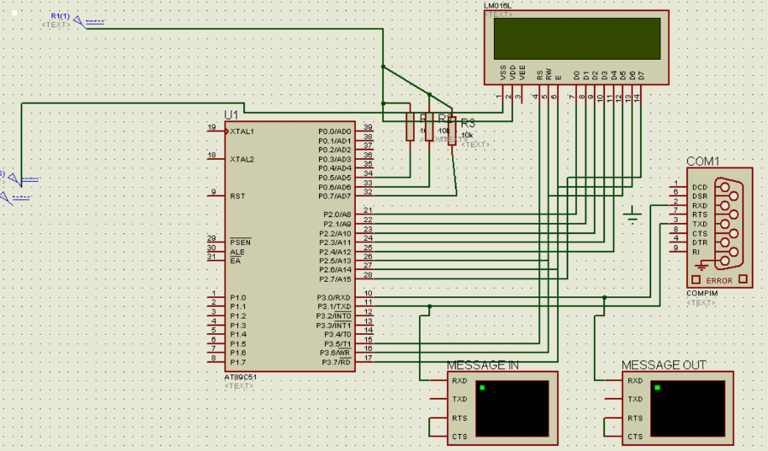

**METHODOLOGY**

***WORKING OF PROJECT* :**

**The working of this project controlled by microcontroller NXP P89V51 RD2 and GSM modem is used for receiving and transmitting message.**

**PROJECT WORKS IN THE FOLLOWING WAYS:**

* **Interface the all circuitarry as per connection.**
* **Send SMS on GSM module SIM number , to ‘START’ or ‘STOP’.**
* **The user can send MSG goes on to the GSM module .**
* **This mMSG read by controller and activate output through relay.**
* **From above procedure microcontroller take decision to turn ON or turn OFF water pump motor.**

**EXPERIMENTATION**

The entire circuit is simulated in Proteus Professional 7.1.

Microcontroller:

It is the Heart of the circuit. We will be usin 89c51 microcontroller. The controller is a 40 pin microcontroller with 32 I/O lines. The controller communicates with the GSM modem & the water pump.

GSM modem :

**GSM** (**Global System for Mobile Communications**, originally ***Groupe Spécial Mobile***), is a standard set developed by the [European Telecommunications Standards Institute](http://en.wikipedia.org/wiki/European_Telecommunications_Standards_Institute) (ETSI) to describe protocols for second generation ([2G](http://en.wikipedia.org/wiki/2G)) digital [cellular networks](http://en.wikipedia.org/wiki/Cellular_network) used by [mobile phones](http://en.wikipedia.org/wiki/Mobile_phone).

The GSM standard was developed as a replacement for first generation ([1G](http://en.wikipedia.org/wiki/1G)) analog cellular networks, and originally described a digital, circuit switched network optimized for [full duplex](http://en.wikipedia.org/wiki/Duplex_(telecommunications)) voice [telephony](http://en.wikipedia.org/wiki/Telephony). This was expanded over time to include data communications, first by circuit switched transport, then packet data transport via [GPRS](http://en.wikipedia.org/wiki/GPRS) (General Packet Radio Services) and [EDGE](http://en.wikipedia.org/wiki/EDGE) (Enhanced Data rates for GSM Evolution or EGPRS).

Further improvements were made when the [3GPP](http://en.wikipedia.org/wiki/3GPP) developed third generation ([3G](http://en.wikipedia.org/wiki/3G)) [UMTS](http://en.wikipedia.org/wiki/UMTS) standards followed by fourth generation ([4G](http://en.wikipedia.org/wiki/4G)) [LTE Advanced](http://en.wikipedia.org/wiki/LTE_Advanced)standards.

**LCD:**

We will be using 2-Line, 16 characters LCD. This will be used to display the real time, scan successful or not and other such details.

**Power Supply:**

The complete circuit works on 5v this voltage is generated in the power supply section which basically consists of a 220V to 9V adapter and further using regulator IC 7805 for reducing it to 5

* ***ADVANTAGES :***
* ***The user can control the water pump from anywhere by sending SMS(not limit of distance).***
* ***By using one microcontroller one GSM modem we can control multiple devices and its operation.***
* ***Easy to operate and it is gives protection from shock.***
* ***User can send commands using internet also , through various free sms sending websites.***
* ***Cheaper :*** SMS services are generally cheap and are sometimes provided for

free (at least for certain periods) by service providers. Furthermore, most service providers do not charge users for receiving SMS.

* **DISADVANTAGES:**
* **System failure if**

**->No network**

**->No power from mains**

* **SIM needs to be recharged**
* **24 x 7 power consumption**

**CONCLUSION *:***

* ***AREA OF APPLICATION:***
* ***This project is generally used for agriculture purposes.So,***

***it has a widespread application in this field.***

* ***It will be also used in industrial application for switching different type of machineries.***

* ***FUTURE SCOPES :***
* ***More than one devices can controlled using same circuit , if other unused port are used efficiently.***
* ***The user can control the device by dialing tone from anywhere***

**PROJECT SCHEDULE**

|  |  |  |
| --- | --- | --- |
| 1 | Mini project topic finalization | 02.01.13 |
| 2 | Literature survey | 09.01.13 |
| 3 | Specification/ Problem statement | 16.01.13 |
| 4 | Block diagram and complete paper work design using datasheet | 23.01.13 |
| 5 | Algorithm and flowchart of software and software testing of complete circuit | 30.01.13  06.02.13 |
| 6 | Test point verification on bread board | 13.02.13 |
| 7 | Layout design | 20.02.13  27.02.13 |
| 8 | PCB designing | 06.03.13 |
| 9 | Final testing of project and preparing bills of materials | 13.03.13  20.03.13 |
| 10 | Seminar and Project Report | 27.03.13 |

**REFERENCES**

* ***Muhammad Ali Mazidi , Janice Gillispi Mazidi , Rolin D. Mckinly.***

***second edition , “ THE 8051 MICROCONTROLLER AND EMBEDDED***

***SYSTEM ”***

* **K.J. Ayala,Third edition,” THE 8051 MICROCONTROLLER** ”

**WEBSITES :**

* [**www.google.com**](http://www.google.com/)
* **www. 8051project.com**
* **www,efyproject .com**
* [**www.8051prpjects.net**](http://www.8051prpjects.net/)
* [**www.youtube.com**](http://www.youtube.com/)