# Wireframe

Wireframe

# FLIGHT FARE PREDICTION

DATE OF SUBMISSION– 5/1/2022

ABHISHEK MONARCH

EMMANUAL

Document Version Control

Wireframe

|  |  |  |  |
| --- | --- | --- | --- |
| Date | Version | Description | Author |
| 7/28/2023 | 1.0 | COMPLETE PROJECT | ABHISHEK |

**Contents**

Wireframe

[**Abstract** 4](https://docs.google.com/document/d/1ZLlZEVdMuxYl3o0PziQjZcUbNmAcz-PR/edit#heading=h.gjdgxs)

**Web Interface 5**

**User Input 5**

**Result Page 6**

**Abstract**

Wireframe

The recent international things had a large impact on the aviation sector because of several reasons. This documentation is all about the user interface wireframe, here the home page of our flight fare prediction project is explained.

**1. Web Interface**

Wireframe

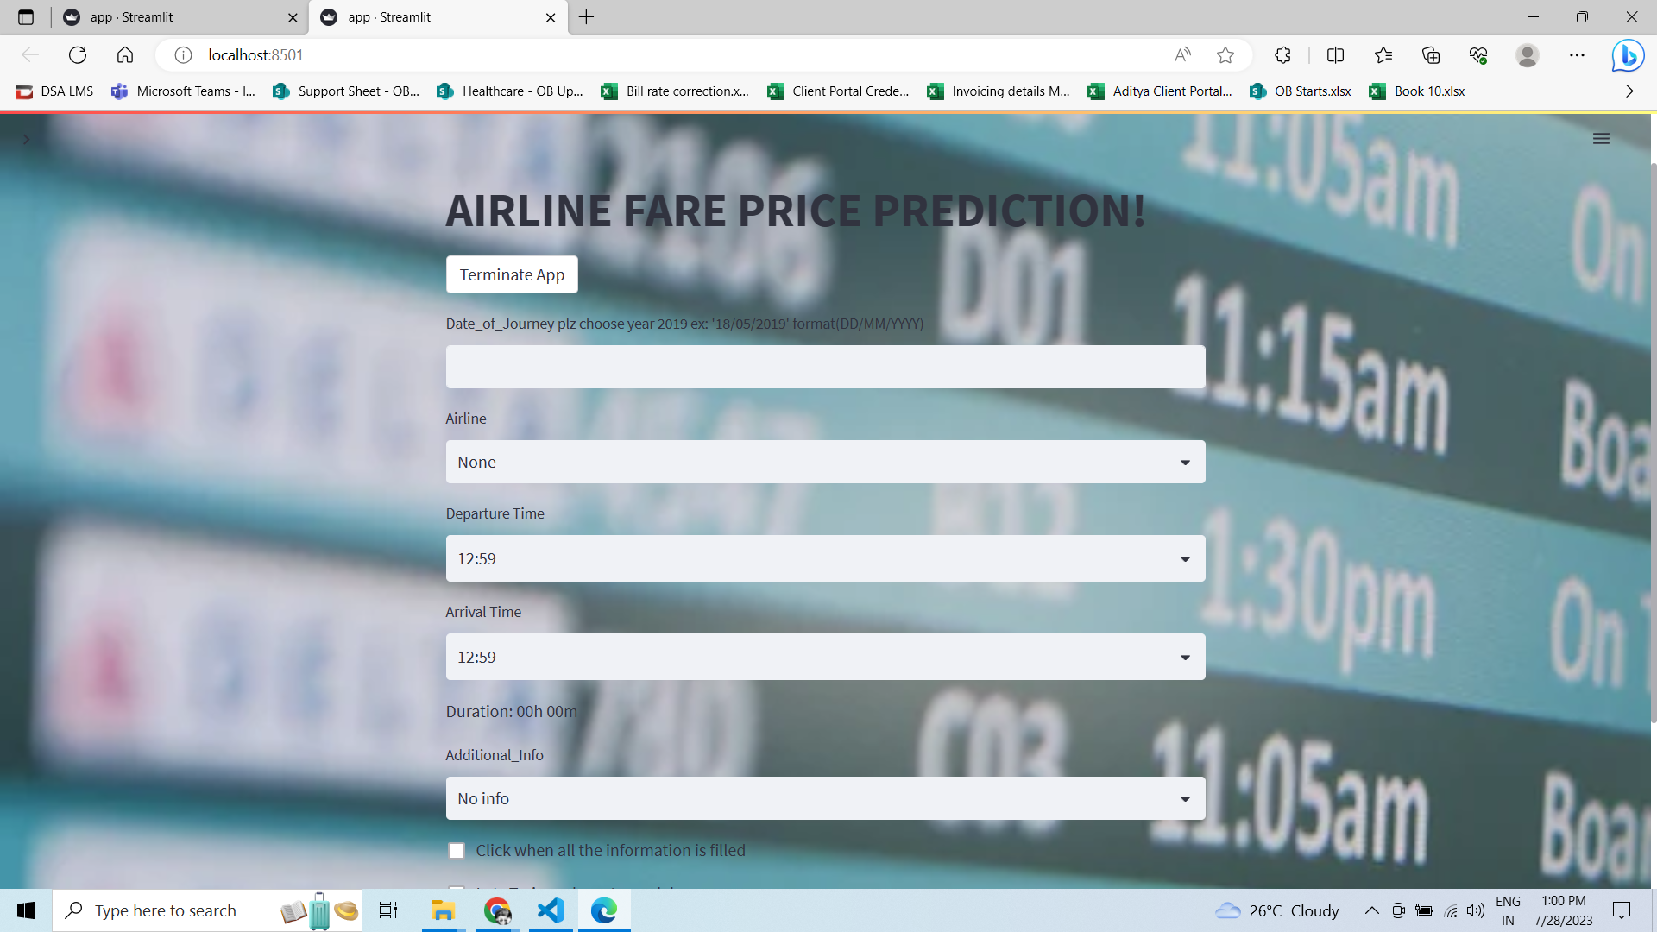

My Webpage it can take input from the user predict the value base upon user input and performs training and give output of predicted fare price.

**2. User Input**

Whenever the user hits our url, they first see the user input page here they have to provide the information like:

* Every user input has its own dropdown where the user can select their input.
* After providing the required input and pressing the submit button, the page refreshes and displays the output

**3. Result Input**

Once User submit the detail and click on the button to create dictionary the next button comes for creating csv file hit and the webpage will ask begin training and the user will get predicted value.