A Major Project

On

**SPHOORTHY PROJECT BOARD**

*Submitted in partial fulfillment of the requirements for the award of the degree of*

**BACHELOR OF TECHNOLOGY**

IN

**COMPUTER SCIENCE AND ENGINEERING**

**BY**

**M.ABHISHEK(14N81A0549)**

**ATHULYA KARUNAKARAN (14N81A0589)**

**V.SAI TEJA (14N81A05C5)**

**A. AMANI(14N81A05K0)**

Under the guidance of

**Mrs. A. JYOSHNA**



**DEPARTMENT OF COMPUTER SCIENCE AND ENGINEERING**

**SPHOORTHY ENGINEERING COLLEGE**

**Near L B Nagar, Sagar Road, Nadergul (V)**

**Saroornagar (M), R.R(Dist)**

**2014-2018**

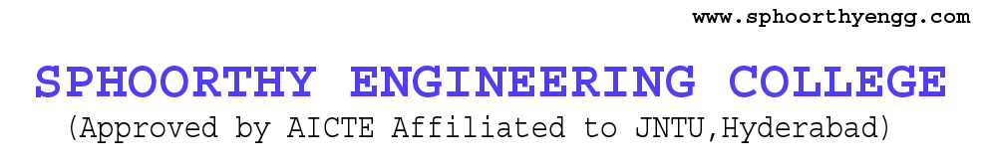

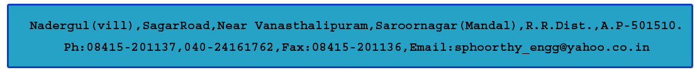

**DEPARTMENT OF COMPUTER SCIENCE AND ENGINEERING CERTIFICATE**

This is to certify that project entitled “**SPHOORTHY’S PROJECT BOARD**” is a bonafide work carried out by M. ABHISHEK (14N81A0549), ATHULYA KARUNAKARAN (14N81A0589), V.SAI TEJA (14N81A05C5),A.AMANI(14N81A05K0)in partial fulfillment for the award of Bachelor of Technology in Computer Science and Engineering, Sphoorthy Engineering College, Hyderabad during the year 2016-2017 under my supervision and guidance. The result embodied in the Project Work has not been submitted to any other University or Institute for the award of any Degree or Diploma.

**INTERNAL GUIDE HEAD OF DEPARTMENT**

**Mrs. A. JOSHNA**  **Mrs. J. DEEPTHI**

Assistant Professor Assistant Professor

**EXTERNAL EXAMINER**  **PRINCIPAL**

**DR. K.S. SHAJI**

**DECLARATION**

We, the undersigned, declare that the project title “**SPHOORTHY’S PROJECT BOARD**” carried out at “SPHOORTHY ENGINEERING COLLEGE” is original and is being submitted to the Department of COMPUTER SCIENCE AND ENGINEERING, Sphoorthy Engineering College, Hyderabad towards partial fulfillment for the award of Bachelor of Technology.

We, declare that, the result embodied in the Project work has not been submitted to any other University or Institute for the award of any Degree or Diploma.

|  |  |
| --- | --- |
| **Date:**  **Hyderabad.** | **M.ABHISHEK(14N81A0549)  ATHULYAKARUNAKARAN(14N81A0589)  V.SAI TEJA (14N81A05C5)  A. AMANI(14N81A05K0)** |

**ACKNOWLEDGEMENT**

The completion of this project work gives us an opportunity to convey our gratitude to all those who have helped us to reach a stage where we have the confidence to launch our career in the competitive world in the field of Computer Science.

We would like to express our heartfelt thanks to **External Guide** forpermitting us to do a project work in their esteemed organization.

We express our sincere thanks to**,** **Dr. K. S. Shaji,** Principal, Sphoorthy Engineering College for providing all necessary facilities in completing our project report.

We express our sense of gratitude to **Prof**. **Mrs.** **J. Deepthi,** Head of Department of Computer Science and Engineering, who encouraged us to select the project and completion of this project with providing necessary facilities.

Our honest thankfulness **to** **Mrs. A. Joshna Ma’am**, (Internal Guide) for his kind help and for giving us the necessary guidance and valuable suggestions in completing this project work and in preparing this report.

We take the opportunity to express our gratitude to the Management, Teaching and Non-Teaching Staff of Sphoorthy Engineering College for their kind co-operation during the period of our Study.

Finally, we would like to thank our parents & friends for their continuous encouragement and support during the entire course of this project work.

|  |  |
| --- | --- |
| **BATCH : 2014 – 2018** | **M. ABHISHEK (14N91A0549) ATHULYA KARUNAKARAN(14N81A589)  V.SAI TEJA (14N81A5C5) A. AMANI(14N81A5K0)** |

**ABSTRACT**

“Sphoorthy Project Board” this product gives the list of projects and explains about the project which is done by the college students. When a student creates a project they usually keep an icon representing their project.

These icons will be attached to the Sphoorthy Project Board, where the students can scan the icon using project share app to know about the project in detail. This is mainly useful to the students who are asked to do a project for the first time they may face many problems to find idea and to domain to be selected. The sphoorthy project board will help the students to know what projects are already done in the college so that they can easily find extensions of the project. They can also find various platforms on which projects are done by various departments.

**CONTENT**

|  |  |  |
| --- | --- | --- |
| **SNO** | **PARTICULARS** | **PAGE NO** |
| 1 | **INTRODUCTION** |  |
| 2 | **LITERATURE SURVEY** |  |
| 3 | **SYSTEM ANALYSIS**  EXISTING SYSTEM  PROPOSED SYSTEM  SYSTEM REQUIREMENTS |  |
| 4 | **REQUIREMENT ANALYSIS**  FEASIBILITY STUDY  OPRATIONAL FEASIBILITY  ECONOMICAL FEASIBILITY  SOCIAL FEASIBILITY  TECHNICAL FEASIBILITY |  |
| 5 | **SYSTEM DESIGN** 5.1 MODULES5.2 MODULE DESCRIPTION5.3 SYSTEM ARCHITECTURE5.3.1 DATA FLOW DIAGRAM5.3.2 E-R DIAGRAM5.4 UML DIAGRAMS5.4.1 TYPES OF UML DIAGRAMS5.4.2 USES OF UML DIAGRAMS5.4.3 USE CASE DIAGRAM5.4.4 CLASS DIAGRAM5.4.5 OBJECT DIAGRAM5.4.6 SEQUENCE DIAGRAM 5.4.7 ACTIVITY DIAGRAM |  |
| 6 | **SOFTWARE ENVIRONMENT**  AUGMENTED REALITY  IDE-UNITY  VUFORIA |  |
| 7 | **IMPLEMENTATION**  DESCRIPTION  SAMPLE CODE |  |
| 8 | **RESULTS**  SCREEN SHOTS |  |
| 9 | **SYSTEM TESTING**  INTRODUCTION  TESTING METHODOLOGIES  TEST CASE DOCUMENT CONTENT  TEST CASES |  |
| 10 | **CONCLUSION AND FUTURE ENHANCEMENTS**  CONCLUSION  FUTURE WORK |  |
| 11 | **BIBLIOGRAPHY**  REFERENCES |  |

**1.INTRODUCTION**

This documentation provides the entire details of the project contents, basic information about the project, the services, differentiates the existing system with the proposed system and also concentrates on the future enhancement by providing a prototype which can be applied to any product.

Sphoorthy’s Project Board provides a easier way to access the implemented projects which are done in our college. This is implemented using the “Augmented Reality” Technology which helps our coming juniors to visualize the projects and also help them by letting them know the extensions possible for a respective project.

This will not only help juniors but also to the faculty members which can suggest for better projects to their students.

1. **LITERATURE SURVEY**

**2.1 Abstract:**

In the current times of digital world, the education institutes try to do various projects with students containing different platforms, technologies and tools etc. As time goes by many ideas being executed where this data can also be helpful to the coming students which will give as reference and also used them to give further extensions. Hence we are here to develop a proper system to fulfill the above requirements.

**2.2 Keyword-**

* Augmented Reality on Mobile Devices

**2.3 Introduction**

**2.3.1 Purpose:**

The problem that we faced while finding ideas for the sake of doing Degree was that most of the ideas were already implemented by the seniors, by others or already being placed on internet. Some students who want to find the reference to find ideas could not always find a proper way of finding the best idea as soon as possible because they have to search whether it has been already implemented or whether it has any further implementation or a module to be added or it truly feasible or not. The students also take more time to find a right idea which may not be obtained in all the situations. They also tend have doubts while extending the previous project where some of them rarely communicate with the people who developed the project**.**

**2.3.2 Introduction to Augmented Reality:**

AR brings about an interactive experience, but aims to supplement the real world, rather than creating an entirely artificial environment. Here we are going to use an AR app to showcase the best project via scanning the logos of the projects to show the information about the project. This can help the showcasing the information in an innovative way and also to reduce usage of paper where the description can be implemented in app rather than the using paper to describe the project

**2.4 Literature survey**

During our survey we have used two types of validation methods. They are

* Online Suggestion Form (Used google form)
* Personal Form

**2.4.1 Background knowledge of topic**

When the students start collecting the ideas for the only few students able to get the right idea at very short time. Others tend to collect the ideas via various sources like web, friends and their seniors. When they select an idea and they don’t know whether it is already implemented or not. If implemented they again have to start searching for a new one or try to find an appropriate extension for the present project.

* + 1. **Approaches others used**

Majorly the students tend to collect the ideas via web sources, seniors help and etc. The web applications display’s or show the already executed projects by where some show the abstract and videos of the final output but only few applications show the proper way to preparing the complete a project in a rightful manner.

**2.4.3 What are the gaps in the present system.**

There were times where the students are wanted to know that if their current project ideas is already being implemented or not where the answer may not be accurate in all times. Sometime the faculties also tend to know if the idea is already implemented or not to remove the redundancy.

* + 1. **Difference’s that we make**
* Build a unified system to access the all the ideas that were previously executed IN OUR COLLEGE
* Provide a small board where students can scan some of the best projects
* Provide clean and graphical interface for the types of projects executed
* Provide the additional details about the project idea which can help upcoming students while ideation process and simplify the searching process
  + 1. **Placing in current context**

There are web platform and android application to complete the required system to provide the universal and the free access of the system that we intended to develop.   
Apart from the web we also intended to develop a board where the students can able to scan some of the best projects of out college

**2.5 PROS and Scope of our Project**

**Students**

* Ideas can be found at very moment
* Domains selection for an idea can be made easier
* They don’t have spend money on random websites while searching for idea
* Time saving during searching process
* Get or implement new extension on existing projects
* Domain Information can be obtained freely

**Faculty**

* + Verify whether ideas are not redundant or not
  + Maintaining a unified system about the projects made

**Head of Departments**

* Collect a report of projects being done by the students every year
* Keeping a digital system rather than using the third party application

**Management**

* Showcasing the best Project from all departments
* Storing the projects

**2.6 CONS of our Project**

* Regular maintenance of the system
* Storage may run out as the projects increase
* Version can be changed frequently
* Thus the app update may be frequent

**2.7 CONCLUSION:**

Hence we conclude that the project is very useful in the real time implementation with a great amount of data and with a good speed of the application which suits every user needs.

**2.LITERATURE SURVEY**

The problem that we faced while finding ideas for the sake of doing Degree was that most of the ideas were already implemented by the seniors, by others or already being placed on internet. Some students who want to find the reference to find ideas could not always find a proper way of finding the best idea as soon as possible because they have to search whether it has been already implemented or whether it has any further implementation or a module to be added or it truly feasible or not. The students also take more time to find a right idea which may not be obtained in all the situations. They also tend have doubts while extending the previous project where some of them rarely communicate with the people who developed the project.

While doing the survey we conducted a small validation survey where we intended to go out and ask for the opinions of the various students (as they are end users) and faculties in the college, where some people have questions like how would we manage many pictures at a time on a small board and the details of the passed out batch, current batch of students along with the upcoming batches has to be updated.

CONCLUSION:

Hence we conclude that the project is very useful in the real time implementation with a great amount of data and with a good speed of the application which suits every user needs.

**3.SYSTEM ANALYSIS**

**3.1 EXISTING SYSTEM**

In the play store there are many apps which fulfil the above problems in the various ways. These projects tend to charge some amount for obtaining the details about a respective project. The android may feature some of the features like giving overview of the idea and the platform used etc, but doing so it would develop an big scrolling screen output which may take time to search for a proper idea and also can be a time consuming task.

**3.2 PROPOSED SYSTEM**

In this project we trying to create an augment app where we will tend to display the project’s information completed by the seniors just by scanning the logo of the respective project where we try to display the project’s overview, achievements, videos, photos and contacts of the people who did the project if the respective information available. This would decrease the usage of paper and also makes it more digital project.

**3.3 SYSTEM REQUIREMENTS**

|  |  |
| --- | --- |
| OPERATING SYSTEM | * Windows 7,8,10, 64bit version only * Mac OSX 10.9+ * Windows XP and vista are not supported |
| RAM REQUIRED | 4GB Recommended(500MB for IDE+1.5 GB for Android SDK and emulator system image) and also to Unity Engine |
| SOFTWARES USED | * Unity 2017.3 or 5.6 * Vuforia SDK * XAMPP OR WAMP |
| ADDITIONAL REQUIREMENTS | * Java Development Kit * Android SDK Tool(if testing on an android device) * VISUAL STUDIOS |

**4. REQUIREMENT ANALYSIS**

Requirement analysis is the process of determining user expectations for a new or modified product. This specifies the quantifiable, relevant and detailed. It explains about feasibilities, and also software and hardware requirements.

**4.1 FEASIBILITY STUDY**

An analysis and evaluation of a proposed project to determine following feasibility regarding Technical, economical, operational feasibilities. Feasibility Study says that the project would be able to implement to success as it was carefully planned. Generally, feasibility studies precede technical development and project implementation.

A feasibility study is the analysis of how successfully a project can be completed, accounting for factors that affect it such as technically and legally. Project managers use feasibility studies to determine potential positive and negative outcome of a project.

A feasibility study tests the growth of an idea, a project. The goal of a feasibility study is to place priority on potential problems that could occur if a project is pursued and determine if, after all factors are considered, the project should be continued.

During system analysis the feasibility study of the proposed system is to be carried out. For feasibility analysis, some understanding of the major requirements for the system is essential. Three key considerations involved in the feasibility analysis they are economic feasibility, technical feasibility, social feasibility but in our project we have only technical feasibility.

The information you gather and present in your feasibility study will help you:

* Identify all the things you need to make the project work
* Serve as a solid foundation for developing your project plan

An analysis and evaluation of a proposed project to determine is technically feasible. The cost feasibility comes into picture but we use only platform as the software is open source.

Preliminary investigation examines project feasibility the likelihood the system will be useful to the organization. The feasibility of the project is analyzed in this phase with a very general plan for the project and some cost estimates. During system analysis the feasibility study of the proposed system is to be carried out. For feasibility analysis, some understanding of the major requirements for the system is essential.

The main objective of the feasibility study is to test the Operational, Economical and Social feasibility for adding new modules and debugging old running system. All systems are feasible if they are unlimited resources and infinite time.

* Operational Feasibility.
* Economic Feasibility.
* Technical Feasibility.

**OPERATIONAL FEASIBILITY:**

Operational feasibility is dependent on human resources available for the project and involves projecting whether the system will be used if it is developed and implemented. It is a measure of how well a proposed system solves the problems, and takes advantage of the opportunities identified during scope definition and how it satisfies the requirements identified in the requirements analysis phase of system development. This reviews the willingness of the organization to support the system.

The essential questions that help in testing the operational feasibility of a system include the following:

* Does current mode of operation provide cost-effective services to the end user?
* Does current mode of operation make maximum use of available resources, including Natural resources?
* Does current mode of operation provide reliable services?
* Are the services flexible and expandable?
* Government regulations
* Will the proposed system really benefit the End User?
* Does the overall Utility Increase?
* Will accessibility or Control will be lost?
* How do the end-users feel about the new system?

**ECONOMIC FEASIBILITY**

Economic analysis could also be referred to as cost/benefit analysis. It is the most frequently used method for evaluating the effectiveness of a new system. In economic analysis, the procedure is to determine the benefits that are expected from a candidate system and compare them with costs. If benefits outweigh costs, then the decision is made to design and implement the system.

Possible questions raised in economic analysis are:

* Is the system cost effective?
* Do benefits outweigh costs?
* The cost of doing full system study.
* Estimated cost of hardware.
* Estimated cost of software/software development.

The concerned business must be able to see the value of the investment it is pondering before committing to an entire system study.  If short-term costs are not overshadowed by long-term gains or produce no immediate reduction in operating costs, then the system is not economically feasible, and the project should not proceed any further. If the expected benefits equal or exceed costs, the system can be judged to be economically feasible. Economic analysis is used for evaluating the effectiveness of the proposed system. This will review the expected costs to see if they are in-line with the projected budget or if the project has an acceptable return on investment. At this point, the projected costs will only be a rough estimate. It is only required to determine if it is feasible that the project costs will fall within the target budget or return on investment. A rough estimate of the project schedule is required to determine if it would be feasible to complete the systems project within a required timeframe. The required timeframe would need to be set by the organization

**TECHNICAL FEASIBILITY:**

This details how you will deliver your product or service, including issues of material and technology needed. This is based on an outline design of system requirements, to determine whether we can handle the project.

The following should be taken to consideration:

1. **Storage Compatibility :**As the project goes on increasing the contents of the files such as the pictures or logos of the project and respective information is going to be gets increasing, hence we need to take care of storage analysis of the project after deployment.
2. **Maintaining unique logos:**   
   There is no need that every team who does the project tends to keep the unique logos. There may also a need to check the uniqueness of the logos be presented for sake of proper working of the app.
3. **Version Compatibility:**  
    As the android and the platforms upgrade we need to keep track of the produced app for sake of longer working of the app.
4. **SYSTEM DESIGN**

Systems development is systematic process which includes phases such as planning, analysis, design, deployment, and maintenance, we will primarily focus on

* SYSTEMS ANALYSIS
* SYSTEMS DESIGN

1. **SYSTEMS ANALYSIS**

It is a process of collecting and interpreting facts, identifying the problems, and decomposition of a system into its components.

System analysis is conducted for the purpose of studying a system or its parts in order to identify its objectives. It is a problem solving technique that improves the system and ensures that all the components of the system work efficiently to accomplish their purpose. Analysis specifies what the system should do.

1. **SYSTEMS DESIGN**

It is a process of planning a new business system or replacing an existing system by defining its components or modules to satisfy the specific requirements. Before planning, you need to understand the old system thoroughly and determine how computers can best be used in order to operate efficiently.

System Design focuses on how to accomplish the objective of the system.

System Analysis and Design (SAD) mainly focuses on −

* Systems
* Processes
* Technology

**5.1 MODULES**

1. AUGMENTED REALITY APPLICATION
2. WEB APPLICATION

**5.2 MODULES DESCRIPTION**

1. the augmented reality app is used to display the details regarding the project which is identified by project’s logo
2. the web application is used to display the previous projects so that the students can access more number of ideas
   1. **SYSTEM ARCHITECTURE**

**5.3.1 DATA FLOW DIAGRAM:**

* + A data flow diagram (DFD) illustrates how data is processed by a system in terms of inputs and outputs. As its name indicates its focus is on the flow of information, where data comes from, where it goes and how it gets stored.
  + The DFD is also called as bubble chart. It is a simple graphical formalism that can be used to represent a system in terms of input data to the system, various processing carried out on this data, and the output is generated by this system.
  + The data flow diagrams (DFD) are one of the most important modeling tools. It is used to model the system components. These components are the system process, the data used by the process, external entity that interacts with the system and the information flows in the system.
  + History of Data Flow Diagrams

Data flow diagrams became popular in the 1970s in software development. They were first described in a classic text about Structured Design written by Larry Constantine and Ed Yourdon. Yourdon & Coad's Object Oriented Analysis and Design (OOA/OOD) was a way of visualizing software systems before UML diagrams

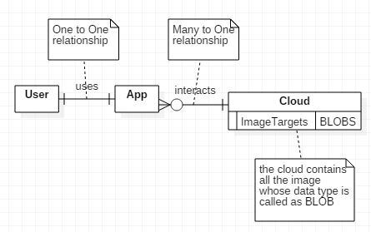

**Fig 5.3.1 Data Flow Diagram of Project**

**5.3.2 ENTITY RELATIONSHIP DIAGRAM**

Any object, for example, entities, attributes of an entity, relationship sets, and attributes of relationship sets, can be represented with the help of an ER diagram.

**5.3.2.1 ENTITY**

Entities are represented by means of rectangles. Rectangles are named with the entity set they represent.

  
**Fig 5.3.1 Example for Entities**

## **5.3.2.2 RELATIONSHIP**

Relationships are represented by diamond-shaped box. Name of the relationship is written inside the diamond-box. All the entities (rectangles) participating in a relationship, are connected to it by a line.

**One-to-one** − When only one instance of an entity is associated with the relationship, it is marked as '1:1'.

**One-to-many** − When more than one instance of an entity is associated with a relationship, it is marked as '1:N'.

**Many-to-one** − When more than one instance of entity is associated with the relationship, it is marked as 'N:1'.

**Many-to-many** − more than one instance of an entity on the left and more than one instance of an entity on the right can be associated with the relationship.

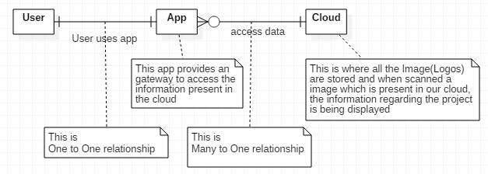

**Fig 5.3.2 ER Diagram of Project**

**5.4 UML DIAGRAMS:**

UML stands for Unified Modeling Language. Improved integration between structural models like class diagrams and behaviour models like activity diagrams. Added the ability to define a hierarchy and decompose a software system into components and sub-components. A UML system is represented using five different views that describe the system from distinctly different perspective. Each view is defined by a set of diagram, which is as follows.

1. User Model View

* This view represents the system from the user perspective.
* The analysis representation describes a usage scenario from the end-user’s perspective.

2. Structural model view

* In this model the data and functionality are arrived from inside the system.
* This model view models the static structures.

3. Model View

It represents the dynamic of behavioural as parts of the system, depicting the interactions of collection between various structural elements described in the user model and structural model view.

4. Implementation Model View

In this the structural and behavioural as parts of the system are represented as they are to be built.

5. Environmental Model View

In this the structural and behavioural aspects of the environment in which the system is to be implemented are represented.

**5.4.1 TYPES OF UML DIAGRAMS**

The current UML standards call for 13 different types of diagrams. These diagrams are organized into two distinct groups: structural diagrams and behavioural or interaction diagrams.

**5.4.1.1 STRUCTURAL UML DIAGRAMS**

1. Class diagram
2. Package diagram
3. Object diagram
4. Component diagram
5. Composite structure diagram
6. Deployment diagram

**5.4.1.2 BEHAVIORAL UML DIAGRAMS**

1. Activity diagram
2. Sequence diagram
3. Use case diagram
4. State diagram
5. Communication diagram
6. Interaction overview diagram
7. Timing diagram

**5.4.2 USES OF UML**

UML is quite useful for the following purposes −

1. Modeling the business process
2. Describing the system architecture
3. Showing the application structure
4. Capturing the system behaviour
5. Modeling the data structure
6. Building the detailed specifications of the system
7. Sketching the ideas
8. Generating the program code
   * 1. **Use case diagram**

Use case diagrams consists of actors, use cases and their relationships. The diagram is used to model the system/subsystem of an application. A single use case diagram captures a particular functionality of a system. Hence to model the entire system, a number of use case diagrams are used

the purposes of use case diagrams can be said to be as follows −

* + - Used to gather the requirements of a system.
    - Used to get an outside view of a system.
    - Identify the external and internal factors influencing the system.
    - Show the interaction among the requirements are actors.

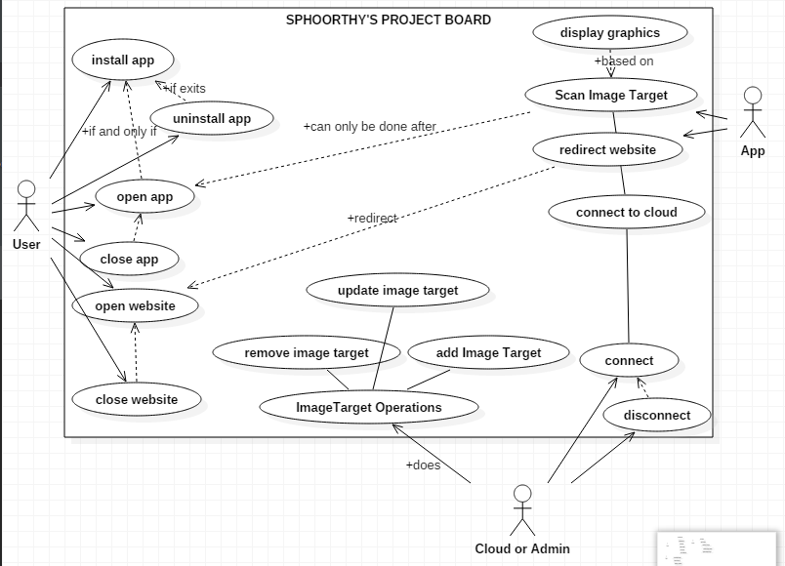

**Fig 5.4.1 Use Case Diagram of our project**

* + 1. **Class diagram**

Class diagram is a static diagram. It represents the static view of an application. Class diagram is not only used for visualizing, describing, and documenting different aspects of a system but also for constructing executable code of the software application.

Class diagram describes the attributes and operations of a class and also the constraints imposed on the system

Class diagram shows a collection of classes, interfaces, associations, collaborations, and constraints. It is also known as a structural diagram.

The purpose of the class diagram can be summarized as −

* Analysis and design of the static view of an application.
* Describe responsibilities of a system.
* Base for component and deployment diagrams.
* Forward and reverse engineering.

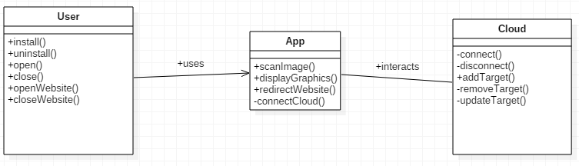

**Fig 5.4.2 Class Diagram of our project**

* + 1. **Object diagram**

Object diagrams are used to render a set of objects and their relationships as an instance.  
The purpose of the object diagram can be summarized as −

* Forward and reverse engineering.
* Object relationships of a system
* Static view of an interaction.
* Understand object behaviour and their relationship from practical perspective

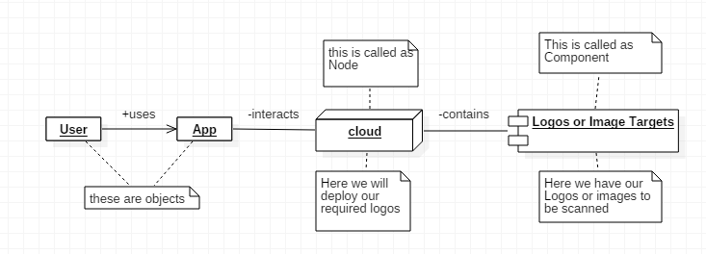

**Fig 5.4.3 Object Diagram of our project**

* + 1. **Interaction diagram**

This interactive behaviour is represented in UML by two diagrams known as Sequence diagram and Collaboration diagram. Sequence diagram emphasizes on time sequence of messages and collaboration diagram emphasizes on the structural organization of the objects that send and receive messages. Sequence and collaboration diagrams are used to

capture the dynamic nature but from a different angle.  
The purpose of interaction diagram is –

* To capture the dynamic behaviour of a system.
* To describe the message flow in the system.
* To describe the structural organization of the objects.
* To describe the interaction among objects.

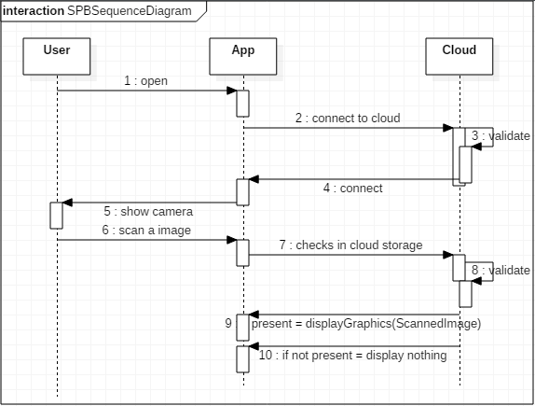

**Fig 5.4.4 Sequence Diagram of our project**

* + 1. **Activity Diagram**Activity diagram is basically a flowchart to represent the flow from one activity to another activity. The activity can be described as an operation of the system.  
       The purpose of an activity diagram can be described as −
* Draw the activity flow of a system.
* Describe the sequence from one activity to another.
* Describe the parallel, branched and concurrent flow of the system.

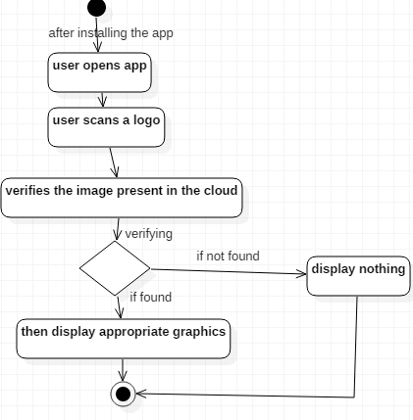

**Fig 5.4.5 Activity Diagram of Project**