WEEK 3 REPORT

Advanced Data Analysis and Visualization in Logistics

Project: Logistics Delivery Time Analysis and Performance Exploration

NSDC Logistics Data Analyst Internship
Week 3 Task Report
Prepared using Python, Pandas, Matplotlib and Seaborn
Dataset: Hypothetical / Simulated Supply Chain Logistics Dataset

Contents
- 1. Objective
- 2. Dataset and Data Simulation
- 3. Methodology
- 4. Exploratory Data Analysis
- 5. Visualizations and Interpretations
- 6. Analytical Insights
- 7. Recommendations
- 8. Python Code Excerpts
- 9. Conclusion

1. Objective
The objective of Week 3 was to perform advanced exploratory data analysis (EDA) and visualization on a hypothetical logistics dataset using Python. The analysis focuses on delivery lead time, shipping costs, traffic congestion, weather severity, port congestion, supplier reliability, route risk, customs clearance, delay probability and delivery time deviation. The purpose is to identify trends, understand distributions, examine correlations and derive insights relevant to operational efficiency, cost drivers and potential bottlenecks.

2. Dataset and Data Simulation
The dataset used for the analysis contains 32,065 records and 28 variables. It represents a hypothetical supply-chain and logistics environment in which shipment, transportation, operational and risk-related factors are observed together.

Key Variables Used
Variable | Purpose in Analysis
lead_time_days | Overall delivery lead time in days; the primary performance metric.
shipping_costs | Estimated shipping cost associated with a logistics movement.
traffic_congestion_level | Traffic-related congestion indicator.
weather_condition_severity | Severity level of weather conditions.
port_congestion_level | Congestion indicator for port operations.
supplier_reliability_score | Reliability score of the supplier.
route_risk_level | Risk level associated with the selected route.
customs_clearance_time | Time required for customs clearance.
delay_probability | Probability of delay.
delivery_time_deviation | Deviation in delivery timing.
risk_classification | Categorical risk group: Low, Moderate or High Risk.
timestamp | Date and time information used to derive month and day-of-week trends.

3. Methodology
- Data loading and verification: The CSV dataset was loaded with Pandas. Dataset dimensions, columns, data types and required variables were checked before analysis.
- Descriptive statistics: Measures of central tendency and dispersion were calculated, including mean, median, standard deviation, minimum, maximum and quartiles.
- Distribution analysis: Histograms were used to examine the frequency distribution and spread of lead time, shipping costs, delay probability and delivery time deviation.
- Correlation analysis: Pearson correlation coefficients were calculated to explore linear relationships among selected logistics variables.
- Comparative analysis: Boxplots and bar charts were used to compare lead time across risk classifications and days of the week.
- Time-pattern analysis: Monthly averages were visualized using a line chart to identify potential temporal patterns.
- Relationship analysis: Scatter plots were used to examine the relationship between lead time and individual operational variables.

4. Exploratory Data Analysis

4.1 Lead Time Statistics
Metric | Value
Dataset records | 32,065
Number of variables | 28
Mean lead time | 5.23 days
Median lead time | 3.30 days
Standard deviation | 4.52 days
Minimum lead time | 1.00 days
Maximum lead time | 15.00 days
First quartile (Q1) | 1.24 days
Third quartile (Q3) | 8.63 days
Average shipping cost | $459.37
Average delay probability | 69.9%
Average supplier reliability score | 0.501 / 1.000
The average lead time is 5.23 days, while the median is 3.30 days. The standard deviation of 4.52 days and the range from 1.00 to 15.00 days show substantial variation in delivery duration.

4.2 Correlation with Lead Time
Pearson correlation was used to examine linear relationships between lead time and selected operational variables. The strongest relationships in absolute value are shown below.
Variable | Correlation with Lead Time | Interpretation
supplier_reliability_score | -0.0130 | Very weak negative linear relationship
fuel_consumption_rate | -0.0126 | Very weak negative linear relationship
route_risk_level | -0.0090 | Very weak negative linear relationship
shipping_costs | -0.0070 | Very weak negative linear relationship
port_congestion_level | +0.0051 | Very weak positive linear relationship
loading_unloading_time | -0.0039 | Very weak negative linear relationship
traffic_congestion_level | -0.0030 | Very weak negative linear relationship
customs_clearance_time | -0.0028 | Very weak negative linear relationship
All displayed correlations are very weak in practical terms. This means that, within this simulated dataset, no single selected variable explains lead-time variation well on its own. The result does not prove that operational variables are unimportant; it indicates that their effects may be nonlinear, interactive, or distributed across multiple factors.

5. Visualizations and Interpretations
The following visualizations were produced to capture distributions, comparisons, temporal patterns and relationships among logistics variables. Each visualization was selected according to the type of analytical question being answered.

Figure 1. Distribution overview of key logistics variables

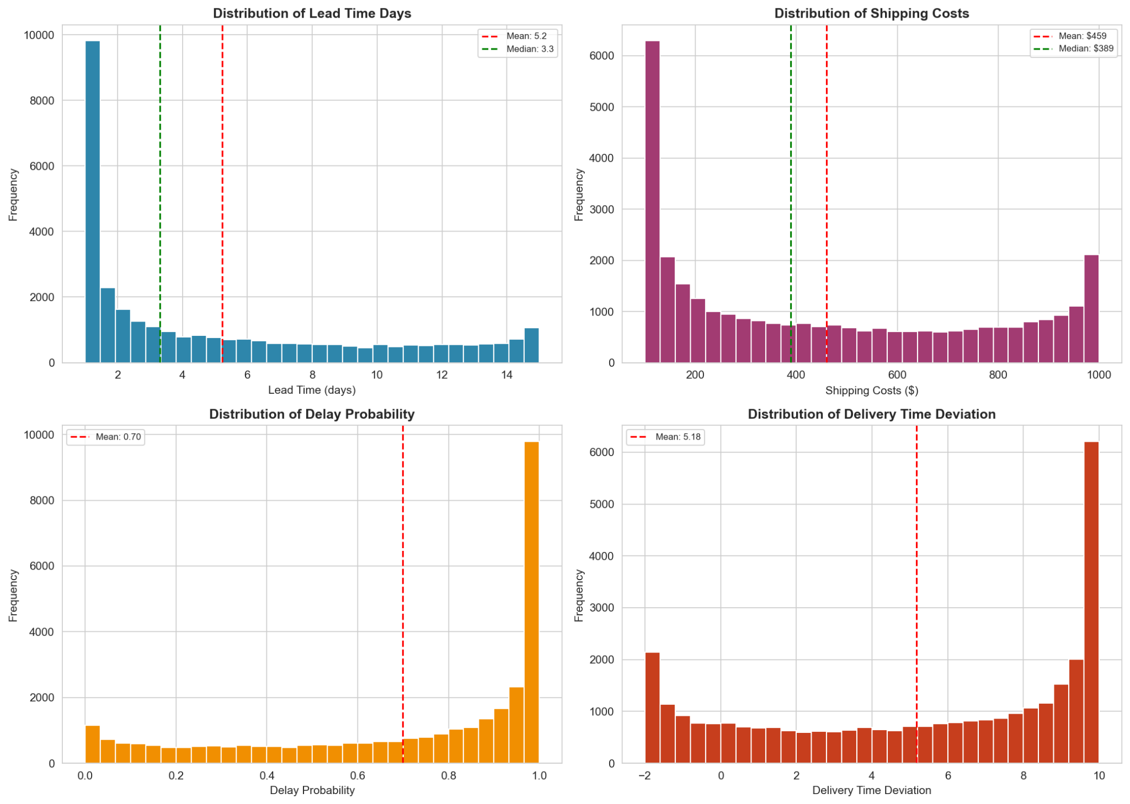
Interpretation: A combined histogram view is used to compare the distributions of lead time, shipping costs, delay probability and delivery time deviation. Histograms are appropriate for showing frequency patterns, spread and possible skewness.

Figure 2. Distribution of Lead Time Days

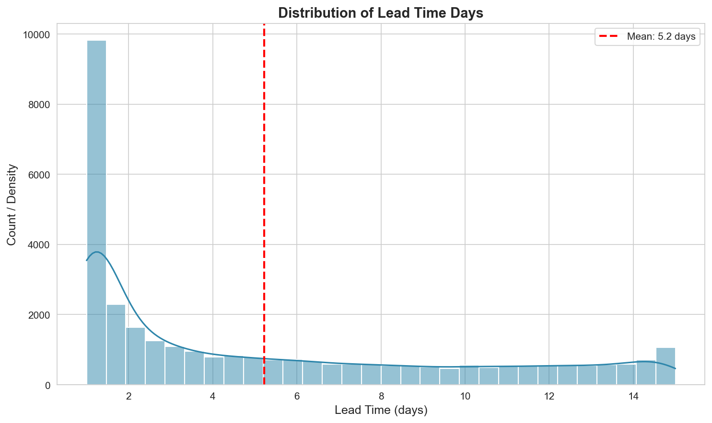
Interpretation: The histogram is suitable for understanding the central tendency and spread of delivery lead times. The data shows substantial variation around the overall mean.

Figure 3. Distribution of Shipping Costs

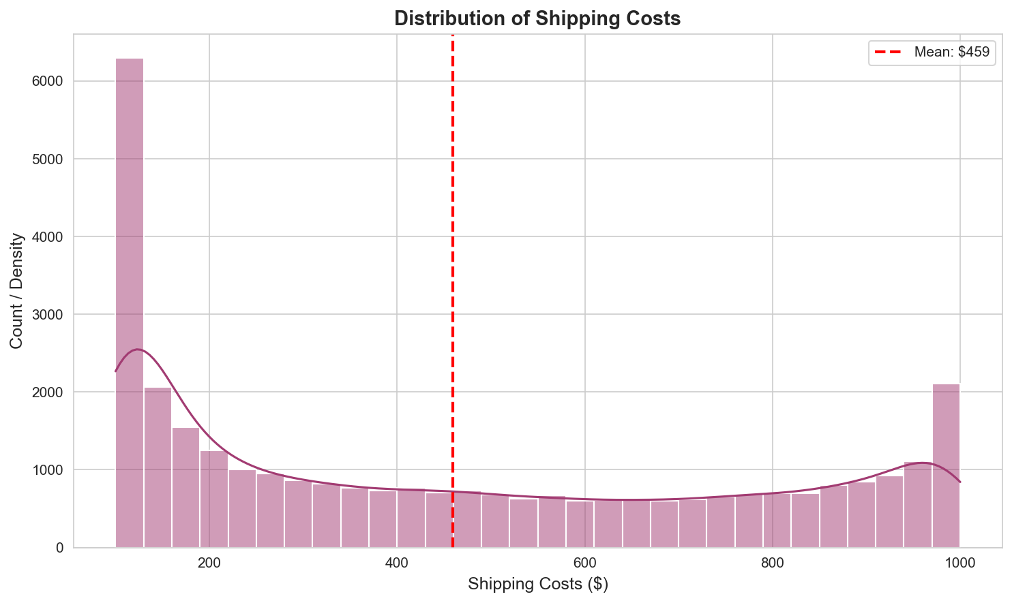
Interpretation: This visualization helps assess the spread of transportation costs and identify the presence of low-cost and high-cost shipments. It supports cost-driver exploration.

Figure 4. Traffic Congestion Level vs Lead Time

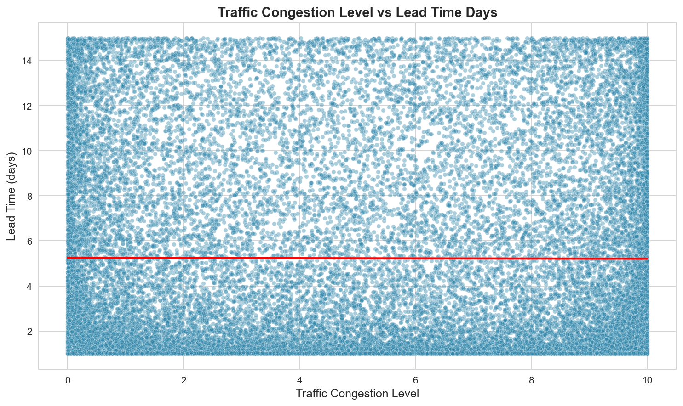
Interpretation: A scatter plot is appropriate for examining whether higher traffic congestion is associated with longer lead time. The broad scatter indicates no strong individual linear relationship.

Figure 5. Shipping Costs vs Lead Time

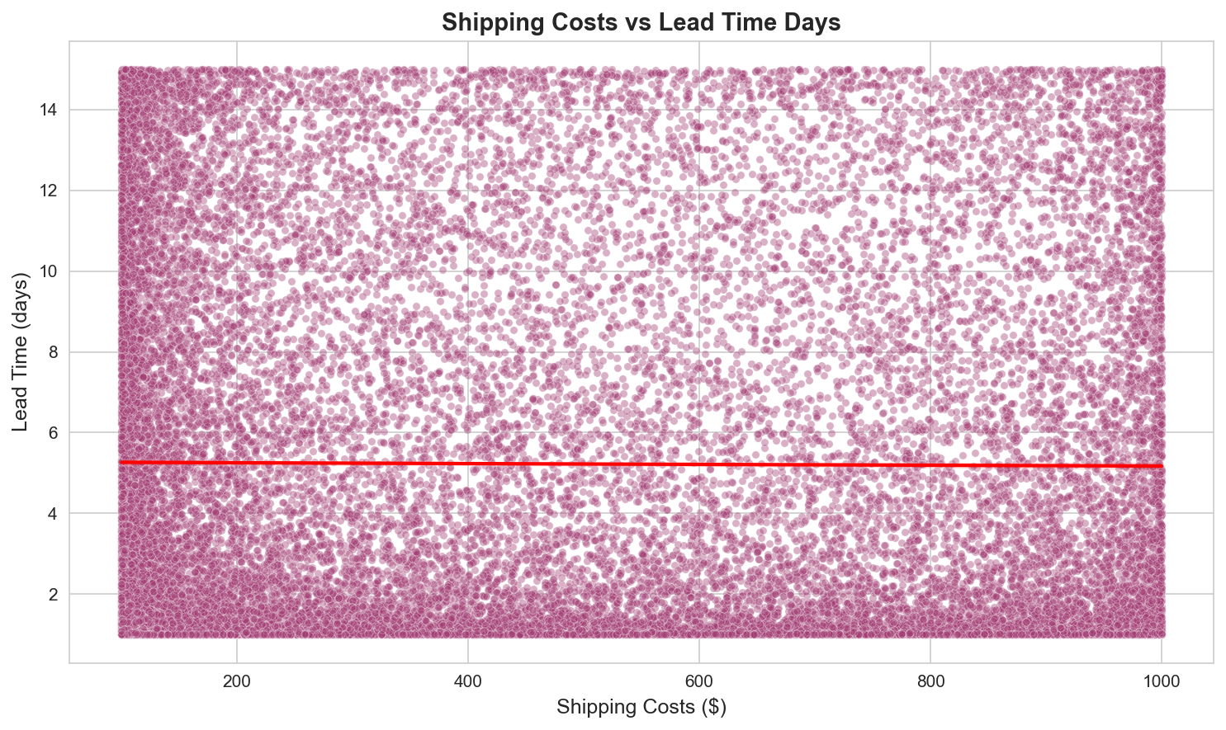
Interpretation: The scatter plot examines the relationship between cost and delivery duration. It is useful for assessing whether expensive shipments systematically correspond to faster or slower delivery.

Figure 6. Port Congestion Level vs Lead Time

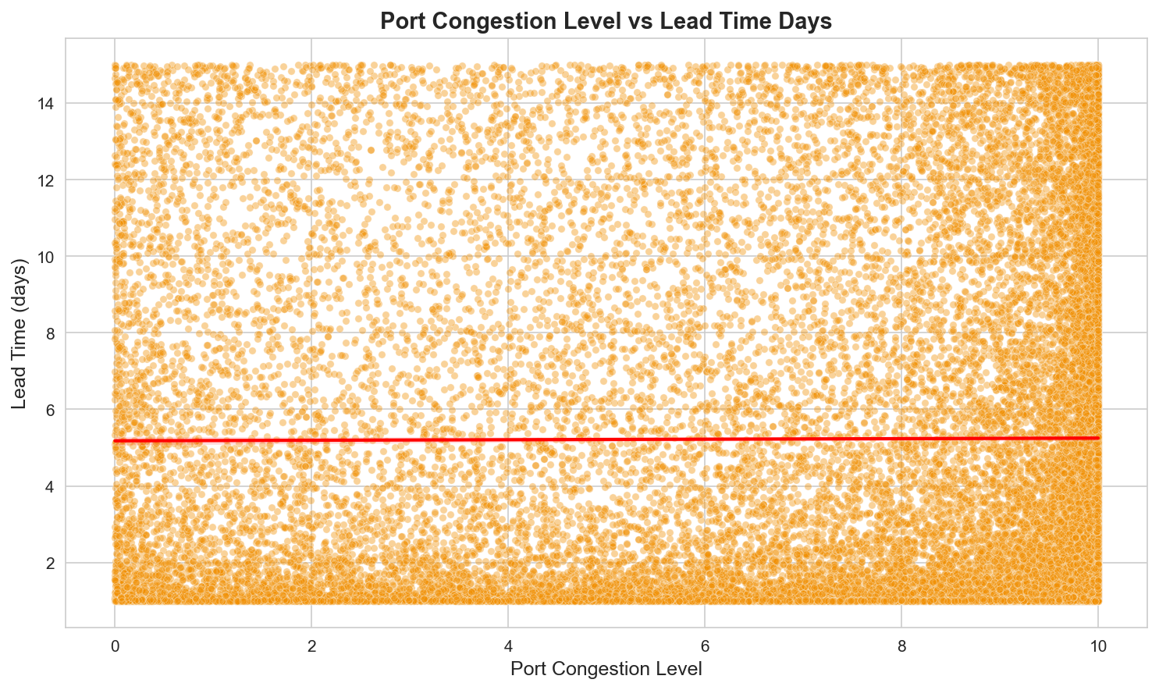
Interpretation: This scatter plot evaluates whether port congestion is a visible operational bottleneck. The absence of a strong trend suggests congestion alone does not explain lead-time variation in this simulated dataset.

Figure 7. Delay Probability vs Lead Time

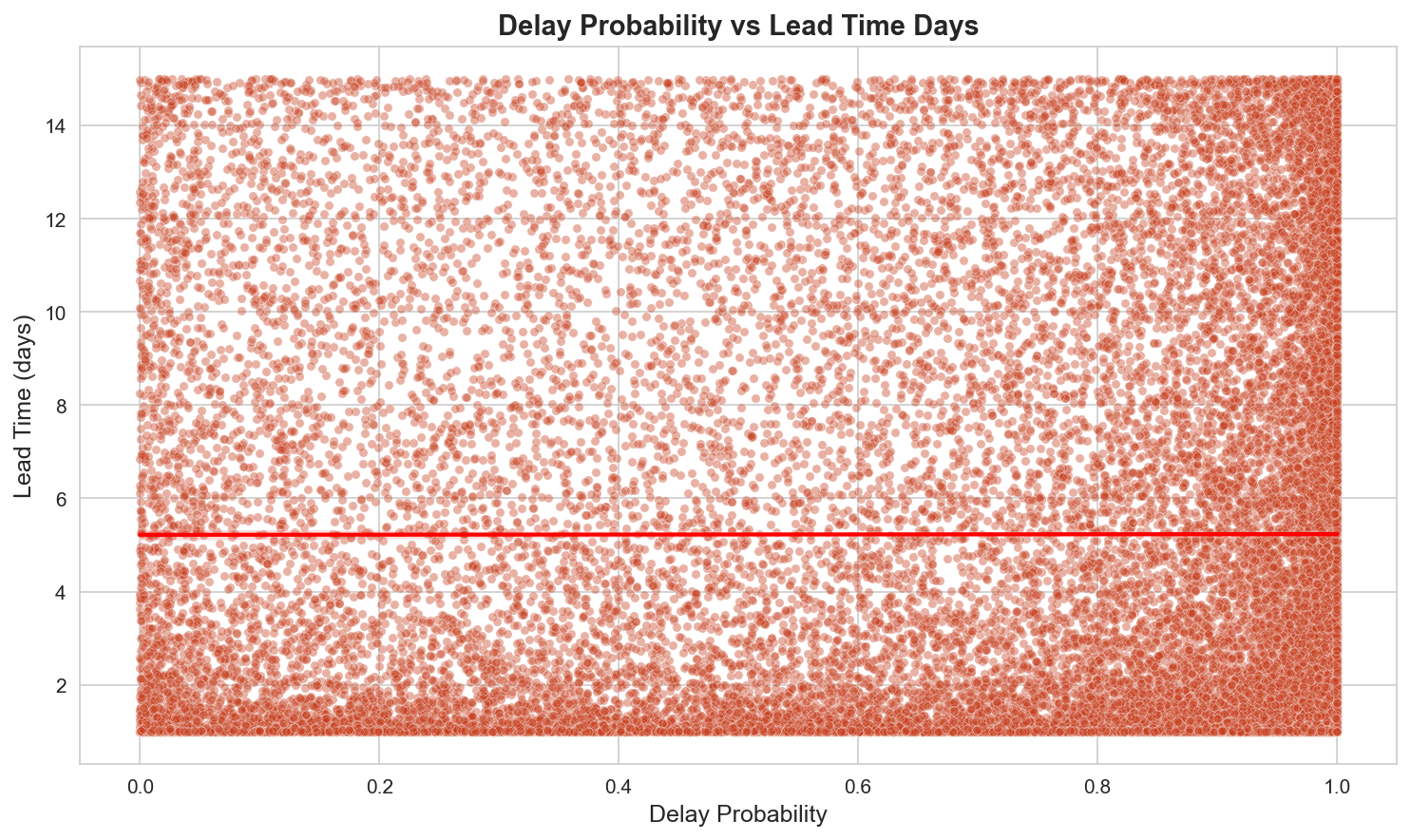
Interpretation: The chart compares predicted delay probability with observed lead time. The points are widely dispersed, indicating a weak direct linear relationship.

Figure 8. Lead Time Days by Risk Classification

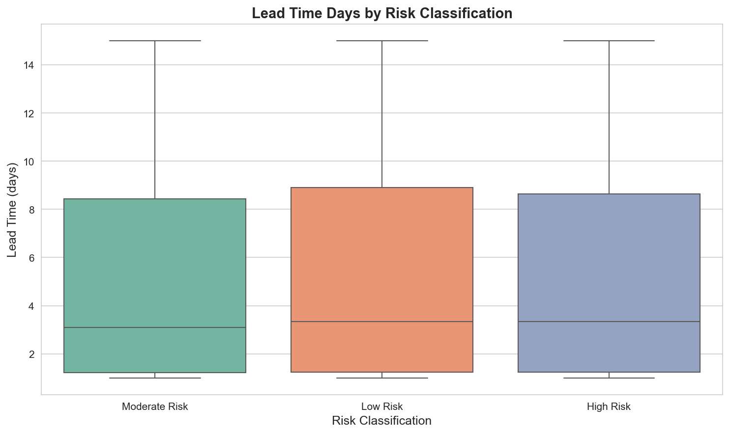
Interpretation: A boxplot is chosen because it compares median, spread and extreme values across risk groups. The three groups have broadly similar distributions and wide variability.

Figure 9. Average Lead Time by Risk Classification

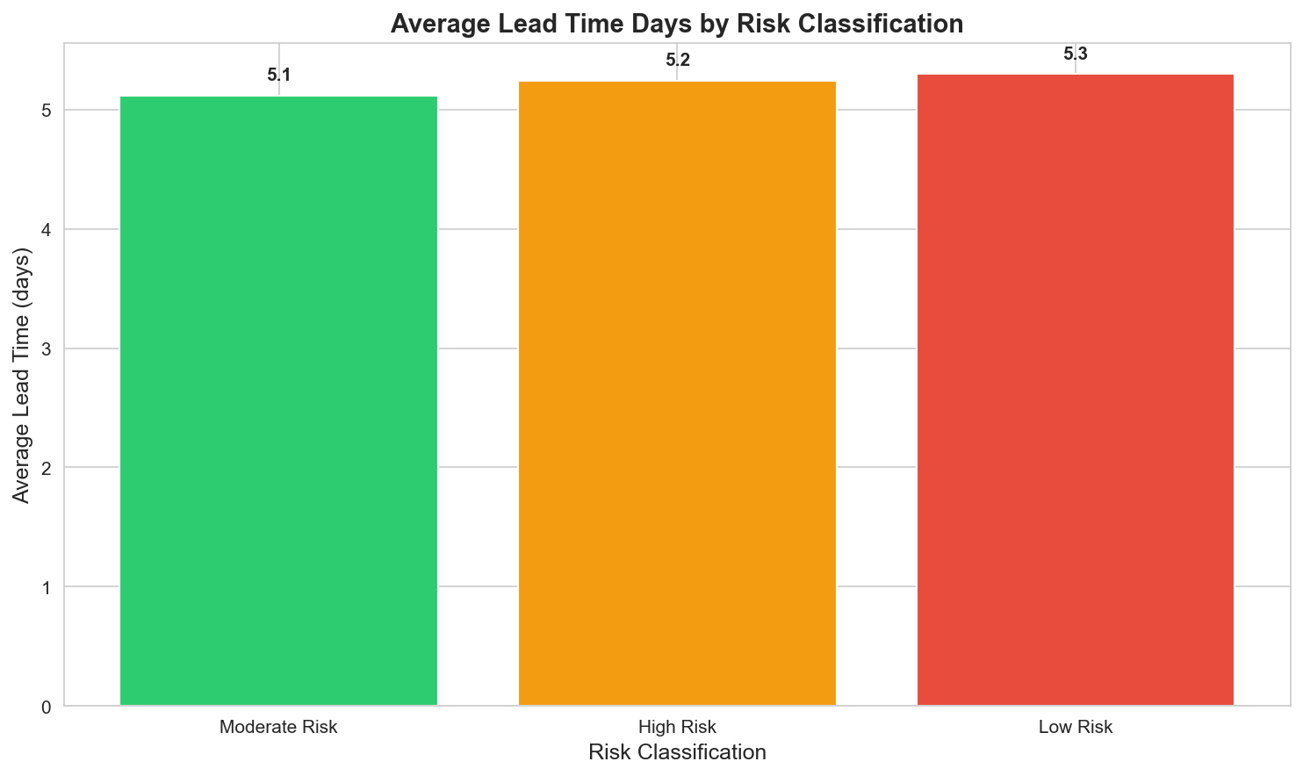
Interpretation: A bar chart makes small differences in group averages easy to compare. Average lead time is very similar across the risk classifications.

Figure 10. Correlation Heatmap of Selected Logistics Variables

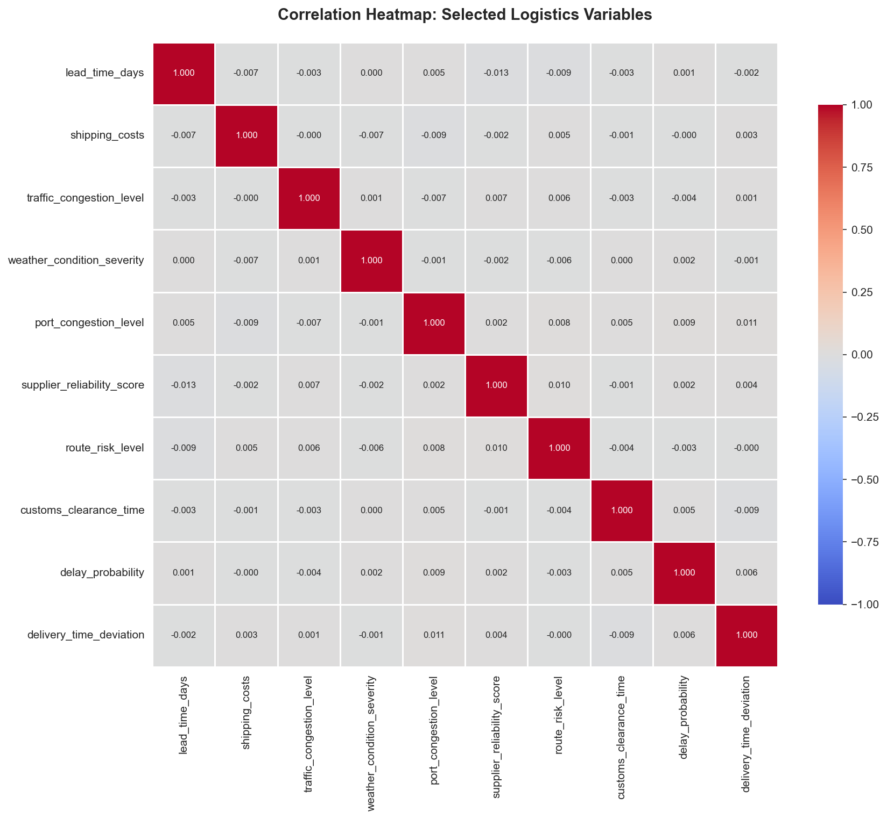
Interpretation: A heatmap provides a compact view of linear relationships among multiple variables. Most off-diagonal values are close to zero, showing very weak pairwise linear correlations.

Figure 11. Average Lead Time Days by Month

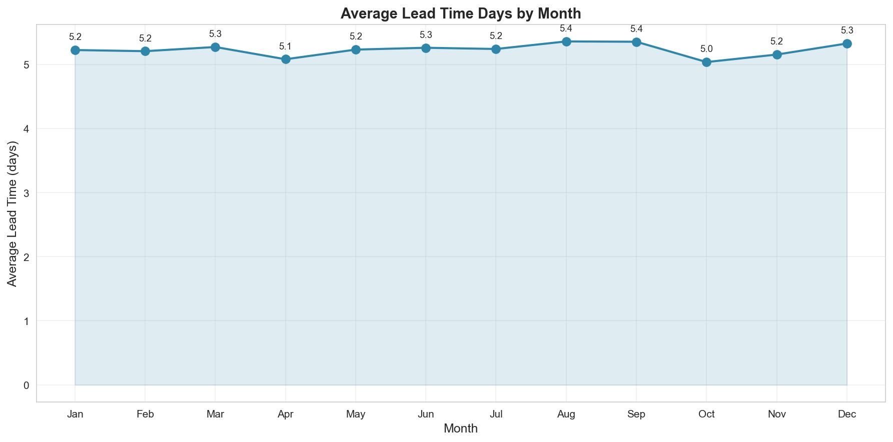
Interpretation: A line chart is appropriate for time-based trends. Monthly averages remain stable, approximately between 5.0 and 5.4 days.

Figure 12. Weather Condition Severity vs Lead Time

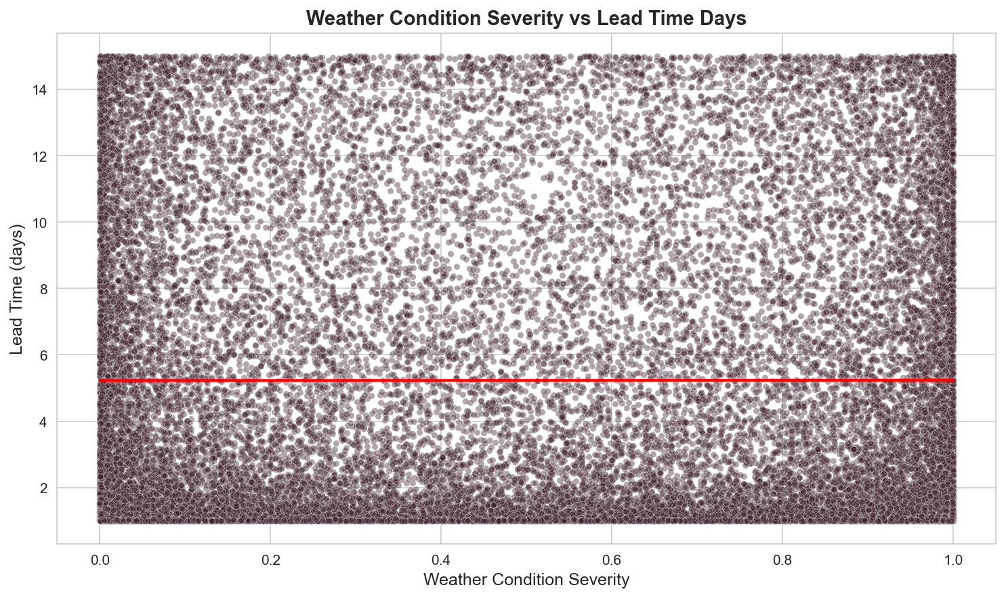
Interpretation: The scatter plot checks whether more severe weather corresponds to longer lead time. The spread shows no strong individual linear trend.

Figure 13. Customs Clearance Time vs Lead Time

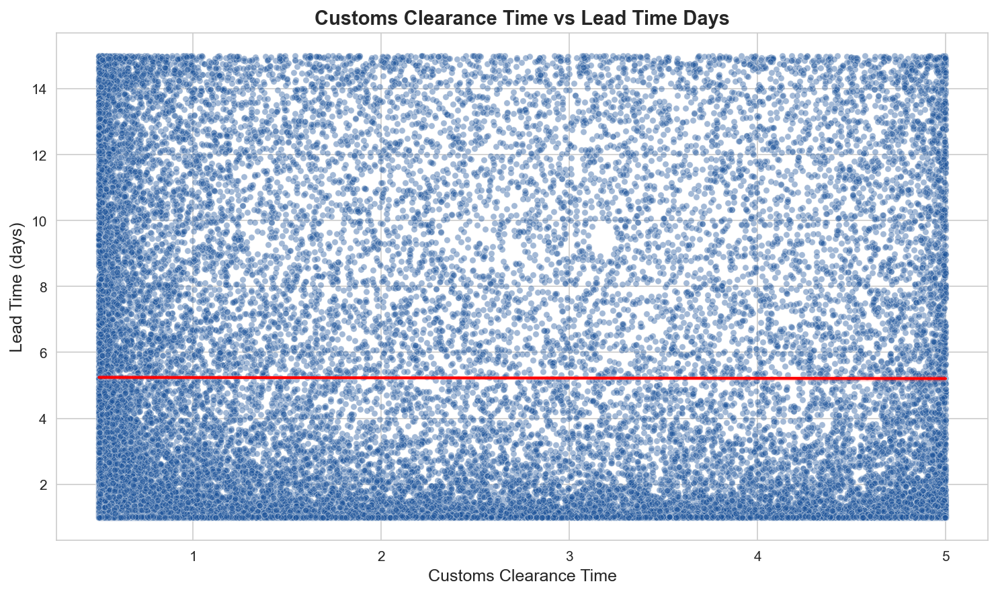
Interpretation: This plot explores customs clearance as a potential bottleneck. Lead times vary widely at all clearance-time levels, suggesting a weak standalone relationship.

Figure 14. Supplier Reliability Score vs Lead Time

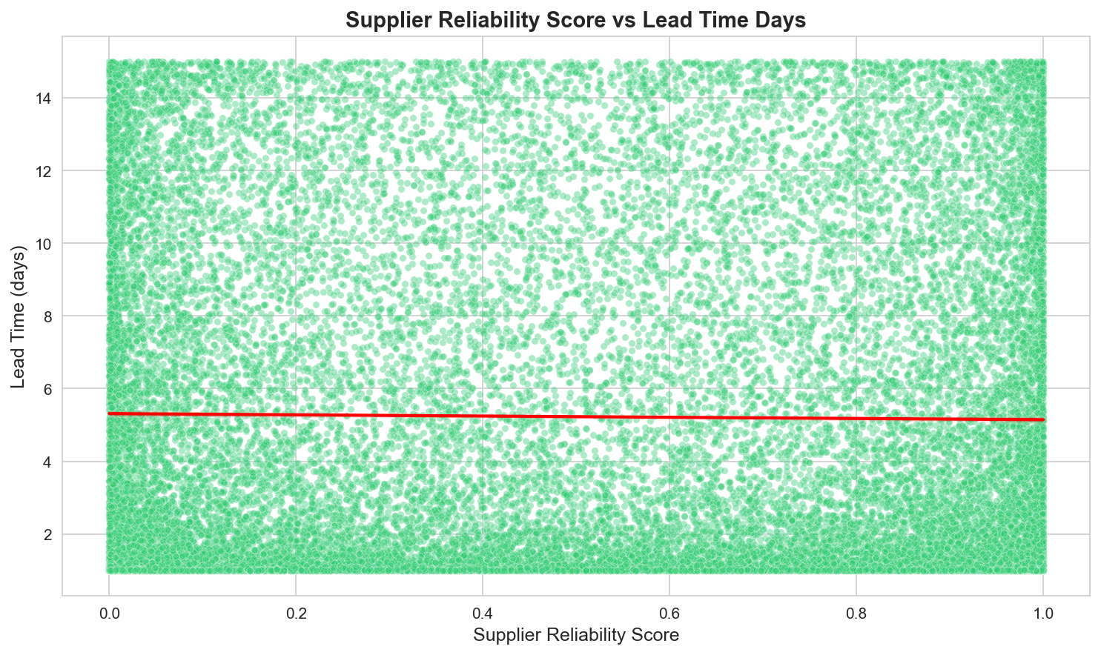
Interpretation: The chart assesses whether supplier reliability is directly associated with shorter lead time. The data is broadly dispersed, indicating no strong linear association.

Figure 15. Delivery Time Deviation vs Lead Time

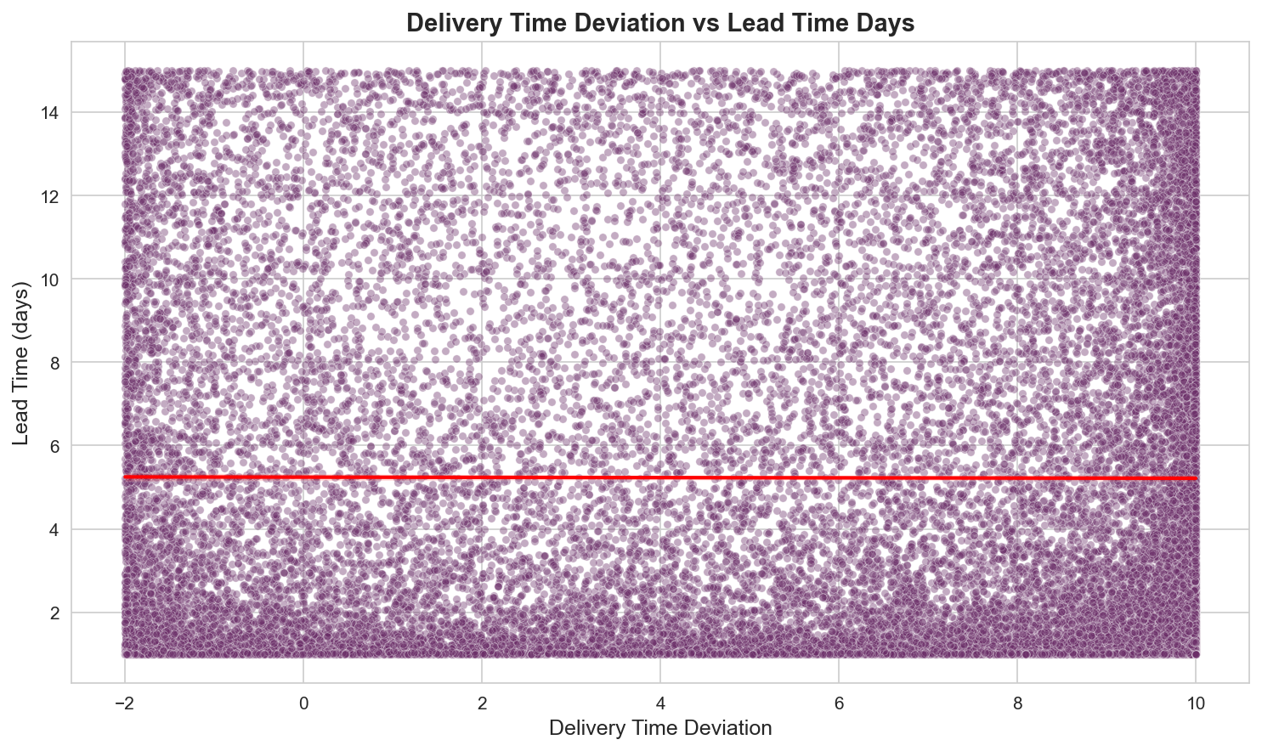
Interpretation: The scatter plot compares delivery deviation with overall lead time. The absence of a clear slope indicates that delivery deviation alone is not a strong predictor.

Figure 16. Average Lead Time Days by Day of Week

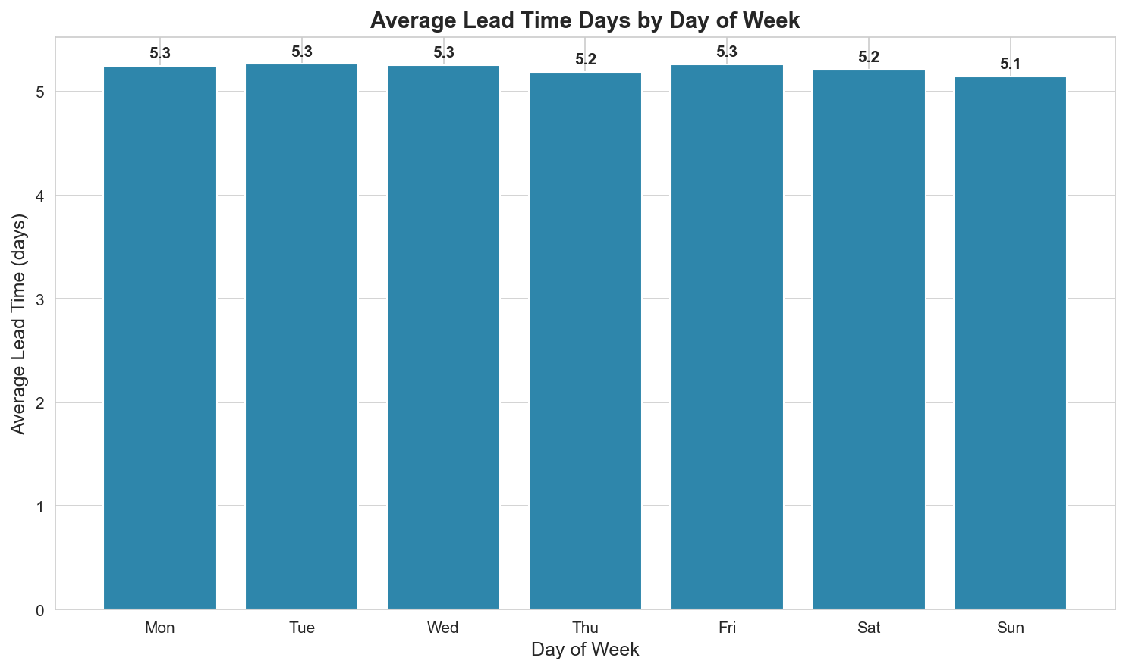
Interpretation: A bar chart clearly compares average lead time across days. The differences are small, indicating limited day-of-week effects in this dataset.

6. Analytical Insights
- Lead-time performance is centered around approximately 5.2 days, but individual shipments range from 1.0 to 15.0 days, demonstrating considerable shipment-level variability.
- The correlation analysis shows that the selected individual variables have very weak linear relationships with lead time. This suggests that lead-time variation is not dominated by one standalone factor in the simulated data.
- The risk-classification boxplot and average comparison show only small differences between Low, Moderate and High Risk groups. Risk labels alone therefore do not strongly separate delivery duration in this dataset.
- Monthly average lead time remains relatively stable, with the chart showing only small month-to-month changes. No strong seasonal pattern is visible.
- Day-of-week averages are also closely grouped, indicating that operational performance is relatively consistent across the week in the simulated dataset.
- The average shipping cost is $459.37, while the distribution plot shows substantial cost variation. This supports monitoring costs at shipment or route level rather than relying only on a single overall average.
- Scatter plots for weather severity, customs clearance, supplier reliability, delay probability and delivery time deviation show broad dispersion. These factors may still contribute to outcomes in combination, but the charts do not support a strong standalone linear effect.

Operational Efficiency, Cost Drivers and Bottlenecks
Operational efficiency is best interpreted through the stability of lead-time averages together with the large shipment-level spread. The main analytical challenge is therefore reducing variability, not simply reducing the overall mean. Shipping costs show meaningful dispersion and should be monitored alongside route, shipment and service-level information. Potential bottlenecks such as traffic, port congestion and customs clearance should not be evaluated in isolation because the current analysis shows weak pairwise relationships with lead time.

7. Recommendations
- Use multivariable analysis or machine-learning models to examine combined effects and interactions instead of relying only on pairwise correlations.
- Monitor high-variability shipments and investigate their operational context, because the range of lead times is much wider than the difference between group averages.
- Track shipping cost together with route, demand, congestion and delivery performance to identify cost-efficient logistics patterns.
- Create operational dashboards with lead-time, delay probability and cost KPIs so managers can monitor both average performance and variability.
- Apply outlier detection to identify unusually long lead times and investigate possible causes.
- For a real-world deployment, validate the simulated findings with actual operational data and add domain-specific features such as distance, shipment type, carrier, mode of transport and warehouse location.

8. Python Code Excerpts
The analysis was implemented in Python using Pandas for data handling and Matplotlib/Seaborn for visualization. Representative excerpts are included below.
import pandas as pd
import matplotlib.pyplot as plt
import seaborn as sns
df = pd.read_csv("cleaned_logistics_data.csv")
print(df.shape)
print(df.columns)
print(df.describe())
# Descriptive statistics for lead time
lead_time_stats = df["lead_time_days"].describe(
percentiles=[0.25, 0.5, 0.75]
)
print("Mean:", df["lead_time_days"].mean())
print("Median:", df["lead_time_days"].median())
print("Standard deviation:", df["lead_time_days"].std())
# Correlation analysis
corr_vars = [
"lead_time_days", "shipping_costs",
"traffic_congestion_level",
"weather_condition_severity",
"port_congestion_level",
"supplier_reliability_score",
"customs_clearance_time",
"delay_probability",
"delivery_time_deviation"
]
corr_matrix = df[corr_vars].corr()
sns.heatmap(corr_matrix, annot=True, cmap="coolwarm")
plt.show()
# Example scatter plot
sns.scatterplot(
data=df,
x="shipping_costs",
y="lead_time_days",
alpha=0.4
)
sns.regplot(
data=df,
x="shipping_costs",
y="lead_time_days",
scatter=False,
color="red"
)
plt.title("Shipping Costs vs Lead Time")
plt.show()
# Average lead time by day of week
day_order = ["Mon", "Tue", "Wed", "Thu", "Fri", "Sat", "Sun"]
df["day_name"] = pd.to_datetime(df["timestamp"]).dt.day_name().str[:3]
daily_avg = df.groupby("day_name")["lead_time_days"].mean()
daily_avg = daily_avg.reindex(day_order)
daily_avg.plot(kind="bar")
plt.ylabel("Average Lead Time (days)")
plt.show()

9. Conclusion
This Week 3 task successfully applied advanced exploratory data analysis and visualization techniques to a hypothetical logistics dataset. The analysis established an overall average lead time of approximately 5.23 days and identified substantial variation across individual shipments. Distribution plots, scatter plots, comparative charts and a correlation heatmap were used to examine logistics performance from multiple perspectives. The key finding is that the selected individual operational variables have very weak linear relationships with lead time in this dataset. Therefore, future analysis should focus on multivariable modelling, interaction effects and anomaly detection to better explain logistics performance and improve decision-making.

Appendix: Summary of Visualization Choices
Visualization Type | Used For | Why It Is Appropriate
Histogram | Variable distributions | Shows frequency, spread and shape.
Scatter plot | Variable relationships | Shows possible trends, clusters and dispersion.
Regression line | Relationship direction | Provides a visual indication of linear tendency.
Boxplot | Risk-group comparison | Shows median, quartiles, spread and extremes.
Bar chart | Group averages | Makes category-to-category comparisons easy.
Line chart | Monthly trend | Highlights changes over time.
Correlation heatmap | Multiple relationships | Summarizes many pairwise correlations in one view.

