WEEK 1 INTERNSHIP REPORT
Strategic Planning and Data Exploration in Logistics
Project Title: Logistics Delivery Time Analysis and Prediction Using Data Analytics and Machine Learning

1. Executive Summary
The logistics industry depends on efficient transportation, timely deliveries, and effective resource allocation. Delivery delays and variations in delivery time can increase operational costs, affect customer satisfaction, and reduce overall supply chain efficiency. Data analytics provides an opportunity to analyze historical logistics data and identify factors that influence delivery performance.
This project focuses on analyzing logistics delivery data to understand patterns related to delivery time, transportation mode, distance, shipping cost, and other relevant operational variables. The project will use Python-based data analysis techniques to clean and preprocess the dataset, perform exploratory data analysis, visualize logistics performance, and develop a predictive model for estimating delivery time.
The project will be completed as a four-week analytical workflow. Week 1 focuses on strategic planning, defining the logistics problem, identifying key performance indicators, researching relevant data sources, and designing the analytical methodology. Week 2 will focus on data collection, cleaning, and preprocessing. Week 3 will involve exploratory data analysis and visualization, while Week 4 will focus on predictive modeling and logistics optimization recommendations.
The expected outcome is to identify important factors associated with delivery performance and develop insights that may support better logistics planning and resource allocation.

2. Introduction and Background
Logistics plays an important role in ensuring that products move efficiently from suppliers and warehouses to customers. One of the major challenges faced by logistics and supply chain organizations is maintaining efficient and predictable delivery performance.
Delivery time can be affected by multiple factors, including transportation distance, transportation mode, shipment characteristics, warehouse processing time, and operational conditions. When delivery times are longer than expected, organizations may face increased costs and reduced customer satisfaction.
Data analytics can help organizations understand these challenges by analyzing historical logistics records. Python provides useful tools for collecting, cleaning, analyzing, visualizing, and modeling logistics data.
This project proposes a data-driven approach to analyze logistics delivery performance and predict delivery time using machine learning techniques.

3. Project Definition

Logistics Scenario
A logistics organization manages shipments between warehouses, distribution centers, and customers. The organization experiences variations in delivery time across different shipments.
Some deliveries take longer than expected due to factors such as:
- Long transportation distances
- Transportation mode
- Shipment characteristics
- Warehouse processing time
- Operational inefficiencies
- High logistics workload
- Other available factors within the dataset
The organization needs to analyze historical logistics data to understand which factors influence delivery performance. The project will analyze the available dataset and later develop a predictive model capable of estimating delivery time based on relevant shipment and operational features.

4. Project Objectives
The main objective of this project is to analyze logistics delivery data and understand the factors influencing delivery time.
Specific objectives include:
1. To collect and study a publicly available logistics dataset.
2. To clean and preprocess the dataset using Python.
3. To identify important logistics performance indicators.
4. To perform exploratory data analysis on delivery performance.
5. To visualize relationships between logistics variables.
6. To identify potential patterns and operational bottlenecks.
7. To develop and evaluate a machine learning model for predicting delivery time.
8. To provide data-driven recommendations for improving logistics operations.

5. Key Performance Indicators (KPIs)

5.1 Average Delivery Time
Average Delivery Time measures the average duration required to complete a delivery.
Formula: Average Delivery Time = Total Delivery Time / Number of Deliveries
This KPI helps evaluate the overall speed of logistics operations.

5.2 On-Time Delivery Rate
The On-Time Delivery Rate represents the percentage of deliveries completed within the expected delivery period, if expected delivery information is available in the dataset.
Formula: On-Time Delivery Rate = (Number of On-Time Deliveries / Total Deliveries) × 100
This KPI helps measure delivery reliability.

5.3 Delivery Delay Rate
The Delivery Delay Rate represents the proportion of shipments that exceed their expected delivery time. This KPI helps identify potential delivery performance problems.

5.4 Average Shipping Cost
Average Shipping Cost measures the average cost associated with transportation and delivery. This KPI can help analyze cost efficiency.

5.5 Transportation Mode Performance
Transportation mode performance compares delivery time and other available performance measures across transportation methods. This analysis can help identify differences in operational efficiency.

6. Literature and Data Research
The project will use a publicly available logistics or supply chain dataset as the primary source of analysis. The selected dataset should ideally contain variables related to:
Variable | Purpose
Order or Shipment ID | Identify individual records
Order Date | Analyze order timing
Dispatch Date | Measure processing and shipment timing
Delivery Date | Calculate delivery time
Expected Delivery Date | Analyze on-time performance
Distance | Analyze travel impact
Transportation Mode | Compare transport performance
Shipping Cost | Analyze cost efficiency
Shipment Weight/Volume | Analyze shipment characteristics
Location Information | Analyze geographical patterns
The final dataset selection will depend on the availability and quality of publicly available logistics data.

7. Proposed Data Science Methodology

7.1 Data Collection
A publicly available logistics dataset will be selected. The dataset will be examined to understand the number of records, available variables, data types, missing values, and data quality limitations.

7.2 Data Cleaning and Preprocessing
The dataset will be cleaned using Python. Possible steps include removing duplicate records, handling missing values, converting incorrect data types, converting date columns, detecting unusual values, handling outliers where appropriate, and preparing numerical variables for modeling.

7.3 Exploratory Data Analysis
Exploratory Data Analysis will be performed to understand the characteristics of the dataset. The analysis may include mean, median, minimum, maximum, standard deviation, distribution analysis, and correlation analysis.

7.4 Data Visualization
Visualizations will be used to identify trends and relationships. Possible visualizations include histograms, bar charts, boxplots, scatter plots, and correlation heatmaps. These visualizations will help interpret logistics performance and identify possible bottlenecks.

7.5 Predictive Modeling
A machine learning model will be developed to predict delivery time. Potential models include Linear Regression, Decision Tree Regressor, and Random Forest Regressor. The final model selection will depend on the characteristics of the selected dataset.

8. Strategic Four-Week Roadmap

Week 1: Strategic Planning and Data Exploration
- Define logistics problem
- Identify KPIs
- Research datasets
- Design methodology
- Create project roadmap
- Prepare Python code illustrations

Week 2: Data Collection, Cleaning and Preprocessing
- Select the final dataset
- Examine dataset structure
- Identify missing values
- Remove duplicates
- Handle data quality issues
- Detect outliers
- Transform and preprocess data

Week 3: Exploratory Data Analysis and Visualization
- Perform descriptive statistics
- Analyze distributions
- Analyze relationships between variables
- Create visualizations
- Interpret logistics performance
- Identify trends and potential bottlenecks

Week 4: Predictive Modeling and Optimization
- Define prediction target
- Prepare features
- Train machine learning models
- Evaluate model performance
- Compare models
- Develop logistics optimization recommendations
- Prepare final conclusions

9. End-to-End Process Flow
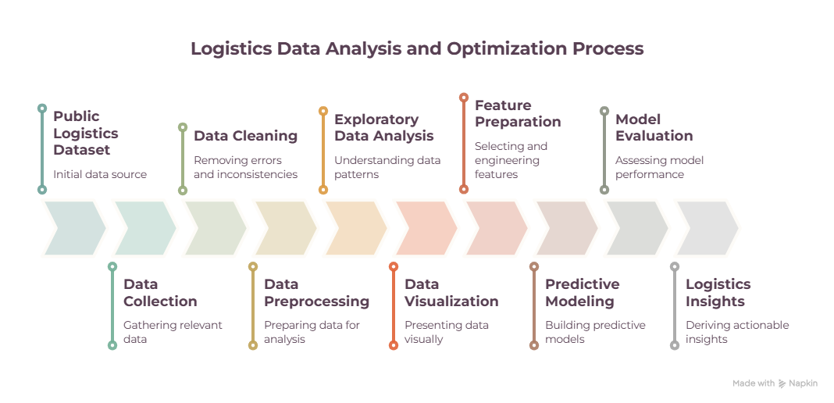

10. Python Code Illustration

Loading the Dataset
import pandas as pd
df = pd.read_csv("logistics_data.csv")
print(df.head())
print(df.info())
This code will be used to load and initially inspect the logistics dataset.

Checking Missing Values
missing_values = df.isnull().sum()
print(missing_values)
This will help identify columns that contain missing information.

Removing Duplicate Records
df = df.drop_duplicates()
Duplicate records can affect analytical accuracy and may create misleading results.

Converting Date Columns
df["Dispatch_Date"] = pd.to_datetime(df["Dispatch_Date"])
df["Delivery_Date"] = pd.to_datetime(df["Delivery_Date"])
Date conversion is necessary for calculating delivery time.

Calculating Delivery Time
df["Delivery_Time"] = (
df["Delivery_Date"] - df["Dispatch_Date"]
).dt.days
This creates a numerical delivery time variable that can be analyzed and used for predictive modeling.

Basic Exploratory Analysis
print(df.describe())
This will generate descriptive statistics for numerical variables.

11. Proposed Analytical Tools
Library | Purpose
pandas | Data loading and manipulation
numpy | Numerical operations
matplotlib | Data visualization
seaborn | Statistical visualization
scikit-learn | Machine learning and preprocessing

12. Expected Outcomes
- Improve understanding of logistics delivery performance.
- Identify important variables associated with delivery time.
- Identify trends and patterns in logistics data.
- Highlight possible operational bottlenecks.
- Provide visual insights into logistics performance.
- Develop a predictive model for estimating delivery time.
- Generate recommendations that may help improve logistics planning and resource allocation.
The results of the project are intended to support data-driven decision-making rather than guarantee specific operational improvements.

13. Conclusion
This project presents a strategic plan for analyzing logistics delivery performance using data analytics and machine learning. The proposed workflow covers the complete analytical process, beginning with data collection and preprocessing, followed by exploratory data analysis, visualization, predictive modeling, and logistics optimization recommendations.
During Week 1, the focus is on defining the logistics problem, identifying relevant KPIs, researching suitable datasets, and designing the proposed analytical methodology. The following weeks will progressively implement the planned workflow using Python.
The final project is expected to demonstrate how logistics data can be transformed into meaningful analytical insights. By identifying patterns related to delivery performance and developing a predictive model, the project may support better planning, resource allocation, and operational decision-making in logistics systems.

