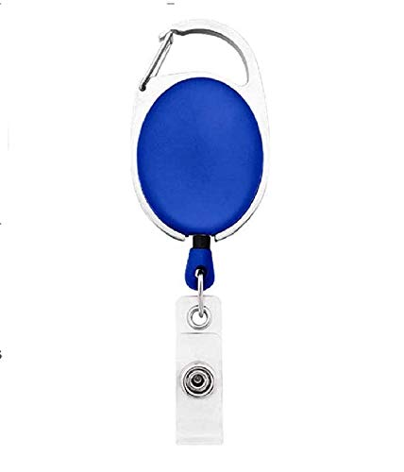

ID CARD

|  |  |
| --- | --- |
| **Daniel Padillo** | PHOTO |
| **Finance** |
| **03/16/2022** |
| **AB +ve** |
| **7619990999** |

Questions / Queries – Drop an email to mailmukeshkala@gmail.com