**How to work with Windows Credentials**

In Windows, you can view and manage your network-based logon credentials (i.e., Usernames and Passwords) using Credential Manager.

**How to get all Credentials Activities in UiPath**

Install the **"UiPath.Credentials.Activities"** Package from "Manage Packages" in UiPath Studio to use these Credential Activities.



These Activities are used to work with the credentials. Robot can use these activities to store the credentials in **"Windows Credential Manager"** and retrieve web and windows credentials from user by prompting a Input Dialogue Box.

After installing the **"UiPath.Credentials.Activities"** Package below activities are available under **"System > Credentials"**:

1. Add Credential

2. Delete Credential

3. Get Secure Credential

4. Request Credential

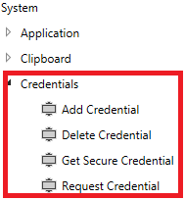

**Add Credential**

**"Add Credential"** activity can be used to add/store the Web and Window application Credentials in **"Windows Credential Manager"** in your system.

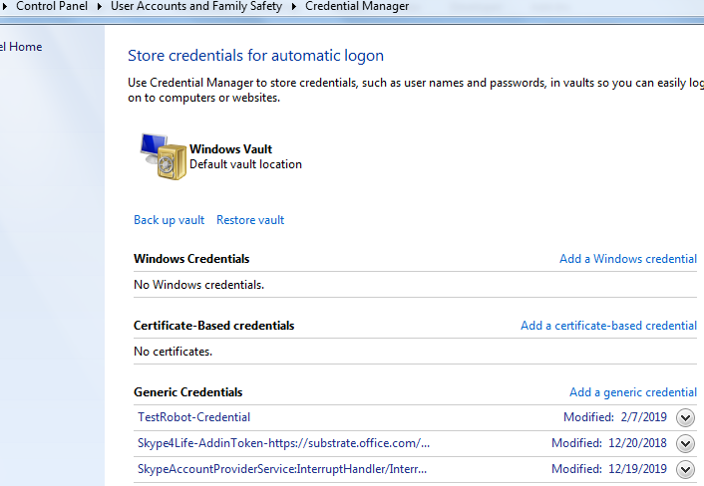

**"Credential Manager"** is used to view and manage your logon credentials (i.e., Usernames and Passwords).

**Add Credential - Properties:**

To work with the "Add Credential" activity - you need to enter the **Credential Type, Persistance Type, User Name, Password, Target,** and **Result** as **Output.**

Stores a specified credential in the Windows Credential Manager with a custom persistence type, and returns a Boolean value to let you know if the process was successful or not.

**Input:**

**Username** : The username to be used with the credentials. This field supports strings and string variables.

### Note:

All strings have to be placed between quotation marks.

**Password :** The password to be used with the credentials. This field supports strings and string variables.

**Target** : The Internet or network address that is to be used with the given credentials. This field supports strings and string variables.

**Credential Type**: The type of credential to be added. There are Five types of Credential Types are available in UiPath:

1. **None** - No credential type is applied. This may cause the credential to not be saved.
2. **Generic** - A generic credential that is not used by a particular authentication package.
3. **DomainPassword** - A password credential that is specific to Microsoft authentication packages (NTLM, Kerberos, Negotiate).
4. **DomainCertificate** - A certificate credential that is specific to Microsoft authentication packages (Kerberos, Negotiate, Schannel).
5. **DomainVisiblePassword** - A password credential specific to Microsoft authentication packages (Passport).

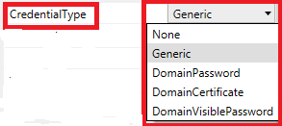

**Persistance** **Type**: Defines the rules according to which the given credentials are stored. The following options are available:

1. **Session** - The credentials are stored in the Windows Credential Manager only for the life of the current logon session. They are not visible to other logon sessions of this same user. They do not exist after this user logs off and back on.
2. **LocalComputer** - The credentials persists for all subsequent logon sessions on this same computer. They are visible to other logon sessions of this same user on the same machine, but not to logon sessions for this user on other machines.
3. **Enterprise** - The credentials persists for all subsequent logon sessions on the same machine. They are visible to other logon sessions of this same user on the same machine and to logon sessions for this user on other computers.

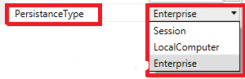

**Output:**

**Result** - A Boolean variable that indicates whether the given credentials were successfully stored in the Windows Credential Manager.

**Common:**

**DisplayName** - The display name of the activity.

**Misc:**

**Private** - If selected, the values of variables and arguments are no longer logged at Verbose level.

**Delete Credential**

Deletes the credentials for a specified target from the Windows Credential Manager, and returns a Boolean value to let you know if the process was successful or not.

**Delete Credential - Properties:**

Deletes the credentials for a specified target from the Windows Credential Manager, and returns a Boolean value to let you know if the process was successful or not.

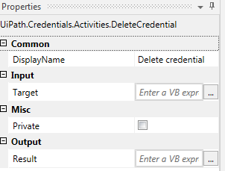

**Input:**

**Target** - The website address or network location for which to delete the credentials from the Windows Credential Manager. This field supports strings and string variables. The target is not case sensitive.

### Note:

All strings must be placed between quotation marks.

**Output:**

**Result** - A Boolean variable that indicates whether the credentials of the given target were successfully deleted from the Windows Credential Manager.

**Common:**

**DisplayName** - The display name of the activity.

**Misc:**

**Private** - If selected, the values of variables and arguments are no longer logged at Verbose level.

**Get Secure Credential**

Retrieves the credentials from a specified target from the Windows Credential Manager as a secure string (password) and a string (username). Additionally, a Boolean value is returned to let you know if the process was successful or not.

**Get Secure Credential - Properties:**

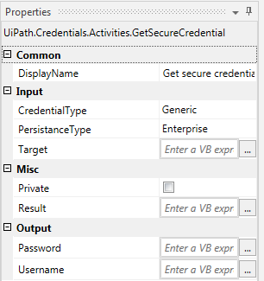

**Input:**

**Target**: The website address or network location for which to retrieve the credentials stored in the Windows Credential Manager. This field supports strings and string variables. The target is not case sensitive.

### Note: All strings must be placed between quotation marks.

**CredentialType:** The credential type of the credentials that you want to retrieve from the Windows Credential Manager. If the type does not coincide with that of the credentials you are trying to retrieve, an error is thrown.

**PersistanceType:** The persistence type of the credentials that you want to retrieve from the Windows Credential Manager. If the persistence type does not coincide with that of the credentials you are trying to retrieve, an error is thrown.

**Output:**

**Username** - The username retrieved for the specified target, as a string variable.

**Password** - The password retrieved for the specified target, as a secureString variable.

**Result** - A Boolean variable that indicates whether the credentials of the given target were successfully retrieved from the Windows Credential Manager.

**Common:**

**DisplayName** - The display name of the activity.

**Misc:**

**Private** - If selected, the values of variables and arguments are no longer logged at Verbose level.

**Request Credential**

Displays a dialog box with a custom message and title that prompts a user to add his/her credentials, and stores the username and password as string variables, that can be later used to log into other apps.

**Request Credential - Properties:**

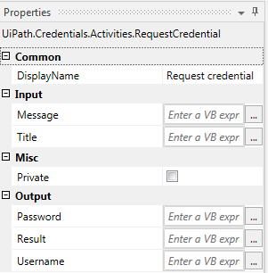

**Input:**

**Message** - The message displayed in the dialog box. This field supports only strings and string variables.

### Note: All strings must be placed between quotation marks.

**Title - The title of the dialog box. This field supports only strings and string variables.**

**Output:**

**Username** - The username added by the user, as a string variable.

**Password** - The password added by the user, as a string variable.

**Result** - A Boolean variable that lets you know if the user clicked OK or Cancel. Clicking OK returns true, while clicking Cancel returns false.

**Common:**

**DisplayName** - The display name of the activity.

**Misc:**

**Private** - If selected, the values of variables and arguments are no longer logged at Verbose level.