Abhishek Niwalkar
Abhishekniwalkar543@gmail.com

Abstract
This project delivers a full-stack SQL Server data warehouse using Medallion Architecture — ingesting raw CRM and ERP data through automated ETL pipelines and transforming it into a business-ready star schema for sales, product, and customer analytics.
DATA WAREHOUSE
USING SQL SERVER
A Comprehensive Data Engineering Report

TABLE OF CONTENTS
SQL Data Warehouse Project Report

Section | Page
01. Executive Summary | 2
02. Project Overview | 3
03. Data Architecture | 4
04. Data Flow & Lineage | 6
05. Data Integration Design | 7
06. ETL Methodology | 9
07. Data Model —The Sales Data Mart | 11
08. Data Quality Framework | 14
09. Repository Structure | 16
10. Analytics & Reporting Capabilities | 17
11. Conclusion | 18
12. Future Scope | 14

1. Executive Summary
This report provides a thorough walkthrough of the SQL Data Warehouse project — a portfolio-grade data engineering solution built on Microsoft SQL Server. The project demonstrates real-world skills across the full data pipeline lifecycle, from raw data ingestion through to business-ready analytics.

At its heart, the project answers a very practical challenge: businesses often have their data scattered across multiple systems — a CRM tracking customer relationships and a separate ERP handling operations. Reporting teams then have to stitch this data together manually, which is slow, error-prone, and inconsistent. This project solves that by building a centralized, clean, and business-ready data warehouse.

The architecture chosen is the Medallion Architecture, a modern and widely adopted pattern in the data engineering world. Data flows through three progressively refined layers:

Layer | Status | Purpose
Bronze | Raw Ingestion | Stores data exactly as received from source CSV files — no changes made.
Silver | Cleaned & Standardized | Applies data cleansing, normalization, and quality transformations.
Gold | Business-Ready | Builds the star schema — dimensions and facts ready for analytics.

The end result is a clean star schema data mart that analysts, BI tools, and machine learning models can query directly — with confidence in the data quality behind it.

2. Project Overview

2.1 The Business Problem
Imagine a sales organization that keeps customer records in a CRM system and product/transaction data in an ERP system. Every time someone needs a report — say, 'What are the top-selling products by customer country?' — an analyst has to manually pull data from both systems, join them in Excel, clean up inconsistencies, and build the report from scratch. This happens every week, for every report. The process is slow, inconsistent, and doesn't scale.

A data warehouse solves this by doing the heavy lifting once, automatically. Once built, analysts can answer complex business questions with a simple SQL query — no manual data wrangling required.

2.2 Project Goals
- Consolidate data from two source systems (CRM and ERP) into a unified SQL Server database.
- Apply rigorous data quality processes to cleanse, standardize, and validate the data.
- Produce a star schema data model optimized for analytical queries.
- Enable SQL-based reporting and BI dashboards for Customer Behavior, Product Performance, and Sales Trends.
- Demonstrate industry best practices in data engineering and ETL development.

2.3 Technology Stack
Tool / Technology | Role in the Project
Microsoft SQL Server Express | Host database engine for all three warehouse layers.
SQL Server Management Studio | Primary IDE for writing, executing, and managing SQL scripts.
CSV Files (CRM & ERP) | Source data files loaded into the Bronze layer via BULK INSERT.
T-SQL Stored Procedures | ETL automation — Bronze loader and Silver transformation procedure.
SQL Views (Gold Layer) | Virtual tables combining silver data into the final star schema.
Git / GitHub | Version control for all SQL scripts and documentation.
Draw.IO | Architecture diagrams, data flow maps, and data model visuals.

3. Data Architecture
The project is built on the Medallion Architecture — a layered approach to organizing data in a warehouse. Think of it like a kitchen: raw ingredients come in, get prepared and organized, and finally get cooked into a finished dish. Each layer serves a specific purpose and audience.

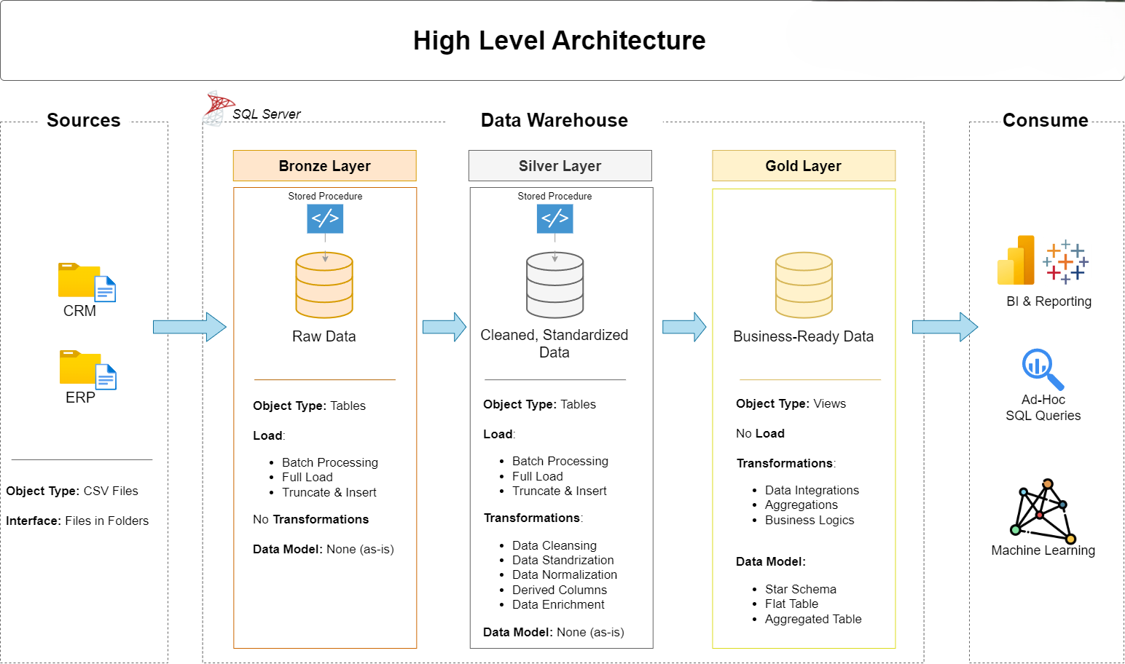
Figure 1: High-Level Medallion Architecture — from CSV sources through Bronze, Silver, and Gold layers to BI consumption.

3.1 Source Systems
Data enters the warehouse from two source systems, both delivered as CSV files:

CRM System  cust_info.csv — customer demographics and status  prd_info.csv — product catalog with pricing history  sales_details.csv — transactional order records | ERP System  CUST_AZ12.csv — customer birthdates and gender  LOC_A101.csv — customer country/location data  PX_CAT_G1V2.csv — product category taxonomy

3.2 Bronze Layer — The Raw Store
The Bronze layer is the data warehouse's memory — it stores a faithful copy of everything received from the source systems, completely untouched. No transformations, no corrections, no opinions about what the data should look like. If the source data has a typo, the Bronze layer has that same typo.
This is intentional. The Bronze layer serves as a safety net: if something goes wrong in later processing stages, engineers can always go back to the raw data and reprocess from scratch. It also provides traceability, which is critical for debugging data quality issues.
Loading mechanism: A stored procedure (bronze.load_bronze) uses SQL Server's BULK INSERT command to efficiently load all six CSV files into their corresponding Bronze tables in a single execution. The procedure truncates tables before loading, ensuring a clean full-refresh on every run.

3.3 Silver Layer — The Cleaning Station
The Silver layer is where raw data gets transformed into something trustworthy. Every record that comes through from Bronze is examined, corrected, standardized, and enriched before it can proceed. This is the most code-intensive layer of the project.

Transformations applied in the Silver layer include:
- Deduplication: For customers with multiple records, only the most recent record is kept using ROW_NUMBER() window functions.
- Standardization: Abbreviated codes are expanded — 'M' becomes 'Married', 'F' becomes 'Female', 'M' for male becomes 'Male', country codes like 'DE' become 'Germany'.
- Data Derivation: Product keys are split to extract category IDs; product end dates are calculated as one day before the next version's start date.
- Sales Validation: Sales amounts are recalculated as Quantity x Price when the stored value is missing, zero, or inconsistent.
- Date Casting: Integer-format dates (e.g., 20140101) are cast to proper DATE types; invalid dates become NULL.
- Prefix Removal: Customer IDs from the ERP system sometimes carry a 'NAS' prefix that must be stripped before joining with CRM data.
- Future Date Handling: Birthdates in the future (data entry errors) are set to NULL.

3.4 Gold Layer — The Business Layer
The Gold layer is where data engineers hand off to data analysts. It contains three SQL Views that implement the star schema — a data modeling pattern purpose-built for analytical queries. Unlike Bronze and Silver (which use physical tables), Gold uses views, meaning they always reflect the latest Silver data without needing a separate load job.
Surrogate keys are generated using ROW_NUMBER() window functions, giving each customer and product a clean integer key for joining. Historical product records are filtered out — only current, active products appear in the dimension.

4. Data Flow & Lineage
Understanding where data comes from — and how it moves — is essential for debugging, auditing, and extending the warehouse. The diagram below shows the complete lineage from source CSVs all the way to the final Gold layer tables.

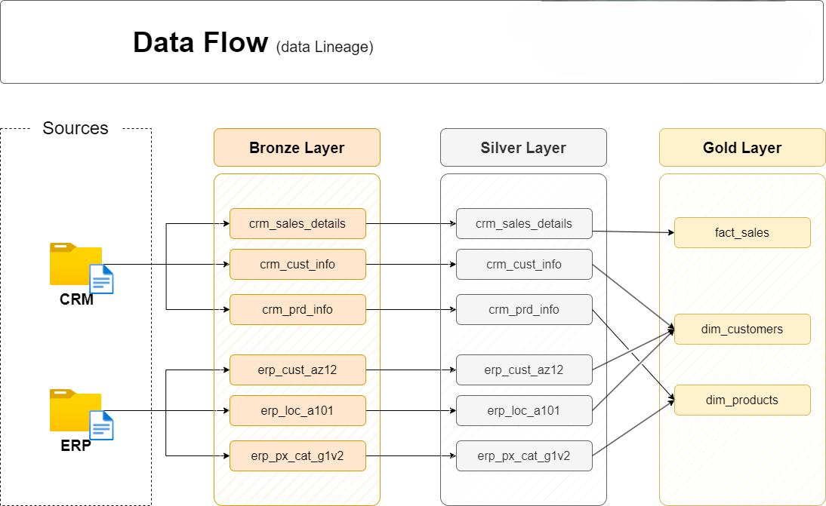
Figure 2: Data Lineage — tracing each source file through Bronze and Silver layers into the Gold dimension and fact tables.
Reading the diagram from left to right:
- Three CRM files (crm_sales_details, crm_cust_info, crm_prd_info) and three ERP files (erp_cust_az12, erp_loc_a101, erp_px_cat_g1v2) are the starting points.
- Each file lands in a corresponding Bronze table with the same name, preserving the source structure.
- Silver tables mirror the Bronze structure but with transformed, validated data.
- At the Gold layer, data integration happens: multiple Silver tables are joined together to produce the three final objects — fact_sales, dim_customers, and dim_products.

Notice how dim_customers is fed by three Silver sources: crm_cust_info (primary name/status data), erp_cust_az12 (birthdate and gender backup), and erp_loc_a101 (country). Similarly, dim_products draws from crm_prd_info and erp_px_cat_g1v2. This cross-system integration is the core value of the warehouse.
5. Data Integration Design
One of the more interesting challenges in this project is that the two source systems — CRM and ERP — have different ways of identifying the same customer. They don't share a single clean common key out of the box, so the integration design had to carefully align them.



Figure 3: Data Integration Map — how CRM and ERP tables relate to each other through shared entity keys.

5.1 Customer Integration
The CRM system holds the primary customer profile (name, marital status, gender, create date) identified by cst_id and cst_key. The ERP system holds supplementary customer data — birthdates in erp_cust_az12 and country locations in erp_loc_a101 — both identified by a 'cid' field.
The Silver layer data cleansing ensures these keys can be joined: the 'NAS' prefix is stripped from ERP customer IDs, and dashes are removed from location IDs so they match the CRM's cst_key format. The Gold dim_customers view then joins all three using LEFT JOINs, ensuring every CRM customer is preserved even if ERP records are missing.
Gender data deserves special mention: the CRM is considered the primary source. If CRM has a valid gender ('Male' or 'Female'), that is used. Only if CRM returns 'n/a' does the view fall back to the ERP's gender field. This is implemented with a CASE/COALESCE pattern in the view definition.

5.2 Product Integration
Products present a different challenge: the CRM's prd_key field encodes both a category reference and the actual product identifier, separated by a dash. The Silver transformation splits this — extracting the first five characters as the category ID (after replacing dashes with underscores) and the remainder as the clean product key.

This extracted category ID then serves as the join key to erp_px_cat_g1v2, which holds the full category taxonomy (category name, subcategory, and maintenance flag). The Gold dim_products view performs this join to produce a fully enriched product dimension.

5.3 Sales Integration
The fact_sales view is the simplest in structure but the most important in purpose. It takes the cleansed sales transactions from silver.crm_sales_details and resolves them to surrogate keys by joining against the two dimension views. The resulting view contains one row per order line item, with all the measures needed for analysis: order date, ship date, due date, sales amount, quantity, and unit price.

6. ETL Methodology
ETL (Extract, Transform, Load) - is the backbone of any data warehouse. This project implements a thoughtful and layered approach to ETL, using different techniques at each layer of the medallion architecture.

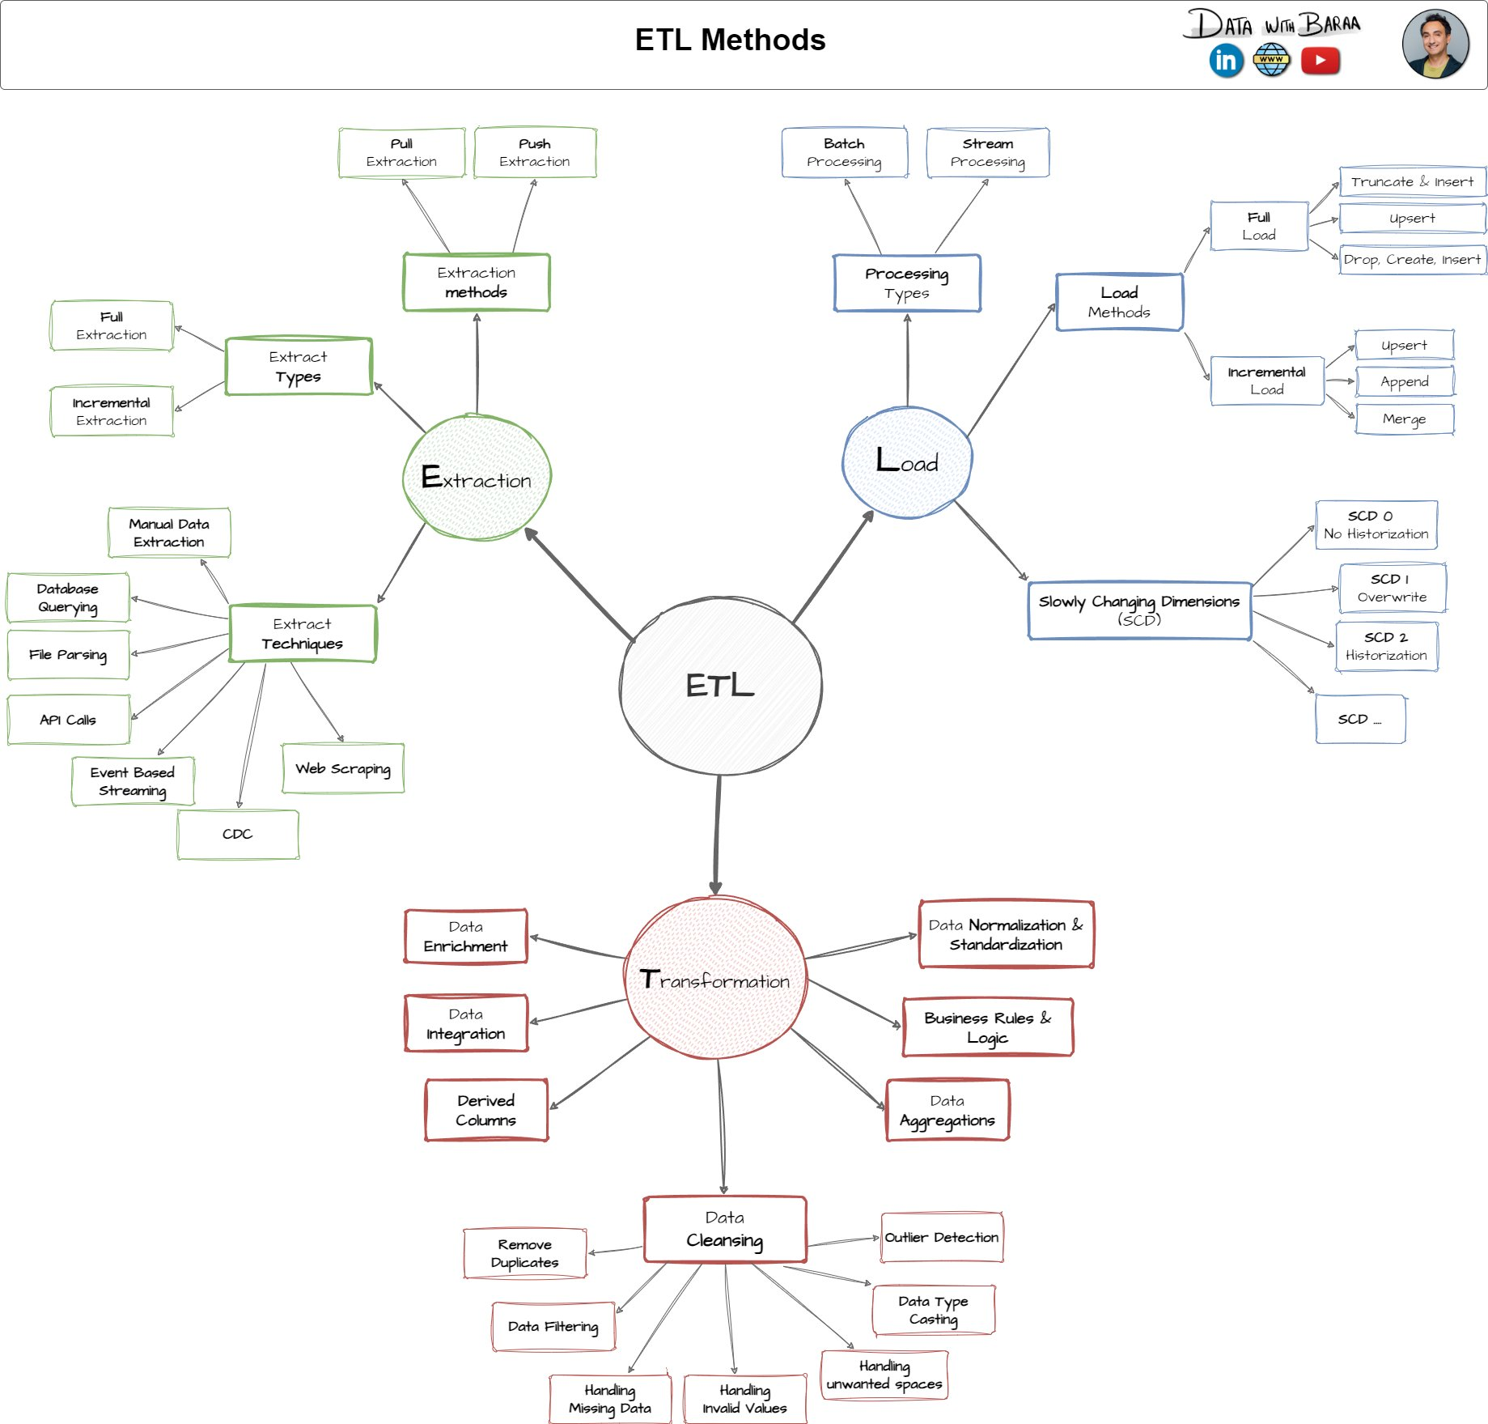
Figure 4: ETL Methods Reference Map — extraction techniques, transformation types, and load patterns used across the project.

6.1 Extraction — Getting Data In
Data is extracted from CSV files using SQL Server's BULK INSERT command — the fastest way to load flat files into SQL Server tables. The extraction is a Full Extract pattern, meaning every run loads the complete dataset rather than just changes since the last run. This keeps the implementation simple and reliable for a dataset of this scale.

6.2 Transformation — Making Data Trustworthy
Transformation happens entirely within the Silver stored procedure, leveraging pure T-SQL. The transformations span several categories:

Transformation Type | What It Does in This Project
Data Cleansing | Removes duplicate customers, trims whitespace, nullifies invalid dates.
Standardization | Converts codes to readable labels (e.g., 'S' -> 'Single', 'DE' -> 'Germany').
Normalization | Separates product keys into category IDs and clean product identifiers.
Derived Columns | Calculates product end dates from the next version's start date.
Data Enrichment | Joins CRM and ERP customer data to build complete customer profiles.
Business Rules | Recalculates sales = quantity x price when stored value is wrong or missing.

6.3 Load — Delivering Clean Data
Both the Bronze and Silver layers use a Truncate & Insert (Full Load) strategy. Before each load run, the target tables are completely emptied, then repopulated from scratch. This approach trades off incremental efficiency for simplicity and reliability — there are no complex merge logic or change-tracking mechanisms to maintain.
The Gold layer requires no loading at all — its views are computed on-the-fly each time they are queried, always reflecting the current state of the Silver layer.

6.4 Performance & Observability
Both stored procedures (bronze.load_bronze and silver.load_silver) include timing instrumentation. DATETIME variables capture the start and end time of each individual table load, and the total batch duration is printed upon completion. This makes it easy to identify slow-loading tables or spot performance regressions after data volume changes.
Error handling is implemented via TRY/CATCH blocks in both procedures. If any step fails, the error message, error number, and error state are printed to the output — providing clear diagnostic information without crashing silently.

7. Data Model —The Sales Data Mart
The Gold layer implements a classic Star Schema — the gold standard (pun intended) for analytical data models. It is called a star schema because when drawn on paper, the fact table sits in the center surrounded by dimension tables, forming a star shape.

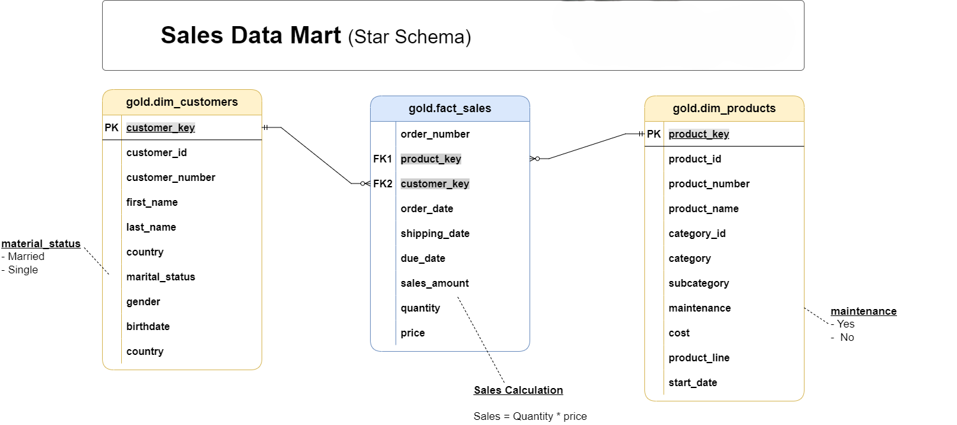
Figure 5: Sales Data Mart Star Schema — gold.fact_sales at the center, joined to gold.dim_customers and gold.dim_products.
The star schema contains three objects:

7.1 gold.dim_customers
The customer dimension holds one row per unique customer, enriched with data from both source systems. Key design decisions:
- customer_key is a surrogate integer key generated via ROW_NUMBER(), decoupling the warehouse model from source system IDs.
- customer_number preserves the original CRM identifier for traceability.
- country comes from the ERP location table, joined by customer key.
- gender applies a priority rule: CRM data takes precedence; ERP is used as a fallback only.
- birthdate is sourced from the ERP, with future dates nullified as part of quality rules.

Column | Type | Description
customer_key | INT (PK) | Surrogate key for warehouse joins.
customer_id | INT | Original numeric ID from CRM.
customer_number | NVARCHAR(50) | Alphanumeric CRM reference code.
first_name / last_name | NVARCHAR(50) | Customer name fields, trimmed and cleaned.
country | NVARCHAR(50) | Country of residence from ERP location data.
marital_status | NVARCHAR(50) | Married or Single (normalized from codes).
gender | NVARCHAR(50) | Male, Female, or n/a (CRM-first, ERP fallback).
birthdate | DATE | Date of birth; future dates set to NULL.
create_date | DATE | When the customer record was first created.

7.2 gold.dim_products
The product dimension holds one row per currently active product. Historical product versions are filtered out using WHERE prd_end_dt IS NULL — keeping only the current record for each product. This is an implementation of SCD Type 0 (no historization) at the Gold level.
- product_key is generated via ROW_NUMBER() ordered by start date and product key for consistent, repeatable assignment.
- category and subcategory are joined from the ERP product category table.
- maintenance_required indicates whether the product needs scheduled maintenance (Yes/No).
- product_line is expanded from single-character codes to readable descriptions ('R' -> 'Road', 'M' -> 'Mountain', etc.).

7.3 gold.fact_sales
The fact table is the analytical heart of the warehouse. It stores one row per sales order line item and links to both dimensions via foreign keys. Every query that analyzes sales performance goes through this view.

An important business rule is embedded here: Sales Amount = Quantity x Price. The Silver transformation enforces this rule, so analysts can trust all three measures to be internally consistent. This eliminates the most common source of conflicting numbers across reports.

Column | Type | Description
order_number | NVARCHAR(50) | Unique alphanumeric sales order identifier.
product_key | INT (FK) | Links to gold.dim_products.
customer_key | INT (FK) | Links to gold.dim_customers.
order_date | DATE | Date the order was placed.
shipping_date | DATE | Date the order was dispatched.
due_date | DATE | Payment due date for the order.
sales_amount | INT | Total order line value (validated = qty x price).
quantity | INT | Number of units ordered.
price | INT | Unit price (derived if original value invalid).

8. Data Quality Framework
Data quality is not an afterthought in this project — it is a core discipline built into every layer of the pipeline. Quality checks are implemented at both the Silver and Gold layers, with clear expectations for each check.

8.1 Silver Layer Quality Checks
After the Silver stored procedure runs, a dedicated quality check script validates the transformation results. Each check has a documented expectation — the goal is always zero results returned. If any rows come back, it signals a data quality issue that needs investigation.

Table | Check Type | What Is Validated
crm_cust_info | Null / Duplicate PK | No customer should appear more than once or have a null ID.
crm_cust_info | Unwanted Spaces | Customer keys must be trimmed — no leading/trailing spaces.
crm_cust_info | Standardization | Only 'Married', 'Single', or 'n/a' values in marital_status.
crm_prd_info | Null / Duplicate PK | No product ID duplication or nulls.
crm_prd_info | Negative Cost | All product costs must be zero or positive.
crm_prd_info | Date Order | Product end date must not precede start date.
crm_sales_details | Invalid Dates | Dates must be valid 8-digit integers in acceptable range.
crm_sales_details | Date Ordering | Order date must not be later than ship or due dates.
crm_sales_details | Sales Consistency | sales_amount must equal quantity x price exactly.
erp_cust_az12 | Date Range | Birthdates must fall between 1924-01-01 and today.
erp_cust_az12 | Standardization | Only 'Male', 'Female', or 'n/a' in gender column.
erp_loc_a101 | Standardization | Country values must be full names, not abbreviations.
erp_px_cat_g1v2 | Unwanted Spaces | Category, subcategory, maintenance fields must be trimmed.

8.2 Gold Layer Quality Checks
The Gold layer quality checks focus on the integrity of the star schema relationships. Two categories of checks are performed:

Surrogate Key Uniqueness: Both dim_customers and dim_products are checked to ensure no duplicate surrogate keys exist. Since these keys are generated by ROW_NUMBER() over the Silver data, duplicates would indicate a problem in the Silver layer (e.g., duplicate records not properly deduplicated).

Referential Integrity: The fact_sales view is joined against both dimension views to confirm that every order line can be resolved to a valid product and a valid customer. Any orphaned fact rows — where no matching dimension record exists — would indicate an integration failure that could produce misleading analytics.

9. Repository Structure
The project follows a clean, layered folder structure that mirrors the three-layer medallion architecture. This makes it easy for anyone joining the project to understand where each script belongs and what it does.

File / Folder | Purpose
init_database.sql | Creates the DataWarehouse database and the three schemas (bronze, silver, gold).
scripts/bronze/ddl_bronze.sql | Defines the six Bronze tables to hold raw source data.
scripts/bronze/proc_load_bronze.sql | Stored procedure to BULK INSERT all six CSV files into Bronze tables.
scripts/silver/ddl_silver.sql | Defines the six Silver tables with added dwh_create_date metadata columns.
scripts/silver/proc_load_silver.sql | Stored procedure to cleanse, standardize, and load Bronze data into Silver.
scripts/gold/ddl_gold.sql | Creates the three Gold Views implementing the star schema.
tests/quality_checks_silver.sql | SQL quality validation queries for all six Silver tables.
tests/quality_checks_gold.sql | SQL quality validation for Gold surrogate keys and referential integrity.
datasets/source_crm/ | Three CRM source CSV files.
datasets/source_erp/ | Three ERP source CSV files.
docs/data_catalog.md | Gold layer table and column definitions for business and technical stakeholders.
docs/naming_conventions.md | Naming rules for all schemas, tables, columns, and stored procedures.

9.1 Naming Conventions
The project enforces consistent naming conventions across all database objects, documented in naming_conventions.md:
- Snake_case is used for all object names — lowercase letters with underscores between words.
- Bronze and Silver tables follow the pattern <sourcesystem>_<entity> (e.g., crm_cust_info, erp_loc_a101).
- Gold objects use category prefixes: dim_ for dimension views, fact_ for fact views.
- Surrogate keys use the _key suffix (e.g., customer_key, product_key).
- System-generated metadata columns use the dwh_ prefix (e.g., dwh_create_date).
- Stored procedures follow load_<layer> naming (e.g., load_bronze, load_silver).

10. Analytics & Reporting Capabilities
With the Gold layer in place, the data warehouse is ready to support a broad range of analytical use cases. The star schema is specifically designed to make common business questions easy to ask and fast to answer.

10.1 Customer Analytics
- Total and average sales by customer, country, or marital status.
- Customer segmentation by age group (derived from birthdate), total spend, or order frequency.
- New vs. returning customer trends over time using create_date.
- Geographic distribution of customers and their purchasing behavior.

10.2 Product Performance
- Revenue contribution by product category, subcategory, and product line.
- Best-selling products ranked by total sales amount or quantity sold.
- Products that require maintenance vs. those that do not — do they sell differently?
- Average selling price vs. standard cost to estimate gross margins.

10.3 Sales Trends
- Monthly, quarterly, and annual sales trends using order_date.
- Order fulfillment speed: average days between order_date and shipping_date.
- Running totals and moving averages using SQL window functions.
- Period-over-period comparisons: this year vs. last year, this month vs. last month.

10.4 Sample Analytical Queries
Here are examples of business questions the warehouse can answer with a simple SQL query:

Business Question | SQL Pattern
Which country generates the most revenue? | GROUP BY country with SUM(sales_amount)
What are the top 10 products by revenue? | GROUP BY product_name ORDER BY SUM(sales_amount) DESC
How has monthly revenue changed over 3 years? | GROUP BY YEAR/MONTH(order_date) with trend analysis
What % of sales comes from Mountain bikes? | SUM(sales) for category / total SUM(sales) x 100
Which customers haven't ordered in 6 months? | MAX(order_date) per customer with DATEDIFF filter
What is the average order value per gender? | JOIN dim_customers on customer_key, GROUP BY gender

11. Conclusion
This project is more than a collection of SQL scripts — it is a working demonstration of modern data engineering principles applied end-to-end on a realistic dataset.
Starting with raw, imperfect CSV files from two different systems, the pipeline methodically cleans, integrates, and models the data into a form that analysts and business users can rely on. The Medallion Architecture provides clear separation of concerns: Bronze for raw history, Silver for clean data, Gold for business-ready analytics.
What makes this project particularly valuable as a portfolio piece is its completeness. It doesn't just build the warehouse — it also documents the data model, enforces naming conventions, implements quality validation, and provides meaningful instrumentation in the ETL procedures. These are the hallmarks of production-grade data engineering work.

The skills demonstrated across this project span the full data engineering spectrum:
Skill Area | Evidence in This Project
Data Architecture | Medallion Architecture design with clear layer separation and purpose.
ETL Development | Two stored procedures with timing, error handling, and logging.
Data Modeling | Star schema with surrogate keys, dimension design, and fact relationships.
Data Quality | Comprehensive Silver and Gold quality check scripts with documented expectations.
SQL Development | Advanced T-SQL: window functions, CASE expressions, CTEs, date manipulation.
Documentation | Data catalog, naming conventions, architecture diagrams, and this report.

For anyone learning data engineering, this project serves as a practical reference for how professional warehouse solutions are structured. For hiring managers, it demonstrates the ability to think at multiple levels — from raw data ingestion all the way to business-facing analytics — and to document and communicate that work clearly.

