PRDA-01: Profit Analysis
Impact of R&D, Administration & Marketing Spend on Startup Profit
Analysis Report

1. Problem Understanding
The objective of this analysis is to determine how spending on Research & Development (R&D), Administration, and Marketing affects the Profit of a startup. The analysis further uses a regression model to predict Profit for two new startups given their spend figures, visualizes the dataset to derive business insights, and provides data-backed recommendations for the company.

2. Dataset Source Confirmation
Source type: Database
The dataset was sourced from a MySQL database (Database: project_profit_analysis, Table: startup) using the credentials provided in the project PRD. The table was exported to CSV for downstream analysis after connecting via MySQL Workbench.

3. About the Dataset
The dataset contains records for 50 startups located across three U.S. states — New York, California, and Florida. It includes the following features:
- R&D Spend — amount spent on Research & Development
- Administration — amount spent on administrative overhead
- Marketing Spend — amount spent on marketing strategies
- State — location of the startup (NY / CA / FL)
- Profit — profit made by the startup
Data quality check: no missing values were found, and all numeric fields (RD_Spend, Administration, Marketing_Spend, Profit) had correct data types.

4. Methodology
- Connected to the MySQL database using the given credentials (Host, DB name, Table name) via MySQL Workbench.
- Exported the 'startup' table (50 rows) to CSV for analysis.
- Verified data quality — no missing values, correct numeric types.
- Performed Multiple Linear Regression in Excel using the Data Analysis ToolPak, with Profit as the dependent variable and R&D Spend, Administration, and Marketing Spend as independent variables.
- Used the resulting regression equation to predict Profit for two new input rows.
- Built visualizations in Power BI to explore relationships between spend categories and Profit, and to examine state-wise patterns.

5. Regression Output

5.1 Model Summary
Metric | Value
Multiple R | 0.9751
R Square | 0.9507
Adjusted R Square | 0.9475
Standard Error | 9232.34
Observations | 50

5.2 Coefficients & Significance
Variable | Coefficient | P-value | Significance (α=0.05)
Intercept | 50122.19 | 1.06E-09 | Significant
R&D Spend | 0.8057 | 2.63E-22 | Significant
Administration | -0.0268 | 0.6018 | Not significant
Marketing Spend | 0.0272 | 0.1047 | Not significant

Regression Equation:
Profit = 50122.19 + (0.8057 × R&D Spend) + (−0.0268 × Administration) + (0.0272 × Marketing Spend)

6. Interpretation of Results

R&D Spend
Coefficient = 0.8057, p-value ≈ 0.00 — highly significant. Every ₹1 spent on R&D adds approximately ₹0.81 to Profit. This is by far the strongest driver of Profit in the dataset.

Marketing Spend
Coefficient = 0.0272, p-value = 0.1047 — not statistically significant at the 5% level, though it shows a mild positive trend with Profit.

Administration
Coefficient = −0.0268, p-value = 0.6018 — not statistically significant. Administration spend shows no reliable relationship with Profit.

Overall Model Fit
R² = 0.9507 — the three predictors together explain approximately 95% of the variation in Profit, indicating a strong-fitting model.

7. Profit Prediction for New Inputs
Using the regression equation derived above, predicted Profit for the two new startups specified in the PRD:
R&D Spend | Administration | Marketing Spend | Predicted Profit
21892.92 | 81910.77 | 164270.70 | 70034.27
23940.93 | 96489.63 | 137001.10 | 70551.91

Both predictions fall well within the training data's Profit range (approximately ₹35,000 to ₹1,92,000), indicating reasonable, non-extrapolated estimates.

8. Power BI Visualizations
The following dashboard was built to explore RD_Spend vs. Profit, Marketing_Spend vs. Profit, and Average Profit by State:
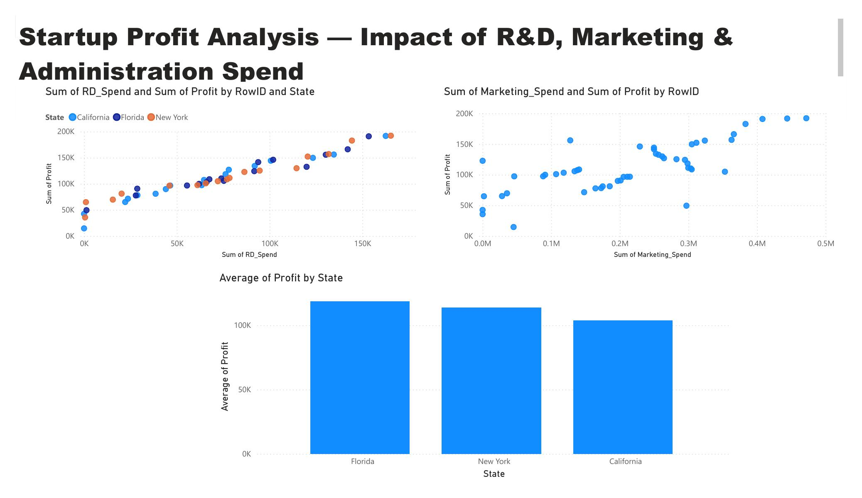

9. Key Insights
- R&D Spend is the dominant driver of Profit — a near 1:1 relationship, and the only statistically significant predictor.
- Marketing Spend shows a mild positive trend with Profit, but it is not statistically strong enough to confirm on this dataset.
- Administration Spend has no meaningful relationship with Profit — higher admin spend does not translate into higher profit.
- State/location has little impact — average profit is broadly similar across New York, Florida, and California.
- The regression model explains ~95% of the variation in Profit (R² = 0.95), making it a strong fit for this dataset.

10. Recommendations to the Company

Prioritize R&D Investment
Since R&D spend is the strongest and only statistically significant driver of Profit, allocating a larger share of the budget here is likely to yield the best returns.

Re-evaluate Administration Spend
Administration spend shows no measurable link to Profit — consider auditing this budget for cost-saving opportunities.

Test Marketing Spend Cautiously
Marketing shows a weak positive trend; controlled experiments (A/B testing spend levels) could clarify its real impact before scaling it up.

Location Is Not a Limiting Factor
Since State has little effect on Profit, expansion decisions can be driven by other factors (talent, cost of living, market access) rather than profit potential alone.

11. Conclusion
This analysis confirms that R&D investment is the primary lever for improving startup profitability in this dataset, while Administration and Marketing spend show comparatively weak or statistically insignificant effects. The regression model, with an R² of 0.95, provides a reliable basis for the profit predictions and recommendations presented above.

Data Source: MySQL Database | Tools Used: MySQL Workbench, Excel, Power BI

