Basic Information about Cabbage:
1. Name:
- Cabbage (Brassica oleracea var. capitata): Cabbage is a leafy vegetable belonging to the Brassica family, which includes other vegetables like broccoli, cauliflower, kale, and Brussels sprouts. The term "capitata" refers to its head-like structure, where the leaves form a tight, round shape.
2. Best Season for Growing Cabbage:
- Cabbage is a cool-season crop that prefers moderate temperatures. It thrives best in spring or fall, with temperatures ranging from 15°C to 20°C (59°F to 68°F).
- Spring Season: For a spring crop, cabbage is usually planted in early spring so that the plants mature before the hot summer months. Early varieties are often used, which mature faster.
- Fall Season: In fall, cabbage is planted in late summer so that it matures when temperatures are cooler and not subject to the heat of summer. Fall crops can also tolerate light frost, which can improve flavor in some varieties.
3. Best Soil Type:
- Cabbage prefers loamy soil, which is well-drained and rich in organic matter. Loam consists of a balanced mixture of sand, silt, and clay, providing good moisture retention while allowing excess water to drain away.
- Soil pH: Cabbage grows best in slightly acidic to neutral soils with a pH range of 6.0 to 6.5. If the soil is too acidic (pH below 6), it can lead to poor plant growth, while soil that is too alkaline (pH above 7) can hinder nutrient absorption.
- Nutrient Requirements: Cabbage requires high amounts of nutrients, especially nitrogen, to grow strong, healthy leaves. A well-fertilized soil rich in organic matter or compost is ideal.
4. Time Period:
- Germination Time: Cabbage seeds typically germinate in 7 to 10 days when planted under the right conditions. The temperature should be around 18°C to 22°C (65°F to 72°F).
- Growth Time:
  - The time it takes from planting to harvest depends on the variety of cabbage and environmental conditions.
  - Early varieties (e.g., Early Jersey Wakefield) take around 70 to 85 days to mature.
  - Late varieties (e.g., Savoy or Late Flat Dutch) may take 100 to 120 days to reach full maturity.
- Time to Harvest: Cabbage can be harvested when the heads are firm and well-formed, which varies from 70 to 120 days.
5. Estimated Cost per Acre:
The cost can vary based on factors like region, input costs (seeds, fertilizers, etc.), and labor. The estimated cost per acre of cabbage cultivation in India could range between ₹35,000 to ₹50,000.
6. Main Varieties of Cabbage:
- Green Cabbage: This is the most common type, with varieties such as Golden Acre, Early Jersey Wakefield, and Savoy. Green cabbage has tight, crisp heads and is widely used for making salads, soups, and coleslaw.
- Red Cabbage: Red cabbage is purple and slightly more bitter than green cabbage. Varieties like Red Express and Ruby Ball are popular. It’s often used in pickling or raw preparations like salads.
- Savoy Cabbage: Savoy cabbage has crinkled, tender leaves and is milder in flavor compared to regular cabbage. Wintergreen and Savoy Express are varieties with good cold tolerance. It's excellent for cooking, stir-fries, and soups.
- Napa Cabbage (Chinese Cabbage): This variety has long, pale green leaves and a mild flavor, used primarily in Asian cuisine. Michihili and Pak Choi are common varieties, often used in dishes like kimchi and stir-fries.

Common Diseases of Cabbage and Symptoms:
1)Downy Mildew
a) Symptoms:

- Yellow patches on upper leaf surface

- White to grey mold under the leaves

- Wilting in severe infections

b) Cure:

- Spray Metalaxyl + Mancozeb (0.25%)

- Use Fosetyl-Al (Aliette)

c) Prevention:

- Improve field drainage and aeration

- Avoid wetting foliage during irrigation

d) Causes:

- Fungal disease caused by Peronospora parasitica

- Favors high humidity and cool temperatures

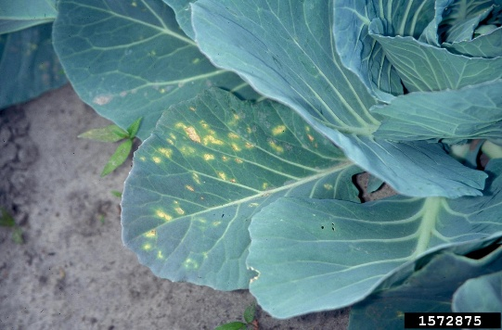
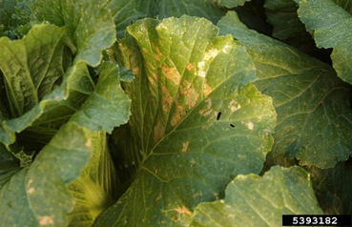
2. Clubroot:
Symptoms:
- Root Swelling: Roots become swollen and club-shaped.
- Stunted Growth: Plants are smaller and weaker.
- Yellowing of Leaves: Due to reduced nutrient and water uptake.
- Wilting: Especially during dry conditions.
- Premature Leaf Drop: Leaves fall off early.
- Reduced Head Formation: Smaller, less dense cabbage heads.
Cure (Fertilizers and Treatments):
- Lime: Raise soil pH to 7.0–7.5 to reduce pathogen activity.
- Phosphorus and Potassium Fertilizers: Strengthen the plant's resistance and root health.
- Organic Compost: Improves soil structure and supports root growth.
- Biological Control: Use fungi like Trichoderma harzianum to suppress the pathogen.
Prevention:
- Crop Rotation: Avoid growing cabbage or other brassicas in the same soil for 3-4 years.
- Resistant Varieties: Use clubroot-resistant cabbage varieties.
- Soil pH Management: Maintain a neutral to alkaline pH (around 7.0).
- Sanitation: Clean tools and remove infected plants to prevent spread.
- Well-Drained Soil: Ensure good drainage to prevent pathogen spread.
Causes:
- Pathogen: Plasmodiophora brassicae, a soil-borne protist.
- Spread: Through contaminated soil, water, tools, or infected plant material.
- Soil Conditions: The disease thrives in acidic, poorly-drained soils with a pH below 6.0
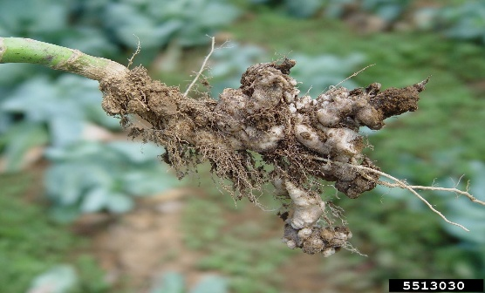
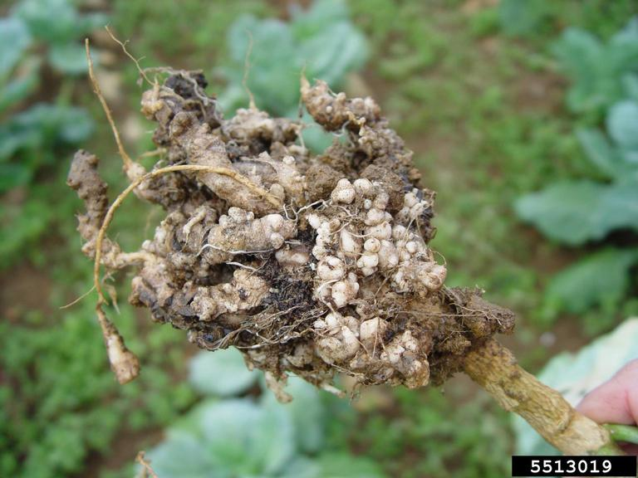

3) Black Rot
a) Symptoms:

- Yellowing of leaf edges

- V-shaped lesions spreading inward

- Blackening of veins and rotting of heads

b) Cure (Fertilizers/Pesticides):

- Spray Copper Oxychloride @ 2.5 g/liter + Streptocycline @ 100 ppm

- Use Bioagents like Pseudomonas fluorescens

c) Prevention:

- Use disease-free seeds

- Practice crop rotation (3–4 years)

- Avoid overhead irrigation

d) Causes:

- Bacterial infection caused by Xanthomonas campestris pv. campestris

- Spread through seeds, water, and contaminated tools
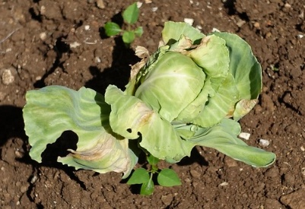
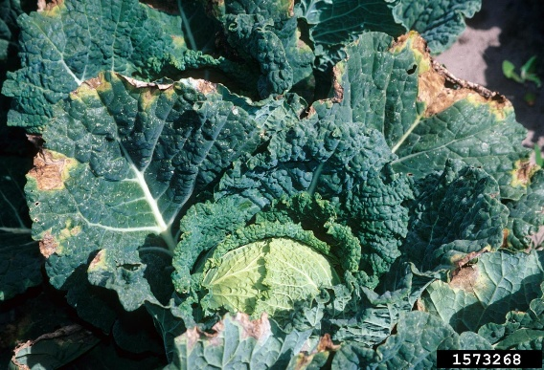
This Photo by Unknown Author is licensed under CC BY-NC

4)Alternaria Leaf Spot

a) Symptoms:

Circular dark brown spots with concentric rings

Premature leaf drop

b) Cure:

Spray Chlorothalonil or Mancozeb every 10–12 days

c) Prevention:

Remove plant debris

Provide good air circulation

d) Causes:

Caused by Alternaria brassicae and Alternaria brassicicola

Enhanced by moist, warm conditions

General Cabbage Care and Disease Management Tips:
- Crop Rotation: Rotate cabbage with non-Brassica crops (e.g., beans, corn, tomatoes) every 2 to 3 years to prevent the buildup of soil-borne diseases like clubroot.
- Watering: Water cabbage deeply but avoid overhead irrigation that can wet the leaves, promoting fungal diseases like downy mildew or powdery mildew. Use drip irrigation or water at the base of the plant.
- Weeding: Regularly remove weeds, as they can harbor pests and diseases that affect cabbage. Weeds also compete for nutrients and water.
- Fertilization: Cabbage is a heavy feeder and requires a lot of nitrogen early in its growth cycle. Use well-rotted compost or a balanced fertilizer rich in nitrogen during the early stages. However, be careful with excess nitrogen later in the season as it can lead to soft heads and reduced shelf life.
- Pest Control: To prevent pests, consider using row covers during the early stages of growth. For larger infestations, consider introducing beneficial insects such as ladybugs for aphid control or parasitic wasps to manage caterpillar pests.

- Pest/Insect
a) Symptoms:
- Aphids: Curled leaves, yellowing of leaves, sticky residue on plants.
- Cabbage Worms: Holes in the leaves, chewed edges, and visible caterpillars.
- Root Maggot: Wilting, stunted growth, and yellowing of leaves.
b) Cure (Fertilizer):
- Use Neem oil or insecticidal soaps for aphid control.
- For Cabbage worms, treat plants with Bacillus thuringiensis (Bt) or pyrethrin-based insecticides.
- To control root maggots, use insecticide-treated soil or natural predators like nematodes.

1) Nitrogen Deficiency
- Symptoms:
  - Yellowing of older leaves (chlorosis), starting from the lower leaves and moving upward.
  - Stunted growth and small leaves.
  - Reduced head size and poor yield.
- Cure (Fertilizers):
  - Apply Nitrogen-rich fertilizers, such as Urea or Ammonium Nitrate, to promote green growth.
  - Incorporate well-rotted manure or compost to improve nitrogen content naturally.

2) Phosphorus Deficiency
- Symptoms:
  - Dark green leaves with a reddish-purple tinge, especially in older leaves.
  - Stunted growth and poor root development.
  - Reduced flowering and fruiting (in case of flowering brassica varieties).
- Cure (Fertilizers):
  - Use phosphorus-based fertilizers like Single Superphosphate (SSP) or Diammonium Phosphate (DAP).
  - Bone meal or rock phosphate can also be used to provide phosphorus naturally.

3) Potassium Deficiency
- Symptoms:
  - Yellowing at the edges of older leaves, which may develop into scorched or brown spots.
  - Weak stems and poor disease resistance.
  - Wilting and poor growth.
- Cure (Fertilizers):
  - Apply Potassium-based fertilizers such as Muriate of Potash (MOP) or Potassium Sulfate to improve plant health and growth.
  - Compost rich in potassium can also help.

4) Calcium Deficiency
- Symptoms:
  - Tip burn on young leaves, with edges turning brown and curling inward.
  - Deformed heads or poor head formation.
  - Soft stems and weak plants, especially under stress conditions.
- Cure (Fertilizers):
  - Use Calcium-rich fertilizers like Calcium Nitrate.
  - Lime can be used to correct calcium deficiency, especially in acidic soils.

5) Magnesium Deficiency
- Symptoms:
  - Interveinal chlorosis (yellowing between the veins) on older leaves, while veins remain green.
  - Red or purple coloration on older leaves.
  - Weak growth and poor overall vigor.
- Cure (Fertilizers):
  - Apply Magnesium sulfate (Epsom Salt) to correct the deficiency.
  - Dolomitic lime can also help, as it contains magnesium in addition to calcium.

6) Iron Deficiency
- Symptoms:
  - Yellowing of young leaves while the veins remain green.
  - Poor leaf growth and stunted plants.
- Cure (Fertilizers):
  - Use Iron chelates (e.g., Fe-EDTA) or Ferrous Sulfate to correct iron deficiency.
  - Adding organic matter like compost can also help improve iron availability in the soil.

7) Sulfur Deficiency
- Symptoms:
  - Yellowing of younger leaves, starting from the tips.
  - Stunted growth and small leaves.
- Cure (Fertilizers):
  - Apply Sulfur-based fertilizers like Ammonium Sulfate or Gypsum.
  - Organic sulfur sources, such as sulfur-containing compost, can also help.

