Basic Information about Ladyfinger (Okra)
1. Name:
- Ladyfinger (Abelmoschus esculentus): Also known as okra, bhindi, or gumbo, it is a warm-season vegetable belonging to the Malvaceae family. It is grown for its edible green pods, which are commonly used in cooking, especially in soups, stews, and stir-fries.
2. Best Season for Growing Ladyfinger:
- Best Growing Season: Ladyfinger is a warm-season crop that thrives in hot, sunny conditions. It is generally grown in spring and summer when the temperatures are consistently warm.
  - Optimal Temperature: The ideal temperature range for growing okra is between 25°C and 35°C (77°F and 95°F). It can tolerate high temperatures but does not perform well in cold or frosty conditions.
  - Planting Time: Okra is typically planted after the last frost in spring when soil temperatures have reached 21°C to 25°C (70°F to 77°F), as the seeds germinate best in warm soil.
3. Best Soil Type:
- Soil Requirements: Okra prefers well-drained, loamy soil with plenty of organic matter. It can tolerate a wide range of soil types, but it grows best in soil that is rich in nutrients and has good water retention.
  - Soil pH: Okra grows best in slightly acidic to neutral soils, with a pH range of 6.0 to 7.5. Soil that is too acidic or too alkaline can affect nutrient availability.
  - Soil Texture: Loamy, sandy loam, or silty soil with good water drainage is ideal. While okra can grow in heavier soils, excessive clay content may affect root growth and overall plant health.
  - Soil Preparation: It's beneficial to amend the soil with organic compost or well-rotted manure to improve soil fertility and ensure the soil is loose and well-aerated for optimal root growth.
4. Time Period:
- Germination: Okra seeds typically take 7 to 14 days to germinate under ideal conditions, depending on soil temperature.
- Time to Maturity:
  - Okra generally requires about 50 to 65 days from planting to harvest, depending on the variety and environmental conditions.
  - For early varieties, maturity might be closer to 50 days, while late varieties may take up to 80 days to fully mature.
- Harvest: Okra pods are typically harvested when they are 3 to 5 inches long and tender. Regular harvesting encourages the production of new pods. Pods left on the plant too long will become tough and fibrous, making them unsuitable for consumption.
Rough Estimated Cost per Acre (in Rupees):
- This varies widely depending on location, seed cost, fertilizer, labor, and pest control. A rough estimate can range from ₹50,000 to ₹150,000 per acre.

6. Main Varieties of Ladyfinger (Okra):
- Green Varieties:
  - Clemson Spineless: This is one of the most popular varieties, known for its smooth, tender pods and spine-free (thornless) stems. It is well-suited for harvesting by hand.
  - Annie Oakley II: A high-yielding variety that is known for producing straight, tender pods and is resistant to common okra diseases.
  - Emerald: A medium-sized variety with a strong disease resistance and smooth texture. It is a popular choice for home gardeners and small-scale farmers.
- Red Varieties:
  - Red Velvet: A unique red variety of okra that turns green when cooked. It has the same culinary uses as green okra but adds color to dishes.
  - Burgundy: Known for its deep red color, this variety produces tender, flavorful pods that are similar in texture to green okra when cooked.
- Other Varieties:
  - Jambalaya: A hybrid variety that is fast-growing and productive. It is highly resistant to yellow vein mosaic virus and root knot nematodes, making it ideal for disease-prone areas.

Common Diseases of Ladyfinger (Okra) and Symptoms:
1)Yellow Vein Mosaic Virus (YVMV):
a) Symptoms:

Yellowing of veins in young leaves

Whole leaf turns yellow; plant stunted

Poor fruit development

b) Cure – Fertilizer/Pesticide:

No direct cure; control vectors (whiteflies)

Spray Imidacloprid 17.8 SL @ 0.3 ml/l

Use Neem oil (2%) or NSKE (5%)

c) Prevention:

Grow resistant varieties like Parbhani Kranti, Arka Anamika

Remove infected plants early

Use yellow sticky traps

d) Causes:

Caused by a Begomovirus, transmitted by whiteflies

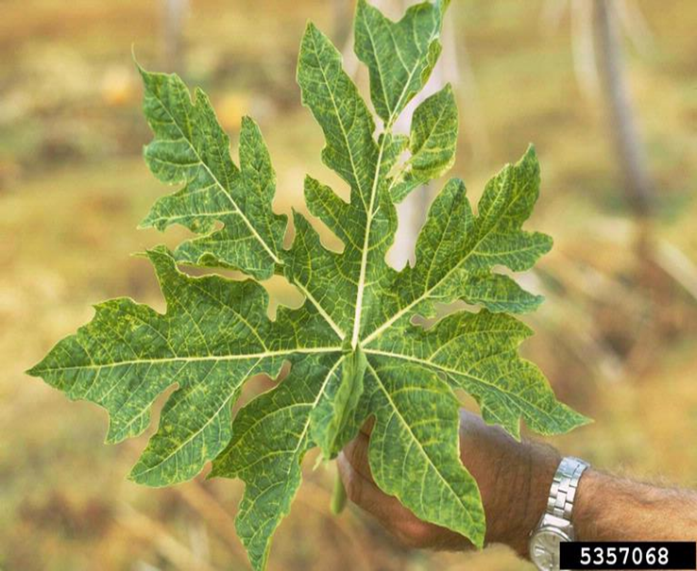

2. Fusarium Wilt:
a) Symptoms:

Yellowing of lower leaves, wilting

Brown discoloration in vascular tissue

b) Cure:

Soil drenching with Carbendazim or Trichoderma viride

c) Prevention:

Use resistant seeds

Rotate with non-host crops like cereals

d) Causes:

Caused by Fusarium oxysporum

Soil-borne fungus

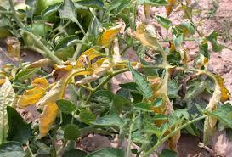

3. Powdery Mildew:
a) Symptoms:

White powdery growth on leaves and stems

Yellowing, premature leaf fall

b) Cure:

Spray Sulfex (Sulfur) or Carbendazim @ 1 g/l

Use Potassium bicarbonate spray as organic option

c) Prevention:

Maintain plant spacing

Avoid overhead watering

d) Causes:

Fungal disease caused by Erysiphe cichoracearum

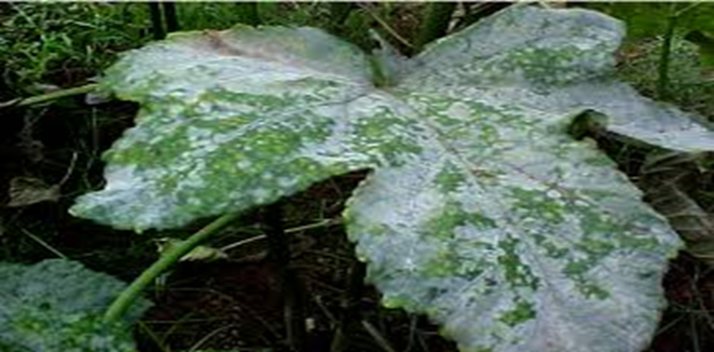

4)Cercospora Leaf Spot
a) Symptoms:

Circular brown spots with yellow halos on leaves

Spots enlarge and merge, causing leaf drop

Severe cases reduce plant vigor and yield

b) Cure:

Spray Mancozeb or Chlorothalonil @ 2 g/L

Repeat every 10–14 days during wet conditions

c) Prevention:

Use crop rotation

Remove and destroy infected leaves

Use resistant varieties if available

d) Causes:

Caused by Cercospora malayensis

Spreads through wind, rain splash, and infected debris

General Ladyfinger (Okra) Care and Disease Management Tips:
- Crop Rotation: Rotate okra with non-Solanaceous crops (e.g., beans, corn) to prevent the buildup of soil-borne diseases like Fusarium wilt and nematodes.
- Weeding: Regularly remove weeds to reduce competition for nutrients and water. Weeds also provide a habitat for pests like aphids.
- Watering: Okra needs consistent moisture, but it does not like waterlogging. Use drip irrigation to water the base of the plants, preventing fungal diseases like powdery mildew.
- Fertilization: Okra is a moderate feeder. Apply balanced fertilizers, particularly those high in potassium, to promote strong growth and healthy pod development.
- Pest Control: Regularly monitor for pests like aphids and sucking insects, which can spread diseases. Use organic pesticides or introduce beneficial insects to control pest populations.

3) Pests/Insects
i) Fruit and Shoot Borer (Earias vittella)
a) Symptoms:

Boreholes on fruits with black excreta

Twisted and dry shoots

b) Cure – Fertilizer/Insecticide:

Spray Spinosad 45 SC @ 0.5 ml/l

Use Neem Seed Kernel Extract (5%)

Set up pheromone traps (10–12/acre)

ii) Whiteflies
a) Symptoms:

Sticky honeydew and black sooty mold

Yellowing and curling of leaves

Vector for YVMV disease

b) Cure:

Spray Thiamethoxam or Imidacloprid

Use yellow sticky traps

iii) Aphids
a) Symptoms:

Leaf curling, stunted growth

Clusters of small black/green insects

Also transmit viral diseases

b) Cure:

Spray Dimethoate or Malathion

Apply Neem oil (2%) or NSKE
4) Nutrient Deficiencies
i) Nitrogen Deficiency
a) Symptoms:

Pale green to yellow older leaves

Slow growth and fewer pods

b) Cure – Fertilizer & Compost:

Apply Urea (46% N) in split doses

Use farmyard manure, vermicompost, green manure

ii) Phosphorus Deficiency
a) Symptoms:

Purplish discoloration on leaves

Poor flowering and fruit setting
b) Cure:

Apply Single Super Phosphate (SSP) or DAP

Use bone meal compost or rock phosphate

iii) Potassium Deficiency
a) Symptoms:

Leaf tip browning and curling

Weak stems, poor fruit quality

b) Cure:

Apply Muriate of Potash (MOP)

Use banana peel compost, ash compost

iv) Magnesium Deficiency
a) Symptoms:

Interveinal yellowing on older leaves

Early leaf drop

b) Cure:

Apply Magnesium sulfate (MgSO₄) @ 5 g/l

Use dolomite lime and leaf compost
v) Zinc Deficiency
a) Symptoms:

Small, narrow, yellowing leaves

Poor growth, short internodes

b) Cure:

Spray Zinc sulfate (ZnSO₄) @ 0.5%

Apply zinc-enriched compost or micronutrient mix

