Basic Information
- Name: Tomato (Solanum lycopersicum)
- Best Season: Tomatoes can be cultivated throughout the year in Maharashtra. However, optimal planting times are:
  - Rainy Season: June to July
  - Winter Season: October to November
  - Summer Season: January to February citeturn0search3
- Best Soil Type: Well-drained loamy soils rich in organic matter with a pH range of 6.5–7.5 are ideal for tomato cultivation.
- Time Period: Tomatoes typically take about 120 days from transplanting to harvesting. citeturn0search3
- Estimated Cost per Acre: The approximate cost of tomato cultivation per acre is ₹30,150. citeturn0search3
- Main Varieties:
- • Phule Raja – Early maturing variety developed by MPKV Rahuri, ideal for Kharif and Rabi seasons.
- • Phule Tejas – Medium-duration variety with good fruit firmness and shelf life.
- • Vaishali – Popular open-pollinated variety suited for local markets and home gardens.
- • Dhanashree – High-yielding hybrid with good transportability and disease resistance.
- • Abhinav – Locally preferred hybrid in Pune and Nashik for large uniform fruits.
- • Pusa Ruby – Traditional variety known for its adaptability and good cooking quality.
- • Naveen – Suitable for processing with round, firm fruits and uniform ripening.
- • Rashmi – Local hybrid with uniform fruit size and high market demand.
- • Megha – Heat-tolerant hybrid variety grown in summer season.
- • Sankranti – Locally grown in western Maharashtra with moderate yield and early harvest.
  - .
Common Diseases and Their Management
- Leaf Curl Virus:
  - Symptoms: Upward curling of leaves, reduction in leaf size, stunted growth, and flower drop.
  - Possible Causes: Transmitted by whiteflies.
  - Control Measures:
    - Insecticides: Apply insecticides such as Imidacloprid (70% WG) at 0.1 g per liter of water to control whitefly populations.
    - Cultural Practices: Remove and destroy infected plants; use reflective mulches to deter whiteflies. citeturn0search2
    - 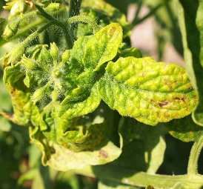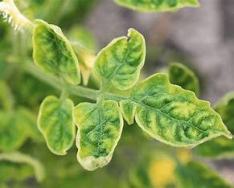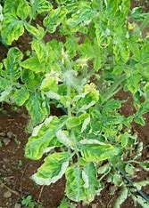
- Fruit Borer (Helicoverpa armigera):
  - Symptoms: Larvae bore into fruits, causing holes and making them unmarketable.
  - Possible Causes: Adult moths lay eggs on flowers and fruits; upon hatching, larvae penetrate the fruits.
  - Control Measures:
    - Insecticides: Spray Chlorantraniliprole (18.5% SC) at 0.3 ml per liter of water.
    - Cultural Practices: Install pheromone traps at 5 per acre to monitor and control moth populations. citeturn0search2
    - 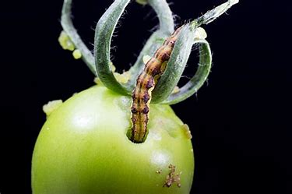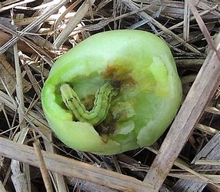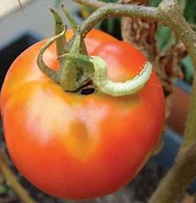
1. Damping-Off (Seedling Stage):
  - Symptoms:
  - Seedlings fail to emerge from the soil.
  - Young seedlings exhibit water-soaked stems, leading to collapse.
  - Possible Causes:
  - Fungal pathogens such as Pythium and Rhizoctonia thrive in overly moist soil conditions.
  - Management:
  - Ensure well-draining soil and avoid overwatering.
  - Use sterilized soil for seed starting.
  - Apply appropriate fungicides as a preventive measure.
Fertilizer/Amendment:
- Trichoderma viride (Bio-fungicide)
- Neem Cake
  - 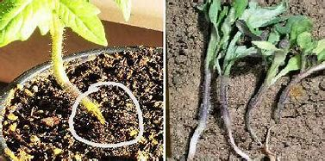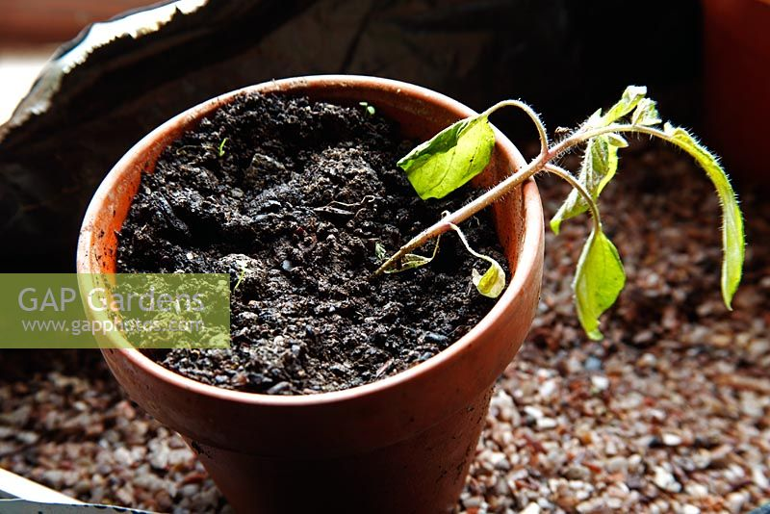
- 2. Early Blight (Alternaria solani):
  - Symptoms:
  - Dark brown spots with concentric rings on older leaves.
  - Yellowing of leaves leading to defoliation.
  - Lesions on stems and fruits in severe cases.
  - Possible Causes:
  - Fungus persists in soil and plant debris.
  - Spread facilitated by splashing water and wind.
  - Management:
  - Practice crop rotation and remove plant debris.
  - Apply fungicides containing chlorothalonil or copper. • Copper-based fungicidal foliar sprays (e.g., Copper Oxychloride)
  - • Potassium Sulphate
  - Ensure proper plant spacing for air circulation.
  - 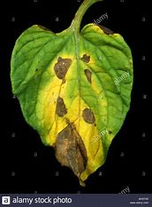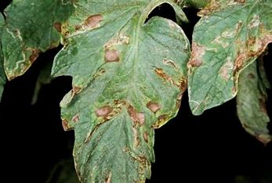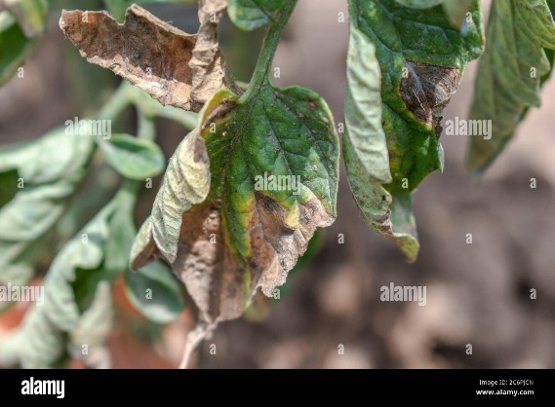
- 3. Late Blight (Phytophthora infestans):
  - Symptoms:
  - Water-soaked lesions on leaves, stems, and fruits.
  - White mold growth under leaves in humid conditions.
  - Rapid plant collapse in favorable conditions.
  - Possible Causes:
  - Oomycete pathogen thrives in cool, wet weather.
  - Spores spread via wind and rain.
  - Management:
  - Remove and destroy infected plants immediately.
  - Apply fungicides like mancozeb or chlorothalonil preventively, • Mancozeb + Metalaxyl
  - • Phosphoric acid-based foliar fertilizers Avoid overhead watering to reduce leaf wetness.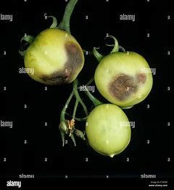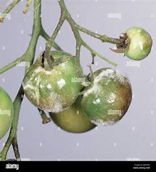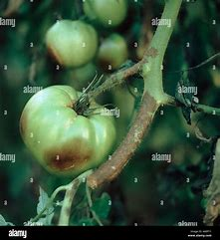
- 4. Septoria Leaf Spot (Septoria lycopersici):
  - Symptoms:
  - Numerous small, circular spots with gray centers on lower leaves.
  - Premature leaf drop leading to reduced yield.
  - Possible Causes:
  - Fungus overwinters in soil and plant debris.
  - Spread through water splashes and contaminated tools.
  - Management:
  - Remove affected leaves and dispose of them properly.
  - Use drip irrigation to minimize leaf wetness.
  - Apply fungicides containing copper or chlorothalonil, • Copper Oxychloride
  - • Sulphur-based foliar sprays
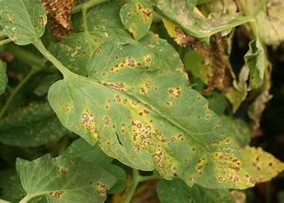 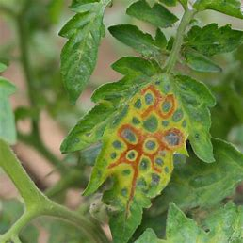 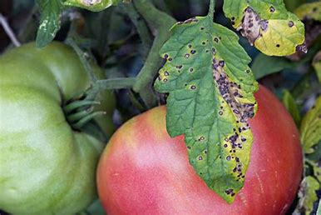
- 5. Fusarium Wilt (Fusarium oxysporum f. sp. lycopersici):
  - Symptoms:
  - Yellowing and wilting of leaves, often on one side of the plant.
  - Brown discoloration of vascular tissue when stems are cut.
  - Possible Causes:
  - Soil-borne fungus enters through roots and blocks water transport.
  - Management:
  - Plant resistant tomato varieties., • Biofertilizers like Pseudomonas fluorescens
  - • Neem Cake + Farm Yard Manure (FYM)
  - Practice crop rotation with non-host plants.
  - Remove and destroy infected plants to prevent spread.
- 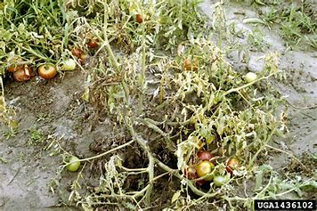 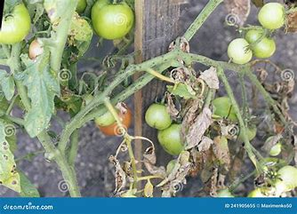 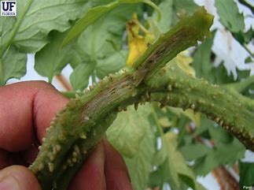 6. Verticillium Wilt (Verticillium spp.):
  - Symptoms:
  - Yellowing between leaf veins and wilting of lower leaves.
  - Stunted growth and reduced yield.
  - Possible Causes:
  - Soil-borne fungi infect roots and disrupt water flow.
  - Management:
  - Use resistant varieties and grafting techniques.
  - Implement crop rotation and soil solarization.
  - Maintain optimal soil health to support plant vigor., • Trichoderma-enriched compost
  - • Vermicompost with neem cake
  - 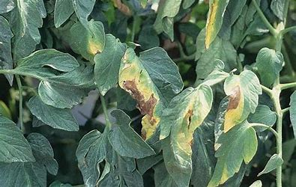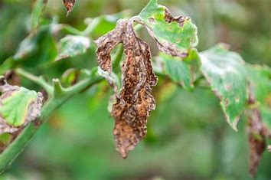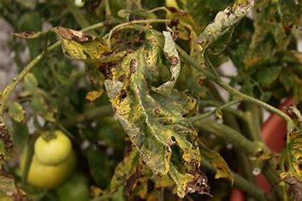
- 7. Blossom End Rot:
  - Symptoms:
  - Dark, sunken lesions on the blossom end of fruits.
  - Lesions enlarge and become leathery over time.
  - Possible Causes:
  - Calcium deficiency in developing fruits.
  - Fluctuations in soil moisture affecting calcium uptake.
  - Management:
  - Maintain consistent watering practices.
  - Apply calcium-rich amendments like gypsum.
  - Mulch to conserve soil moisture and regulate temperature.
  - 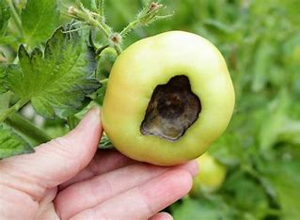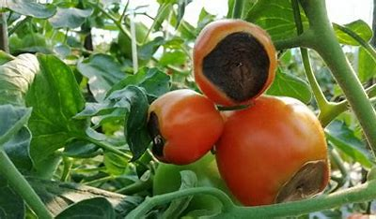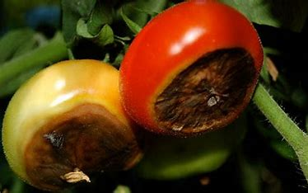
- 8. Anthracnose (Colletotrichum spp.):
  - Symptoms:
  - Circular, sunken lesions on ripe fruits.
  - Lesions may coalesce, leading to extensive fruit rot.
  - Possible Causes:
  - Fungus survives in soil and plant debris.
  - Infection favored by warm, humid conditions.
  - Management:
  - Harvest fruits promptly as they ripen.
  - Apply fungicides during wet periods.
  - • Calcium Nitrate (CaNO₃)
  - • Gypsum (Calcium Sulphate)
  - 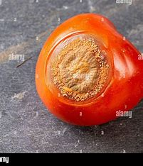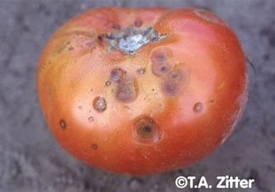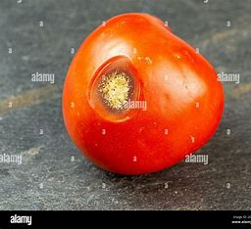

Deficiencies:

1. Nitrogen (N) Deficiency
- Symptoms:
  - Older leaves turn pale yellow or light green
  - Stunted growth
  - Poor fruit development
- Fertilizers to Use:
  - Urea (46% N)
  - Ammonium Sulphate
  - Organic compost or well-decomposed FYM

2. Phosphorus (P) Deficiency
- Symptoms:
  - Leaves appear dull dark green with purplish veins
  - Slow growth and poor root development
  - Delayed flowering and fruiting
- Fertilizers to Use:
  - Single Super Phosphate (SSP)
  - Di-Ammonium Phosphate (DAP)
  - Bone meal (organic)

3. Potassium (K) Deficiency
- Symptoms:
  - Leaf edges turn yellow and scorched (leaf burn)
  - Weak stems
  - Poor fruit size and low resistance to disease
- Fertilizers to Use:
  - Muriate of Potash (MOP)
  - Sulfate of Potash (SOP) – better in saline soil
  - Wood ash (organic alternative)

4. Calcium (Ca) Deficiency
- Symptoms:
  - Blossom End Rot on fruits
  - Young leaves may be distorted
  - Reduced root and shoot growth
- Fertilizers to Use:
  - Calcium Nitrate
  - Gypsum (Calcium Sulphate)
  - Dolomite lime (if soil is acidic)

5. Magnesium (Mg) Deficiency
- Symptoms:
  - Interveinal chlorosis (yellowing between veins) on older leaves
  - Leaf edges curl upwards
- Fertilizers to Use:
  - Magnesium Sulphate (Epsom salt)
  - Dolomite lime (if pH is low)

6. Sulphur (S) Deficiency
- Symptoms:
  - Overall yellowing of young leaves (resembles nitrogen deficiency)
  - Thin stems and reduced leaf size
- Fertilizers to Use:
  - Ammonium Sulphate
  - Gypsum
  - Elemental Sulphur granules

7. Zinc (Zn) Deficiency
- Symptoms:
  - Shortened internodes (rosette appearance)
  - Young leaves show interveinal yellowing
- Fertilizers to Use:
  - Zinc Sulphate (ZnSO₄) – 0.5% foliar spray
  - Chelated Zinc EDTA (soil or foliar)

8. Iron (Fe) Deficiency
- Symptoms:
  - Young leaves turn yellow-white with green veins
  - Common in alkaline soils
- Fertilizers to Use:
  - Ferrous Sulphate (FeSO₄) – 0.5% foliar spray
  - Chelated Iron (Fe-EDTA or Fe-DTPA)

9. Boron (B) Deficiency
- Symptoms:
  - Cracked fruits
  - Deformed leaves and poor flower development
- Fertilizers to Use:
  - Borax (apply in very low quantities)
  - Solubor (Boron foliar spray)

10. Manganese (Mn) Deficiency
- Symptoms:
  - Yellowing between veins in middle leaves
  - Poor fruit setting
- Fertilizers to Use:
  - Manganese Sulphate (MnSO₄) – 0.3% foliar spray

Common Pests and Their Management

1. Fruit Borer (Helicoverpa armigera)
- Symptoms:
  - Holes in fruits with excreta
  - Caterpillar often found inside fruit
- Pest Description:
  - Greenish-brown caterpillar; feeds on developing fruits
- Control:
  - Install pheromone traps
  - Release Trichogramma chilonis (egg parasitoid)
- Insecticides:
  - Spinosad 45 SC (0.3 ml/l)
  - Emamectin Benzoate 5 SG (0.4 g/l)
  - Novaluron 10 EC (1 ml/l)

2. Whitefly (Bemisia tabaci)
- Symptoms:
  - Yellowing and curling of leaves
  - Sticky honeydew on leaves; Sooty mold formation
  - Also transmits Tomato Leaf Curl Virus
- Pest Description:
  - Tiny white-winged insects found on the underside of leaves
- Control:
  - Use yellow sticky traps
  - Encourage ladybugs or lacewings
- Insecticides:
  - Imidacloprid 17.8 SL (0.3 ml/l)
  - Thiamethoxam 25 WG (0.3 g/l)
  - Pymetrozine 50 WG (0.3 g/l)

3. Aphids (Aphis gossypii)
- Symptoms:
  - Clusters of small soft-bodied insects on new leaves
  - Leaf curling and reduced growth
- Pest Description:
  - Green, black, or brown small insects sucking sap
- Control:
  - Use neem oil spray
  - Encourage predatory insects (ladybugs)
- Insecticides:
  - Dimethoate 30 EC (1 ml/l)
  - Acetamiprid 20 SP (0.25 g/l)
  - Neem oil 1500 ppm (5 ml/l)

4. Thrips (Thrips tabaci)
- Symptoms:
  - Silver streaks on leaves
  - Leaf curling and stunted growth
- Pest Description:
  - Small slender insects, very fast movers
- Control:
  - Blue sticky traps
  - Spray neem-based insecticides
- Insecticides:
  - Fipronil 5 SC (1 ml/l)
  - Spinosad 45 SC (0.3 ml/l)
  - Emamectin Benzoate (0.4 g/l)

5. Leaf Miner (Liriomyza spp.)
- Symptoms:
  - Tunneling patterns on leaves
  - Reduced photosynthesis and premature leaf fall
- Pest Description:
  - Tiny maggots feed between leaf surfaces
- Control:
  - Remove and destroy infected leaves
  - Use light traps at night
- Insecticides:
  - Abamectin 1.9 EC (0.5 ml/l)
  - Spinosad 45 SC (0.3 ml/l)

6. Root-Knot Nematodes (Meloidogyne spp.)
- Symptoms:
  - Galls (swellings) on roots
  - Yellowing and wilting of plant
- Pest Description:
  - Microscopic worms in soil attacking roots
- Control:
  - Use neem cake + Trichoderma harzianum
  - Crop rotation with non-host crops
- Soil Treatment:
  - Carbofuran granules (Use only under expert advice)
  - Neem-based granules

7. Red Spider Mite (Tetranychus urticae)
- Symptoms:
  - Fine webbing on underside of leaves
  - Yellow speckled leaves, later drying
- Pest Description:
  - Tiny red mites suck sap from leaves
- Control:
  - Spray miticides or neem oil
  - Maintain good field hygiene
- Miticides/Insecticides:
  - Propargite 57 EC (1 ml/l)
  - Fenpyroximate 5 EC (0.5 ml/l)

